# J:\Desktop\Test.pngLabour Market Conditions in the Pilbara

The Pilbara region is dominated by the resources sector, in particular, the iron ore and natural gas sectors[1]. Mining was the largest employing sector in the Pilbara in 2011 (latest available data), with 36 per cent of workers employed in the industry. Mining also contributes substantially to employment in other industries, such as Construction (development of mine sites and infrastructure) and Manufacturing (downstream processing), which together accounted for a further 20 per cent of the region’s workforce.

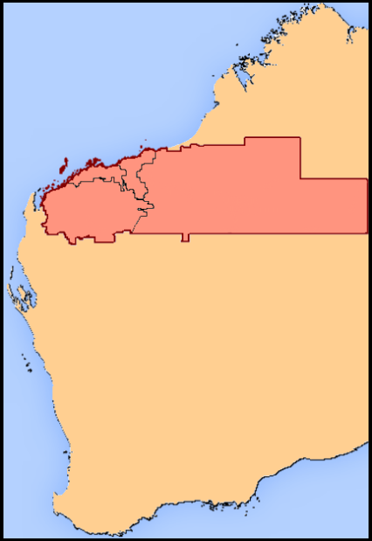

Ashburton

East Pilbara

Roebourne

Port Hedland

Ongoing strong international demand for resources and energy has resulted in the Pilbara consistently outperforming almost every other region in the nation in recent years. More recently, however, a slowdown in the Mining industry has become evident. Against this backdrop, and with the Mining industry transitioning from the construction phase, to a less labour intensive production phase of the cycle, conditions in the Pilbara have also softened. The unemployment rate for the region increased from 2.6 per cent in December 2012 to 5.1 per cent in December 2013 (latest available data), although it remains below the national average (5.8 per cent in March 2014).

Despite the relatively low unemployment rate, there is considerable variation in unemployment rates across the region. For instance, the Local Government Area (LGA) of Ashburton recorded an unemployment rate of just 2.1 per cent in December 2013, while the LGA of Port Hedland recorded an unemployment rate of 7.3 per cent.

**Feedback from employers in the area**

The Department of Employment undertook a *Survey of Employers’ Recruitment Experiences* in November 2013 to collect information on local labour demand and recruitment outcomes. More than 250 employers responded to the survey. A similar survey was undertaken in the region in August 2010.

The survey findings suggest that, while recruitment conditions have eased in the Pilbara since it was last surveyed in 2010 (at which time the region was experiencing the peak of the post GFC Mining boom), recruitment conditions in the Pilbara remain more difficult than those experienced by employers in other regions across Australia.

**Recruitment activity remains strong, although staff turnover is driving recruitment**

In line with the general softening in labour market conditions in the region, the recruitment rate, which measures the annual number of vacancies per 100 staff, has fallen significantly since the Pilbara was last surveyed, from a high of 79 in 2010 to just 37 in 2013. Nevertheless, the recruitment rate remains more than double the rate recorded for the other regions surveyed by the Department of Employment in the nine months to November 2013.[2]



Staff numbers were reduced by 30 per cent of employers in the Pilbara in the 12 months prior to the survey (compared with just 11 per cent in 2011). Results suggest that employers have begun to shed staff in an attempt to lower costs in light of the deteriorating economic conditions, with the vast majority (90 per cent) of employers who have reduced staff numbers doing so due to lower or uncertain demand for their goods or services.

By comparison, 17 per cent of employers increased their staff numbers in the year to November 2013, which is broadly in line with other regions surveyed. This result suggests that the higher rate of recruitment activity in the Pilbara (compared with other regions) is more likely to be due to higher levels of staff turnover rather than a strengthening in labour market conditions.

**Location and differences in wages the most common causes of recruitment difficulty**

The proportion of employers reporting that recruitment was difficult in their most recent recruitment round (43 per cent) has declined considerably since 2010, when 61 per cent of employers reported difficulty recruiting.

The remoteness of the Pilbara is the most significant challenge employers face when recruiting, with ‘Location’ (47 per cent) being the most common reason cited by employers who had difficulty recruiting. This was followed by ‘Not enough applicants’ (25 per cent) and ‘Wages / contract / conditions’ (24 per cent) reflecting challenges attracting workers to many parts of the region and difficulties competing with large Mining companies for workers. These results differ considerably from other regions surveyed, where ‘Technical skill requirements of the job’ is generally the most common reason that employers have difficulty recruiting.

Employers reported the greatest difficulty filling higher skilled positions, with almost two thirds of employers indicating that it was ‘difficult’ to fill vacancies for Managers and Professionals. However, the recruitment difficulty for Technicians and Trade workers has eased substantially since 2010.

Around one third of employers stated that recruitment for lower skilled occupations (such as Machinery Operators and Drivers) was ‘difficult’.



**Applicant numbers remain low**

Given the remoteness of the region and its small local population base, it is not surprising that, on average, there were only 6.3 applicants per vacancy, compared with 10.1 for other regions. In 2010, when labour market conditions were significantly stronger, employers received an average of 4.9 applicants per vacancy.

‘Lack of relevant experience’ (49 per cent) was the most common reason that applicants did not qualify for an interview, suggesting that many local employers are looking for workers who they know will ‘hit the ground running’ rather than being prepared to develop less experienced staff. While less experienced workers generally receive lower wages many employers complained that it can be difficult to retain staff once they have been trained and developed. The second most commonly cited reason that applicants did not qualify for an interview in the Pilbara was ‘Applicant located out of the local area’ (26 per cent), suggesting that many employers in the Pilbara have a preference to hire local job seekers. That said, this result might not reflect employer views for the broader Mining industry which is more inclined to offer ‘fly-in/fly-out’ arrangements.

**Many employers use informal recruitment methods**

Informal methods of recruitment (such as word of mouth and being approached directly by a job seeker) were more commonly used in the Pilbara (64 per cent of employers in their most recent recruitment exercise) than in other regions (52 per cent). Informal methods of recruitment were particularly common when employers were advertising for lower skilled vacancies (71 per cent). Job seekers who do not tap into the informal labour market will therefore miss out on a large proportion of the available employment opportunities in the region.

Other common recruitment methods used by employers included advertising on the internet (39 per cent), putting a job advertisement in a newspaper (24 per cent) and using a recruitment agency (9 per cent). Many employers use more than one recruitment method to fill a vacancy.

**Employers say skills development and improving labour market engagement will advance the employment prospects of Indigenous job seekers**

Indigenous persons account for around 15 per cent of Pilbara’s population and continue to have poorer labour market outcomes than non-Indigenous Australians. For instance, in 2011 (latest available data) the Indigenous unemployment rate in the Pilbara stood at 13.9 per cent, well above the 1.6 per cent recorded for non-Indigenous persons.

Employers in the 2013 survey were asked the following question: *‘From the perspective of your business, what could be done to improve the employment prospects of Indigenous job seekers in your area?’*

Employer responses indicate developing skills and improving labour market engagement will advance the employment prospects of Indigenous job seekers in the Pilbara. Responses most frequently related to the need for ‘further education and training’ (28 per cent), and improving the ‘availability, reliability and retention’ (24 per cent) of Indigenous persons.

**Growing concerns about future economic conditions in the region**

Reflecting the softening in the labour market since the Pilbara was last surveyed in 2010, almost half (46 per cent) of employers in 2013 indicated that ‘*low or uncertain demand for their products’* or *‘concern about the economy’* was their single greatest future concern, compared with just 7 per cent in 2010.



**Where are the opportunities?**

Encouragingly, 53 per cent of employers surveyed in the Pilbara indicated that they would recruit in the next 12 months. While the majority of employers said they would recruit to replace staff who they expected would leave their business, almost a quarter of employers indicated they expected to increase staff numbers.

Employers frequently expected to recruit for a number of Technicians and Trades Workers occupations including Structural Steel and Welding Workers, Motor Mechanics and Electricians. Employers in the Pilbara also expected to recruit for many lower skilled occupations over the next 12 months such as Sales Assistants, Truck Drivers, Housekeepers, Waiters, Checkout Operators and Office Cashiers, General Clerks, Kitchenhands and Commercial Cleaners.

Local opportunities may also exist for occupations requiring higher levels of education and training, for which employers had difficulty filling vacancies, including Registered Nurses, Welfare Support Workers, Retail Managers and Child Carers.

1. In 2012, around 95 per cent of Australia’s iron ore was produced in the Pilbara, while 70 per cent of Australia’s natural gas was sourced and processed in the region.
2. In the nine months to November 2013, 17 regions were surveyed. Their results are combined and used as ‘other regions’ comparison throughout this report.