# Slide 1: Improving your odds in the jobs market

Slides for job seekers
Presented in July 2016 by Mr Ivan Neville, Branch Manager, Labour Market Research and Analysis Branch
Australian Government Department of Employment

# Slide 2: So, where are the jobs?

(Employed, '000)
Health Care and Social Assistance: 1532.1
Retail Trade: 1265.9
Construction: 1050.8 (Producing Industry)
Professional, Scientific and Technical Services:990.0
Education and Training: 937.0
Manufacturing: 877.5 (Producing Industry)
Accommodation and Food Services: 825.7
Public Administration and Safety: 741.0
Transport, Postal and Warehousing: 623.9
Other Services: 472.8
Financial and Insurance Services: 430.9
Administrative and Support Services: 422.1
Wholesale Trade: 371.9
Agriculture, Forestry and Fishing: 321.7 (Producing Industry)
Mining: 227.9 (Producing Industry)
Arts and Recreation Services: 226.5
Rental, Hiring and Real Estate Services: 211.6
Information Media and Telecommunications: 208.8
Electricity, Gas, Water and Waste Services: 144.0 (Producing Industry)


## Notes

*Source: ABS, Labour Force, Australia, May quarter 2016 (annual average data)*

# Slide 3: Most new jobs will be in the services industries…

92% of new jobs will be in services industries
Around 989,700 new jobs in Australia by 2020
Health Care and Social Assistance: 250,200
Professional, Scientific and Technical Services: 151,200
Education and Training: 121,700
Retail Trade: 106,000
Agriculture, Mining and Manufacturing are projected to decline

## Notes

Source: Department of Employment, Industry projections, five years to November 2020

# Slide 4: …and in higher skilled occupations

Projected national employment growth, five years to November 2020
Projected share of new jobs:
Higher skilled: 71%
Lower skilled: 29%

## Notes

Source: Department of Employment, 2016 Employment Projections, five years to November 2020

# Slide 5: You need to stand out when applying for a job

Vacancies advertised on the internet or in a newspaper, Australia
Average number of applicants per vacancy: 15
Average number of applicants interviewed: 3
12 not interviewed

## Notes

Source: Department of Employment, Survey of Employers’ Recruitment Experiences, All regions surveyed and Metro, 12 months to December 2015

# Slide 6: So, how do you stand out?

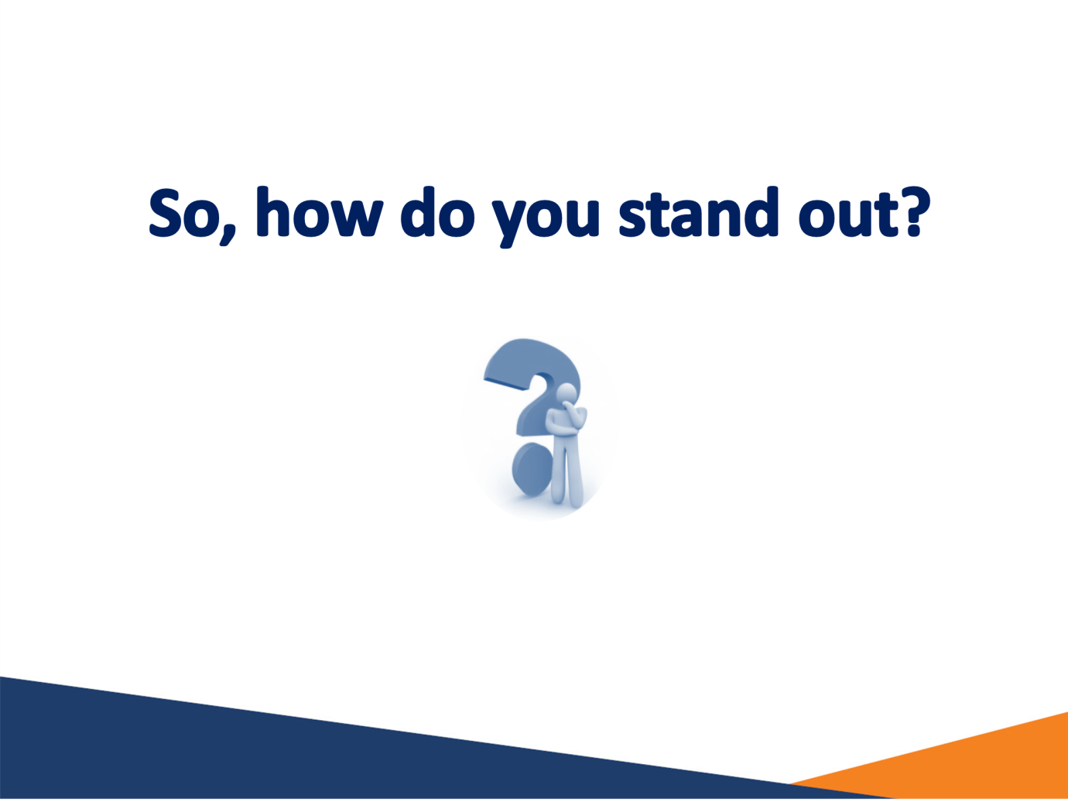

# Slide 7: Education and training is increasingly important

Unemployment rate by highest educational attainment, Australia
Bachelor degree or higher qualification: 3.4%
Advanced Diploma/Diploma: 4.0%
Certificate III/IV: 4.8%
- 93% of all new jobs will require post-school education
The wrong training is of no benefit
Year 12: 7.7%
Certificate I/II: 12.8%
Below Year 12: 10.4%


## Notes

Source: ABS, Education and Work, May 2015, 15 to 74 years; Department of Employment, Skill level projections, five years to November 2020

# Slide 8: Don’t let any opportunity pass you by

What if you don't get the job you want straight away?
Volunteering and acquiring a transitional job demonstrates to employers:
Motivation and reliability
You are building your skills
You are gaining experience

# Slide 9: But soft skills are equally important to employers as technical skills and experience

Relevant experience
Qualifications
Technical knowledge
Availability
Enthusiastic, reliable and engaged
Good communication skills
Well mannered/presented
Good people skills

## Notes

Source: Department of Employment, Survey of Employers’ Recruitment Experiences, 2016

# Slide 10: Employers are also increasingly seeking these transferable skills…

Critical thinking
Digital literacy
Creativity
Problem solving
Financial literacy
Skills not easily replicated by artificial intelligence
Job advertisements requiring these skills have increased by over 200% since 2012

## Notes

Source: Foundation for Young Australians, The New Basics, April 2016

# Slide 11: …because the jobs market is changing

2016:
App developer
Mobile Groomer
Zumba Instructor
Drone Pilot
3D Print Professional
What we know:
Emerging technologies
Ageing population
Globalisation
Learning for life is essential

# Slide 12: Research jobs you are interested in

Research the organisation
Research the industry
Call or visit the organisation
Ask questions to properly understand the job
If in doubt, Google it!

## Notes

Source: Department of Employment, ‘Improving the employment prospects of young Australians’, selected regions surveyed

# Slide 13: When writing your application and resume

Match each application to the specific job
Make sure it looks and sounds professional
Write to the job requirements
Spelling, punctuation and grammar need to be perfect



## Notes

Source: Department of Employment, ‘Improving the employment prospects of young Australians’, selected regions surveyed

# Slide 14: You can only make one first impression

You can build on a good first impression
Be punctual
Dress appropriately
Good handshake
Appear confident & friendly

# Slide 15: Every application is a learning experience

Do job seekers know why they miss out on jobs?
Reasons employes gave for applicatns missing out on jobs?
Qualifications/Training
Experience/Skills
Poorly written/presented application
Inadequate soft skills
Why applicants thought they had missed out on a job
Qualifications/Training (Correct)
Experience/Skills (Correct)
Poorly written/presented application (Incorrect)
Inadequate soft skills (Incorrect)
Employer feedback is highly useful

## Notes

Source: Department of Employment, Survey of Employers’ Recruitment Experiences, All regions surveyed; ABS, Job Search Experience, Australia, 2013

# Slide 16: Approach employers directly where possible

1 in 3 jobs are not advertised, Australia
Formally advertised: 66%
Informally advertised: 34% (Word of mouth, Approached by job seeker, Social media and Networking)


## Notes

Source: Department of Employment, Survey of Employers’ Recruitment Experiences, All regions surveyed and Metro, 12 months to December 2015

# Slide 17: Don’t limit your job search to your local area

Number of vacanices, June 2016
New South Wales: 66,400
Victoria: 43,200
Queensland: 29,700
Western Australia: 13,200
South Australia: 7,200
Australian Capital Territory: 5,300
Northern Territory: 2,100
Tasmania: 1,600

## Notes

Source: Department of Employment, Internet Vacancy Index, June 2016 (trend data)

# Slide 18: Tips for improving odds

Think and explore
Education
Soft skills
Job search

# Slide 19: Tools to assist with job search

Websites:
joboutlook.gov.au
Phone apps:
Australian Jobsearch
Career Quiz (http://joboutlook.gov.au/careerquiz.aspx)
Publications:
Australian Jobs (www.employment.gov.au/australianjobs)
Fact Sheets:
Looking for a Job - Employer Advice for Young People (lmip.gov.au)
Employers' tips for mature age job seekers (lmip.gov.au)
Australian Jobs (www.employment.gov.au/australianjobs)
Recruitment Methods Used by Employers - Infographic


# Slide 20

Australian Government Department of Employment.
If you have any questions about the presentation please contact the Employment Pathways Analysis section on 1800 059 439 or email recruitmentsurveys@employment.gov.au