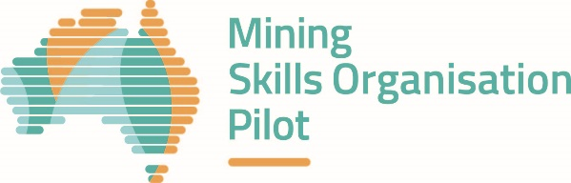

08 SEPTEMBER 2020

PILOT BULLETIN – THIRD QUARTER 2020
Welcome to your quarterly update on the Mining Skills Organisation Pilot (MSOP).
Following the official launch of the MSOP by Senator the Hon Michaelia Cash, Minister for Employment, Skills, Small and Family Business and the Hon Steve Irons, Assistant Minister for Vocational Education and Training and Apprenticeships on 7 May, the Minerals Council of Australia has been making progress on:
- Development of a dedicated MSOP web page
- Establishment and activation of the Steering Group, with six executive members representing industry, and three advising observers from government, education and training and state chambers
- Establishment and activation of the Working Group, with a broad mix of representatives from key stakeholder cohorts including industry, education and training, the current Vocational Education and Training (VET) system and other peak or professional bodies
- Both the Steering and Working Groups have had multiple meetings, a joint planning session and numerous project development workshops to confirm industry priorities and identify pilot projects.
Project hubs
The Steering Group and Working Group have also agreed on three project hubs – apprenticeships, digital transformation and attraction and retention – with the aim of challenging and reforming the existing VET framework in these areas for the benefit of industry, individuals and participating organisations.
Apprenticeships hub
- Modernise how skilled tradespeople for the sector are educated, trained and developed
- Focusing on in-demand Heavy Duty Diesel Fitters initially, the hub will develop content, delivery and assessment modes that better align industry need and apprentice knowledge, with the goal of creating a flexible model for future use with other trades
- Key Goal: 1000 additional apprenticeships.
Digital transformation hub
- Training products developed for the sector relating to automation and the application of digital technologies should be part of Australia’s nationally-recognised training product library
- The hub’s aim is to develop this system and achieve greater speed to market in training product endorsement
- Key Goal: embedding existing automation training products into Australia’s training package framework.
Attraction and retention hub
- Focus on relationship between workforce planning (in terms of capability identification), transferable skills and pathways
- Identifying and testing strategies that make a career in the industry attractive to those with partial or transferable skills and qualifications
- By aligning the skills necessary for a successful career in mining with those in other industries, the hub will provide a tangible demonstration of these linkages to better identify and meet required industry capability needs in a timely way at a whole of sector level
- Key Goal: establishing a Mining Fundamentals skill set.
What’s next?
- With in-principle endorsement from the Steering Group, the Working Group will now develop and refine these projects for final approval and implementation
- The Steering Group and Working Group will continue to identify and source key participants and collaborators for projects
- The MSOP will provide more opportunities for stakeholders to share their perspectives and get involved in the pilot
- The web page will be updated to feature details on the project hubs as they develop and to introduce the members of the Steering Group and Working Group.
Questions? Comments? Feedback? Interested in engaging with MSOP on any of these Project Hubs? Email us: MiningSOPilot@dese.gov.au
Visit the Mining Skills Organisation Pilot website to learn more.

