

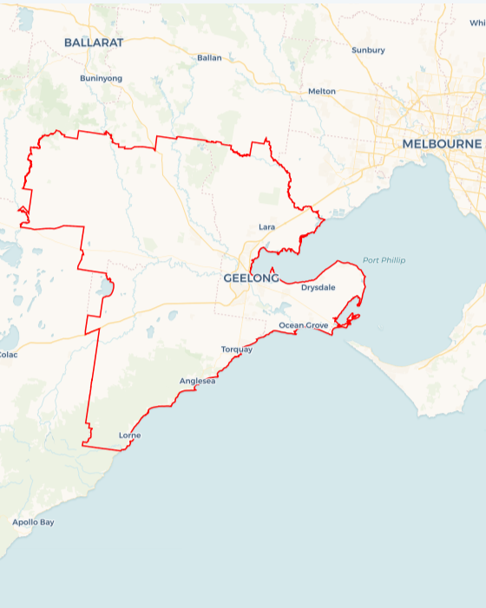Local Jobs Plan

Barwon ****Employment Region**** | VIC | ****April 2024****

Workforce Australia Local Jobs (Local Jobs) is a program that supports tailored approaches to accelerate   
reskilling, upskilling and employment pathways in response to current and emerging local workforce needs.

## Local Jobs elements

### Local Jobs Plan

The Local Jobs Plan sets out the skills and employment challenges and priorities of the region, and associated strategies that will drive the design and implementation of activities to be implemented to address these challenges.

### Employment Facilitators

Employment Facilitators and Support Officers support the delivery of the program by bringing together key stakeholders including businesses, employment services providers, higher education and training organisations.

### Local Jobs and Skills Taskforce

Each Employment Region has its own Taskforce. Representatives include local stakeholders who have demonstrated experience in upskilling, reskilling, and an ability to represent, connect and collaborate with others in the region to meet labour market needs.

### Local Recovery and National Priority Funds

The Local Recovery Fund supports projects that meet the priorities identified in the Local Jobs Plan. The National Priority Fund provides funding for innovative local solutions to address structural barriers to employment.

Explore labour market insights for the  
[Barwon](https://www.jobsandskills.gov.au/work/employment-region-dashboards-and-profiles/monthly-labour-market-dashboards) Employment Region

## Local labour market challenges in the region

* Places with challenges: Many parts of the region have a history of social, economic, and labour market challenges, including Norlane, Corio, Whittington, North Geelong, Newcomb, Moolap, and Portarlington.
* Transport challenges: Public transport is not always available for individuals. This is especially true for the Bellarine, Golden Plains and Surf Coast areas. Obtaining a car licence can be hard. Cost of living pressures can make obtaining a vehicle and covering costs unattainable. Wait times are longer in the Northern suburbs for programs like City of Greater Geelong’s L2P program that helps young people get a driver’s licence.
* Transition to Net Zero: Victoria aims for net zero emissions by 2045 and 95% renewable energy by 2035. These goals are transforming energy use across the economy. Much of the transformation involves clean   
  economy-related manufacturing, construction, installation and modifications. We need a new wave of skilled workers to be able to complete this transformation safely and to the highest quality.
* Apprentices and Trainees: More support is needed for individuals to start and finish their apprenticeships and traineeships in the region. Women are under-represented in apprenticeships in traditional trades, including electrotechnology, plumbing and carpentry.
* Culturally and Linguistically Diverse (CALD): Parts of the CALD community require additional support to obtain educational and literacy outcomes and have limited exposure to local employment. Businesses need education on inclusive hiring to help remove cultural challenges to first jobs in Australia.
* Labour Market Conditions: Labour shortages exist in all industries, including health care and tourism, hospitality, retail, personal services, and the arts. This is especially true in rural areas. Manufacturing in the Barwon Region will continue to grow. This includes chemicals and refining, engineering, food and agri-businesses, metal fabrication, fibre and textiles, and timber processing. There will be more jobs in the Avalon Employment Precinct, including through the building of the Hanwha Defence facility.

## Local jobs and skills priorities and strategies in the region

### Priority 1 – Supporting local industry to engage the local labour market to meet changing industry need

#### What are our challenges and opportunities?

The labour market is unable to meet the needs and expectations of industry. The needs of individuals have changed, and individuals now seek flexibility and career control. There is a mismatch between the skill level of individuals and the skill level of advertised roles, with a trend for more higher skilled jobs forecast to continue. This provides a chance for individuals to learn new skills through upskilling and reskilling as the economy continues to change.

#### How are we responding?

* We will partner with local groups to deliver a series of Jobs Expos to raise awareness of current and future jobs available. The expos will feature presentations from local businesses, providing links to existing jobs and training options. The Jobs Expos will focus on hospitality and tourism, early childhood education and care, multicultural as well as Aboriginal and Torres Strait Islander events.
* We will support businesses to redesign jobs to better align with the skills of individuals seeking work. We will encourage local businesses to improve their hiring practices. These changes will help make workplaces more inclusive and attract and retain employees. We will support businesses to design work that lets individuals balance work and other duties. This will create meaningful paths to employment and promote diversity in local industry.
* We will raise awareness of the benefits of existing pathway programs. We will also create pathways to jobs in key industries in the region, including health care, manufacturing, construction, early childhood education and care, the clean economy, the arts, tourism, and education.
* We will support the workforce to access varied employment modes, including self-employment.
* We will work with key businesses in current and growing industries to tailor initiatives to meet their workforce needs. We will help local industry meet the growing need for workers in the care and support economy. We will also help them with the transition to net zero and with digital and technological change.

### Priority 2 – Supporting the local economy to transition to a Net Zero economy, including apprenticeship pathways

#### What are our challenges and opportunities?

There is a lack of understanding of projects, infrastructure, and support required to achieve State and Federal Government priorities. These priorities include Big Build projects, transition to a net zero economy, increasing apprenticeship and traineeship participation, and increasing women’s engagement in non-traditional apprenticeship pathways.

#### How are we responding?

* We will create links between local individuals and clean energy careers, including promoting apprenticeships and traineeships within the sector.
* We will ensure that local employment agencies are aware of the job paths for current and planned net zero opportunities in the region, including Workforce Australia Employment Service Providers.
* We will create and deliver information sessions to raise awareness of clean energy opportunities for individuals and businesses in the region. We will deliver an apprenticeship and traineeship session at the Geelong Small Business Festival, to provide businesses with information on the range of support available for apprentices and trainees.
* We aim to increase women’s participation in non-traditional apprenticeship pathways, by partnering with local industry, training providers and support organisations. We will develop activities to create awareness and link to available apprenticeships in the region.
* We will partner with local businesses to help create pathways for young people in a net zero economy, through work experience, structured workplace learning, and career immersion programs. We will also partner with local training organisations to investigate training for clean energy projects.

### Priority 3 – Minimising challenges for cohorts to access education and sustainable employment

#### What are our challenges and opportunities?

Some cohorts face extra challenges to employment. These groups include Aboriginal and Torres Strait Islander peoples, youth, people with a disability, mature age, multicultural communities, parents returning to work and long term unemployed. Challenges include access to suitable and affordable housing, a lack of transport to work or study, limited childcare, and access to flexible work. Activities can address challenges and build confidence for this group, allowing more individuals to join the workforce in the region and have access to sustainable jobs.

#### How are we responding?

* We will create skill development opportunities to meet local industry needs, allowing for economic growth and future job creation. We will also focus on reducing challenges to employment. We will support existing programs helping individuals to build their capacity to work, including Learn Local providers, Launch into Work programs and Skills and Jobs Centres.
* We will help individuals get their driver’s license by working with agencies that run driving programs. These include the City of Greater Geelong’s L2P program and the Geelong Project.
* We are exploring transport solutions for the expanding Avalon Employment precinct. These solutions will enable greater access to employment opportunities within the precinct.
* We will investigate opportunities for individuals not in the labour force to re-engage. We will support programs and activities that promote flexible work. This helps those returning to the workforce or facing challenges to employment.
* We are investigating ways to increase marketing and promotion of existing program benefits to raise awareness among vulnerable groups, including Workforce Australia Employment Services participants.

### Priority 4 – Boosting training and employment opportunities for the Aboriginal and Torres Strait Islander community

#### What are our challenges and opportunities?

Aboriginal and Torres Strait Islander peoples in the region can face extra challenges, particularly in accessing employment. Local businesses need education to support Aboriginal and Torres Strait Islander peoples and provide culturally safe workplaces. First Nations people can help drive Australia's energy transformation. This transition should occur with a strong First Nations voice and include priorities that are important to First Nations people.

#### How are we responding?

* We will support First Nations people to participate in clean energy transformation.
* We will collaborate with local Aboriginal and Torres Strait Islander agencies to educate local organisations on creating culturally safe workplaces and increasing inclusive recruitment practices.
* We will support Aboriginal and Torres Strait Islander careers and employment events, including Jobs Expos.
* We will provide links between employment services, including Workforce Australia Employment Services Providers, and Aboriginal and Torres Strait Islander agencies, to provide culturally specific support.
* We are supporting the Geelong Aboriginal Employment Taskforce, and The Gordon TAFE’s Regional Reconciliation Action Community of Practice, designed for local industry leaders to develop best practice Reconciliation Action Plans in the region.

## Want to know more?

* Contact: Tracey Jeffery and Carley Brennan, Barwon Region Employment Facilitators: employmentfacilitator@barwonregionlocaljobs.org.au
* Visit: [Local Jobs](https://www.dewr.gov.au/local-jobs) or [Workforce Australia](https://www.workforceaustralia.gov.au/)