

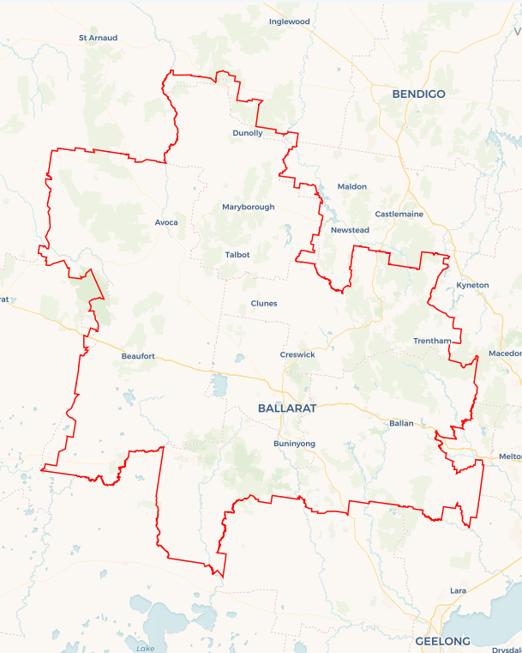Local Jobs Plan

Ballarat Employment Region | VIC | JULY 2024

Workforce Australia Local Jobs (Local Jobs) is a program that supports tailored approaches to accelerate   
reskilling, upskilling, and employment pathways in response to current and emerging local workforce needs.

## Local Jobs elements

### Local Jobs Plan

The Local Jobs Plan sets out the skills and employment challenges and priorities of the region, and associated strategies that will drive the design and implementation of activities to be implemented to address these challenges.

### Employment Facilitators

Employment Facilitators and Support Officers support the delivery of the program by bringing together key stakeholders including businesses, employment services providers, higher education, and training organisations.

### Local Jobs and Skills Taskforce

Each Employment Region has its own Taskforce. Representatives include local stakeholders who have demonstrated experience in upskilling, reskilling, and an ability to represent, connect and collaborate with others in the region to meet labour market needs.

### Local Recovery Fund, Local Initiatives Fund and National Priority Funds

The Local Recovery Fund supports projects that meet the priorities identified in the Local Jobs Plan. The National Priority Fund provides funding for innovative local solutions to address structural barriers to employment.

Explore labour market insights for the  
[Ballarat](https://www.jobsandskills.gov.au/data/employment-region-dashboards-and-profiles/monthly-labour-market-dashboards) Employment Region

## Local labour market challenges in the region

* **Mature age** **–** Mature age individuals may face specific challenges to gaining employment due to their age and the changed labour market. Barriers may include difficulty accessing training, low digital literacy, difficulty arranging flexible work opportunities, and challenges identifying and promoting transferrable skills.
* **Youth****–** Young people represent a significant percentage of the region’s Employment Services Provider caseload. Young people in the region that do not transition into work or training after leaving school are likely to become or remain disengaged.
* **First Nations people –** The unemployment rate for First Nations people tends to be higher than non-Indigenous Australians in the Ballarat Employment Region. First Nations people not connected to education or employment can experience labour market dislocation.

* **Women –** Women in the region may face additional barriers finding suitable and sustainable employment due to issues such as domestic violence, the availability and cost of childcare, caring responsibilities, work-life balance, pay inequality, lower wages in female dominated industries, and lack of flexible working arrangements.
* **People with disability –** Working-aged people living with a disability tend to be unemployed longer and may experience several unique challenges, including discriminatory recruitment practices, a lack of understanding of the supports available, difficulties negotiating reasonable adjustments in the workplace, and limited access to transport.
* **Culturally and Linguistically Diverse –** Culturally and Linguistically Diverseindividuals in the Ballarat Employment Region may experience unique barriers to inclusive employment, including self-confidence, language, cultural bias, and/or lack of networks.

## Local jobs and skills priorities and strategies in the region

### Priority 1 – Advocate for female employment within the region

### What are our challenges and opportunities?

Women in the region may face additional barriers finding suitable and sustainable employment. Community and employer advocacy and education can assist women to address these potential barriers.   
**How are we responding?**

* Engaging with women’s networking groups, Government, and stakeholders to connect women to services that address barriers.
* Engaging with local industry and business groups to create flexible pathways for women into local jobs, particularly within male-dominated industries.
* Collaborating with Workforce Australia Employment Services Providers, Registered Training Organisations, and business groups to identify emerging job opportunities and prepare women for these.

### Priority 2 – Broker opportunities for youth skill development and employment, including apprenticeships and traineeships

### What are our challenges and opportunities?

Young people in the region that do not transition into work or training after leaving school may become or remain disengaged. Engaging with young people about their career choices earlier will empower them to make more informed decisions based on local labour market needs. Young people in regional communities must have access to secure and sustainable employment opportunities.

### How are we responding?

* Identifying training opportunities for youth that align with current local employment needs.
* Collaborating with stakeholders including secondary schools, Highlands Local Learning Employment network, Workforce Australia Employment Services Providers, businesses, Transition to Work Providers, the Australian Apprenticeships Service Network, and Registered Training Organisations to identify apprenticeship, traineeship, and job placement opportunities for young people.
* Engaging with local industry and business groups (with a focus on large-scale infrastructure and development projects) to create flexible pathways for youth.

### Priority 3 – Support First Nations people to access local employment and training opportunities

### What are our challenges and opportunities?

First Nations people not connected to education or employment can experience labour market dislocation. Assisting First Nations people to identify and connect with employment opportunities requires innovative and collaborative solutions that identify and support any complex challenges to employment.

### How are we responding?

* Collaborating with First Nations organisations, Government, and stakeholders to connect First Nations people with relevant services.
* Boosting employment and training opportunities for First Nations people in collaboration with local First Nations organisations.
* Enhancing organisations knowledge to meet social procurement policies and create inclusive workplaces, enhancing employment opportunities within the community.

### Priority 4 – Support Culturally and Linguistically Diverse individuals to access local employment and training opportunities

### What are our challenges and opportunities?

### Culturally and Linguistically Diverse (CALD) individuals may experience unique challenges (self-confidence, language, cultural bias, lack of networks) to inclusive employment. CALD individuals may require a tailored approach to developing individual skill sets and abilities to meet the requirements of growth and in-demand industry vacancies. How are we responding?

* Collaborating with the local community groups to educate employers and stakeholders on creating cultural safe workplaces and increasing inclusive work practices.
* Collaborating with CALD organisations and other stakeholders to identify and link individuals to suitable local vacancies or support services.
* Establishing a supportive network for CALD individuals, enhancing their self-confidence, language, and networking skills.

### Priority 5 – Broker employment opportunities for mature age individuals

### What are our challenges and opportunities?

### Mature age individuals may experience disadvantage gaining employment due to employer discrimination, digital capability particularly with online recruitment processes, lack of qualifications and skill sets, and location of available positions. Promoting education and upskilling opportunities to mature age individuals and advocating to employer will assist in creating employment opportunities matched to local labour market and employer needs.

### How are we responding?

* Working with industry to review their recruitment practices and encourage job flexibility.
* Promoting existing programs to enhance local employment and training opportunities.
* Engaging with organisations to identify and link individuals to suitable local vacancies.
* Collaborating with Workforce Australia Employment Services Providers and Registered Training Organisations to ensure individuals are better equipped to identify and promote transferrable skills.

### Priority 6 – Broker employment opportunities for people with disability

### What are our challenges and opportunities?

Working-aged people with disability (PWD) are generally unemployed longer. PWD may experience several unique challenges. These may include discriminatory recruitment practices, a lack of understanding of the supports available, difficulties negotiating reasonable adjustments in the workplace and limited access to transport.

### How are we responding?

* Collaborating with Disability Employment and National Disability Insurance Scheme providers to enhance understanding and awareness of local employment opportunities for PWD.
* Working with employers and business groups to enhance organisations’ knowledge and tools necessary to meet social procurement policies, create inclusive workplaces, and develop individualised pathways to employment for individuals.
* Working to enlighten employers and stakeholders on impactful ways to support PWD and encourage their recruitment.

## Want to know more?

* Contact: Margi Cousins, Ballarat Employment Facilitator: [margi.cousins@ballaratemploymentfacilitator.com.au](mailto:margi.cousins@ballaratemploymentfacilitator.com.au)
* Visit: [Local Jobs](https://www.dewr.gov.au/local-jobs) or [Workforce Australia](https://www.workforceaustralia.gov.au/)