

New voluntary service for parents

Consultation Guide for businesses

The Australian Government has announced that it will work with stakeholders to design a new voluntary service for parents who care for young children.

The new service will be for parents who receive a Parenting Payment. It will help them to:

* plan for their future education and employment goals
* build their capabilities and skills
* work toward the type of paid work they want, when they’re ready.

Parent’s and children’s needs are the key focus of the new service. What you tell us will help build a supportive service that helps parents.

We would like to hear from businesses about the:

* personal characteristics, skills and experience they are looking for in prospective employees
* support the new service could provide to help prepare parents meet the needs of business
* support the business’ need to engage parents in secure work.

With the appropriate help and supports through the new service, parents can be a key source of untapped talent for businesses. Research has shown closing the workforce participation gap between women and men would increase Australia’s gross domestic product (GDP) by 8.7 per cent, or $353 billion, by 2050.[1] Studies have shown that inclusive workplaces provide stronger value propositions to their employees and customers, have better decision-making processes and stronger financial performance.[2]

# Who we’re consulting

We are consulting with:

* **Parents**: Parents on Parenting Payment with young children who may benefit from the new voluntary service. This includes parents who used the ParentsNext program, and potential users of the new voluntary service.
* **Service providers:** Organisations and businesses that provide services to parents and young children. This includes existing providers of government services, including self-employment services, and those that may be involved in future delivery.
* **Businesses:** This includes businesses and industry peak bodies who may want to hire more parents or become a more parent-friendly and flexible workplace.
* **Community organisations:** Not-for-profit organisations and advocacy groups that represent and support the interests of (or provide services to) parents, young children and diverse communities.
* **Experts:** Individuals and organisations with expertise in, and in-depth insights about, a range of topics relevant to the design of a new service. This includes experts like academics, researchers and other professionals.

# Consultation timing

We’re talking to businesses between **July 2023 and September 2023.** We’ll consult in 4 phases:

1. **Pre-design:** We have sought people’s input to what our consultation should look like, and how our stakeholders prefer to participate (May to June).
2. **Design:** Consult and collaborate to understand parents’ needs and goals, and the kind of supports we could provide (July to August).
3. **Check-in:** Check-in with people about what we’ve learned, present our thoughts on what design could look like and get their feedback and advice (August).
4. **Design options:** We’ll come back to people to talk about options, and seek their feedback and advice to inform our decisions (August to September).

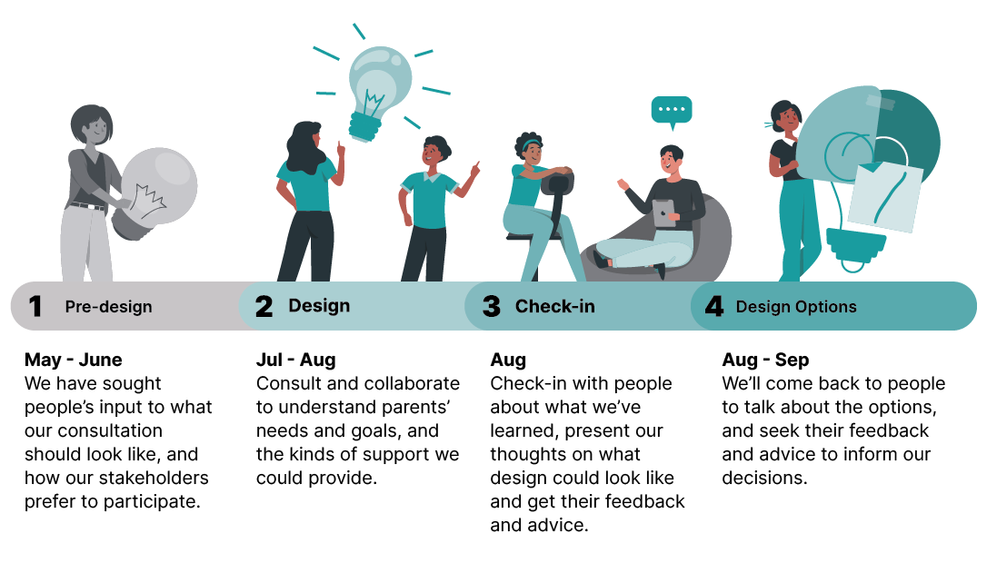

# What we want to hear from you about

Our discussions with you will focus on the new **voluntary pre-employment service** to support **parents.** We have identified discussion topics on pages 4-5.

Broadly, we’ll ask you about your:

1. **Ideas**: The features of a new pre-employment service for parents to help them prepare for future work and meet the workforce needs of businesses.
2. **Opinions**: What you think of the service options we propose, based on what we heard so far; and whether you consider these services will prepare parents to meet businesses’ workforce needs.

We welcome conversations around the challenges business’s face when employing parents who may be experiencing complex circumstances. Your input will help us design a service that will support parents to achieve their education and employment goals, and to ensure these are relevant to future workforce needs.

# About a pre-employment service

Pre-employment services help people prepare to join the workforce.

A pre-employment service may provide vocational support. For example, helping people with career advice or to build their skills through education and training to get a qualification.

It may also help people with other support they need before they can focus on their vocational goals. For example, this might include help to:

* undertake education or training towards a qualification
* get career guidance and advice on occupations in demand in the local labour market
* apply for jobs when they are ready and want to work
* get access to and with the cost of child care
* build confidence and personal attributes required to be successful in the workplace
* provide financial assistance to parents for the cost of goods and services they may need to achieve their education and employment goals, or to take up work when they are ready
* provide financial assistance to businesses, for example, through wage subsidies to help with the costs of hiring and training new employees
* assist parents who commence work, for an initial period, to help them settle in or with any further training support.

The result is the person is better placed to join the paid workforce. For full-time parents, this means when they’re ready, at a time that suits their family responsibilities.

# Benefits of the service to businesses

The new voluntary service will:

* target services that respond to parents’ individual needs, build confidence, and help them achieve their education and employment goals
* focus on parents’ strengths and build their capability so they are better prepared to move into the workforce
* focus on support that takes account of businesses’ workforce needs and improves job quality and economic security for parents
* benefit businesses by hiring parents who are better prepared and skilled for future jobs.

# Topics for discussion

We’ll discuss what features, information and support options to prioritise to best meet parents’ needs.

## Example questions for discussion

|  |
| --- |
| **Features of the service** |
| *Pre-employment support*   * What examples of support do businesses currently provide? Are there any external supports businesses’ access to support new parents? * What support should be offered to parents as part of the new voluntary pre-employment service? For example, career guidance, skills development, educational attainment, work experience, help with job applications or interview techniques, or support in the initial stages of starting a new job? * What other support should parents receive that businesses consider would be beneficial to them securing work in the future? For example, confidence building, organisational and planning skills, communication skills, motivation and initiative?   + Are there any other specific skills or characteristics that businesses are looking for that would increase the likelihood of hiring parents? * Of the following types of support what do you consider could be included in the new service to make the transition to paid employment easier for parents?   + Accessing affordable and quality childcare   + Writing resumes, applying for jobs, or coaching for interviews   + Organising work experience   + Accessing financial assistance to pay for work related goods or services such as licences or equipment. |
| *Work Related Support*   * What types of support would parents of young children who want to work benefit from?? * What types of support should be available to make transition to paid work easier for parents? * What are the key requirements you look for when employing parents? * What types of support could the new service provide that would increase parents’ chances of securing paid work? * How can parents who have spent time away from the workplace caring for children increase their chances of securing paid work?   + What value do you place value on skills gained while caring for children in recruitment decisions? Which skills do you identify as easily transferrable to workplaces?   + When thinking about the suitability of an applicant, how would you rank the following from most important to least important?     - skills     - experience     - right fit for the job * Do you consider recent work experience (e.g. volunteering) to be essential or valuable in your decisions to hire parents? * In your experience what are the key challenges you face when employing parents? How might these be overcome? * How would employers like to engage with service providers in seeking to employ parents? * What benefit do you see in the new service including support for parents for the initial period of their employment? What type of support would be valuable and for how long? * How willing would you be to offer work experience opportunities to parents? What sort of support would you envisage you and/or parents of young children need? What barriers would prevent you from offering work experience opportunities? * How do we ensure that parents are supported into secure work? What roles can employers play?   How could the online platform better support businesses to connect with parents who want to work.? For example, provide an option for businesses to select flexible work hours / or school hours, or making the vacancies discoverable to individuals seeking those opportunities. |
| *Communication strategy*   * How should the new service be communicated to both parents and businesses? |

# Contact for more information

Contact the Department of Employment and Workplace Relations.

Email - [ParentsConsultation@dewr.gov.au](mailto:ParentsConsultation@dewr.gov.au)

1. Equity Economics (2021) *Back of the pack – How Australia’s parenting policies are failing women and our economy*, December 2021, p 9.
2. Catalyst (n.d.) [*Why diversity and inclusion matter (quick take)*](https://www.catalyst.org/research/why-diversity-and-inclusion-matter/), accessed on 8 September 2022.