



Annual Statistical

Report - 2023

Except for the Commonwealth Coat of Arms, the Department’s logo, any material protected by a trademark and where otherwise noted all material presented in this document is provided under a [Creative Commons Attribution 4.0 International](https://creativecommons.org/licenses/by/4.0/deed.en) (https://creativecommons.org/licenses/by/4.0/deed.en) licence.

The details of the relevant licence conditions are available on the Creative Commons website (accessible using the links provided) as is the full legal code for the [CC BY 4.0 International](https://creativecommons.org/licenses/by/4.0/legalcode) (http://creativecommons.org/licenses/by/4.0/legalcode).

Data referenced in this report are from the Australian Government Department of Employment and Workplace Relations.

This report is for the 2023 calendar year data and reported as of the extraction date of 4 April 2024.

Table of Contents

Introduction 4

Background 4

Executive Summary 5

Key Findings 6

Time series analysis of the VSL program – 2017 to 2023 6

Figure 1: VSL Student numbers and VSL Loan amount (2017 to 2023) 6

Student level focus 7

Figure 2: VSL-assisted student numbers by month, 2023 7

Figure 3: Values of monthly VSL amount and Tuition fees, 2023 7

Table 1: Average VSL loan amount per student (exc. aviation related courses), 2023 8

Employment status, reason for studying and Field of Education, 2023 8

Figure 4: Proportion of study reasons by enrolment, 2023 8

Figure 5: Proportion of student in Field of Education 2023 9

VSL Students demographic profile 9

Figure 6: Number of VSL students by gender, 2023 9

Table 2: Top 10 courses studied by female VSL students, 2023 10

Table 3: Top 10 courses studied by male VSL students, 2023 10

Figure 7: Proportion of VSL students by age breakdown, 2023 11

Location – Where are students studying 11

Table 4: Number of VSL students by States and Territories, 2023 11

Provider level focus 12

Table 5: Number of VSL providers and students by provider type, 2023 12

Table 6: Tuition fees, VSL amount and amount paid upfront by provider type, 2023 12

Table 7: Provider size by number of students 13

Figure 8: Proportion of VSL students share by state* and provider type, 2023 13

Unit of study completions 14

Figure 9: Distribution of VSL unit of study completion rates and number of providers 14

Additional Information on VSL Providers and Courses 15

Glossary 16

# Introduction

This report provides information on VET Student Loans (VSL) provided to eligible students in 2023. Also included is a detailed analysis of the VSL student population, including a breakdown by age, gender, location, provider type and demographics.

To be eligible to access a VSL students must meet the requirements as set out under Part 2, Division 2 of the [*VET Student Loans Act 2016*](https://www.legislation.gov.au/C2016A00098/latest/text)(the Act).

Whilst two six-monthly reports have been issued for 2023, these are not combined to provide the 2023 Annual Report, as data can be updated by providers after the reporting period. Furthermore, student counts and enrolment counts are calculated across the entire year, so a student that studied in both halves of the year will only be counted once in this report, whereas they would have been reported in each of the six-monthly reports.

# Background

The VSL program commenced on 1 January 2017. It replaced the VET FEE-HELP scheme, which closed to new students on 31 December 2016. The program offers income contingent loans to eligible students studying approved course(s) at the Diploma level and above.

The Australian Government Department of Employment and Workplace Relations (DEWR) is responsible for managing and regulating the VSL program as opposed to course accreditation, delivery and provider regulation more broadly, which are the responsibility of the Australian Skills Quality Authority.

The loan amount available to eligible students is based on the type of course they are enrolled in. The list of current VSL approved courses and maximum loan amounts by course tier is available in the [VSL (Courses and Loan Caps) Determination 2016](https://www.legislation.gov.au/F2016L02016/latest/text).

The data tables provided as an attachment to this report provide detailed information on student numbers, approved course providers, loan amounts, courses, tuition fee amounts, and course completions for 2023 year. The data was extracted as at 4 April 2024.

# Executive Summary

In 2023, 24,721 eligible students undertook study in approved courses under the Australian Government VSL program. Tuition fees charged by approved providers to these students were approximately $235 million. The total VSL amount paid to meet the cost of tuition was around $221.6 million (about 94% of total tuition fees) and students paid the remaining $13.2 million (6%) as student contributions.

In 2023, there were 208 Registered Training Organisations (RTOs) that operated as approved VSL course providers. In 2023 private providers had the largest share of students that accessed the VSL program with 42.1%, with other public 22.5% and TAFE 35.4%. In comparison to 2022, when TAFE had the largest proportion of students with 46.7%, with private providers 36% and other public 17.3%. This change may be due to the decrease in VSL students at TAFE from the increased uptake in the Fee-Free TAFE program. TAFE Queensland remains the largest provider with 3,697 (15%) VSL students.

The average amount charged in tuition fees was around $9,500 (including in aviation related courses, which are typically those with the highest tuition fees) and the average VSL loan per student was around $8,960. Excluding aviation related courses, the average VSL loan amount was lower at around $6,607.

Nursing remains the most popular course with 4,118 students in 2023. This is despite a 40.5% drop in student numbers from 2022. Nursing and other health-related course have seen decreased VSL student numbers over time.

VSL students reported undertaking their studies in several ways, including employer-based training and online attendance. However, in-person training remains the most popular mode of delivery for about 60% of courses.

Indigenous Australian students make up about 3.2% (786 students) of the total number of VSL students with an average VSL loan amount per student of around $6,860. This population distribution is broadly in line with the representation of Indigenous Australians in the general population.

In 2023, approximately 3,000 VSL students reported to be living with disability. This is about 12.1% of the VSL student population.

Students identifying as female accessed VSL the most (16,115). Approximately one-third (8,392) identify as male, and a small number identified as indeterminate/intersex/unspecified.

Students from Culturally and Linguistically Diverse (CALD) backgrounds account for about 13.8% (3,404) of the VSL student population.

Young people twenty-five and under account for about half of the VSL student population and 26 – 36 years old account for a further quarter of the VSL student population.

Over 20% of VSL students reported as living outside the major cities.

Sixty-five per cent of VSL students reported to be employed while studying and about 28% reported their reasons to undertake study was to gain employment.

The number of VSL students and VSL loan amounts have been decreasing year on year. Student numbers decreased from a peak of 57,874 in 2018 to 24,721 in 2023. This is about a 57% decrease in student numbers. Additional information on VSL students’ characteristics, including their Indigenous status, gender and location is provided in the analysis section below.

# Key Findings

This section provides an overview of the VSL program from 2017 to 2023 and detailed analysis of the 2023 calendar year data. This includes breakdown of student numbers and loans by provider type, monthly figures, state, gender, age and Indigenous status etc.

## Time series analysis of the VSL program – 2017 to 2023

Between 2017 and 2023 calendar years, the Australian Government provided around $1.7 billion in fiscal outlays through the VSL program to eligible students to study at approved providers. Over this period, the program assisted 42,800 students with on average $247.2 million in VSL loans per year.

The number of VSL students and VSL loan amounts have been decreasing year on year since 2018, see Figure 1 below.

Student numbers decreased from a peak of 57,874 in 2018 to 24,721 in 2023. This is about a 57% decrease in student numbers. The demand for VSL in recent years has been impacted by the Job Trainer and Fee-Free TAFE programs.

### Figure 1: VSL Student numbers and VSL Loan amount (2017 to 2023)

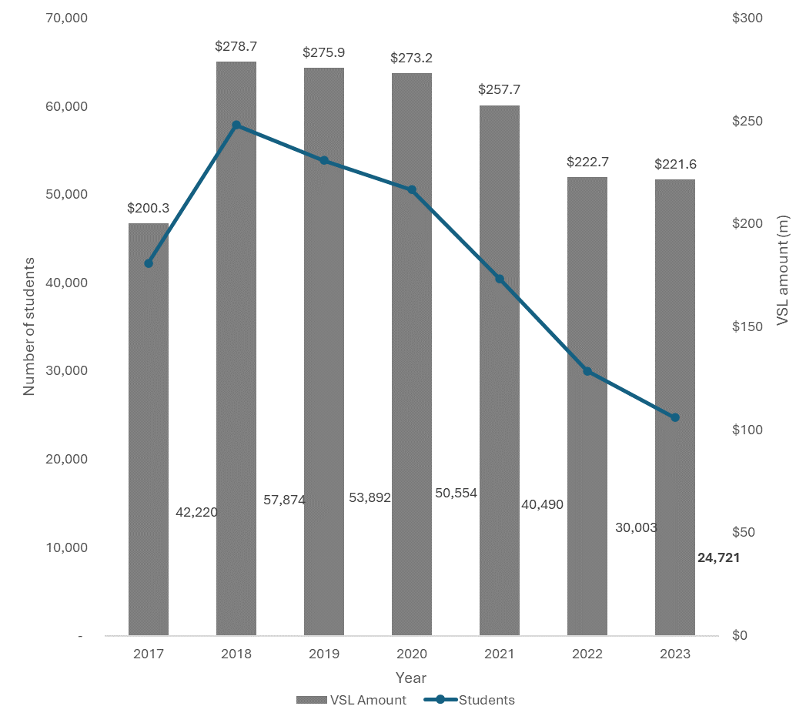

## Student level focus

In 2023, the VSL program supported 24,721 students and delivered $221.6 million in VSL loans. The monthly (census date) breakdown of VSL students is shown in Figure 2. The values of VSL paid and tuition for study undertaken during each month are shown in Figure 3.

About 63% of VSL students reported to have enrolled in the first quarter of the year. The monthly student figures (by unit census date), tuition fees charged, and VSL loans amount paid are highest in March and August, which is broadly in-line with student course census date peaks.

### Figure 2: VSL-assisted student numbers by month, 2023

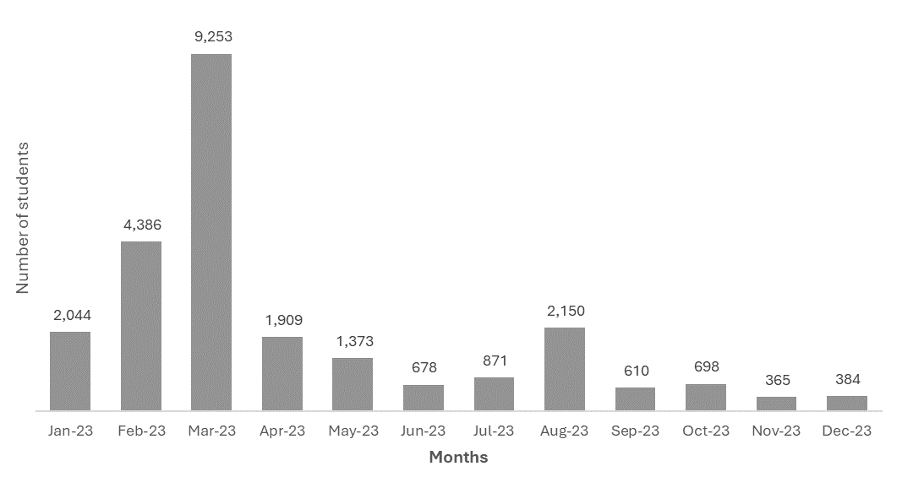

### Figure 3: Values of monthly VSL amount and Tuition fees, 2023.

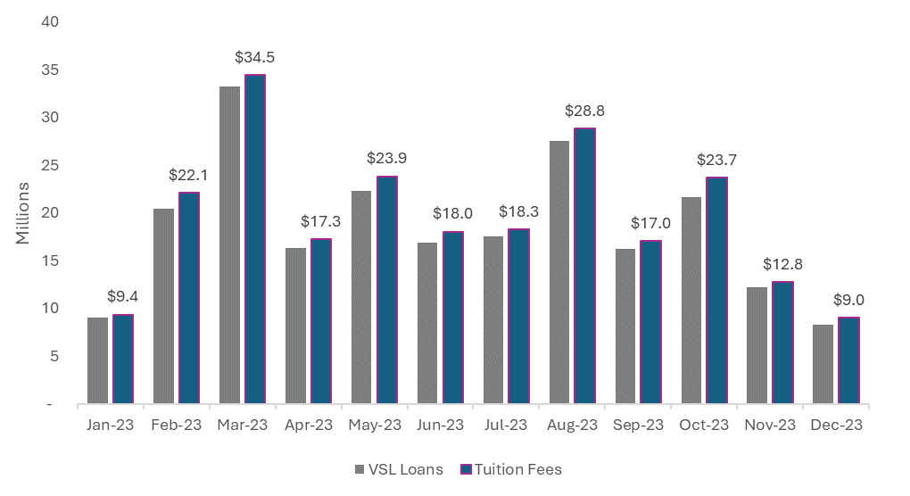

The average loan amount per student was around $8,970. Excluding aviation related courses, the average amount per student was around $6,607. About 80% of the students in non-aviation courses accessed loans of up to $10,000 as shown in Table 1. The average loan amount per student is affected by some known factors including the type of course, course cost and level of tuition fee contribution paid by the student.

### Table 1: Average VSL loan amount per student (exc. aviation related courses), 2023

|  |  |  |
| --- | --- | --- |
| **Loan Amount** | **Number of students** | **Share of total** |
| Up to $500 | 582 | 2.5% |
| $501 to $1,000 | 1,134 | **4.9%** |
| $1,001 to $2,000 | 2,205 | **9.5%** |
| $2,001 to $5,000 | 7,353 | **31.7%** |
| $5,001 to $7,500 | 4,725 | **20.4%** |
| $7,501 to $10,000 | 2,807 | **12.1%** |
| $10,001 to $15,000 | 2,439 | **10.5%** |
| $15,001 to $20,000 | 1,050 | **4.5%** |
| $20,000+ | 882 | **3.8%** |
| Total | **23,177** | **100.0%** |

### Employment status, reason for studying and Field of Education, 2023

As part of VSL program, students are surveyed prior, during and post study. The questions range from their employment status, reasons they studied, satisfaction with their provider. Approximately 64% of VSL students reported to be employed prior to commencing their studies, higher than the 2022 reported figure of 62.4%.

The top three reasons provided by students for their reasons why they study VSL approved courses was to ‘To get a job (27.6%), ‘To try for a different career’ (13.8%) and for ‘personal development’ (12.3%), see figure 4.

### Figure 4: Proportion of study reasons by enrolment, 2023

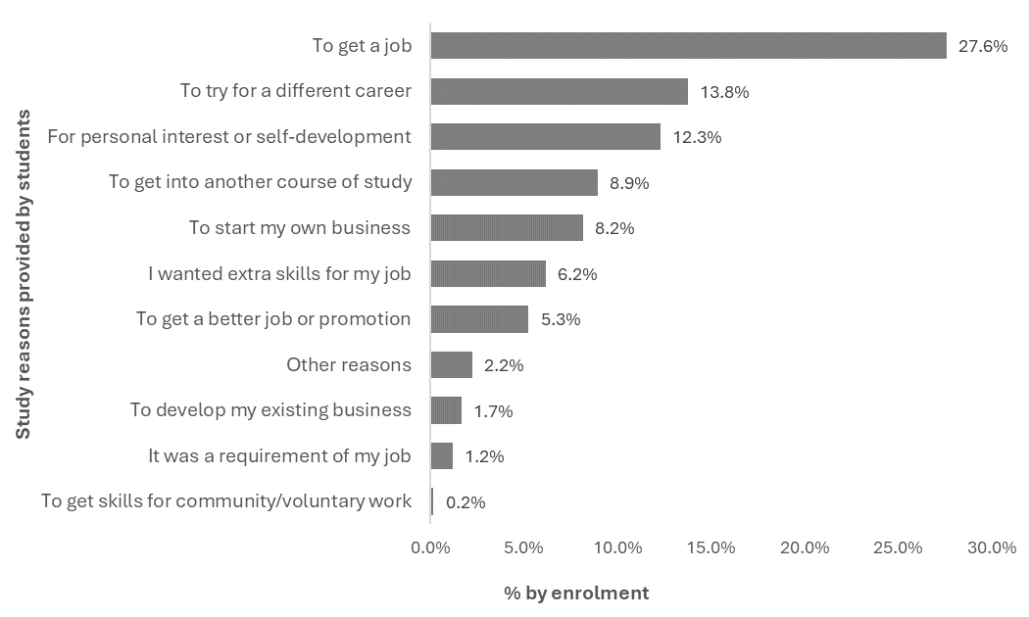

The Australian Standard of Classification of Education (ASCED) developed by the Australian Bureau of Statistics (ABS) has been used to classify the VET courses into field of education. Figure 5 shows the distribution of student numbers by broad field of education. Health was the most popular with about a quarter of all students, followed by Creative Arts and Management and Commerce.

### Figure 5: Proportion of student in Field of Education 2023

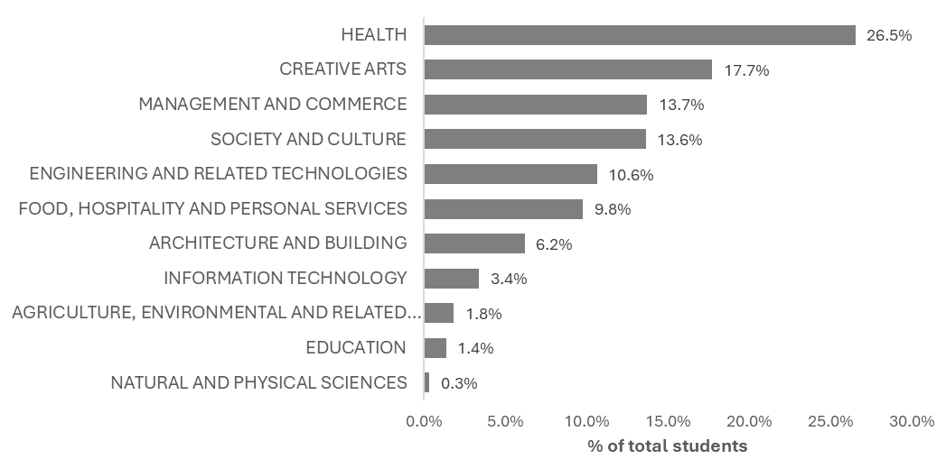

### VSL Students demographic profile

Students who identified as female accessed VSL more than other gender categories, and students identifying as male students represented about a third (8,392) of VSL students, as shown in Figure 6.

### Figure 6: Number of VSL students by gender, 2023

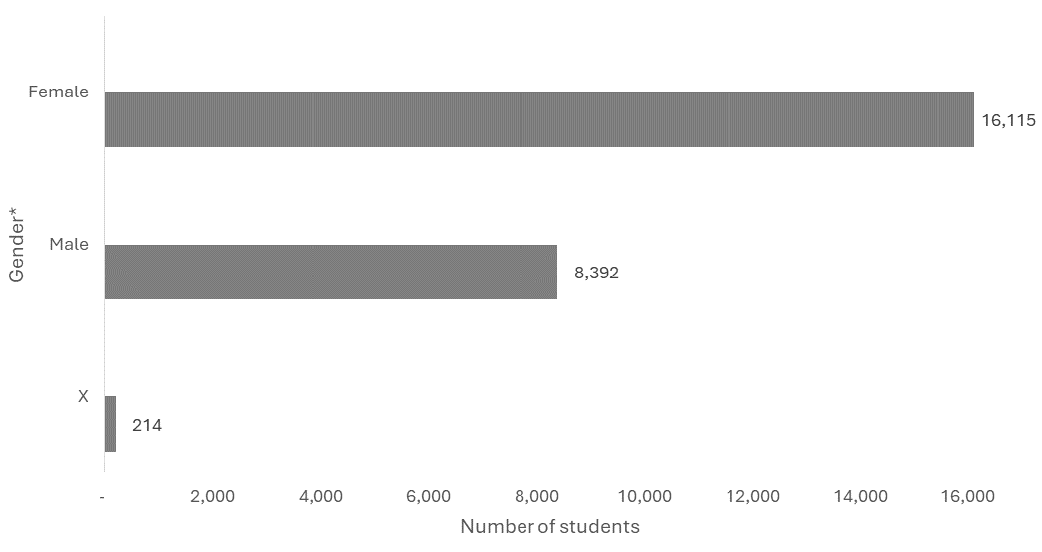

*Based on three options of Male, Female or X (Indeterminate/Intersex/Unspecified) provided to respondents when asked to specify their gender.

The most popular courses studied by Female VSL students were Diploma of Nursing, Diploma of Beauty Therapy and Diploma of Salon Management. The most popular course studied by male VSL students was Diploma of Aviation. The most popular courses for students that identified as Indeterminate/Intersex/Unspecified are Diploma of Visual Arts, Diploma of Screen and Media and Diploma of Library and Information Services. Additional information on the top courses by student numbers and by Female and Male gender are at Tables 2 and 3 below.

### Table 2: Top 10 courses studied by female VSL students, 2023

|  |  |  |
| --- | --- | --- |
| **Course Name** | **Number of students** | **Share of total** |
| Diploma of Nursing | 3,675 | 22.8% |
| Diploma of Beauty Therapy | 2,397 | 14.9% |
| Diploma of Salon Management | 1,076 | 6.7% |
| Diploma of Remedial Massage | 832 | 5.2% |
| Diploma of Counselling | 793 | 4.9% |
| Diploma of Screen and Media | 724 | 4.5% |
| Diploma of Interior Design | 520 | 3.2% |
| Diploma of Visual Arts | 512 | 3.2% |
| Diploma of Library and Information Services | 445 | 2.8% |
| Diploma of Community Services | 421 | 2.6% |

### Table 3: Top 10 courses studied by male VSL students, 2023

|  |  |  |
| --- | --- | --- |
| **Course Name** | **Number of students** | **Share of total** |
| Diploma of Aviation (Commercial Pilot Licence - Aeroplane) | 910 | 10.8% |
| Diploma of Screen and Media | 718 | 8.6% |
| Diploma of Information Technology | 593 | 7.1% |
| Diploma of Business | 451 | 5.4% |
| Diploma of Nursing | 435 | 5.2% |
| Diploma of Visual Arts | 400 | 4.8% |
| Advanced Diploma of Building Design (Architectural) | 390 | 4.6% |
| Diploma of Aviation (Instrument Rating) | 357 | 4.3% |
| Diploma of Remedial Massage | 354 | 4.2% |
| Diploma of Sport | 270 | 3.2% |

VSL student aged 25 years old or younger accounted for about half of VSL population, ages 26 to 35 years account for about a quarter of the students (see Figure 7 above).

### Figure 7: Proportion of VSL students by age breakdown, 2023

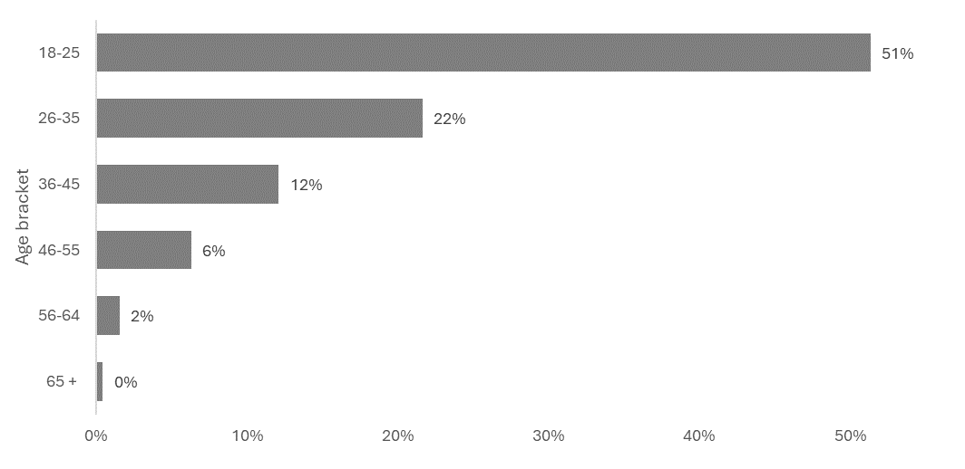

About 3.2% (786) of the VSL population identified as being Aboriginal or Torres Strait Islander, of which:

* about 77% (601) are female (11% higher than the general VSL population)
* approximately 45% (355) studied in TAFE.

Students from Culturally and Linguistically Diverse (CALD) backgrounds account for 13.8% (3,404) of the VSL student population. Approximately 12% (3,002) of students reported to be living with disability.

### Location – Where are students studying.

Victoria (38.2%) had the largest number of students, followed by Queensland (27.8%), and New South Wales (13.8%), see Table 4.

Students that reported to live outside the major cities makes up 20% of total VSL students.

### Table 4: Number of VSL students by States and Territories, 2023

|  |  |  |
| --- | --- | --- |
| States and Territories | Number of students | Share of total |
| Australian Capital Territory | 274 | 1.1% |
| New South Wales | 3,417 | 13.8% |
| Northern Territory | 89 | 0.4% |
| Queensland | 6,874 | 27.8% |
| South Australia | 2,157 | 8.7% |
| Tasmania | 559 | 2.3% |
| Victoria | 9,460 | 38.2% |
| Western Australia | 1,879 | 7.6% |
| *N/A | 16 | 0.1% |
| **Total** | **24,721** | **100.0%** |

*Missing reported addresses/state indicator

## Provider level focus

There were 208 RTOs that operated as approved course providers in the reporting period. Of these, 150 (72 per cent) reported students that accessed the VSL program.

A breakdown of the 150 approved course providers in 2023 by provider type is below:

* 22 TAFEs
* Nine other public institutions (including public universities and other non-TAFE publicly owned providers), and
* 119 private providers (including private universities, and both not-for-profit and ‑for-profit private providers).

Private providers are the main provider types in the VSL program, with 10,421 students and $139.3 million in loans. Contrastingly, TAFE was the main provider type in 2022 but experienced a drop in student numbers attributed to Fee-Free TAFE. For instance, TAFE Queensland as the largest VSL provider saw a drop of about 43% in VSL student numbers between 2022 and 2023.

Public providers (TAFEs and other public providers) account for about 58% of students that accessed VSL in 2023, down by 6% from the 2022 share. Table 5 shows the number and share of students by provider type.

### Table 5: Number of VSL providers and students by provider type, 2023

|  |  |  |  |  |  |
| --- | --- | --- | --- | --- | --- |
| Provider Type | Providers | | Students | | |
|  | Number | Percentage | Number | Percentage |
| TAFE | 22 | 14.7% | 8,762 | 35.4% | |
| Other Public | 9 | 6.0% | 5,578 | 22.5% | |
| Private | 119 | 79.3% | 10,421 | 42.1% | |
| **Total\*** | **150** | **100.0%** | 24,761 | 100.0% | |

* The total is not a unique count of students as some students studied across multiple provider types

Of the total VSL amount paid, private providers accounted for 63% of the loans ($139.3 million) for 10,421 students (42% of total students). Conversely, public providers accounted for about 6 in 10 VSL students and about 37% (about $83.5 million) of VSL loan amount. The average VET student loan for a student studying at TAFE was about $5,420, other public providers about $6,240, and private providers was about $13,367. These averages are influenced by factors like the type of courses and student upfront contribution.

Most of the $83.5 million in total tuition fees charged to VSL students at public providers (TAFEs and/or other public VSL providers) was covered by VSL. This share is lower for VSL students at private providers (92.1%). See Table 6 below.

### Table 6: Tuition fees, VSL amount, and amount paid upfront by provider type, 2023

|  |  |  |  |  |  |  |
| --- | --- | --- | --- | --- | --- | --- |
| Provider Type | Tuition Charged Amount | | VET Students Loan Amount | | *Upfront Paid Amount | |
| ($, m) | Percentage | ($, m) | Percentage | ($, m) | Percentage |
| TAFE | 48.4 | 20.6 | 47.5 | 21.4 | 0.9 | 6.7 |
| Other Public | 35.1 | 15.0 | 34.8 | 15.7 | 0.3 | 2.5 |
| Private | 151.3 | 64.4 | 139.3 | 62.9 | 12.0 | 90.8 |
| **Total** | **234.8** | **100** | **221.6** | **100** | **13.2** | **100** |

*Total fees charged minus VSL amount. Figures may not add up due to rounding.

Across the program, the number of students per provider vary within and across provider types. On average, a VSL provider has 165 students, with the average of 88 students at private providers and an average of 400 at TAFEs. Table 7 shows the number of providers and number of students in each size bracket.

About half the total VSL providers with students reported having up to 50 VSL-assisted students. This means that there are small number of VSL providers with large numbers of VSL assisted students (mostly TAFEs).

### Table 7: Provider size by number of students

|  |  |  |  |  |
| --- | --- | --- | --- | --- |
| Bracket by students | **Providers** | | **Students** | |
| Number | Percentage | Number | Percentage |
| Up to 20 | 55 | 36.7 | 400 | 1.6 |
| 21 to 50 | 25 | 16.7 | 886 | 3.6 |
| 51 to 100 | 24 | 16.0 | 1,611 | 6.5 |
| 101 to 250 | 22 | 14.6 | 3,288 | 13.2 |
| 250+ | 24 | 16.0 | 18,638 | 75.1 |
| **Total\*** | **150** | **100.0%** | 24,823 | 100.0% |

* The total is a unique count of students as some students studied across multiple providers

Figure 8 shows the proportion of VSL students per provider type across states and territories. Victoria and Northern Territory have proportionately large numbers of VSL students in other public approved providers. This can be attributed to the location of dual sector universities with proportionately large numbers of VSL students. The distribution of students by provider and states shows Victoria has most students in Other public providers (87%), QLD had the most TAFE students (40%), and students at private providers were spread across states.

### Figure 8: Proportion of VSL students share by state* and provider type, 2023

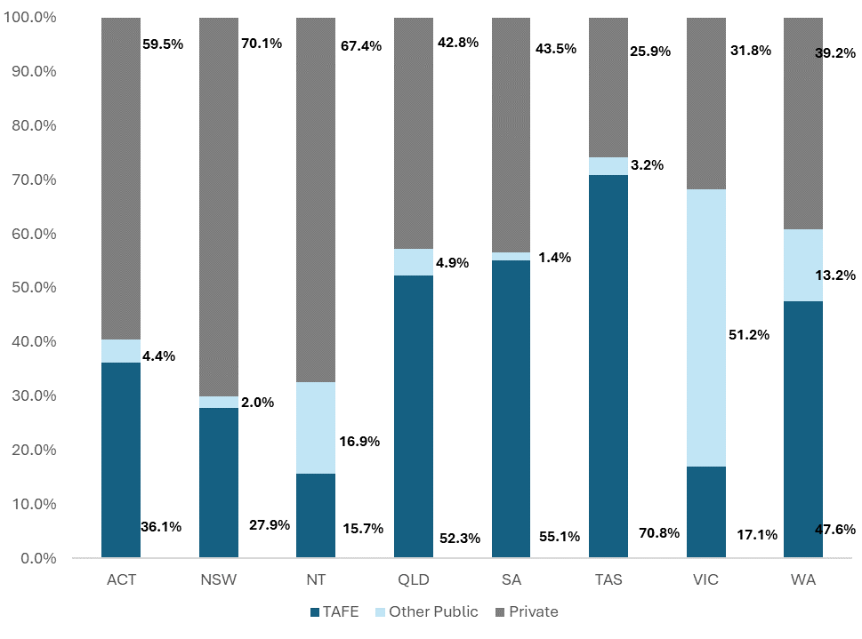

* The state is based on the student’s home address

## Unit of study completions

The unit completion rate for 2023 is 85.2%. Figure 9 shows the unit of study completion rates breakdown by proportion of providers.

A small number of commencing VSL students reported to have studied in 2023 are unlikely to have completed their course by 31 December 2023. About two-thirds (142) of approved providers reported some unit of study completions and the remaining third (75) hod not students or reported all their students’ units of study as in progress.

Of the 142 providers with reported unit of study completion rates:

* 128 (90%) had completion rate above 50%
* Over two-thirds reported a completion rate of above 80%

### Figure 9: Distribution of VSL unit of study completion rates and number of providers

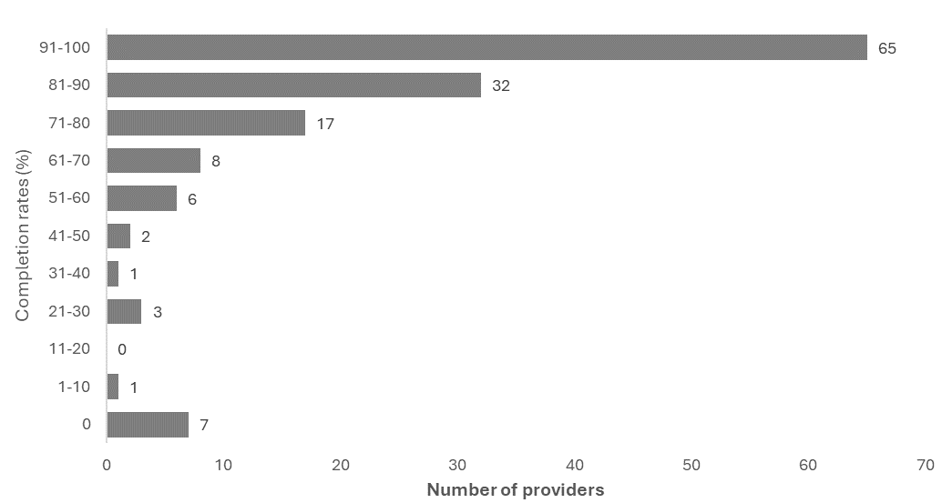

Excludes providers with no reported students and/or all student courses as in progress.

The completion rate in this report is determined on the following basis:

* The report only covers students who used the VSL program in the 2023 calendar year.
* This report includes course completion data reported as of 4 April 2024. Therefore, a completed course that had a final census day in 2023 may be excluded from the report if completed after 4 April 2024.

VSL legislation requires that courses be reported across at least three ‘parts’ (reported as units of study). Thus, reporting on unit of study completion rates provides an alternative way of presenting information on VSL students’ progression through their courses.

The unit of study completion rate is the proportion of units of study successfully passed as a share of total units of study undertaken. These units of study are in Equivalent Full Time Student Load (EFTSL) rather than student numbers. Ongoing units of study are excluded from the completion rate calculation.

Units of study includes units that providers reported VSL students to have withdrawn from, failed, or successfully completed.

# Additional Information on VSL Providers and Courses

The Addendum Table 1 provides the VSL data listed in the report for the reporting period 1 January 2023 to 31 December 2023.

The Addendum Tables 2 to 6 provide additional information on approved course providers and eligible courses offered.

These tables rank providers in order of number of VSL students (Table 2), value of loans paid (Table 3), and rank courses by number of VSL students (Table 4) and in order of value of loans paid (Table 5) and total value of loans paid to individual VSL provider(s) including the course breakdown (Table 6).

These tables also provide the following:

* VSL student numbers (Table 2 and 3)
* course enrolment numbers (Tables 4 and 5)
* Equivalent Full-Time Student Load (EFTSL) by provider and by course
* tuition fees charged
* the amount of the tuition fees paid up-front (paid directly to the provider by the student, rather than deferred through a VSL loan)
* the value of VSL loans
* tuition fees per student (Tables 2 and 3)
* tuition fees per course enrolment (Tables 4 and 5)
* tuition fees per EFTSL
* loan amount per student (Tables 2 and 3)
* loan amount per course enrolment (Tables 4 and 5)
* loan amount per EFTSL
* enrolments, loans, tuition fees, students completing courses and unit of study completion rates by provider and course (Table 6).

Half of the top ten providers ranked by value of total loans paid were public providers. In terms of student numbers, seven out of the top ten providers were public providers.

Diploma of Nursing is the highest-ranked course in terms of course enrolments and Diploma of Aviation (Commercial Pilot Licence - Aeroplane) is ranked highest in terms of value of loans paid.

In order of student enrolment numbers, nursing, beauty therapy and screen and media qualifications are the most popular with VSL students.

Diploma of Salon Management and Diploma of Information Technology moved to the list of top ten courses by student enrolments. Diploma of Interior Design and Diploma of Community Services dropped out of the list.

Note, some courses appear multiple time in Tables 4 and 5 as both superseding and superseded courses were valid in the reporting period.

# Glossary

|  |  |
| --- | --- |
| **Term** | **Definition/Meaning** |
| **Approved Course** | A Course that meets the requirements of Section 13 (Division 3) of the Act. |
| **Approved Course Provider** | Bodies that are approved to offer VSL in accordance with the Act. This may include TAFEs, other public providers, and private providers. |
| **Australian Government Department of Employment and Workplace Relations** | The Commonwealth department that administers the VSL program. |
| **Census Year** | The reporting period for the report: 1 January 2023 to 31 December 2023. |
| **Course Completion rate** | The proportion of units of study that were passed, of the total units of study undertaken, with units of study measured in Equivalent Full Time Student Load (EFTSL). |
| **Eligible Students** | To be an eligible student for VSL, the person must satisfy section 9 (Division 2) of the Act. This includes the citizenship and residency status, enrolment and application and academic suitability requirements. |
| **Enrolment** | The number of courses students studied in the reporting period. |
| **Loan amount** | The VSL amount paid by the Commonwealth to an eligible student to undertake approved courses as described in the Act, excluding upfront amounts paid and/or contributed by the student. |
| **Provider Type** | Whether the provider is a TAFE, other public provider (including public universities and other non-TAFE publicly owned providers) or private provider (including private universities and both not-for-profit and for-profit private providers). |
| ***VET Student Loans Act 2016*** | The principal Commonwealth legislation governing the VSL program. |
| **VET Student Loans Rules 2016** | The Rules as made by the Minister for Skills and Training under the Act to provide for the administration of the requirements of the Act. |
| **VSL Students** | Students that paid tuition fees partly or fully using the VSL program. |
| **VET Student Loan** | See Loan Amount |
| **Tuition Fees** | Fees charged by Approved Providers to students for their courses. |
| **Public Providers** | TAFEs and other public providers |