**Labour Market Conditions in the Bundaberg-Hervey Bay Priority Employment Area**

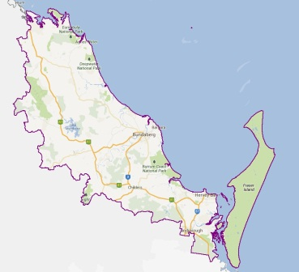Overall, labour market conditions in the Bundaberg-Hervey Bay Priority Employment Area (PEA) remain subdued with evidence of persistent disadvantage.

* The unemployment rate is very high (9.0 per cent) and has remained consistently above the Australian rate over the last five years.[1]

**Bundaberg**

* 29 per cent of people aged 20 to 24 years are neither working nor studying.[2]

**Hervey Bay**

* Population growth was higher among those aged 45 years and older (12 per cent) compared with those under 45 years of age (2 per cent).[3]
* At the time of the 2011 Census, only 59 per cent of 25-34 year olds in the PEA had completed Year 12 or equivalent, well below the national average of 75 per cent.[4]

There are some structural changes occuring across the region.

* The three largest employing industries are Health Care and Social Assistance, Retail Trade and Construction. Employment in the Construction industry decreased by 7 per cent.[5]

|  |  |  |  |  |
| --- | --- | --- | --- | --- |
| **Region** | **Unemployment Rate  (SALM, December 2013)** | **Participation Rate (Census, 2011)\*** | **Proportion of WAP* receiving income support payments[6]** | **Employment Growth**  **(5 years, 2008 - 2013)** |
| Bundaberg-Hervey Bay PEA | 9.0% | 66.9% | 30% | 9% |
| Australia | 6.0%[7] | 75.8% | 17% | 11% |

# *working age population (15-64)

# What employers are telling us[8]

The survey results indicate that recruitment activity has remained subdued since the region was last surveyed in 2012.

* The competition for vacancies was high, with an average of 11.0 applicants per vacancy.
* However, the low average number of suitable applicants (1.5) and the relatively high unfill rate (5.8 per cent) suggest a mismatch between job seekers’ skills and those sought by employers.
* The majority (74 per cent) of applicants did not receive an interview, with employers citing a lack of relevant experience and insufficient qualifications or training as the most common reasons.

|  |  |  |  |  |
| --- | --- | --- | --- | --- |
| **Region** | **% recruited** | **Applicants per vacancy (Average Number)** | **Suitable Applicants (Average Number)** | **%Will Recruit** |
| Bundaberg-Hervey Bay PEA 2013 | 62% | 11.0 | 1.5 | 37% |
| Bundaberg-Hervey Bay PEA 2012 | 63% | 7.7 | 2.1 | 48% |
| All regions Combined (9 Months)[9] | 62% | 10.1 | 1.5 | 39% |

* While 37 per cent of employers expected to recruit in the 12 months following the survey, only 17 per cent expected to increase staff numbers over the same period.

Where are the opportunities?

Employers are currently having difficulty filling vacancies for Child Carers, Early Childhood (Pre-primary school) Teachers, and Truck Drivers. Over the next 12 months, employers expected to recruit for a variety of occupations such as Sales Assistants (General), General Clerks, Receptionists, Real Estate Sales Agents, Bar Attendants and Baristas, Nursing Support and Personal Care workers, Child Carers, Motor Mechanics and Truck Drivers.

1. Department of Employment, Small Area Labour Market data, December quarter 2013
2. ABS, Census of Population and Housing, 2011
3. ABS, Estimated Residential Population, 2006-2011
4. Ibid.
5. ABS, Census of Population and Housing, 2006 and 2011
6. Department of Employment, Administrative data, December 2013; Estimated Resident Population, 2011
7. ABS Labour Force Survey, January 2014 (seasonally adjusted)
8. Based on a Survey of Employers’ Recruitment Experiences of 383 employers undertaken by the Labour Market & Analysis Branch in December 2013
9. Most Recent Combined, 9 months to November 2013