# Slide 1 Introduction to rapid prototyping

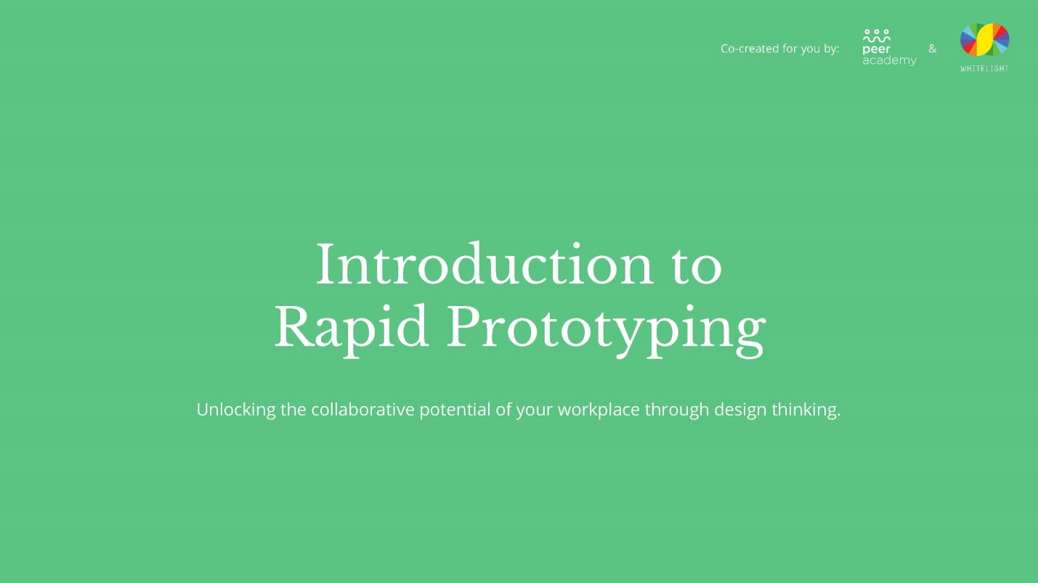

# Slide 2 Peer Academy



# Slide 3 Outline for session

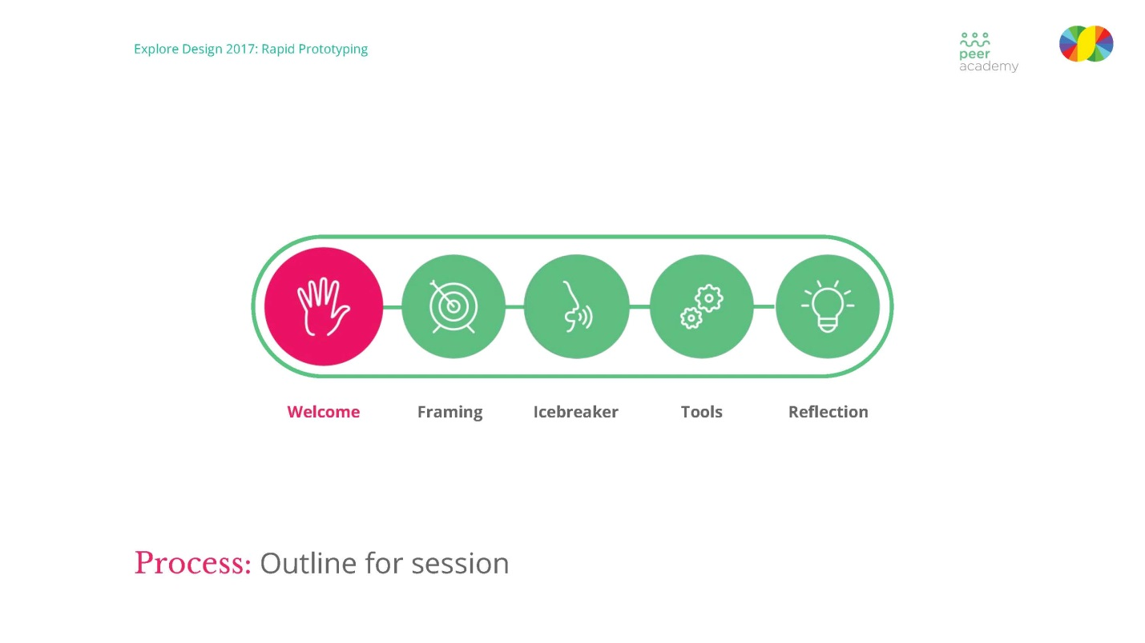

# Slide 4 Time versus capability and impact

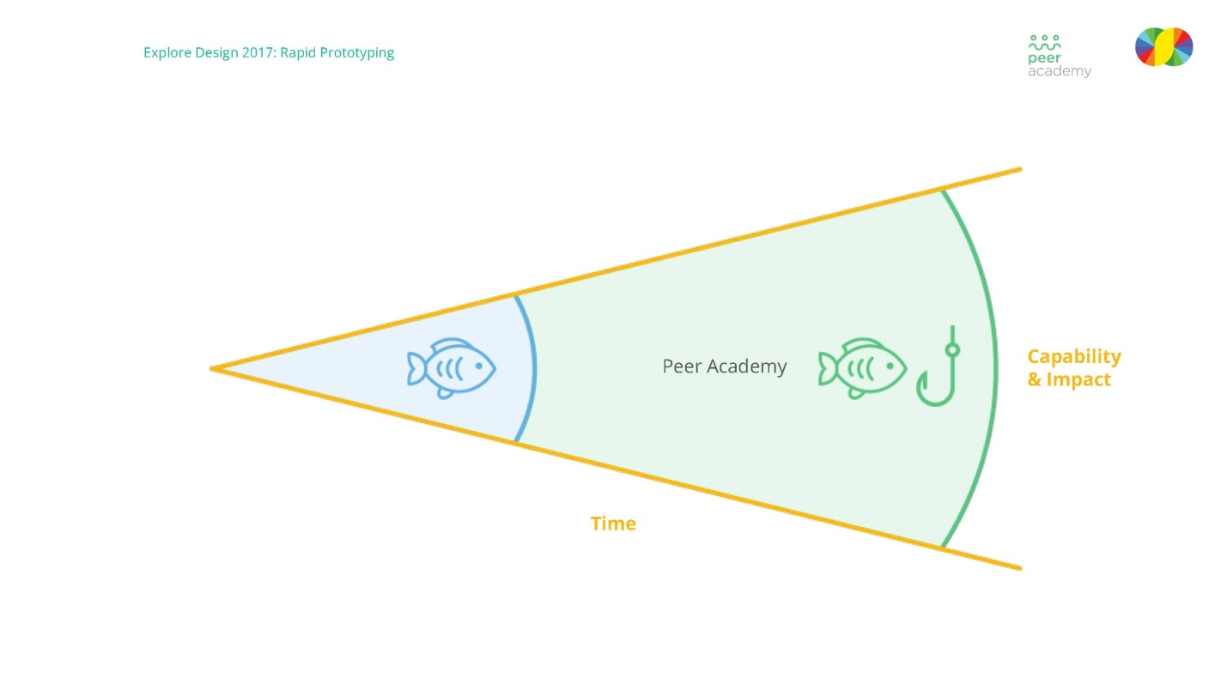

# Slide 5 Why are we here today?

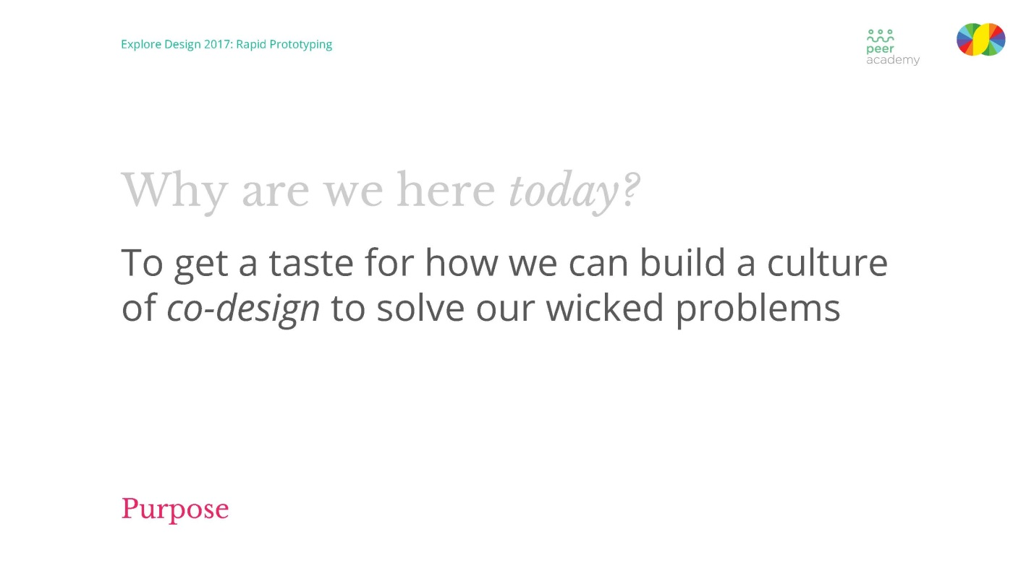

# Slide 6 What will we get out of today?

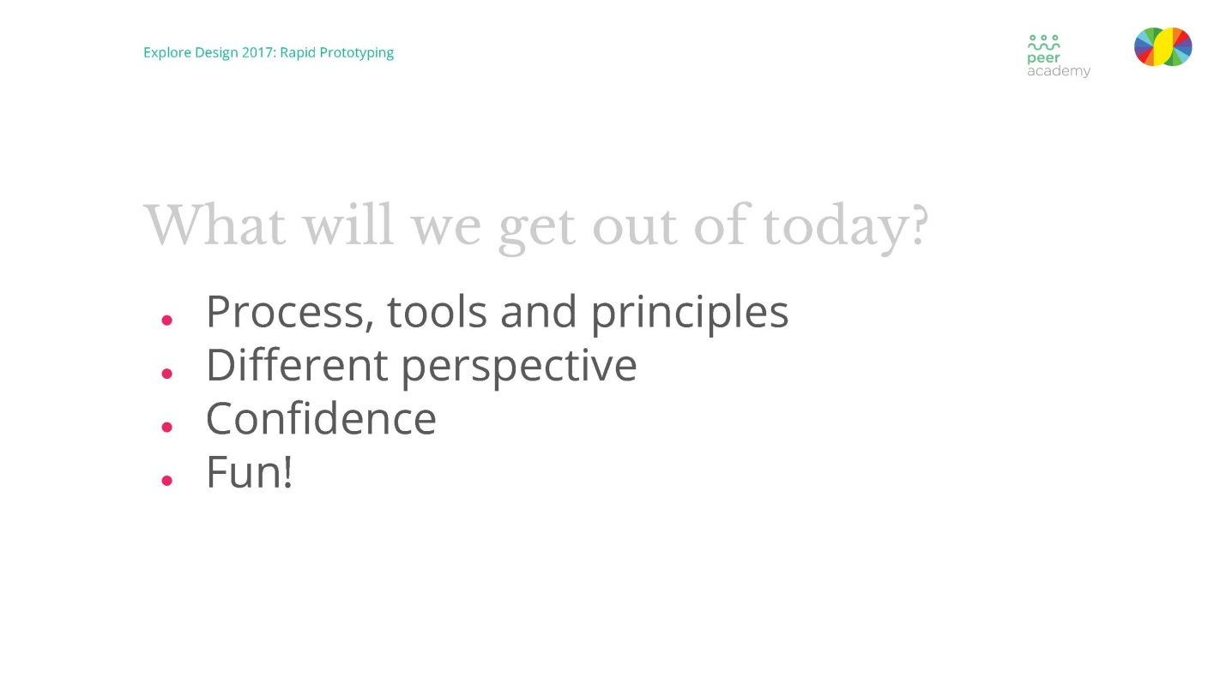

# Slide 7 Framing

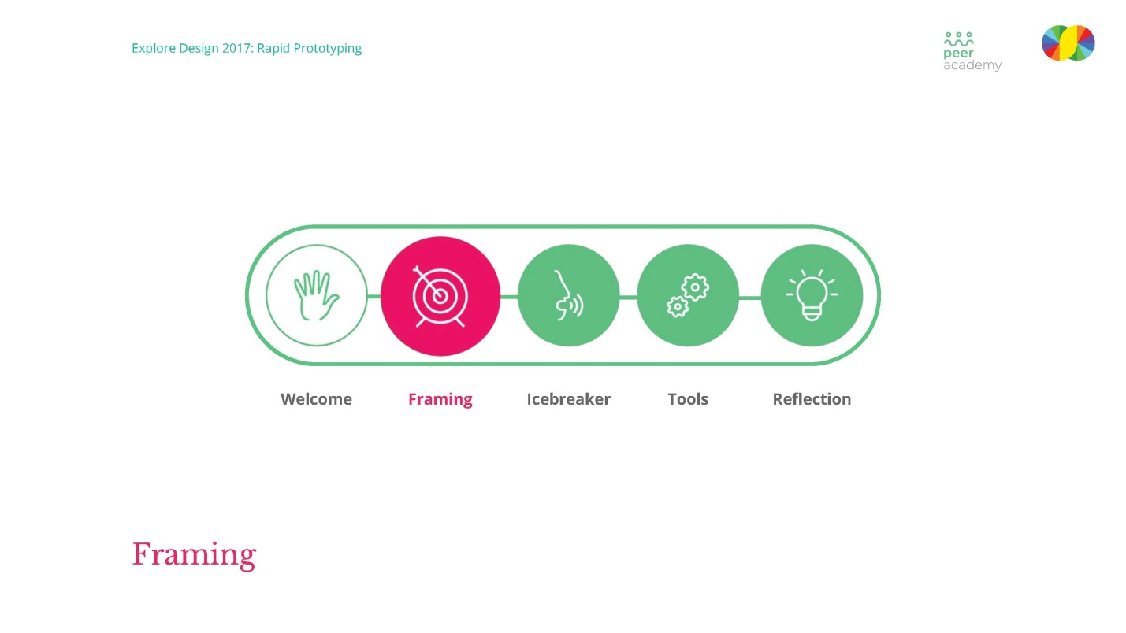

# Slide 8 Rapid prototyping

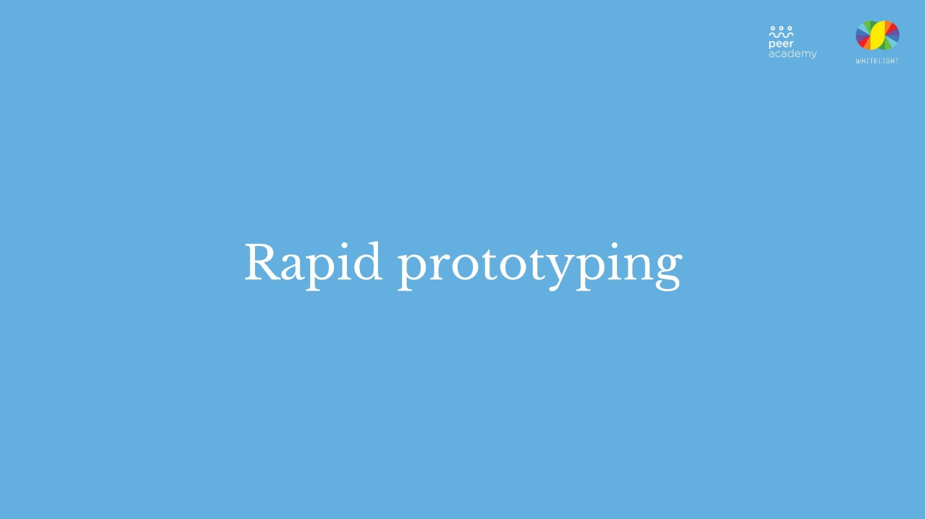

# Slide 9 Prototype

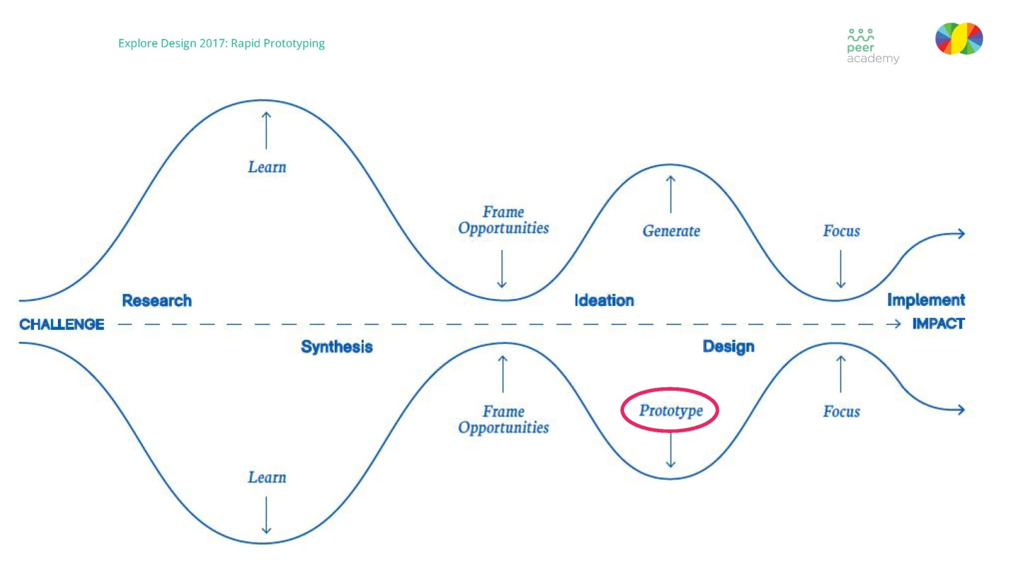

# Slide 10 Tool rapid prototyping

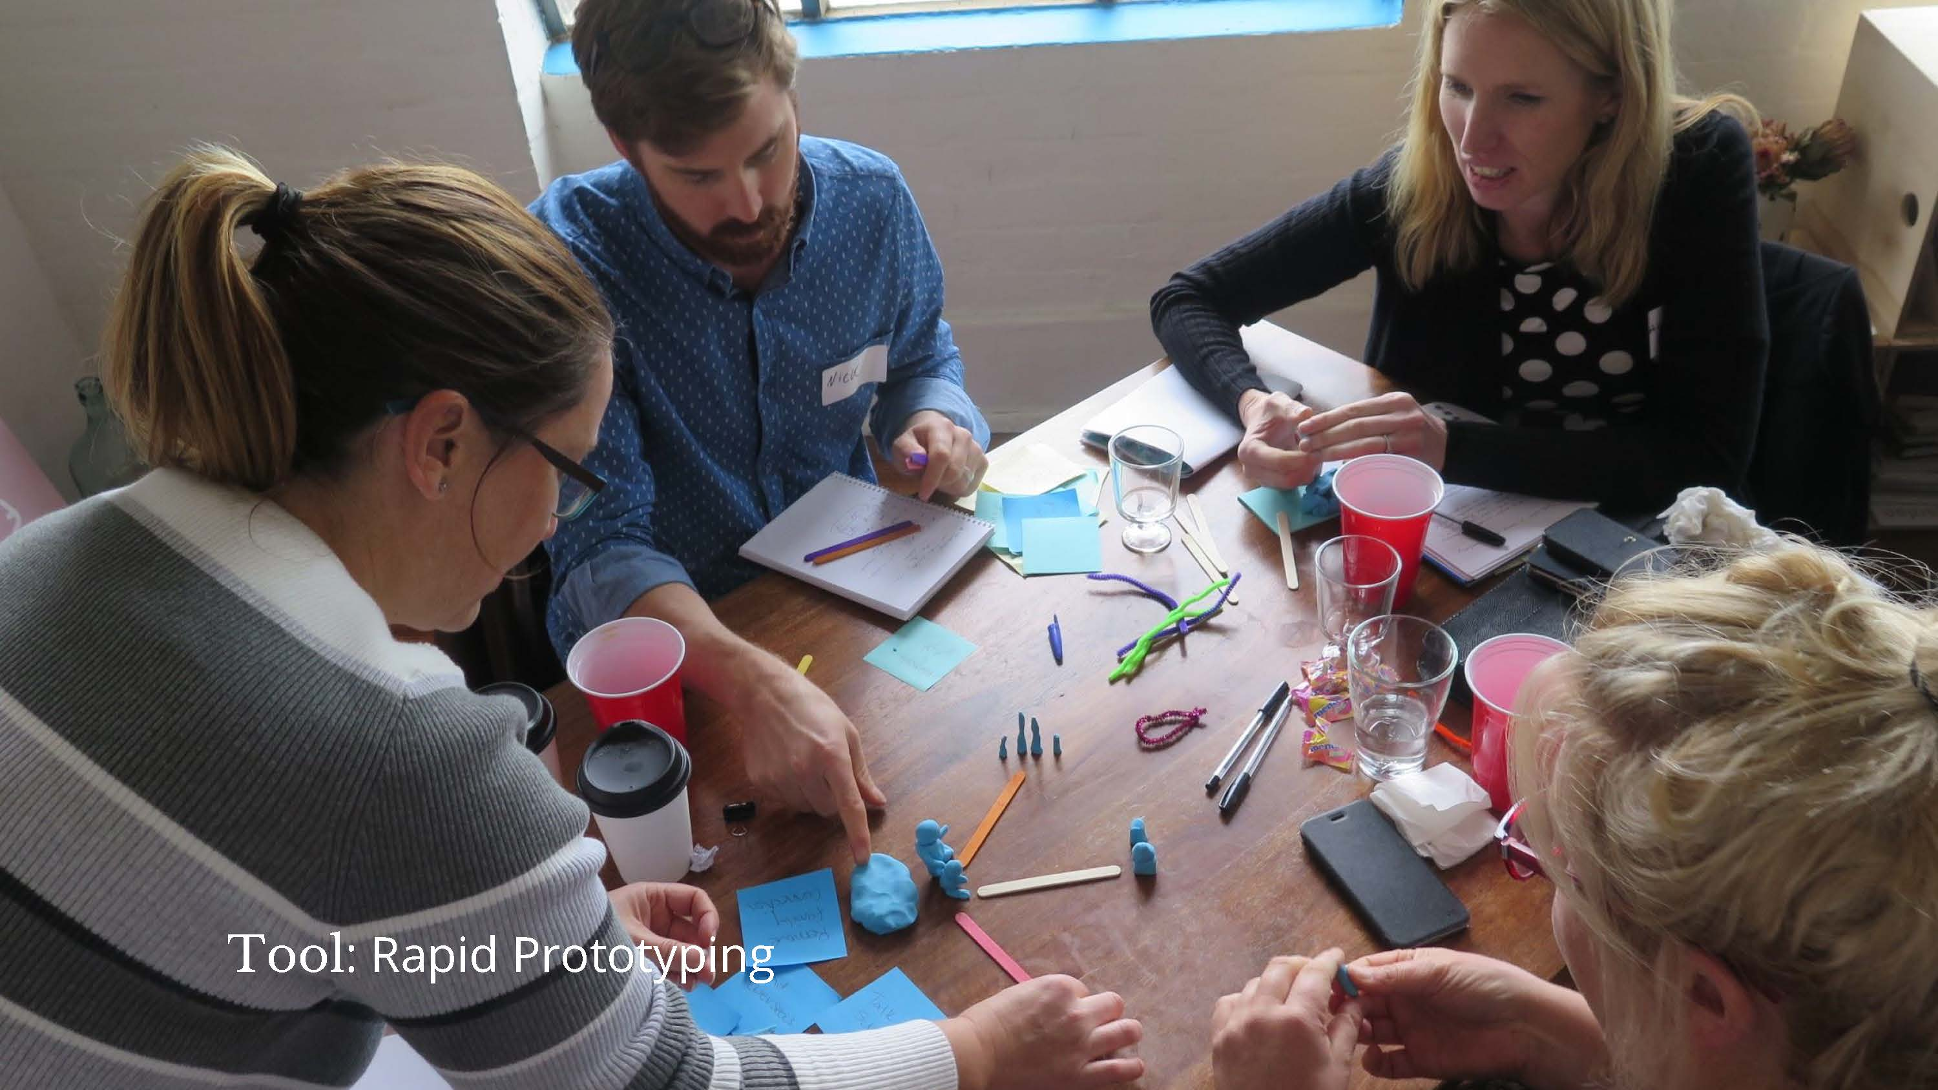

# Slide 11 Why prototype?

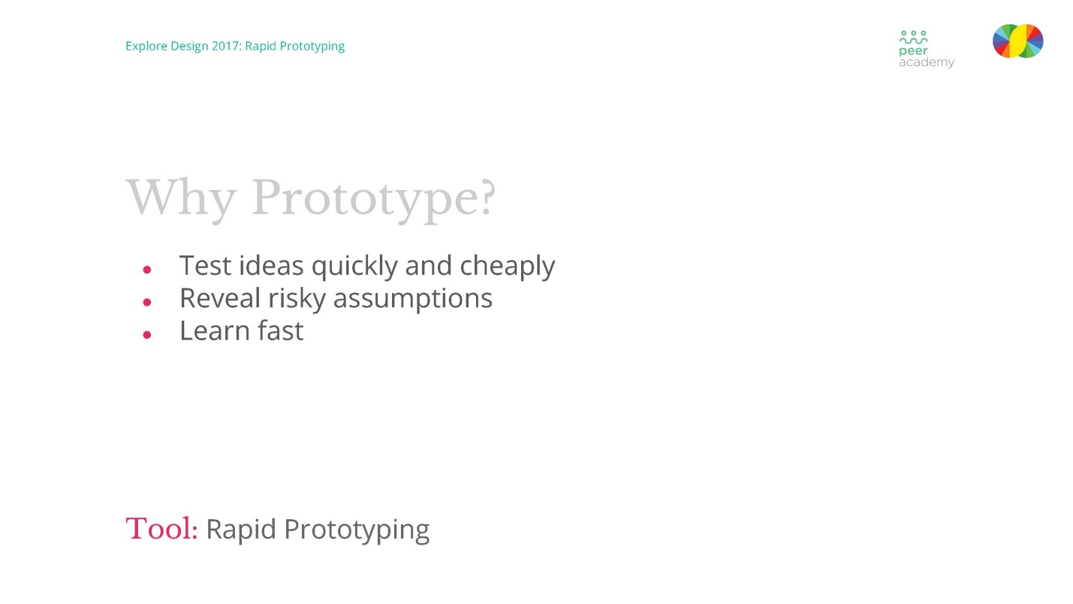

# Slide 12 Rapid prototyping examples

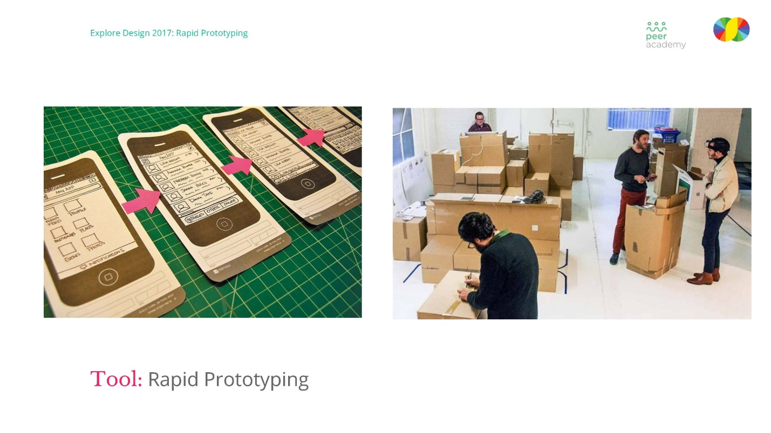

# Slide 13 Rapid prototyping examples

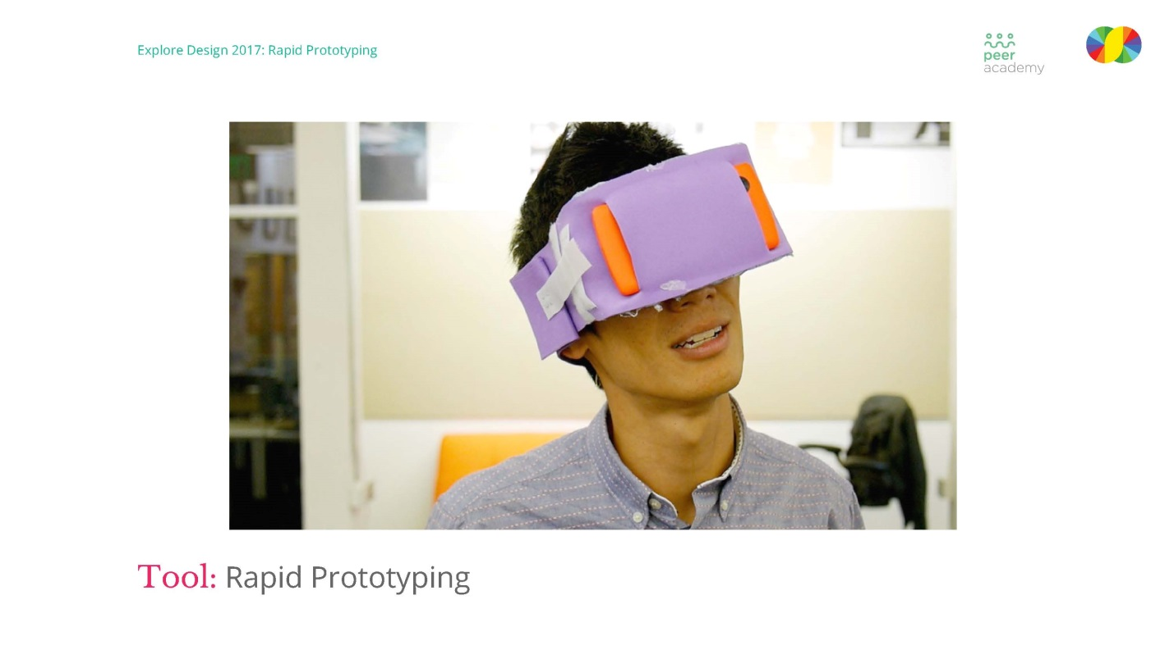

# Slide 14 Icebreaker

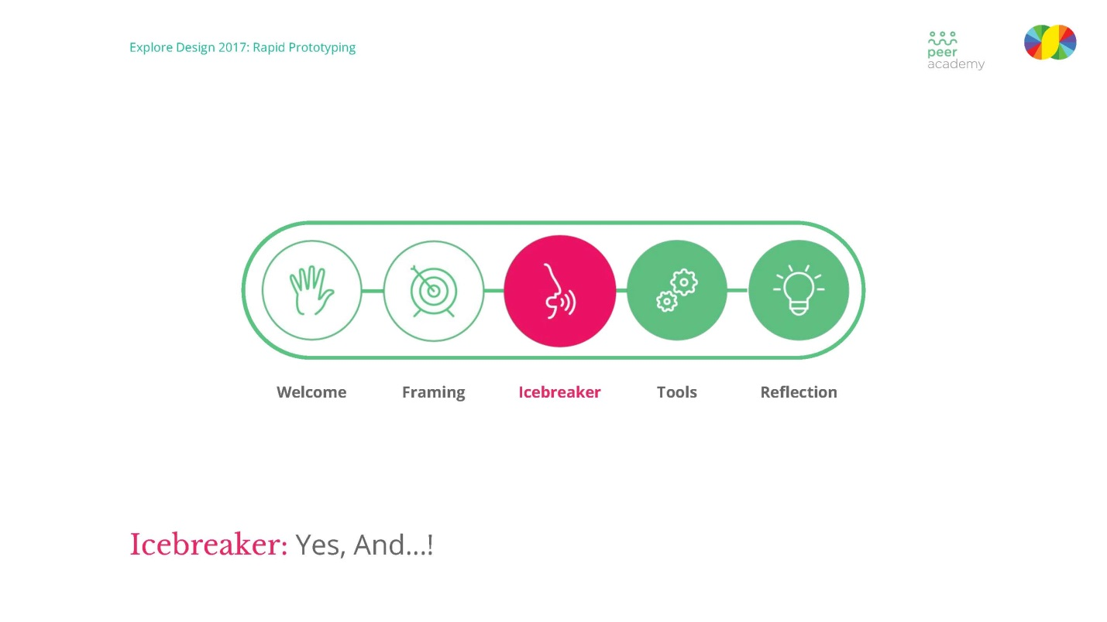

# Slide 15 Yes, and



# Slide 16 Yes, and

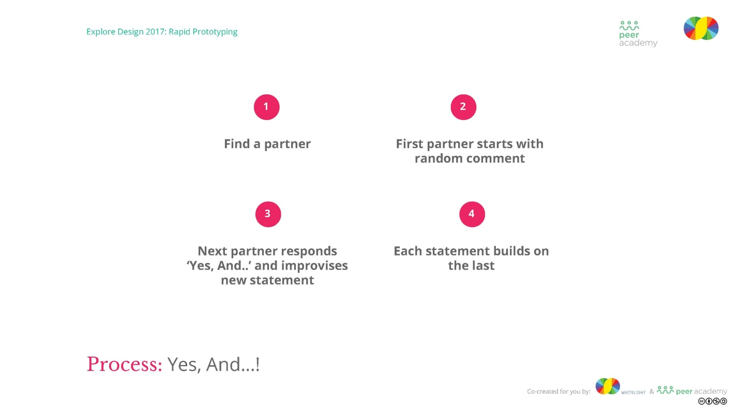

# Slide 17 What is not working

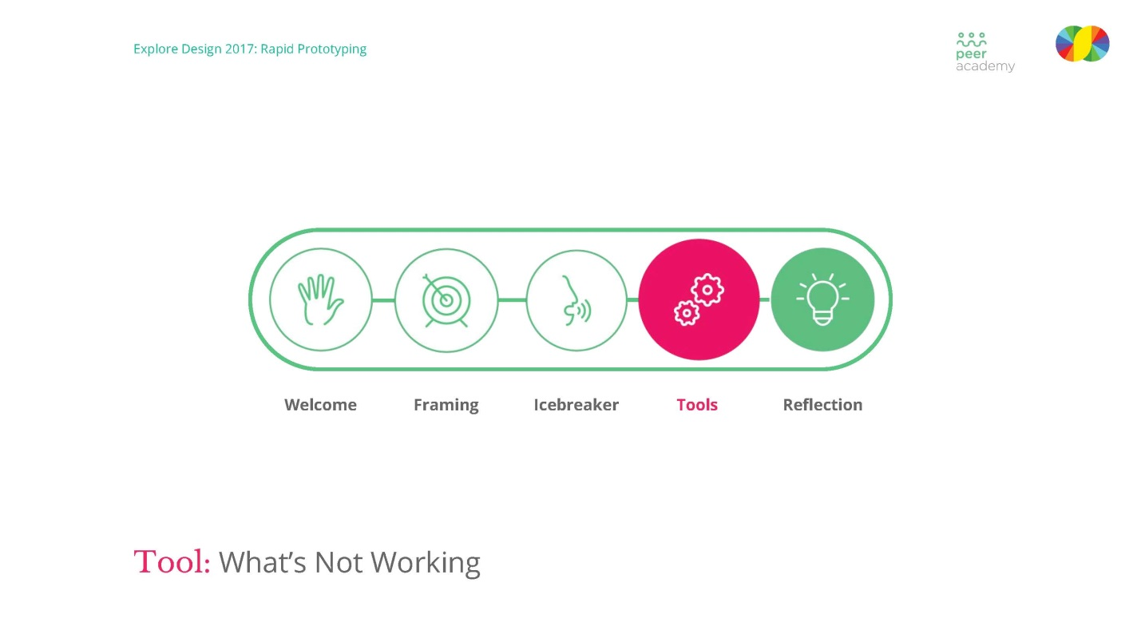

# Slide 18 What is not working

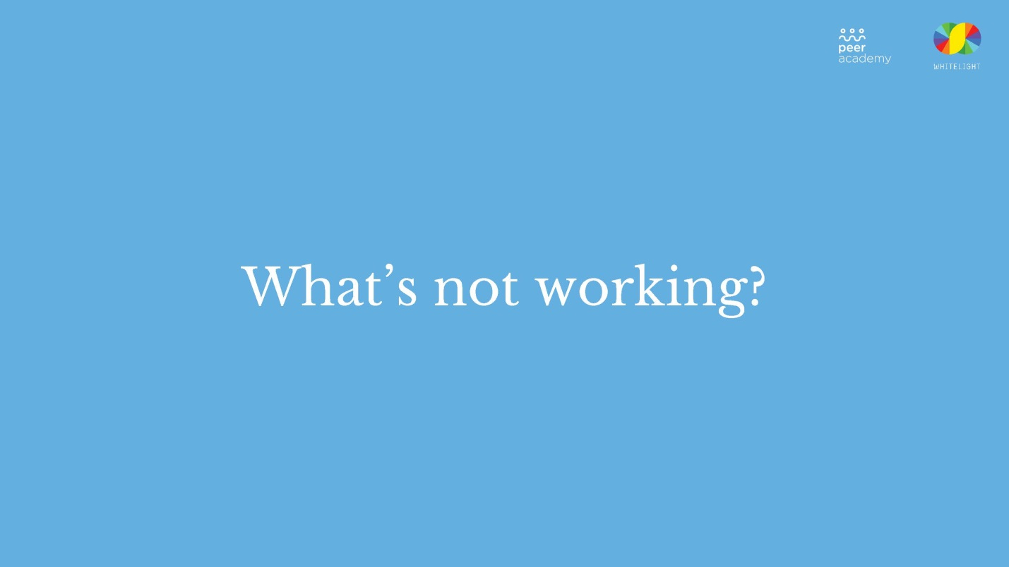

# Slide 19 Examples

Slide with words 'Who are you solving the problem for?, Not too broad, not too narrow, 25 words or less' and paragraph with list 'Examples: How might we better support young people transitioning from out-of-care?, How might we create a safe and accessible safety and support hubs for those experiencing
family violence?, How might we collaborate with startups to help solve our nation's biggest problems?'

# Slide 20 Idea challenge

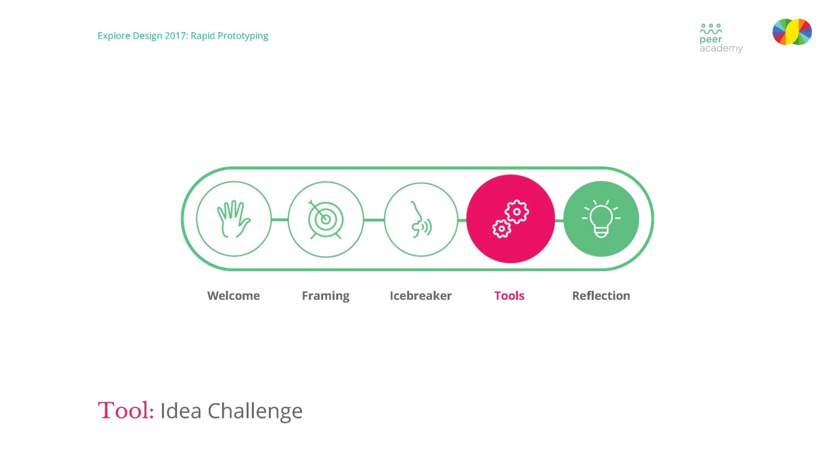

# Slide 21 Idea challenge part 1

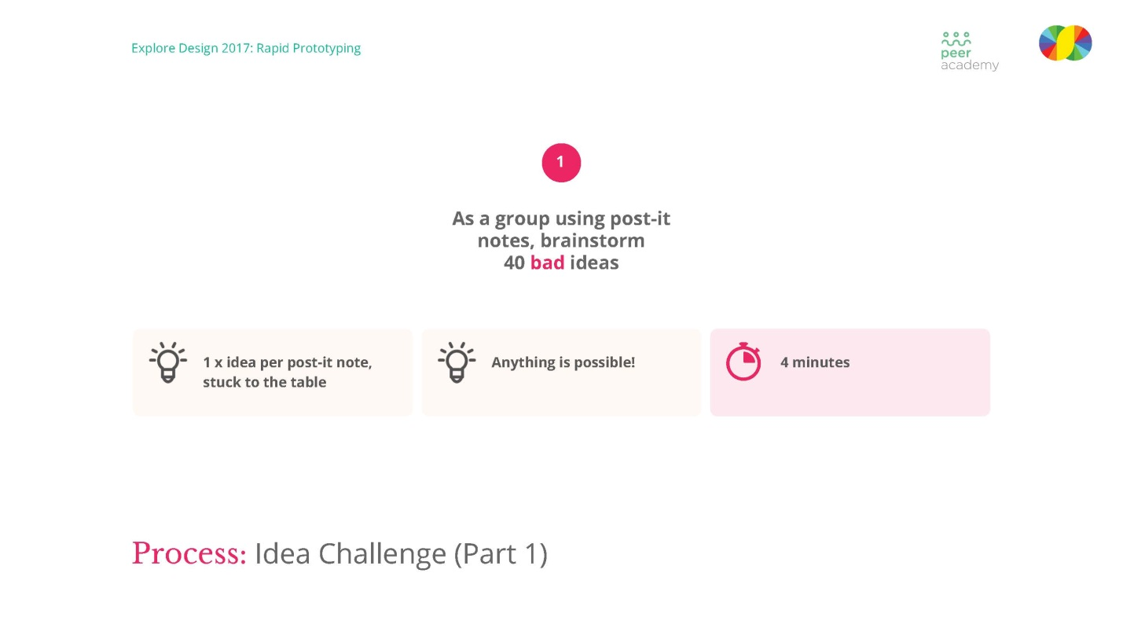

# Slide 22 Idea challenge part 2

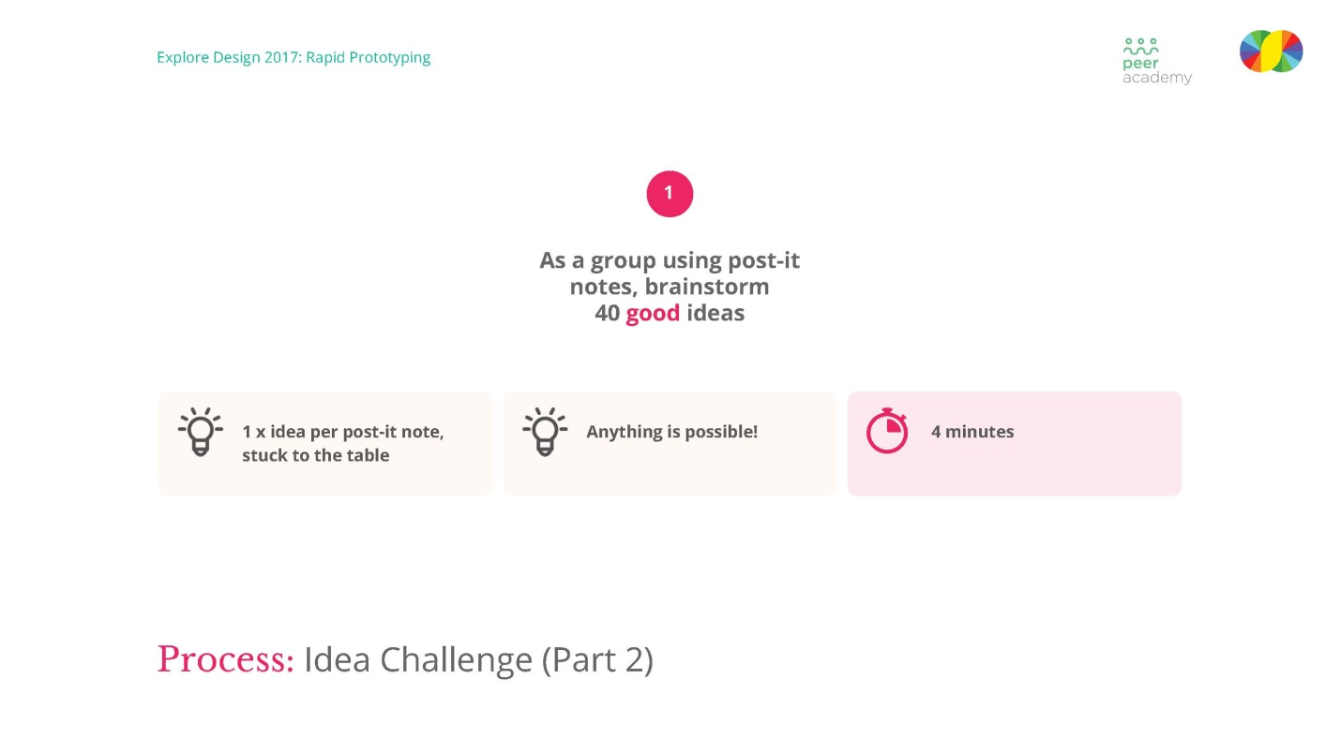

# Slide 23 Tool rapid prototyping

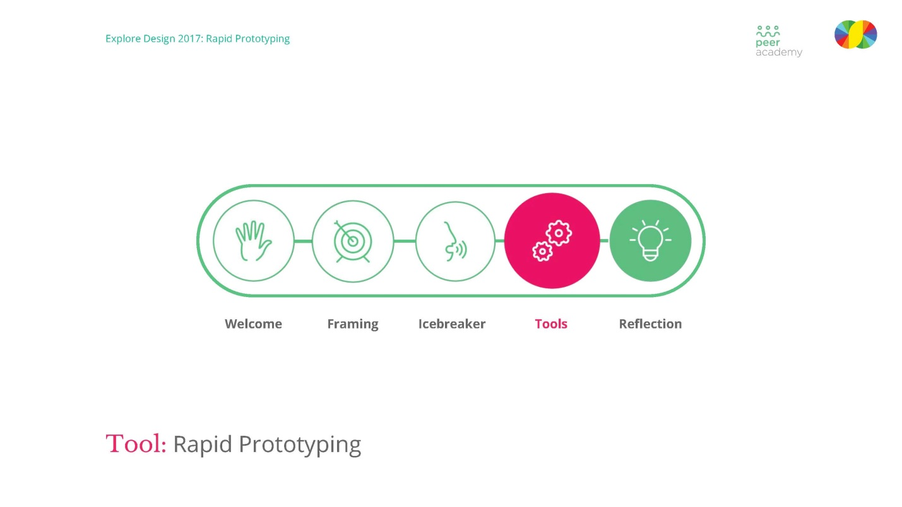

# Slide 24 Process rapid prototyping

Slide with heading 'Tool: Rapid Prototyping' and words 'As a group, rapid prototype one selected idea (Moonshot), Give your idea a bold title and represent it in 3D, At the end of the process,
each team will “pitch” their idea to the rest of group'

# Slide 25 Reflection

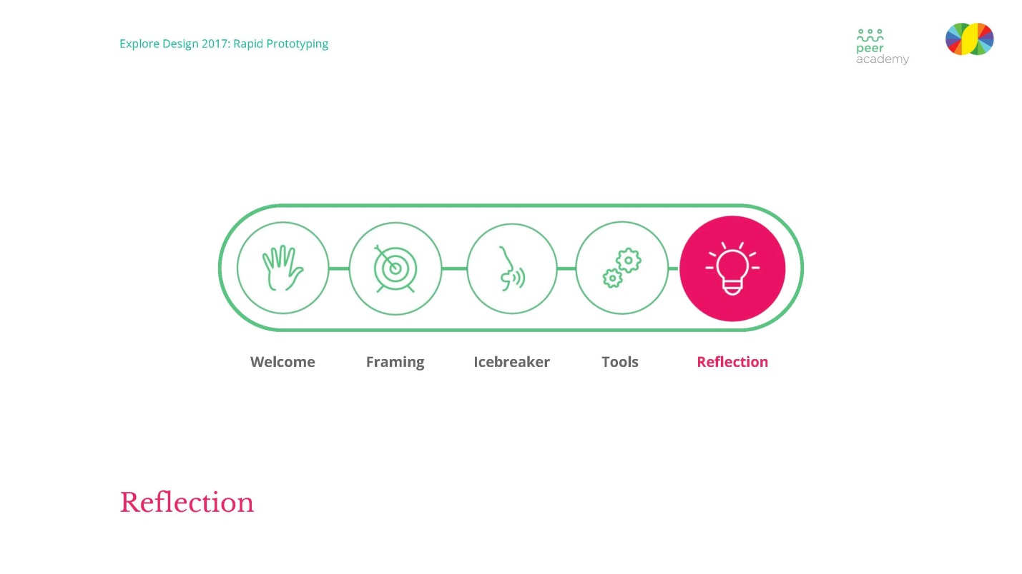

# Slide 26 Recap

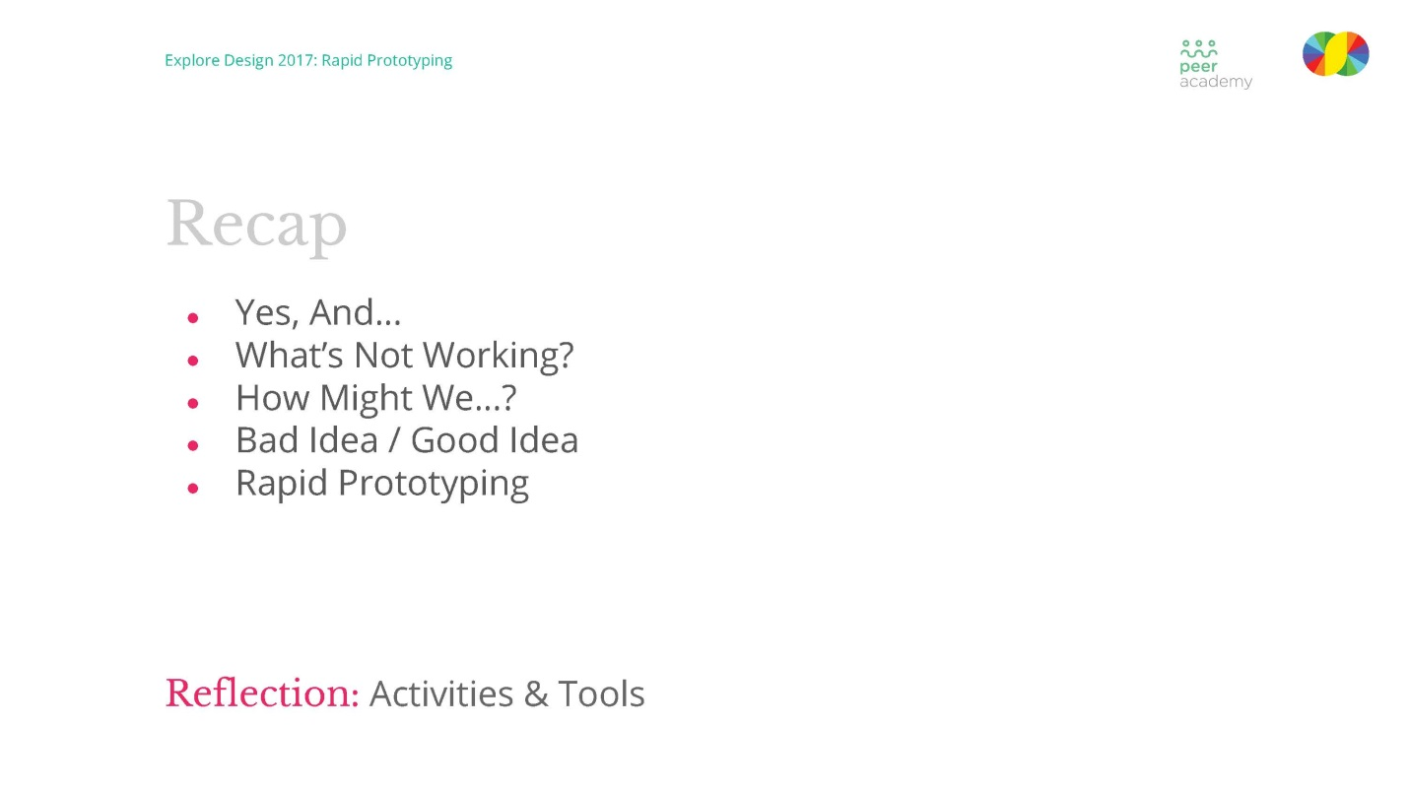

# Slide 27 The co-design problem

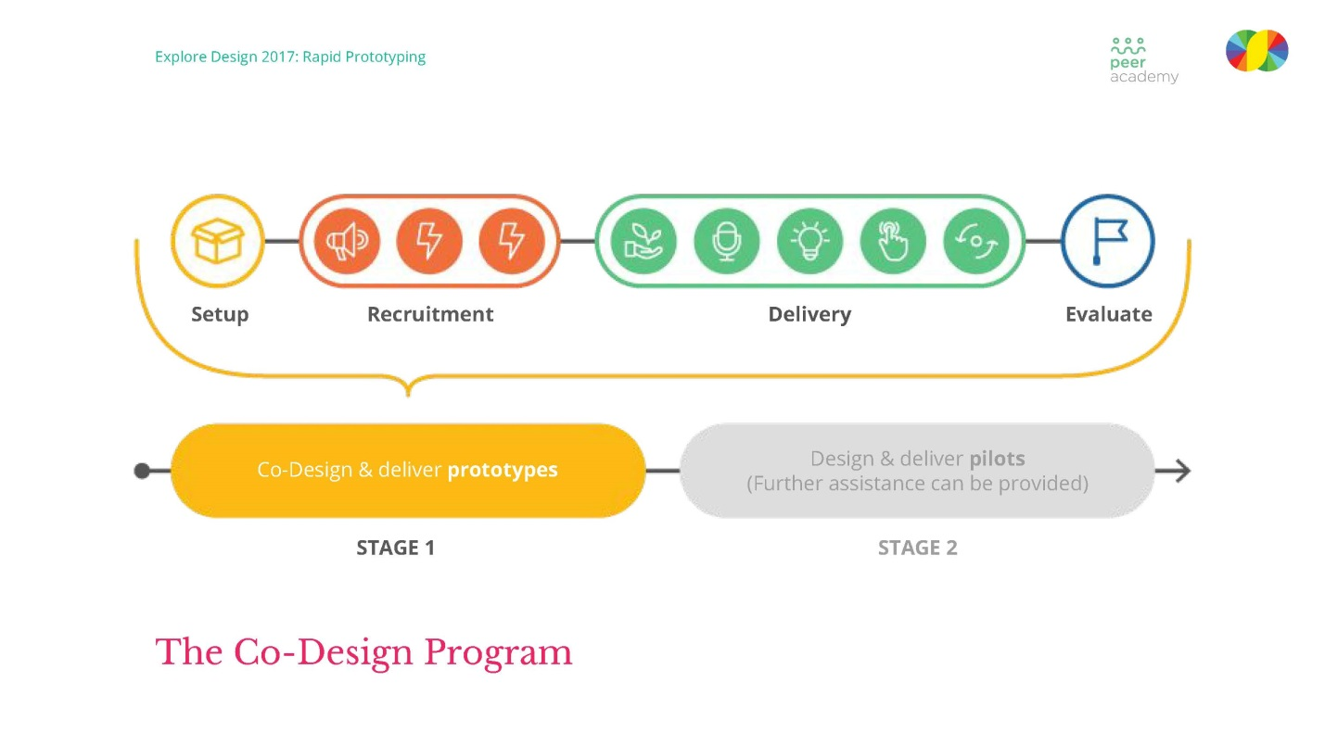

# Slide 28 Three month process

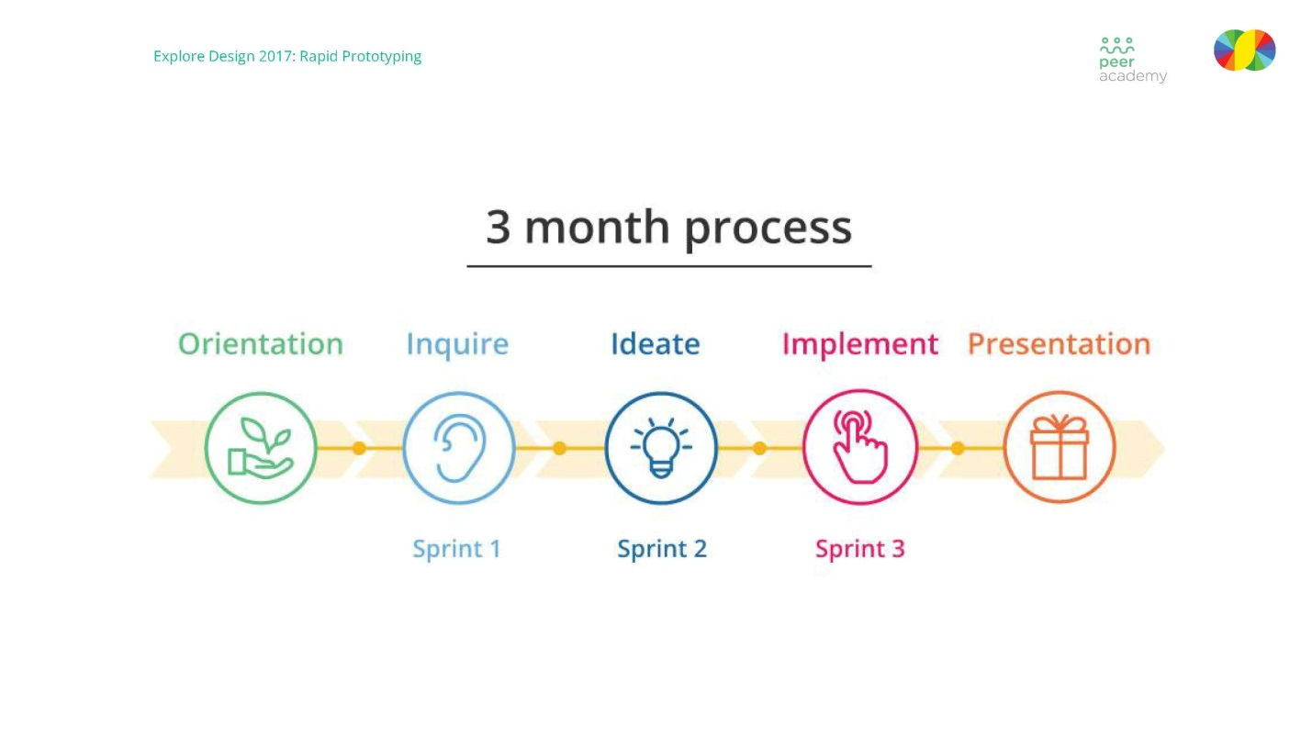

# Slide 29 The co-design program

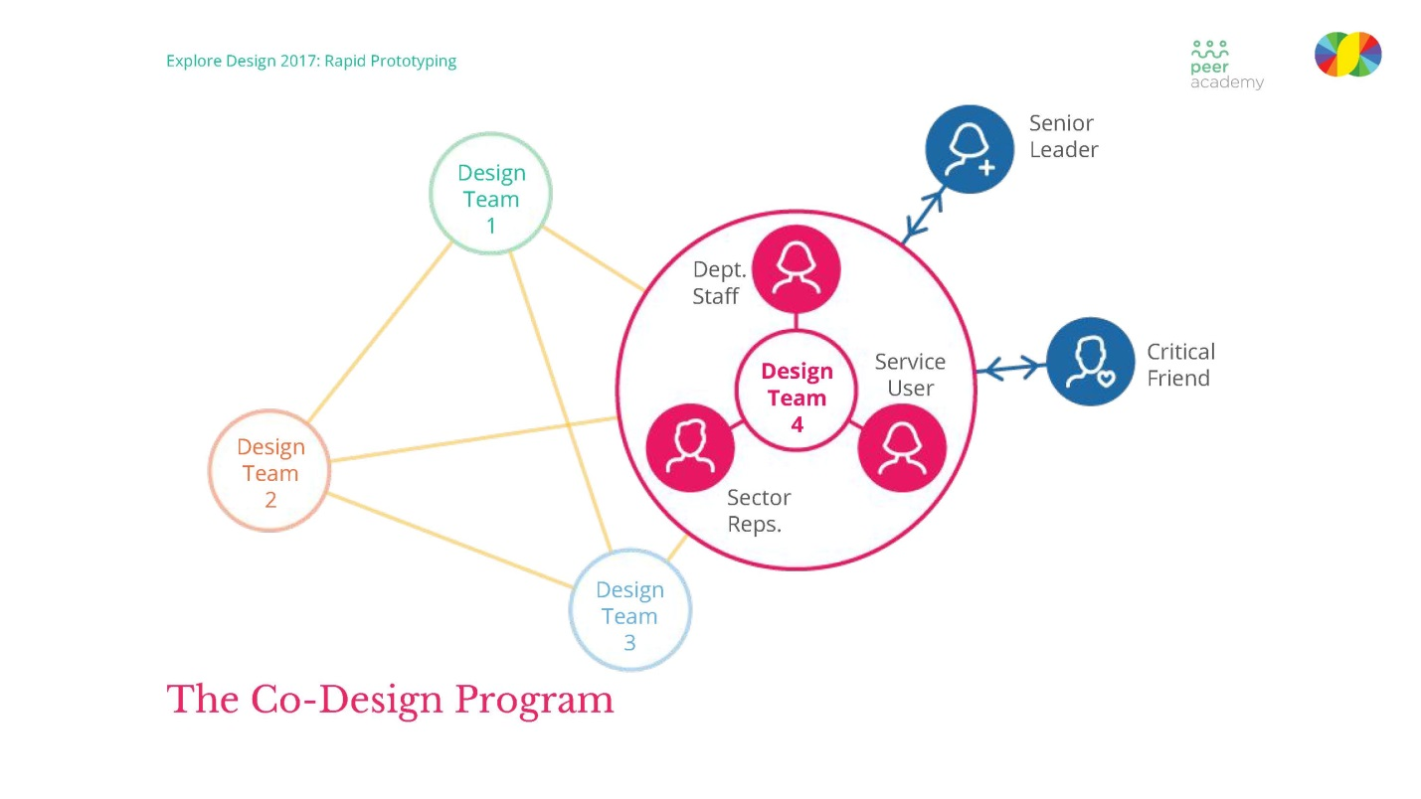

# Slide 30 The co-design program critical friends

Slide with heading 'the co-design program: critical friends' and four paragraphs 'A cross-section of people who are impacted by the
problem area, Not too heavily invested in the problem or a solution, Encouragement and support; identifying assumptions and asking open-ended questions, Provide a fresh and objective outside perspective'

# Slide 31 Targets

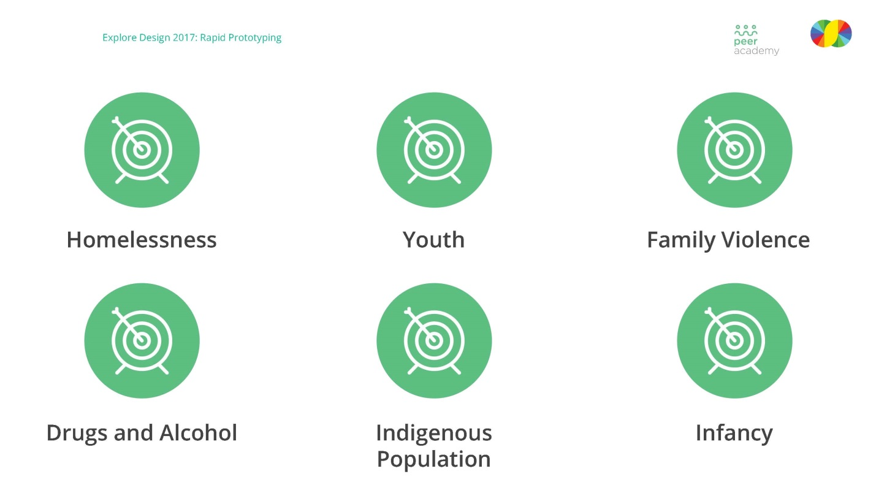

# Slide 32 Thank you

