Quick Guide – Record Keeping
This quick guide provides information on the record keeping requirements for VET Student Loans.

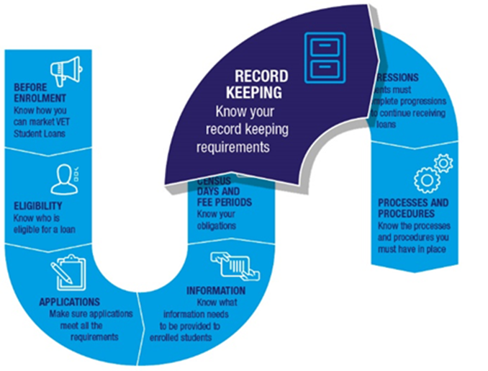

Retaining information and documents
The VET Student Loans Act 2016 states that you must keep records for 7 years or as otherwise specified. For example, the VET Student Loan Rules 2016 specifies the following information and documents must be retained for 5 years:
- the information provided to a student under section 98 of the Rules before the student enrols in an approved course
- documents obtained or assessments undertaken to determine a student’s academic suitability
- records of students’ enrolments, including the day and time the student enrolled in the course
- information and documents collected in relation to an application for a VET Student Loan
- if applicable, the day and time a student gives you a VET Student Loan application
- all correspondence between you and the student (or the student’s parent or guardian) in relation to the course. This includes notices issued to the student.
- records of each use of your grievance procedure
- the census days and tuition fees for approved courses
- a copy of each version of a process or procedure required by the Rules, including the dates when the version was current
- marketing and promotional material relating to approved courses.

Department may request information
We may give written notice requiring you to give information or documents relating to the provision of vocational education and training by you or your compliance with VET Student Loans legislation.
The information or documents must be given in the form requested by the notice. Other requirements may also be included in the notice.

Dealing with personal information
You must comply with the Australian Privacy Principles (APP) in relation to any personal information you obtain for the purposes of the Act. The APPs are set out in the Privacy Act 1988. They deal with the collection and management of personal information.
You must have a procedure for your students to apply for, and receive, a copy of their personal information that you hold.
You should note there are offences under the Act in relation to the misuse of personal information.

Audits
You should be aware you may be audited at any time. This could be in relation to your compliance with statutory requirements and/or in relation to whether your students are ‘genuine students’. Failure to cooperate in audits can lead to serious consequences.
Keeping accurate and detailed records will help you comply with audits.

Further information
For further information on record keeping requirements, refer to the VET Student Loans Manual for Providers (Chapter 4.1 Compliance, Chapter 4.12 Retaining information and documents, and Chapter 4.13 Dealing with personal information).
For the legislation governing record keeping requirements, please see sections 45-46, 51-54 and 99-101 of the VET Student Loans Act 2016, and sections 98 and 105 of the VET Student Loans Rules 2016.

