

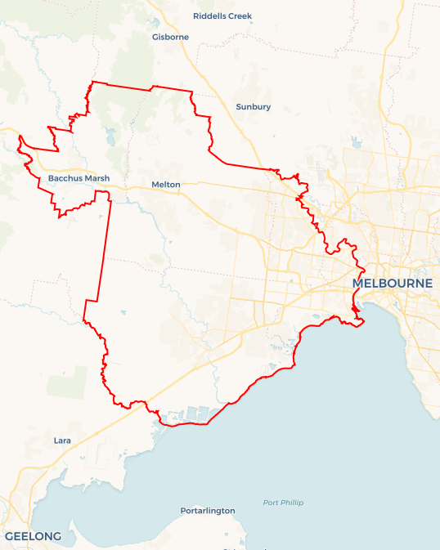Local Jobs Plan

Western Melbourne Employment Region | Victoria | ****July 2024****

Workforce Australia Local Jobs (Local Jobs) is a program that supports tailored approaches to accelerate   
reskilling, upskilling and employment pathways in response to current and emerging local workforce needs.

## Local Jobs elements

### Local Jobs Plan

The Local Jobs Plan sets out the skills and employment challenges and priorities of the region, and associated strategies that will drive the design and implementation of activities to be implemented to address these challenges.

### Employment Facilitators

Employment Facilitators and Support Officers support the delivery of the program by bringing together key stakeholders including businesses, employment services providers, higher education and training organisations.

### Local Jobs and Skills Taskforce

Each Employment Region has its own Taskforce. Representatives include local stakeholders who have demonstrated experience in upskilling, reskilling, and an ability to represent, connect and collaborate with others in the region to meet labour market needs.

### Local Recovery and National Priority Funds

The Local Recovery Fund supports projects that meet the priorities identified in the Local Jobs Plan. The National Priority Fund provides funding for innovative local solutions to address structural barriers to employment.

Explore labour market insights for the  
[Western Melbourne](https://www.jobsandskills.gov.au/work/employment-region-dashboards-and-profiles/monthly-labour-market-dashboards) Employment Region

## Local labour market challenges in the region

* The Western Melbourne region has a diverse labour market profile presenting strong job opportunities in growth industries and skills-in-demand sectors - the region has a history of **labour market and social challenges.**
* The proportion of the **working age population on income support**in Western Melbourne is higher than the Victorian average.
* **Youth looking for work** represent a large percentage of the Workforce Australia caseload in the region. Young people, not currently working or studying, have a higher rate of **disengagement**.
* Foundation skills, such as literacy, numeracy and digital proficiency are lacking in some participant groups, impacting their labour market participation.
* Culturally and linguistically diverse (CALD) and refugee cohorts face multiple challenges. When trying to utilise their skills and experience in the Australian job market, individuals often encounter several challenges to employment. These challenges may include limited language, literacy and numeracy skills, lack of Australian work experience, limited access to transportation and affordable housing near employment opportunities, unfamiliarity with Australian workplace culture and systems, and challenges associated with recognising and validating prior skills and qualifications.
* Access to**public transport and lack of public transport options that align with the start and end times for roles involving shift work.**

## Local jobs and skills priorities and strategies in the region

### Priority 1 – Priority industries, including transport and logistics, health care and social assistance

#### What are our challenges and opportunities?

#### Maximising the benefits of existing Australian, state and local government programs for the local labour market by creating **pathways into major industries**, particularly the transport and logistics, health care and social assistance.

#### How are we responding?

* Collaborating with transport and logistics, health care and social assistance stakeholders to raise awareness of employment opportunities in these sectors.
* Our efforts to address these challenges are not solitary. We are working with local stakeholders to coordinate a range of pathways directly linked to current labour demand in the region. This includes providing upskilling and reskilling for industries, as well as coordinating and collaborating on industry-specific job expos across all levels of government. These collaborative efforts are crucial in providing job opportunities for the local community.
* Supporting priority industries by engaging with social enterprises to collaborate and build programs to support individuals with challenges within the Western Melbourne region.

### Priority 2 – Major projects

#### What are our challenges and opportunities?

#### Maximising the extent to which individuals are skilled to meet the needs of major projects in the region, including infrastructure and other large-scale construction projects.

#### How are we responding?

* Coordinating and collaborating with industry specific events to provide job opportunities.
* Collaborating with local stakeholders to coordinate a range of pathways directly linked to major projects in the region, ensuring a collective effort in providing upskilling and reskilling for industry demand.
* Working with major project contract holders to promote employment opportunities through the Western Melbourne Local Jobs and Skills Taskforce (the Taskforce)

### Priority 3 – Youth

#### What are our challenges and opportunities?

#### Brokering opportunities for **youth skill development and employment** across all sectors, including **apprenticeships and traineeships.**

#### How are we responding?

* Collaborating with local governments to deliver youth careers and employment events with inclusion and consultation with young people, a commitment that ensures ongoing support for young people.
* Working with local community networks to design and deliver industry-specific programs to support young people engaging with industries.
* The Taskforce is developing a consolidated picture of locally available youth services, programs and initiatives to effectively inform the streamlined design of potential education, training and employment pathways to address local needs.

### Priority 4 – Employment ****challenges for culturally and linguistically diverse (CALD) and refugee cohorts****

#### What are our challenges and opportunities?

#### Addressing **employment challenges for CALD and refugee**individuals by targeting supported employment pathways to jobs opportunities in priority sectors.

#### How are we responding?

* Providing support by connecting CALD and refugee individuals to language, literacy and numeracy organisations to help increase their communication skills and broaden their employment opportunities.
* Collaborating with employers to understand and address challenges regarding transport for CALD and refugee individuals. This joint effort is building the capacity to change working hours to align with public transport options, making stakeholders feel involved and part of the solution.
* The Taskforce has engaged with CALD and refugee communities and elders to build an understanding of needs and supports required.

### Priority 5 – Supporting women into employment

#### What are our challenges and opportunities?

#### Engaging with, and supporting **women** to access employment opportunitiesaligned with local skill needs, including in traditionally male dominated industry sectors.

#### How are we responding?

* We are working to build a women's networking group to inspire and provide encouragement for women returning or re-entering the workforce.
* Collaborating with local governments to enact specific programs, careers and employment events, ensuring ongoing support for increased female participation and providing our stakeholders with a sense of security and reassurance.
* Collaborating with male-dominated industries to enhance employment opportunities for women in the local community by engaging with industry-specific employers who support women and implement programs designed by women.

### Priority 6 – Supporting First Nations peoples

#### What are our challenges and opportunities?

#### Reducing the labour market challenges for First Nations peoples in the region.

#### How are we responding?

* Connecting with employers to provide culturally appropriate local employment by working with priority industries within the Western Melbourne region.
* Identifying opportunities to create skills development pathways aligned with growth economies to support Fist Nations peoples and provide additional support through First Nations led initiatives, including employer awareness training.
* The Taskforce is engaging with First Nations communities to build an understanding of the current needs and supports required.

## Want to know more?

* Contact: Kylie Olsen, Western Melbourne Employment Facilitator: [kylie.olsen@employmentfacilitator.com.au](mailto:kylie.olsen@employmentfacilitator.com.au)
* Visit: [Local Jobs](https://www.dewr.gov.au/local-jobs) or [Workforce Australia](https://www.workforceaustralia.gov.au/)