

Quick Reference Guide: How to log into ADMS using your Digital Identity

Your Digital Identity, myGovID gives you fast, easy and secure access to ADMS. This guide will demonstrate how you can log into ADMS.

1. Navigate to the ADMS login page.

**RESULT:** The ADMS login screen display.

Click the log on button for your user type.

**RESULT:** The sign in page will appear.

1. Click ‘Continue with Digital Identity’.

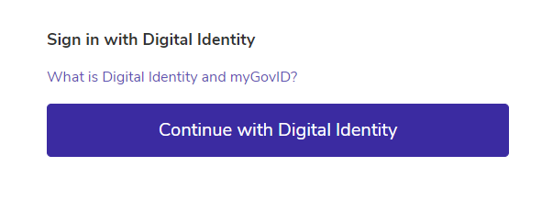

**RESULT:** The identity provider portal will display.

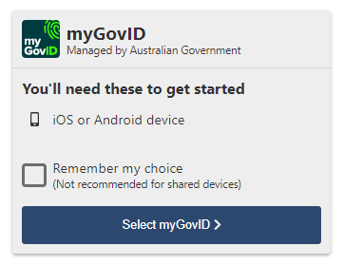

1. Click ‘Select myGovID’.

**RESULT:** You’ll be redirected to the myGovID login.

1. Enter the email address you used to set up myGovID.
2. Click Login.

**RESULT:** A myGovID authorisation code will be displayed on the screen.

1. Open myGovID on your smart device and enter the code.
2. Click Accept.

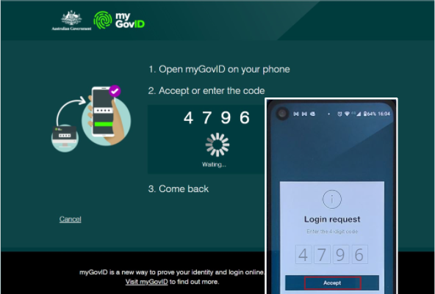

**RESULT:** The ADMS Home Page will be displayed and you can begin using ADMS

# Support

|  |
| --- |
| See our other help and support materials including the overview of the ADMS home page fact sheet and the one-time setup for ADMS access fact sheet. |

For assistance with ADMS, contact the National Customer Service Line (NCSL) on **1800 020 108**.

For feedback on this quick reference guide, contact [ADMSEngagement@dese.gov.au](mailto:ADMSEngagement@dese.gov.au).