

Fact Sheet: Overview of Claim Applications in ADMS

This fact sheet introduces the components and process of managing Claim Applications in ADMS. Use this fact sheet along with the other ADMS help and support resources to quickly raise and submit Claim Applications.

# ADMS Home Screen

Once you have received a notification that you can lodge a Claim Application, you will need to log into ADMS.

After you have logged into ADMS, you will see the ADMS home screen. To access your Claim Application list, click the ‘View claim applications’ button in the Actions section of the home screen. 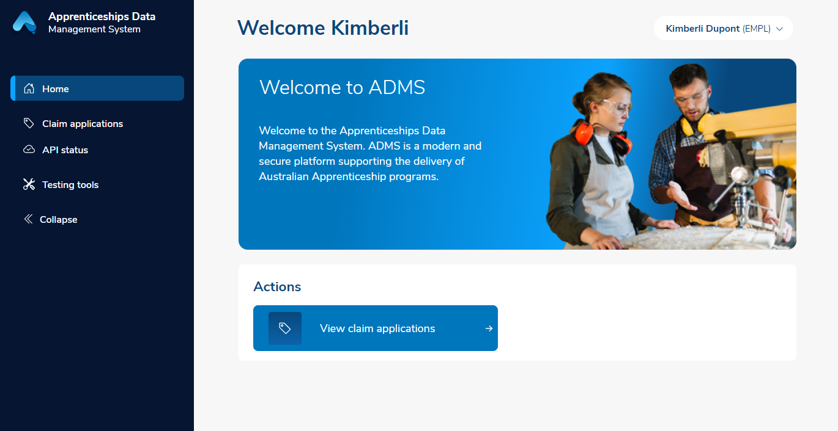

# Claim Applications list

The Claim Applications list displays all available claims. This page has three main components:

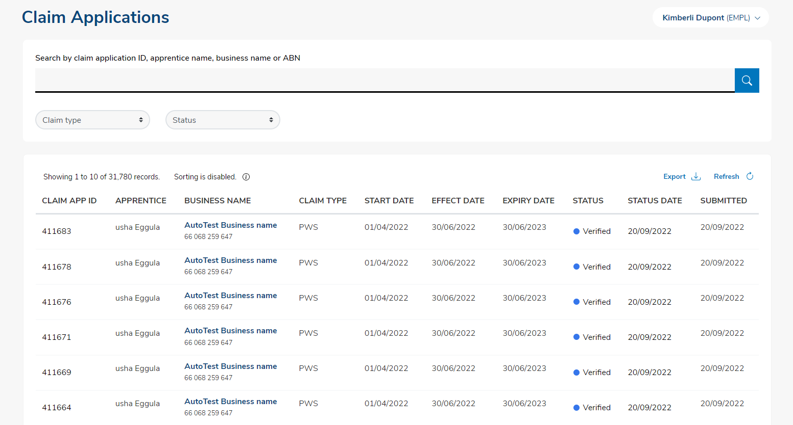

2

3

1

|  |  |  |
| --- | --- | --- |
| Number | Name | Description |
| 1 | Search Bar | The search bar allows you to search for a specific Claim Application using the application ID, apprentice name, business name or ABN |
| 2 | Filter | The Filter allows you to limit the Claim Applications that appear in the list below based on the:   * Status * Claim Type   For example, you can filter the list so that only Priority Wage Subsidy Claim Applications in ‘Draft’ status are displayed. |
| 3 | Claim List | The Claim List shows claims available for you to process and all claims previously submitted. To help you find Claim Applications quickly and easily, you can sort the claim list in ascending or descending order by any of the columns displayed:   * Claim Application ID * Apprentice name * Claim type * Business name * Start date * Effect date * Expiry date * Status * Status date * Submitted date   To sort, just click the up and down arrows next to the column heading. To reverse the sort order, click them again. You can not sort the Claim List if there are more than 5,000 records. |

# Claim application

Clicking on an entry in the Claim List will open the Claim Application. When completing your Claim Application, you will need to add information and evidence to support your claim before submitting. You can edit a Claim Application when its status is “Ready”, “Draft”, or “Returned”. You can view, but not edit a Claim Application when its status is “Submitted”, “Assessment”, “Verified”, “Approved”, or “Rejected”.

For further information about fields or statuses, please visit the [Australian Apprenticeships](http://www.australianapprenticeships.gov.au/about-adms) website.

The Claim Application contains the following sections:

## Apprentice details

The Apprentice details section displays the Apprentice’s name and key information about the qualification they are working towards.

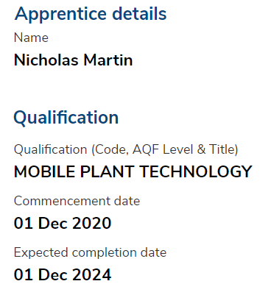

## Employer details

The Employer details section displays key information about the business which allows you to add an alternate contact and select which bank account you would like your payment to be paid into.

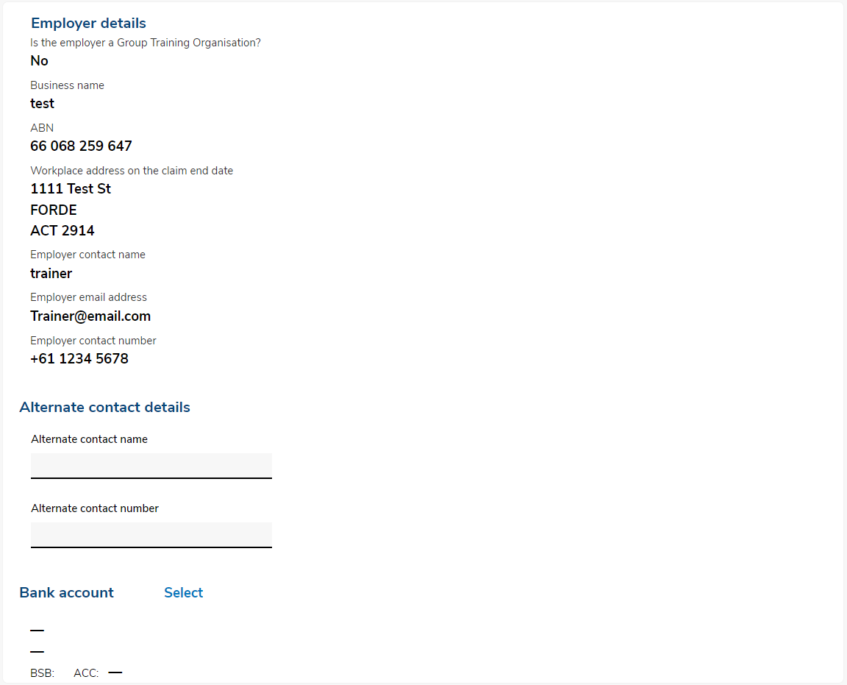

## Claim details

The Claim details section is where you enter key information about the claim, including any other Australian government wage subsidies you receive in relation to the Apprentice, and upload the training plan if you have not previously.

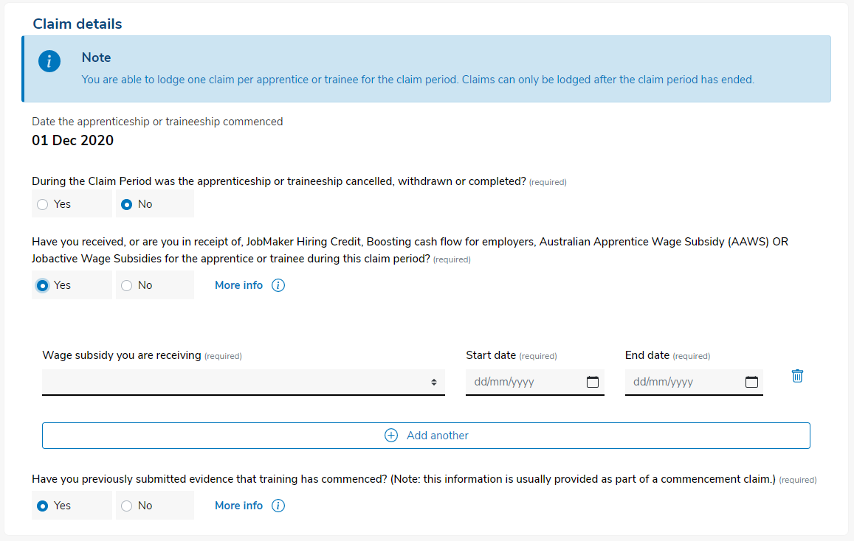

## Wage evidence

The Wage evidence section is where you upload evidence of wages paid to the apprentice during the Claim Period.

For further information about fields or statuses, please visit the [Australian Apprenticeships](http://www.australianapprenticeships.gov.au/about-adms) website.

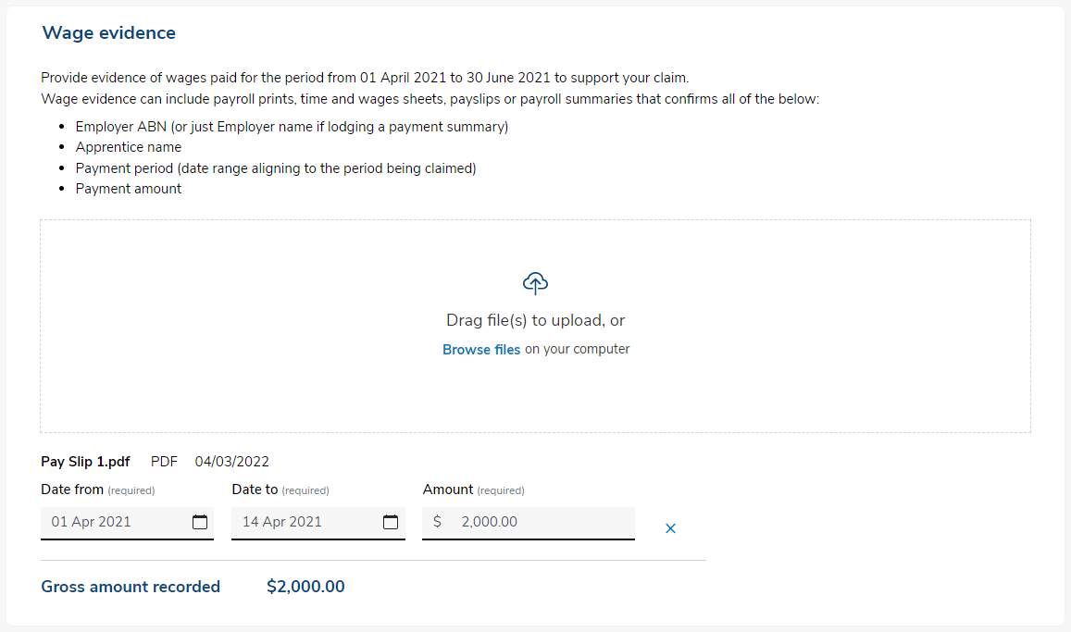

## Claim amounts payable

The Claim amounts payable section displays the claim amount based on the information and evidence provided.

## Wage Subsidy Agreement

The Wage Subsidy Agreement section is where you declare you are authorised to submit the claim and acknowledge you understand and accept the terms and conditions of the wage subsidy agreement.

## Employer declaration

The Employer declaration section is where you can declare that you checked the information that you have provide and that you understand providing false information is a serious offence.

## Submitting your claim

Once you have completed all sections of the wage subsidy Claim Application, you are ready to submit for processing.

# Support

For assistance with your Claim Application in ADMS, contact your Australian Apprenticeship Network Provider.

For feedback on this fact sheet, contact [ADMSEngagement@dese.gov.au](mailto:ADMSEngagement@dese.gov.au).