

Fact Sheet: Overview of Eligibility applications in ADMS

This fact sheet introduces the components and process for Australian Apprentices completing their Eligibility applications in ADMS. Use this fact sheet, along with other ADMS help and support resources to submit loan applications.

Visit [Support for Australian Apprentices](https://www.australianapprenticeships.gov.au/aus-apprenticeships-incentives) for further information about allowances.

# ADMS Home Screen

To begin your application for LAFHA eligibility application, you will first need to [log into ADMS](https://adms.australianapprenticeships.gov.au/adms/how-to-access).

After you have logged into ADMS, you will see the ADMS home page. Click the ‘Review my LAFHA eligibility application’ button in the Actions section to begin your application.

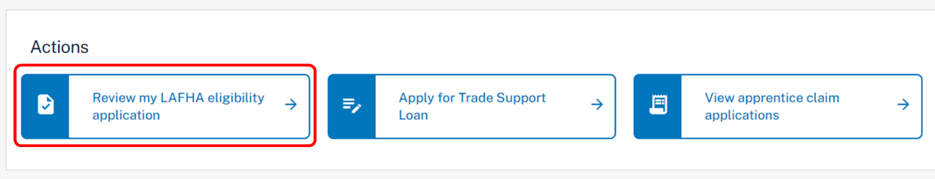

# Apprentice Eligibility application

Clicking on the ‘Review my LAFHA eligibility application’ button will open the eligibility application. When completing your application, you will need to add information and evidence to support your application before submitting.

The Eligibility application contains the following sections:

## Apprentice details

The Apprentice details section displays your name and key contact information.

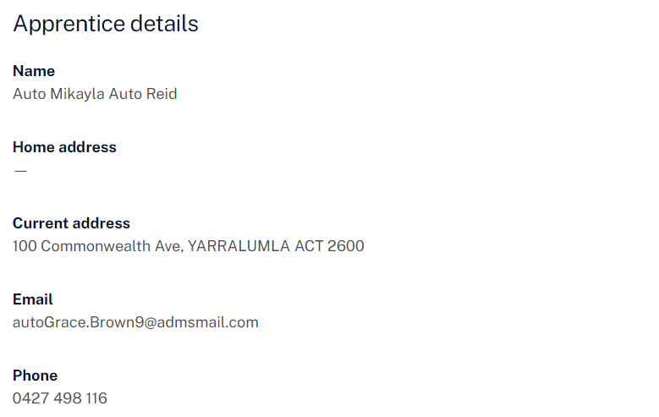

## Qualification

The Qualification section displays information about your qualification.

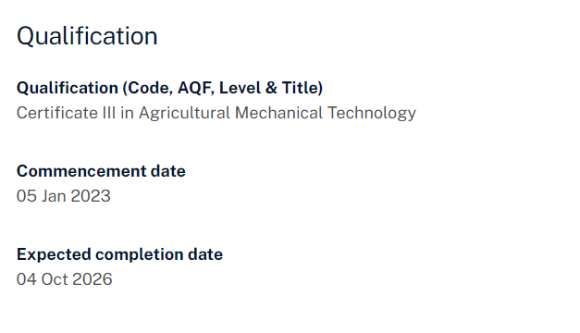

## Employer details

The Employer details section displays key information about your employer.

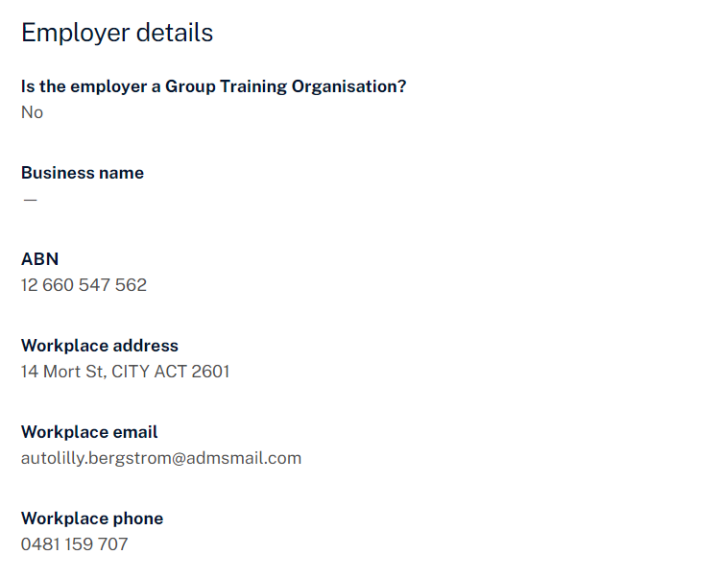

## Eligibility details

The Eligibility details section displays the eligibility information for you to complete. This section is dynamic and will change depending on your answers.

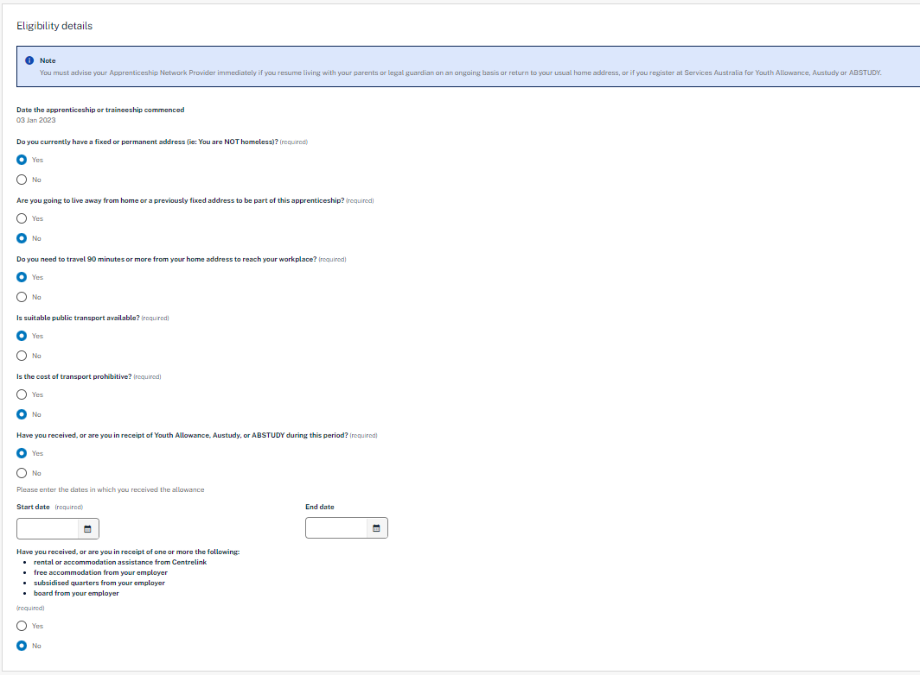

## Document evidence required

The Document evidence required section provides details on appropriate document evidence for an apprentice to support their application.

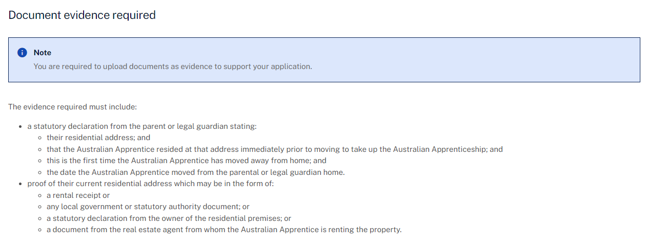

## Upload document evidence

Evidence to confirm your identity and residency status is required to support your loan application. Documents can be uploaded with the following format: ".jpeg", ".jpg", ".bmp", ".png", ".tiff", ".xls", ".xlsx", ".pdf", ".doc", ".docx", ".ppt", ".pptx".

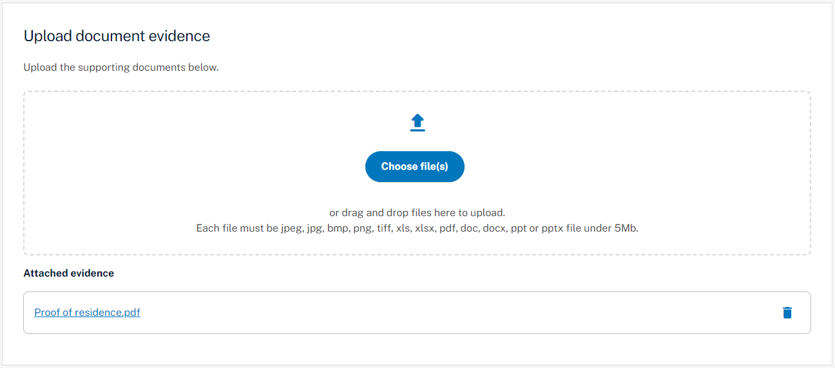

## Apprentice declaration

The Apprentice declaration section is where you will need to declare that you checked all information on the application is accurate and that you understand providing false information is a serious offence.

## Submitting your Eligibility application

Once you have completed all section of the Eligibility application, you are ready to submit for processing.

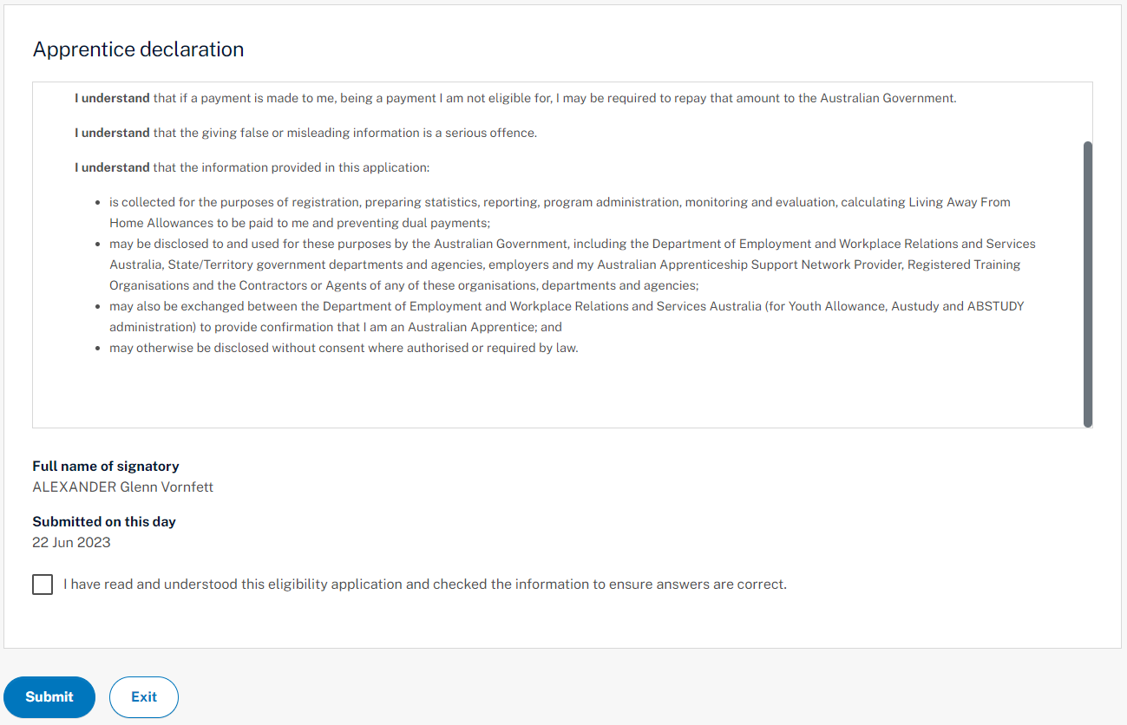

# Support

For assistance with ADMS, contact your Australian Apprenticeship Support Network (AASN) provider.