

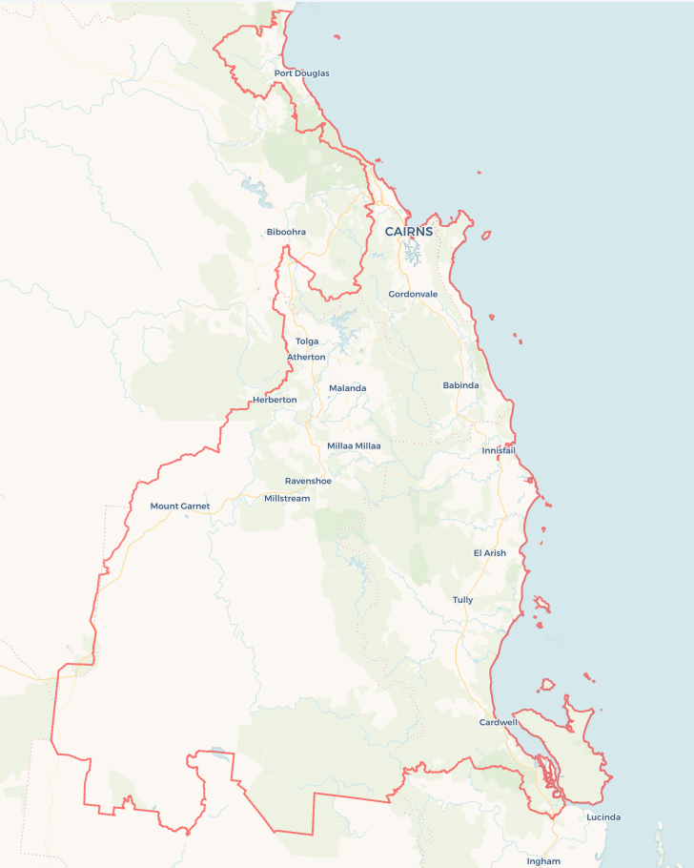Local Jobs Plan

Cairns ****Employment Region**** | QLD | ****November 2024****

Workforce Australia Local Jobs (Local Jobs) is a program that supports tailored approaches to accelerate   
reskilling, upskilling and employment pathways in response to current and emerging local workforce needs.

## Local Jobs elements

### Local Jobs Plan

The Local Jobs Plan sets out the skills and employment challenges and priorities of the region, and associated strategies that will drive the design and implementation of activities to be implemented to address these challenges.

### Employment Facilitators

Employment Facilitators and Support Officers support the delivery of the program by bringing together key stakeholders including businesses, employment services providers, higher education and training organisations.

### Local Jobs and Skills Taskforce

Each Employment Region has its own Taskforce. Representatives include local stakeholders who have demonstrated experience in upskilling, reskilling, and an ability to represent, connect and collaborate with others in the region to meet labour market needs.

### Local Recovery and National Priority Funds

The Local Recovery Fund supports projects that meet the priorities identified in the Local Jobs Plan. The National Priority Fund provides funding for innovative local solutions to address structural barriers to employment.

Explore labour market insights for the  
[Cairns](https://www.jobsandskills.gov.au/data/employment-region-dashboards-and-profiles/monthly-labour-market-dashboards) Employment Region

## Local labour market challenges in the region

* Retention of skilled workers in all sectors and building regional skills capability.
* Hidden unemployment and underemployment especially amongst young people, exacerbated by a high rate of homelessness.
* Engaging First Nations people and communities across the region.
* Long-term and mature-age unemployment.
* Limited connectivity (communications and transport) in geographically dispersed population centres.
* Natural disasters and structural adjustments resulting in loss of trade and workforce and exacerbating competition for skilled workers.
* A critical lack of available, affordable housing.
* Rapid growth in aviation, maritime and care sectors (particularly aged and childcare).
* Access to a viable workforce for the agriculture sector.
* Local small business capacity to develop entry level candidates

## Local jobs and skills priorities and strategies in the region

### Priority 1 – Maximising opportunities for local individuals to fill local positions by ensuring apprenticeship opportunities are optimised; locals are skilled to meet the needs of industry; and creating better access for those most marginalised in the labour force

#### What are our challenges and opportunities?

Major infrastructure projects valued at more than $2 billion are underway or scheduled for commencement. Professional and technical occupations continue to be in short supply and require pathway responses. Growth sectors include the healthcare and social assistance, construction, transport and logistics, manufacturing, agriculture and tourism recovery.

#### How are we responding?

* Encouraging uptake of apprenticeships, wage subsidy and training programs to increase engagement through promotion, education and direct intervention.
* Seeking out opportunities for skilled workers to use their skills in other industry sectors with effective transition preparation via local networks.
* Continuing to map major projects lead times, skills requirements, and sub-contracting schedules (parcelling) to better link overall skills development and work security opportunities and connecting locals seeking employment to those opportunities in a timely manner.
* Strengthening integrated service models to improve outcomes for registered individuals, through collaboration and coordination, recognising complex needs and multi-agency contribution.
* Supporting implementation of regional workforce strategies and actions through engagement and aligning project concepts to the identified actions.
* Creating multiple access points into the workforce for marginalised individuals seeking to engage in the labour market in projects and regional strategies.

### Priority 2 – Creating pathways into key industries, particularly the care sector, construction, manufacturing, transport and logistics and agriculture. This includes cross skilling for multi-sectoral application

#### What are our challenges and opportunities?

Demand is outstripping supply in growth sectors and while the region has a comprehensive plan to develop the skills ‘inhouse’, the cost limits implementation. Ongoing development of the care economy, construction, agriculture, marine and aviation industries present significant employment opportunities. Tourism continues to generate ongoing opportunities for the region.

#### How are we responding?

* Supporting cross sector skilling in occupations identified in the regional workforce strategies.
* Engaging with key industries to review the midterm employment opportunities.
* Developing strategies co-designed with the industry to ensure the creation of relevant and flexible training offers that meet business needs and that include local employment service providers.
* Developing strategies that will address identified needs as they arise, including supporting actions from key industry workforce plans.
* Identifying strategies that will increase opportunities for individuals looking for work.
* Supporting region and industry led strategies that are collaborative and meet specific industry and business needs.

### Priority 3 – Reducing the labour market challenges for First Nations people, young people and people with disability

#### What are our challenges and opportunities?

First Nations people represent 47% of the Workforce Australia caseload in the Cairns Employment Region, with many located in the Yarrabah Local Government Area (LGA). The region has a high youth unemployment rate, compounded by homelessness and disengagement. There is also significant hidden unemployment among young people. Tourism and retail provide the highest number of entry level opportunities. Manufacturing, transport and logistics are developing models to engage more entry level candidates.

#### How are we responding?

* Encouraging development of First Nations specific support services through inclusion in strategic activities, project engagement and culturally appropriate promotion.
* Working with businesses to educate them about the opportunities employing local First Nations people, young people and people with disability can provide.
* Ensuring young people have access to rapid engagement with youth employment and skilling services offering tailored support, opportunities, resources, and networks to address the specific challenges they face in their transition to work.
* Supporting access for all young people (including imminent school leavers) to an offer of tailored, face to face skilled careers guidance that assists them to navigate the changed labour market and training contexts.
* Creating opportunities through Local Jobs forums and other events to link individuals with local opportunities.
* Advocating for greater access to a diverse range of training options in the region.
* Developing coordinated and co-designed training options with businesses and registered training organisations that allow for flexible qualification completion, so that young people can be earning and learning at the same time.
* Developing skilling and employment responses that include the perspective and needs of individuals with differing cultural backgrounds, abilities and complex needs.

### Priority 4 – Facilitating the transition to new employment and self-employment and supporting people whose roles have been impacted by structural adjustment. This priority has a particular focus on reskilling mature age unemployed

#### What are our challenges and opportunities?

Natural disaster impacts include delayed and limited trade, loss of workforce and greater demand for trade skills. Recovery projects are expected to compete with scheduled major project works over the next two years for skills, labour and materials.

#### How are we responding?

* Developing skilling and employment strategies that better link businesses with individuals at LGA and town level.
* Delivering a series of forums with panels to advise businesses on how to take advantage of programs to grow business and increase their workforce.
* Supporting structural adjustment impacted workers and individuals seeking work to develop viable employment responses.
* Participating in events promoting local employment.
* Supporting skilled workers to transition into education and training sector roles.

## Want to know more?

* Contact: Tamilyn Brennan, Cairns Employment Region Employment Facilitator: tamilyn@fnqemployment.com.au
* Visit: [Local Jobs](https://www.dewr.gov.au/local-jobs) or [Workforce Australia](https://www.workforceaustralia.gov.au/)