TECHNICAL data REPORT:

ANALYSIS OF CHANGES IN CASUAL CONVERSION IN AUSTRALIA

Analysis of ABS Longitudinal Labour Force microdata.

July 2022

EXECUTIVE SUMMARY
- In early 2022, the Australian Bureau of Statistics (ABS) was funded through the Attorney-General’s Department (AGD) to explore the extent of any recent changes in the rate of casual conversion in Australia.
- The data source the ABS used to conduct this analysis was the Longitudinal Labour Force (LLFS) microdata [5], which consists of longitudinally linked Labour Force Survey (LFS) data.
- Casual conversion measures were calculated at a quarterly frequency between February 2018 and May 2022, inclusive, along with their standard errors and corresponding 95% confidence bands. These are presented in Figure E1 below. It is important to note that half of this period included the COVID-19 pandemic, with casual employees particularly impacted by changes in employment and hours.
- A particular focus on changes before and after March 2021 was considered useful, given legislation changes with specific regard for casual conversion came into effect at that time.
- A statistical test (the Chow test) was applied to the time-series of the metrics and the outputs of these tests indicated that there was insufficient evidence that there had been a statistically significant shift in the casual conversion rates, the casual transition rate, and the proportion of casual employees in the workforce in recent years, including the period after March 2021.
- It is noted that the ability of the Chow test to determine the existence of any statistically significant change in these rates after March 2021 is limited by the length of the time series after this date. The efficacy of the test would improve once more data points are available to add to the time series.
- A generalised linear mixed model was used to determine what socio-economic and demographic factors had a statistically significant association with casual conversion. These are presented in Table E2 below.
- Results from the generalised linear mixed model also showed that there had been no statistically significant change in the probability of eligible casual employees converting to non-casual employment in recent years, including the period since March 2021.
- There are a number of options for future analytical investigations to further evaluate the effects of the Amendment Act on the rate of casual conversion in Australia, including:
  - using a longer time-series of casual conversion measures for the above analyses once data has been collected from future iterations of the monthly LFS, and
  - complementing the LLFS microdata with other data sources to get a more specific measure of casual conversion.
- The analysis of the LLFS microdata in this report is expected to be impacted by the inherent data quality limitations of the LLFS microdata (see Section 3 for more information), given it is from a sample survey (even with a large sample). These limitations were addressed as much as possible, but the ABS strongly encourages the validation of the analytical findings in this report with other data sources that may provide additional insights into changes in casual conversion. This was out of scope of this analysis, which focused solely on ABS LLFS microdata.

Figure E1: Quarterly estimates and 95% confidence bands for casual conversion rates A and B, the casual transition rate, and the proportion of casual employees in the workforce for the analysis period February 2018 to May 2022.
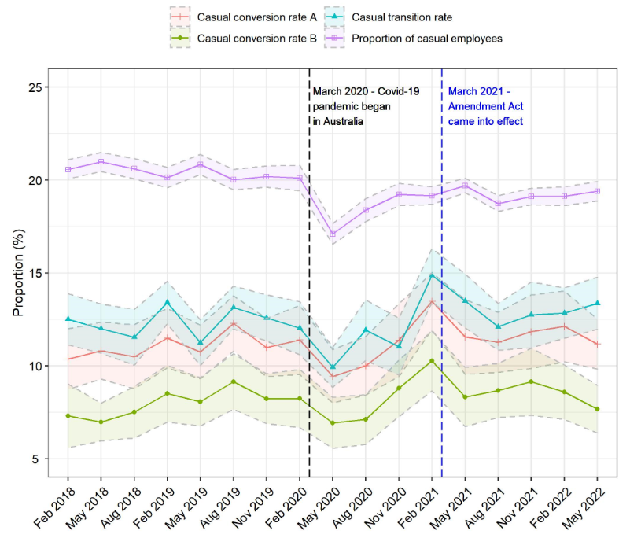

Table E2: Socio-economic and demographic factors that had a statistically significant association with eligible respondents who converted to non-casual employment (as per scoping rules of casual conversion rate A). Note that Appendix B provides the magnitude of the odds of all the associations listed below.
Socio-economic and demographic factor | Nature of association with casual conversion
State or territory of usual residence | - Eligible respondents who usually reside in NSW are more likely to convert to non-casual employment than those who usually reside in SA, WA, TAS and ACT.  - Eligible respondents who usually reside in VIC are more likely to convert to non-casual employment than those who usually reside in SA, WA, TAS and ACT.  - Eligible respondents who usually reside in NT are more likely to convert to non-casual employment than those who usually reside in WA, TAS and ACT.
Age | - Eligible respondents aged 15-24 years are more likely to convert to non-casual employment than those aged 55 years and over, while they are less likely to convert to non-casual employment than those aged 25-34 years.  - Eligible respondents aged 25-34 years are more likely to convert to non-casual employment than those aged 35 years and over.  - Eligible respondents aged 35-54 years are more likely to convert to non-casual employment than those aged 55 years and over.  - Eligible respondents aged 55-64 years are more likely to convert to non-casual employment than those aged 65 years and over.
Country of birth | - Eligible respondents born in Australia are less likely to convert to non-casual employment than those born overseas.
Number of children in household (aged 0 to 14 years) | - Eligible respondents who live in households with children aged 0 to 14 years are more likely to convert to non-casual employment than those who live in households without children aged 0 to 14 years.
Job tenure | - Eligible respondents are 3% more likely to convert to non-casual employment for each addition year of tenure.
Full-time/part-time status | - Eligible respondents who work full-time hours in their casual job are more likely to convert to non-casual employment than those who work part-time hours.
Industry division | - Eligible respondents who work in the Mining, Professional Services and Wholesale Trade industry divisions are more likely to convert to non-casual employment.  - Eligible respondents who work in the Agriculture, Transport and Accommodation industry divisions are less likely to convert to non-casual employment.
Occupation | - Eligible respondents with an occupation classified as ‘Managers’ are more likely to convert to non-casual employment than those with an occupation classified as ‘Professionals’.  - Eligible respondents with an occupation classified as ‘Clerical and administrative workers’ are more likely to convert to non-casual employment than those with an occupation classified as ‘Sales workers’, ‘Machinery operators and drivers’ or ‘Professionals’.  - Eligible respondents with an occupation classified as ‘Technicians and trade workers’ or ‘Community and personal service workers’ are less likely to convert to non-casual employment than those with an occupation classified as ‘Labourers’.
Skill level of occupation | - Eligible respondents with an occupation skill level of 4 (Certificate II or Certificate III) are less likely to convert to non-casual employment than those with an occupation skill level of 1 (Bachelor’s Degree or higher), 2 (Associate Degree or Advanced Diploma), or 3 (Certificate IV).  - Eligible respondents with an occupation skill level of 2 are more likely to convert to non-casual employment than those with an occupation skill level of 5 (secondary education or Certificate I).  - Eligible respondents with an occupation skill level of 4 or 5 are less likely to convert to non-casual employment than those with an undetermined/inadequately described occupation skill level.

INTRODUCTION
In early 2022, the Australian Bureau of Statistics (ABS) was funded through the Attorney-General’s Department (AGD) to explore the extent of any recent changes in the rate of casual conversion in Australia. This analysis focussed on the most recent period, with a particular focus on March 2021 which coincided with the introduction of the Fair Work Amendment (Supporting Australia’s Jobs and Economic Recovery) Act 2021 [1] (Amendment Act). The Amendment Act, which had specific reference to casual conversion, provides casual employees with a pathway to become a non-casual employee [2]. This is therefore a major context change to consider when measuring and analysing casual conversion in Australia.
This report outlines the ABS’s approach to measuring and analysing the rate of casual conversion in Australia from February 2018 to May 2022 using the ABS’s Longitudinal Labour Force microdata (LLFS data) and presents the findings of this analysis.
In addition to providing insights into casual conversion, this analytical project also helps to demonstrate the analysis and research that is possible from the LLFS data, and to identify further enhancements that would be useful. It follows similar exploratory longitudinal analysis from the ABS in 2014 on the topic of short-term dynamics of unemployment, which used the LLFS data when it was in a prototype state [3].
Given the LLFS data is designed to enable analysis of short-term labour market changes, analysis of any change in propensity to change employment, jobs or working arrangements is particularly useful in demonstrating the potential of this microdata product. Casual conversion is an example of a potential change in working arrangements where there has been a longstanding interest from labour market analysts and economists.
This analysis also complements recent ABS time series analysis of changes in casual employment over time and month-to-month transitions into and out of employment through its Gross Flows product and analysis.
Section 2 provides a summary of the Longitudinal Labour Force microdata (LLFS data) and its suitability for this analysis compared to other data sources.
In Section 3, the approach to determining the population in scope of this analysis is outlined. Issues in determining eligibility with the data items available in the LLFS data along with data quality caveats are also discussed in Section 3.
In Section 4, we define metrics for measuring the rate of casual conversion and changes in the proportion of casual employees in the Australian workforce.
The values of these metrics over the period February 2018 to May 2022 are presented in Section 5, along with their standard errors and corresponding 95% confidence bands. We also outline the implementation method for calculating these values at a quarterly frequency using the LLFS data and the analytical results of statistical tests designed to detect any significant recent changes in the metrics since March 2021.
In Section 6, we describe our multivariate modelling approach to answering the following research questions:
- What are the socio-economic and demographic factors associated with the casually employed workers who have converted to non-casual employment since March 2021?
- Has the probability of casually employed workers converting to non-casual employment changed since March 2021?
We also present the analytical findings of the model and provide some options for future analytical investigations related to understanding changes in casual conversion over time.

2. DATA SOURCE: THE LONGITUDINAL LABOUR FORCE MICRODATA
The ABS’s Longitudinal Labour Force microdata (LLFS data) is the data source the ABS used to evaluate any recent changes in casual conversion since March 2021. The LLFS data consists of data collected in the ABS Labour Force Survey (LFS). An outline of the LFS and the LLFS data are provided below, along with a brief justification for the use of the LLFS data compared to other alternative data sources.

2.1 Labour Force Survey
The ABS LFS is a large survey that collects information from the Australian population aged 15 years and over about their labour market characteristics, including whether they are employed, underemployed, unemployed or not in the labour force, and other important characteristics such as their sex, their age, and the state or territory they live in. The LFS is the survey collection from which headline figures such as the monthly unemployment rate estimate are calculated. The LFS, initially a quarterly survey, began in November 1960 and became a monthly survey in February 1978.
Each month, the LFS sample comprises of approximately 26,000 dwellings (both private and non-private dwellings such as hotels and hospitals) which equates to a large cross-sectional sample of approximately 50,000 people. The sample consists of eight sub-samples, often referred to as rotation groups, where each sub-sample remains in the LFS for eight months. A new rotation group is introduced each month to replace an out-going rotation group and it is generally taken from the same geographic area as the out-going rotation group.
The survey questions are asked of any responsible adult (ARA) in the dwelling on behalf of all members of the dwelling aged 15 years and over. Occasionally, there can be inconsistent or inaccurate information provided for LFS respondents via an ARA proxy.
Further information about the ABS’s LFS is available on the ABS website [4].

2.2 Longitudinal Labour Force microdata
Compared to the history of the LFS, the LLFS data is a relatively recent development by the ABS. The first release of the LLFS data into the ABS DataLab in 2012 was experimental in nature and linked the monthly data of LFS respondents over the period January 2008 to December 2010.
A large update to the LLFS data was released in 2019, which linked the monthly data of LFS respondents over the period October 1982 to August 2019. The COVID-19 pandemic then provided the impetus for updating and releasing the LLFS data on a monthly basis. Since May 2020, the latest month of LFS data has been added to the LLFS and released into the ABS DataLab approximately one week after the monthly LFS publication. Currently, the LLFS data contains almost 40 years of LFS data from October 1982 to May 2022.
There is variability in the types of people who leave and stay in the LFS which results in attrition bias over time when linking the monthly data of LFS respondents in the LLFS data. For example,
- males are more likely to leave relative to females;
- younger individuals are more likely to leave relative to older individuals; and
- unemployed individuals are more likely to leave relative to employed individuals or those not in the labour force.
While the LFS is a monthly survey, some data items are only collected on a quarterly basis (that is, in the designated quarter months February, May, August and November) and some data items have only been included relatively recently. For example, the data item that captures the concept of casual employment is only collected in the quarter months and has only been collected in the LFS since August 2014, though the ABS is exploring options for integrating additional historical information from annual supplementary topics collected in the LFS.
Further information about the ABS’s LLFS data is available on the ABS website [5].

2.3 Suitability of the LLFS for analysis of casual conversion
Of all the native data sources available to the ABS at the time of writing, the LLFS was considered the most appropriate data source for evaluating recent trends in casual conversion due to:
- the timeliness with which each new month’s LFS data is added to the LLFS;
- the relevant data collected in the LFS; and
- the longitudinal nature of data enabling comparisons over time.
However, as discussed in Section 3, the casual conversion identified in the LLFS will be different to the concepts and eligibility criteria in the Amendment Act.
While other ABS data contains richer or more comprehensive data on casual employees, such as the Characteristics of Employment supplementary topic, these data are only collected on an annual basis and not from an overlapping sample. This means that the granularity of the data collected does not enable measuring changes in an individual’s circumstances with respect to their employment history over time.
It is anticipated that other administrative data sources may be of benefit in the future. For example, future enhancements to the Single Touch Payroll data the Australian Taxation Office collects from Australian businesses are expected to allow richer data to be collected, however this level of granularity was not available at the time of writing.

3. SCOPING THE POPULATION IN LLFS DATA
In gauging the extent to which there was a recent change in casual conversion in Australia, the ABS had regard for structural changes in the labour market during this period – particularly the introduction of the Amendment Act, which had specific reference to casual conversion.
The first step in using the LLFS data was to identify the population in scope. Casual conversion in Australia has regard for tenure and other aspects of a person’s working arrangements, and the population in scope of the Amendment Act was therefore used, together with the conceptual framework of the LFS, to determine which respondents to include in the analysis.
Several casual conversion eligibility criteria in the Amendment Act match (or closely match) data items available in the LLFS data while other eligibility criteria do not relate to any information collected in the LFS. This has implications for the comparability of the casual conversion rate estimates calculated from the LLFS data with analysis based on other data (for example, information collected directly from employers or employees specifically on casual conversion).

3.1 Matching casual conversion eligibility criteria to LLFS data items
As detailed in Table 1, information related to the following casual conversion eligibility criteria is collected in the LFS and is available to use in the LLFS to scope eligible respondents:
- the respondent is employed on a casual basis;
- the respondent has been employed in their job for 12 months or longer; and
- the respondent has been working a regular pattern of hours on an ongoing basis during at least the last six months of their employment.
Table 1 also details which casual conversion eligibility criteria do not match any information collected in the LFS and thus cannot be used to scope eligible respondents from the LLFS:
- the respondent is not employed by a small business;
- the respondent would not require significant adjustments to continue to work in their current casual job as a non-casual full-time or part-time employee;
- there are no reasonable grounds for the respondent’s employer to not make a casual conversion offer;
- the respondent has received a casual conversion offer or requested casual conversion from their employer;
- the respondent accepted a casual conversion offer from their employer or their request for casual conversion was granted by their employer.

Table 1: Conceptual matching of casual conversion eligibility criteria and data items in the LLFS data.
Casual conversion eligibility criteria [1] | Relevant LLFS data items [5] | Conceptual and data quality caveats
15A – Meaning of casual employee | LFSTATUS – Labour force status  - Employed | - The LFSTATUS data item has been collected in the LFS on a monthly basis since February 1978.
 | STATEMP – Status of employment in main job  - Employee without paid leave entitlements | - The current STATEMP data item has been collected in the LFS on a quarterly basis since August 2014 (and from supplementary topics before that).  - As per the LFS conceptual framework, a respondent who is an employee without paid leave entitlements is considered by the ABS to be a casual employee.
66AA – Subdivision does not apply in relation to an employer that is a small business employer | Nil | - The LFS does not collect information from respondents about the size of their employing business.
66B – Employer offers  (1) … an employer must make an offer to a casual employee … if:  (a) the employee has been employed by the employer for a period of 12 months … ;  66F – Employee requests  (1) … an employee may make a request of an employer … if:  (a) the employee has been employed by the employer for a period of at least 12 months … ; | TENUREYR – Job tenure  - 12 months or more | - The current TENUREYR data item has been collected in the LFS on a quarterly basis since August 2014, and in other forms before that.  - Approximately 27-32% of single job holder respondents do not have coherent reported values of TENUREYR in consecutive quarter months.
 | RTRNCH3M – Lost jobs and retrenchment status last 3 months  - No jobs left or lost in last 3 months | - The current RTRNCH3M data item has been collected in the LFS on a quarterly basis since August 2014 (and from supplementary topics before that).  - Approximately 1-2% of single job holder respondents who have a reported TENUREYR value of at least 3 months, do not have a coherent reported value of RTRNCH3M in any given quarter month.

Casual conversion eligibility criteria [1] | Relevant LLFS data items [5] | Conceptual and data quality caveats
66B – Employer offers  (1) … an employer must make an offer to a casual employee … if:  (b) during at least the last 6 months of that period, the employee has worked a regular pattern of hours on an ongoing basis …  66F – Employee requests  (1) … an employee may make a request of an employer … if:  (b) the employee has, in the period of 6 months ending the day the request is given, worked a regular pattern of hours on an ongoing basis … | HRUWMJ – Hours usually worked in main job | - The current HRUWMJ data item has been collected in the LFS on a monthly basis since July 2014.
 | HRAWMJ – Hours actually worked in main job³ | - The current HRAWMJ data item has been collected in the LFS on a monthly basis since April 2001.  - The current HRAWMJ data item captures the number of hours the respondent actually worked in the main job in the reference week of the month. It does not capture the number of hours the respondent actually worked in the main job in all weeks of the month.
 | WORKMON – Whether worked on Monday last week  WORKTUE – Whether worked on Tuesday last week  …  WORKSUN – Whether worked on Sunday last week | - The WORKMON, WORKTUE, … , WORKSUN data items have been collected in the LFS on a monthly basis since April 2001.  - The WORKMON, WORKTUE, … , WORKSUN data items captures whether the respondent worked on those days in the reference week of the month. They do not capture the days the respondent worked in all weeks of the month.
66B – Employer offers  (1) … an employer must make an offer to a casual employee … if:  (b) … without significant adjustment, the employee could continue to work as a full-time employee or part-time employee (as the case may be).  66F – Employee requests  (1) … an employee may make a request of an employer … if:  (b) … without significant adjustment, the employee could continue to work as a full-time employee or part-time employee (as the case may be)… | Nil | - The LFS does not collect information from respondents about whether significant adjustments would be required to continue to work in their current casual job as a non-casual full-time or part-time employee.

Casual conversion eligibility criteria [1] | Relevant LLFS data items [5] | Conceptual and data quality caveats
66B – Employer offers  (2) The offer must:  (a) be in writing; and  (b) be an offer for the employee to convert: …  66F – Employee requests  (2) The request must:  (a) be in writing; and  (b) be a request for the employee to convert: … | Nil | - The LFS does not collect information from respondents about whether they have received a casual conversion offer from their employer or whether the respondent has requested casual conversion from their employer.
66C – When employer offers not required  (1) … an employer is not required to make an offer … if:  (a) there are reasonable grounds not to make the offer; and  (b) the reasonable grounds are based on facts that are known, or reasonably foreseeable, at the time of deciding not to make the offer.  (3) An employer must give written notice to a casual employee … if:  (a) the employer decides … not to make an offer to the employee; or  (b) the employee … does not meet the requirement referred to in paragraph 66B(1)(b). | Nil | - The LFS does not collect information from respondents about whether there are reasonable grounds (examples are given in paragraph 66C(2)) for their employer to not make an offer for casual conversion.  - Nor does the LFS collect information from respondents about whether they have received a written notice from their employer advising that they are not making an offer for casual conversion.
66D – Employee must give a response  66E – Acceptances of offers  66G – Employer must give a response  66H – Refusals of requests  66J – Grants of requests | Nil | - The LFS does not collect information from respondents about whether the respondent accepted a casual conversion offer from their employer or their request for casual conversion was granted by their employer.

3.2 Data quality caveats for LLFS data items matched to casual conversion eligibility criteria
The LLFS data items STATEMP and TENUREYR, which indicate a respondent’s casual employment status and job tenure respectively, are collected in the LFS on a quarterly basis. While this is not a data quality issue per se, it does dictate that the casual conversion measures calculated using the LLFS data will be on a quarterly frequency. The LLFS data does not support higher frequency measure of casual conversion such as monthly rates of casual conversion.
The TENUREYR data in the LLFS has some quality issues when comparing values of TENUREYR over time. As stated in Table 1, approximately 27-32% of single job holder respondents do not have coherent reported values of TENUREYR in consecutive quarter months in the period from February 2018 to May 2022. Inversely, approximately 68-73% of single job holder respondents do have coherent reported values of TENUREYR in consecutive quarter months in the same period.
The lack of coherence between the TENUREYR and RTRNCH3M (which indicates whether a respondent has lost or left a job(s) in the last 3 months) data items is much less prevalent in the LLFS data. As stated in Table 1, approximately 1-2% of single job holder respondents who have a reported TENUREYR value of at least 3 months do not have a coherent reported value of RTRNCH3M in the period from February 2018 to May 2022. Inversely, 98-99% of single job holder respondents who have a reported TENUREYR value of at least 3 months do have a coherent reported value of RTRNCH3M in the same period.
The LLFS data items:
- HRUWMJ (hours usually worked in main job)
- HRAWMJ (hours actually worked in main job)
- WORKMON, WORKTUE, …, WORKSUN (whether worked on Monday, Tuesday, …, Sunday last week)
relate to the casual conversion eligibility criteria drawn from the Amendment Act (paragraph 66B(1)(b) in [1]), that is “… during the last 6 months … the employee has worked a regular pattern of hours on an ongoing basis …”. However, the following issues were identified when considering the use of these data items to scope LLFS respondents as eligible for casual conversion:
- The concept “worked a regular pattern of hours on an ongoing basis” is not further defined in the Amendment Act. It may be interpreted differently by employers and employees for differing job circumstances and requirements.
- In the quarter month that a respondent is determined to be potentially eligible for casual conversion (as per other scoping data items), they may not have been in the LFS for 6 months or longer. This situation was found to happen for approximately 63% of potentially eligible respondents each quarter month since March 2021.
- While HRUWMJ, HRAWMJ, WORKMON, WORKTUE, … , WORKSUN are all collected on a monthly basis in the LFS, respondents only report on their working days and hours in the reference week of the month; they do not report on their working days and hours for all weeks of the month. This, along with b) above, means that a complete picture of a respondent’s pattern of days and hours worked over the required 6-month period cannot be established with the LLFS data.
- An analysis of the available HRUWMJ, HRAWMJ, WORKMON, WORKTUE, … , WORKSUN data for respondents determined to be potentially eligible for casual conversion (as per other scoping data items) revealed a lot of variability in reported days and hours worked. There was some evidence of regular patterns of work hours for potentially eligible respondents who worked full-time hours in their casual job.
The above data quality issues may be attributable to several causes, including:
- inaccurate respondent recall or ARA proxy reporting;
- data transcribing errors; and/or
- errors incurred during data processing.

3.3 LLFS data items used to scope respondents for inclusion in casual conversion measures
The LLFS data items that were ultimately used in the ABS’s analysis to determine respondents as:
- eligible for casual conversion in a given quarter month, q_{t}; and
- of those eligible respondents, who converted to non-casual employment in the next quarter month, q_{t+1},
are listed in Table 2.

Table 2: LLFS data items used to scope eligible respondents and respondents who convert from casual to non-casual employment.
LLFS data items | Not eligible for casual conversion in q_{t} | Eligible for casual conversion in q_{t} | Converted to non-casual employment in q_{t+1}*
Labour force status (LFSTATUS) | - Unemployed  - Not in the labour force | - Employed | - Employed
Multiple job holders (MULTJOB)^ | - Multiple job holder | - Single job holder | - Single job holder
Job tenure (TENUREYR) | - Less than 12 months | - 12 months or longer | - 12 months or longer
Lost jobs and retrenchment status last 3 months (RTRNCH3M) | - Left or lost jobs in last 3 months | - No jobs left or lost in last 3 months | - No jobs left or lost in last 3 months
Status of employment in main job (STATEMP) | - Employee with paid leave entitlements  - Owner manager of incorporated/ unincorporated enterprise  - Contributing family worker | - Employee without paid leave entitlements (that is, casually employed) | - Employee with paid leave entitlements (that is, non-casually employed)
*Respondent must be determined to be eligible for casual conversion in q_{t} in order to be determined to have converted to non-casual employment in q_{t+1}.
^The exclusion of multiple job holders from being eligible for casual conversion is due to the definitions of TENUREYR and STATEMP referring to a respondent’s ‘main’ job. For a multiple job holder, their main job is the job in which they worked the most hours in the LFS reference week of the month. This means their main job can change and comparisons of casual and non-casual employment conditions within one job over time cannot be accurately made.

The inclusion of the data item MULTJOB (multiple job holders) as an eligibility scoping data item is due to the definition of two other scoping data items STATEMP (status of employment in main job) and TENUREYR (job tenure). For these two data items, respondents provide information about their ‘main job’ only. For a single job holder, ‘main job’ is the respondent’s only job but, for a multiple job holder, ‘main job’ is defined to be the job in which the respondent works the most hours in the reference week of the month.
Consequently, a multiple job holder’s main job in q_{t} can be a different job to their main job in q_{t+1} which unfortunately means that a true case of casual conversion for a multiple job holder cannot be distinguished from a false one. For example, a multiple job holder may be eligible for casual conversion in their casual job, and they also hold a second non-casual job. This respondent could report on their casual job in q_{t} as it was their main job in that month but then could report on their non-casual job in q_{t+1} as they happened to work more hours in their non-casual job in that month. This situation would appear in the data to be a positive case of casual conversion, but it is purely due to the respondent reporting on two different jobs, a casual job and then a non-casual job, in two consecutive quarter months. We cannot determine from the LLFS data whether this respondent did undergo casual conversion in their casual job.
By excluding multiple job holders from being eligible for casual conversion in our scoping of the LLFS data, we are excluding potentially false cases of casual conversion from our measures of casual conversion but at the cost of not including potentially truly eligible respondents and true cases of casual conversion. Given that multiple job holders account for approximately 9% of potentially eligible casually employed respondents, the exclusion of this sub-population may have a minimal impact on the accuracy of our casual conversion measures.
Furthermore, the minor proportion of respondents with incoherent TENUREYR and RTRNCH3M data discussed in Section 3.2 is expected to have minimal impact on the accuracy of our casual conversion measures. For example, a respondent who has been casually employed in their job for 12 months or longer and has an incorrectly reported RTRNCH3M value which indicates they have lost or left a job in the last 3 months, may be excluded from our casual conversion measures (that is, casual conversion rate B which is defined in Section 4.1 and Table 3) despite being potentially eligible. Conversely, a casually employed respondent who has an incorrectly reported TENUREYR value of 12 months or longer and a correctly reported RTRNCH3M value which indicates they have lost or left a job in the last 3 months, may be included in our casual conversion measures (that is, casual conversion rate A which is defined in Section 4.1 and Table 3) despite not being eligible.
Finally, as discussed in Sections 3.1 and 3.2, some casual conversion eligibility criteria are not captured in the LLFS data due to (i) relevant data not conceptually matching the eligibility criteria sufficiently, (ii) relevant data not being of sufficient quality and (iii) relevant data not being collected in the LFS. This means that our eligibility scoping of the LLFS data cannot exclude:
- respondents who are employees of small businesses that are out of scope for the Amendment Act;
- respondents that have not worked a regular pattern of hours for at least the last 6 months of their casual employment;
- respondents that would need significant adjustments to continue to work as a non-casual full-time or part-time employee;
- respondents whose employer may have reasonable grounds for not offering casual conversion and/or who received written notice from their employer that they were not going to offer casual conversion; and
- respondents that received a casual conversion offer from their employer but declined it.
We are potentially including these respondents in our rates of casual conversion which is likely to have the impact of artificially reducing our estimates of the rates, given the broad scope of the casual employee population in the denominator.

4. CASUAL CONVERSION RATES AND CHANGE IN THE EXTENT OF CASUAL EMPLOYMENT IN THE WORKFORCE METRICS
Using the LLFS data items listed in Table 2, the ABS defined the following four metrics to assess the impact, if any, of the Amendment Act:
Casual conversion rates
Casual conversion rates A and B aim to specifically measure, at a quarterly frequency, the rate of casual conversion amongst those who are eligible as per the Amendment Act. Casual conversion rates A and B are differentiated from each other by the accepted levels of data quality in their eligibility scoping rules.
Change in the extent of casual employment in the workforce metrics
Two other metrics were included in the ABS’s analysis to provide additional context. The first metric aims to measure the rate of transition from casual to non-casual employment, either via the legislated casual conversion pathway or an alternative pathway, amongst those who are casually employed. The second metric is simply the proportion of the Australian workforce that is casually employed. Both metrics are broader measures of the amount of change in the extent of casual employment in the Australian workforce over time, calculated at a quarterly frequency.

4.1 Casual conversion rates A and B
The LLFS eligibility scoping rules (that is, the data rules for determining which respondents are eligible for casual conversion and, of the eligible respondents, who has undergone casual conversion) for casual conversion rates A and B are provided in Table 3.
While both casual conversion rates A and B aim to measure the rate of casual conversion amongst those who are eligible, the eligibility scoping rules for casual conversion rate A accept lower levels of data quality in the TENUREYR and RTRNCH3M data items than the eligibility scoping rules for casual conversion rate B.
Respondents are deemed eligible for casual conversion under the scoping rules for casual conversion rate A if they are a single job holder who is casually employed and have been employed in a job for 12 months or longer in a given quarter month q_{t} (the denominator of casual conversion rate A). Respondents are deemed to have undergone casual conversion in the next quarter month q_{t+1} under the scoping rules of casual conversion rate A if they were eligible in q_{t} and then are a single job holder who is non-casually employed and have been employed in a job for 12 months or longer in q_{t+1} (the numerator of casual conversion rate A).
As discussed in Section 3.2, reported values of TENUREYR are not coherent in consecutive quarter months for some respondents. The eligibility scoping rules for casual conversion rate A do not exclude respondents with this data quality issue. For example, a respondent who meets all the conditions for being deemed a positive case of casual conversion under the scoping rules of casual conversion rate A, including reporting to have been employed in a job for 2 years in q_{t} and then 4 years in q_{t+1}, will be included in the casual conversion rate for q_{t+1} despite the obvious data quality issue with their values for TENUREYR in q_{t} and q_{t+1}.

Table 3: LLFS data scoping rules for the numerators and denominators of the four rates used in the ABS’s analysis of casual conversion
Metrics | LLFS eligibility scoping rules
Casual conversion rate A (for q_{t+1}) | Numerator
 | In q_{t}  - LFSTATUS = Employed  - MULTJOB = Single job holder  - TENUREYR ≥ 12 months  - STATEMP = Employee without paid leave entitlements | In q_{t+1}  - LFSTATUS = Employed  - MULTJOB = Single job holder  - TENUREYR ≥ 12 months  - STATEMP = Employee with paid leave entitlements
 | Denominator
In q_{t}
- LFSTATUS = Employed
- MULTJOB = Single job holder
- TENUREYR ≥ 12 months
- STATEMP = Employee without paid leave entitlements
Casual conversion rate B (for q_{t+1}) | Numerator
 | In q_{t}  - LFSTATUS = Employed  - MULTJOB = Single job holder  - TENUREYR ≥ 12 months  - RTRNCH3M = No jobs lost/left in previous 3 months  - STATEMP = Employee without paid leave entitlements | In q_{t+1}  - LFSTATUS = Employed  - MULTJOB = Single job holder  - TENUREYR ≥ (TENUREYR in q_{t}) and TENUREYR ≤ (TENUREYR in q_{t} + 1 year)  - RTRNCH3M = No jobs lost/left in previous 3 months  - STATEMP = Employee with paid leave entitlements
 | Denominator
In q_{t}
- LFSTATUS = Employed
- MULTJOB = Single job holder
- TENUREYR ≥ 12 months
- RTRNCH3M = No jobs lost/left in previous 3 months
- STATEMP = Employee without paid leave entitlements
Casual transition rate (for q_{t+1}) | Numerator
 | In q_{t}  - LFSTATUS = Employed  - MULTJOB = Single job holder  - STATEMP = Employee without paid leave entitlements | In q_{t+1}  - LFSTATUS = Employed  - MULTJOB = Single job holder  - STATEMP = Employee with paid leave entitlements
 | Denominator
In q_{t}
- LFSTATUS = Employed
- MULTJOB = Single job holder
- STATEMP = Employee without paid leave entitlements
Proportion of workforce casually employed (for q_{t}) | Numerator
In q_{t}
- LFSTATUS = Employed
- STATEMP = Employee without paid leave entitlements
 | Denominator
In q_{t}
- LFSTATUS = Employed

The eligibility scoping rules for casual conversion rate B, on the other hand, exclude respondents with this TENUREYR data quality issue. As specified in Table 3, the scoping rules for casual conversion rate B are such that a respondent is deemed eligible if they are a single job holder who has been casually employed in a job for 12 months or longer in q_{t} (like casual conversion rate A) but are only deemed to have undergone casual conversion if they are a single job holder who is non-casually employed in q_{t+1} and have a reported TENUREYR value in q_{t+1} that is either equal to or no more than 1 year longer than their reported TENUREYR value for q_{t}.
Another differentiation between the eligibility scoping rules for casual conversion rate B compared to casual conversion rate A is the use of the RTRNCH3M data item. To be deemed eligible for casual conversion under the scoping rules of casual conversion rate B, respondents must meet the additional requirement of not having lost or left a job in the previous 3 months. Similarly, to be deemed to have undergone casual conversion under the scoping rules of casual conversion rate B, respondents not only have to meet the stricter TENUREYR scoping rule described above but they also must have not lost or left a job between q_{t} and q_{t+1}.
As discussed in Section 3.2, the TENUREYR and RTRNCH3M data for a minor proportion of respondents did not appear to be coherent. Consequently, a small proportion of potentially eligible respondents who indicated a job tenure of 12 months or longer also indicated they had lost or left a job in the previous three months. While this could reflect a legitimate situation, where the respondent gained and then left/lost an additional job within the previous 3 months, it could also reflect data quality issues in either or both of the TENUREYR and RTRNCH3M data items. The eligibility scoping rules for casual conversion rate B exclude these respondents due to their inaccurate data and potential to not be eligible for casual conversion, while the eligibility scoping rules for casual conversion rate A include these respondents as they may truly be eligible and be a true case of casual conversion despite the data quality issues present in their data.
In summary, casual conversion rate A can be thought of as a less conservative measure or upper bound of a casual conversion rate that can be calculated from the LLFS data (with its limitations as previously discussed in Section 3). Conversely, casual conversion rate B can be thought of as a more conservative measure or lower bound of a casual conversion rate than can be calculated from the LLFS data.

4.2 Casual transition rate
While casual conversion rates A and B specifically measure the rate of casual conversion amongst those that are eligible for casual conversion as per the formal pathway specified in the Amendment Act, the casual transition rate aims to measure the rate of transition from casual to non-casual employment for all casual employees.
As detailed in Table 3, the casual transition rate is the proportion of respondents who are casually employed single job holders in q_{t} who then become non-casually employed single job holders in q_{t+1}. This means that the casual transition rate is agnostic to (i) the respondent’s job tenure in both q_{t} and q_{t+1}, and (ii) whether the respondent has lost or left a job between q_{t} and q_{t+1}. It still includes eligible respondents that have undergone casual conversion but it also includes respondents who are casually employed but not eligible (under the scope of the Amendment Act) for casual conversion in q_{t} who then become non-casually employed in q_{t+1} via other means. For example, these respondents may transition to a non-casual employment status in their current casual job by q_{t+1}, or they may lose or leave their casual job after q_{t} and gain non-casual employment in a new job by q_{t+1}).
The casual transition rate has been included in this analysis to provide additional context and an alternative lens for measuring the change in the extent of casual employment in the Australian workforce.

4.3 Proportion of workforce casually employed
The second metric included in this analysis that considers the change in the extent of casual employment in the workforce is the proportion of the Australian workforce that are casually employed. It is a broader measure of change in the extent of casual employment in the workforce than the casual transition rate as it simply considers the ratio of casual employees to all employed people and does not consider individuals’ transitions from casual to non-casual employment. In addition to the casual transition rate, it also provides further context for analysing the casual conversion rates A and B.

5. ANALYTICAL RESULTS: ESTIMATES OF CASUAL CONVERSION RATES AND CHANGE IN THE ENTENT OF CASUAL EMPLOYMENT IN THE WORKFORCE METRICS
In the previous section, we defined and discussed the four metrics the ABS used to gauge changes in casual conversion over time. In this section, the way we calculated these metrics at a quarterly frequency using the LLFS data is outlined and then we present and discuss the estimated values of these metrics for the period February 2018 to May 2022. Finally, we provide the analytical results of the statistical tests we applied to the estimated metrics for the February 2018 to May 2022 period, which test whether there were significant changes in the estimated metrics since March 2021.

5.1 Implementation method for calculating the casual conversion rates and change in the extent of casual employment in the workforce metrics using the LLFS
Our estimates of casual conversion rates A and B calculated from the LLFS data for a given quarter month q_{t+1}, are estimates of the proportion of people in Australia eligible for casual conversion in q_{t} who underwent casual conversion between q_{t} and q_{t+1} (using the eligibility scoping rules for casual conversion rates A and B respectively, as per Table 3). These estimates are based on the proportion of respondents in the LLFS eligible for casual conversion in q_{t} who underwent casual conversion between q_{t} and q_{t+1}.
To calculate this proportion from the LLFS, we could only include the respondents who were:
- in the LFS sample in q_{t};
- found to be eligible for casual conversion in q_{t} (as per the eligibility scoping rules for casual conversion rates A and B respectively, in Table 3); and
- still in the LFS sample in q_{t+1}.
We could not, for example, include respondents who were in the LFS sample in q_{t}, found to be eligible for casual conversion in q_{t} but were no longer in the LFS sample in q_{t+1} (that is, either they did not respond in the LFS in q_{t+1} or their rotation group finished their eighth month in the LFS after q_{t} but prior to q_{t+1}) because we could not determine from the LLFS data whether these respondents did or did not undergo casual conversion between q_{t} and q_{t+1}.
For our analysis period of February 2018 to May 2022, the number of respondents in the LLFS who contributed to each quarterly estimate of casual conversion rate A and casual conversion rate B ranged from approximately 1,400 to 2,100. Appropriate longitudinal weights were applied to each contributing respondent to ensure the estimates reflected the Australian population aged 15 years and over in q_{t}.
The process for calculating the quarterly estimates of the casual transition rate from the LLFS data was much the same as that described above for casual conversion rates A and B.
Further details about how the weights were determined and incorporated in the estimation of the casual conversion rates and the casual transition rate are provided in Appendix A.
The implementation method for calculating quarterly estimates for the fourth metric, the proportion of the Australian workforce that was casually employed, was a different and simpler process (and is also outlined in Appendix A). In a similar manner to the estimates of the other three metrics, an estimate of the proportion of Australian employees who were casually employed in q_{t} is based on the proportion of employed respondents in the LLFS who were casually employed in q_{t}. The difference, however, in calculating these estimates is that respondents’ information is only required from q_{t} – we do not need information from q_{t+1}. The full responding sample in each q_{t}, along with the original weights used to calculate the published LFS estimates, could thus be used to calculate the quarterly estimates of the proportion of casual employees in the Australian workforce for the analysis period February 2018 to May 2022.

5.2 Casual conversion rates and change in the extent of casual employment in the workforce metrics for February 2018 to May 2022
We chose February 2018 to May 2022 (the latest LFS information available at the time of writing) as our analysis period, to allow us to analyse the values and behaviours of the casual conversion rates and change in the extent of casual employment in the workforce metrics during:
- a two-year period prior to the COVID-19 pandemic reaching Australia (that is, February 2018 to February 2020); and
- a two-year period since the COVID-19 pandemic began to take effect in Australia (that is, May 2020 to May 2022).
Given the focus on changes in the labour market since March 2021, we had just over a year of data in our analysis period (that is, May 2021 to May 2022) to analyse changes in the propensity for employees to change from casual to non-casual employment and/or the proportion of casual employees in the workforce. This period also overlapped with the second year of the COVID-19 pandemic, during which time there continued to be changes in casual employment associated with pandemic-related events (for example, the lockdowns in New South Wales, Victoria and the Australian Capital Territory in the second half of 2021, to minimise the spread of the Delta variant).
Table 4 presents the quarterly estimates for casual conversion rates A and B, the casual transition rate, and the proportion of casual employees in the workforce, along with their standard errors. Figure 1 displays these quarterly estimates for the four metrics as four time-series over the analysis period February 2018 to May 2022. The standard errors of the quarterly estimates for each metric are used to create the 95% confidence bands (shaded areas) around the time-series lines.
The 95% confidence band around the time-series for the proportion of casual employees in the workforce is narrower than those of the other three metrics because the quarterly estimates of the proportion of casual employees in the workforce use the full LFS sample in the relevant quarter month while the quarterly estimates of the other three metrics use the common sample between the two relevant consecutive quarter months (see footnote 5).
While the Amendment Act only came into effect in March 2021, we also used the eligibility scoping rules for casual conversion rates A and B in the LLFS data prior to that date to see if the rate of converting to non-casual employment has changed for this group of casual employees after March 2021. Section 5.3 discusses the results of a statistical test that tests whether there is a statistically significant difference between the estimated casual conversion metrics before and after March 2021.

Table 4: Quarterly estimates and standard errors (%) for casual conversion rates A and B, the casual transition rate, and the proportion of casual employees in the workforce for the analysis period February 2018 to May 2022.
Quarter month | Casual conversion rate A |  | Casual conversion rate B |  | Casual transition rate |  | Proportion of casual employees in the workforce
February 2018 | 10.4 | (0.8) | 7.3 | (0.9) | 12.5 | (0.7) | 20.6 | (0.3)
May 2018 | 10.8 | (0.8) | 7.0 | (0.5) | 12.0 | (0.7) | 21.0 | (0.3)
August 2018 | 10.5 | (0.9) | 7.5 | (0.7) | 11.5 | (0.8) | 20.6 | (0.3)
November 2018 | 11.7 | (1.1) | 8.5 | (0.9) | 12.8 | (0.8) | 21.1 | (0.3)
February 2019 | 11.5 | (0.8) | 8.5 | (0.8) | 13.4 | (0.6) | 20.1 | (0.3)
May 2019 | 10.7 | (0.7) | 8.1 | (0.7) | 11.2 | (0.6) | 20.8 | (0.3)
August 2019 | 12.3 | (0.8) | 9.2 | (0.8) | 13.1 | (0.6) | 20.0 | (0.3)
November 2019 | 11.0 | (0.8) | 8.2 | (0.7) | 12.6 | (0.6) | 20.2 | (0.3)
February 2020 | 11.4 | (1.0) | 8.2 | (0.8) | 12.0 | (0.7) | 20.1 | (0.3)
May 2020 | 9.4 | (0.7) | 6.9 | (0.7) | 9.9 | (0.5) | 17.1 | (0.3)
August 2020 | 10.0 | (0.8) | 7.1 | (0.7) | 11.9 | (0.8) | 18.4 | (0.3)
November 2020 | 11.4 | (1.0) | 8.8 | (0.8) | 11.0 | (0.8) | 19.2 | (0.3)
February 2021 | 13.5 | (0.8) | 10.3 | (0.8) | 14.9 | (0.7) | 19.2 | (0.2)
May 2021 | 11.6 | (1.0) | 8.3 | (0.8) | 13.5 | (0.7) | 19.7 | (0.2)
August 2021 | 11.3 | (0.8) | 8.7 | (0.7) | 12.1 | (0.6) | 18.7 | (0.2)
November 2021 | 11.8 | (1.0) | 9.2 | (0.9) | 12.7 | (0.9) | 19.1 | (0.2)
February 2022 | 12.1 | (1.0) | 8.6 | (0.7) | 12.8 | (0.7) | 19.1 | (0.3)
May 2022 | 11.2 | (0.7) | 7.7 | (0.7) | 13.4 | (0.7) | 19.4 | (0.3)
Figure 1: Quarterly estimates and 95% confidence bands for casual conversion rates A and B, the casual transition rate and the proportion of casual employees in the workforce for the analysis period February 2018 to May 2022.

Some notable features of Figure 1 include:
- The time-series of quarterly estimates for the proportion of casual employees in the workforce is higher than those of the other three metrics because it is the broadest measure in terms of its definition and corresponding data scoping rules.
- The time-series of quarterly estimates for the casual transition rate is almost always higher than the time-series of quarterly estimates for casual conversion rate A because it has looser data scoping rules corresponding to its looser definition.
- The time-series of quarterly estimates for casual conversion rate B is lower than the time-series of quarterly estimates for casual conversion rate A because it has stricter eligibility scoping rules.
- The lowest estimated quarterly value occurs in May 2020 for each of the four metrics, coinciding with the beginning of the COVID-19 pandemic in Australia.
- The quarterly estimates for the proportion of casual employees in the workforce were typically above 20% prior to the beginning of the COVID-19 pandemic in Australia and have remained between 18% to 20% since August 2020.
Possible explanations about the movements of casual conversion rates A and B and the casual transition rate near and after March 2021 are as follows.
- The highest estimated quarterly values for casual conversion rates A and B, as well as the casual transition rate, occur in February 2021. These results were primarily caused by the numerators of these rates (that is, the number of conversions or transitions from casual to non-casual work in that quarter) being at their highest point in February 2021 and the increase of the numerator values from November 2020 to February 2021 being the largest increase within the analysis period. The corresponding denominator values of these rates (that is, the number of eligible casually employed respondents in the quarter) were typically not as exceptional. Thus, the estimated rates in February 2021 are reflecting unprecedented disruption to employment from the COVID-19 pandemic, specifically the large numbers of casual employees gaining non-casual employment in 2021, following the falls in employment in 2020.
- The numerators of casual conversion rates A and B and the casual transition rate in May 2021 reflect the second largest number of conversions and transitions from casual to non-casual employment since the first wave of COVID-19 but the corresponding denominators, which indicate the number of casual employees eligible for casual conversion/transition, are at their highest values since the first wave of COVID-19. This gives the impression in Figure 1 that the casual conversion and transition rates have fallen since March 2021. These apparent drops are likely to be more reflective of two competing effects, namely (i) a significant number of conversions or transitions happened just prior to the changes associated with the Amendment Act, in conjunction with a general large increase in the working population (including the number of casual employees) just after March 2021, and (ii) the proportion of casual employees stabilising at around this time, after the relatively large changes early in the pandemic.
- The decrease in the casual conversion and transition rates from May 2021 to August 2021 are primarily due to an increase in the denominators of these rates, while the numerators slightly decrease. The next quarter, November 2021, sees an increase in the casual conversion and transition rates despite the numerators again decreasing, albeit at a lesser rate than the corresponding denominators.

5.3 Has the rate of casual conversion changed since March 2021?
To determine whether the rate of casual conversion has changed since March 2021, an appropriate statistical test called the Chow test [6] was used.
The Chow test assumes that:
- a time-series can be represented by an underlying trend line with random variation around that line, and
- that underlying trend line abruptly changes, possibly in a statistically significant way, at a single point in the time-series, often referred to as a structural break. For example, there may be a level shift or an increasing trend abruptly becomes a decreasing trend.
To apply the Chow test, the exact break point at which a change in the underlying trend line is suspected needs to be specified along with a model for the underlying trend line. The Chow test then splits the time-series into two subsets at the suspected break point and tests whether the estimated parameters for the model fit to the time-series subset prior to the break point are statistically significantly different to the estimated parameters for the model fit to the time-series subset after the break point.
The Chow test was applied to the time-series of the four metrics shown in Figure 1. The specified break points considered in the application of the Chow test were:
- May 2020 - the first quarter month when the first wave of COVID-19 may have presented itself in the LLFS data; and
- May 2021 - the first quarter month after the Amendment Act came into effect.
The model specified for the underlying trend line was a simple horizontal line (that is, a consistent rate over time), except for allowing for changes to that rate between May 2020 and August 2020 (due to the effects of the first wave of COVID-19), and November 2020 and February 2021 (part of the recovery period after the first wave of COVID-19).
For each suspected break point and the specified model, the Chow test performs a statistical test with a resulting p-value. This p-value can be interpreted as the probability that the pattern in the time-series could simply have occurred by chance. A lower p-value means a lower probability that the time-series could have occurred randomly and puts more weight to the idea that there is a structural reason why the time-series prior to the break point might be different to the time-series after the break point. A common threshold for what constitutes a statistically significant difference is a p-value of 0.05; that is, a 5% chance that the pattern in the time-series could have occurred by chance.
Table 5 lists the p-values for the Chow test applied to the time-series for all four metrics, assuming a (mostly) flat rate model and the two suspected break points specified above.
Table 5: Chow test p-values for two suspected structural breaks in the time-series of casual conversion rates A and B, the casual transition rate and the proportion of casual employees in the workforce for the analysis period February 2018 to May 2022.
Suspected structural break point | Casual conversion rate A | Casual conversion rate B | Casual transition rate | Proportion of casual employees in the workforce
May 2020  First wave of COVID-19 in Australia | 0.78 | 0.61 | 0.96 | 0.07
May 2021  Amendment Act was in effect | 0.78 | 0.61 | 0.96 | 0.07

Given that the p-values presented in Table 5 are all greater than 0.05, there is not sufficient evidence in any of the four time-series that there was a statistically significant change in casual conversion rates A and B, the casual transition rate nor the proportion of casual employees in the workforce either after May 2020 or May 2021 (after the Amendment Act came into effect). There is some suggestion of a change in the overall proportion of casual employees in the workforce both after May 2020 and May 2021 given that the p-values for these two suspected break points were both close to 0.05 (that is, 0.07).
The Chow Test was also applied to the four time-series with the data points between May 2020 to Feb 2021 (inclusive) removed as it was surmised that these data points could be too volatile due to the effects of COVID-19 and affecting the Chow test results. It was found that, given the same underlying model specification of flat rates, that there was still no evidence of a break point existing at May 2021.
A limitation of the use of the Chow test to determine if May 2021 coincided with a break point in any of the four time-series is that there may be too few data points in the time-series on the right-hand side of the break point, which would lessen the efficacy of the Chow Test in determining whether there was a statistically significant difference in the estimated rates after February 2021.
Another caveat to take into consideration for this analysis is that the rates were evaluated at the national level. It is possible that there might be structural breaks or other impacts on the rates at which certain sub-populations or groups of people with shared characteristics convert from casual to non-casual employment.
These issues highlight the importance of undertaking a multivariate modelling analysis to evaluate any changes in the rate of casual conversion in Australia more thoroughly, which is presented in Section 6.

6. ANALYTICAL RESULTS: MULTIVARIATE MODELLING
In this section, we describe our multivariate modelling approach to investigating the following research questions:
- What are the socio-economic and demographic factors associated with the casually employed workers who have converted to non-casual employment since March 2021?
- Has the probability of casually employed workers converting to non-casual employment changed since March 2021?
We also present the analytical findings of our multivariate model which provide some answers to the above two research questions. Finally, we provide some options for future analytical investigations that could be undertaken to explore changes in casual conversion over time.

6.1 Multivariate model construction

6.1.1 Data used
LLFS respondents who met the eligibility criteria for casual conversion during the three-year period from May 2019 to February 2022, as per the data scoping rules for casual conversion rate A, were included in the model. It was ensured that each of these respondents was included in the model only once, using the data they provided in the last quarter month they met the eligibility data scoping rules for casual conversion rate A (noting that respondents could potentially respond in up to three quarter months during their 8 months in the LFS). This meant:
- for eligible respondents who converted to non-casual employment in a quarter month in which they responded, their data from the previous quarter month when they were last eligible for casual conversion was included in the model, and
- for eligible respondents who did not convert to non-casual employment in a quarter month in which they responded, their data from the last quarter month in which they responded was included in the model.
The three-year period is shorter than the analysis period over which the four metrics were estimated on a quarterly basis in Section 5.2 and comprises approximately two years prior to and approximately one year after March 2021. The reason this shorter period was chosen for the model was to create a better balance between the number of respondents included in the model who met the eligibility criteria for casual conversion before and after March 2021.
As a result, approximately 16,100 respondents were included in the model with approximately 9,500 respondents meeting the eligibility criteria for casual conversion prior to the Amendment Act coming into effect and approximately 6,600 respondents eligible for casual conversion after the Amendment Act. On average, approximately 1,340 respondents included in the model met the eligibility criteria for casual conversion in each quarter during the three-year period. Approximately 5,600 respondents met the eligibility criteria for casual conversion prior to the COVID-19 pandemic beginning in Australia (in March 2020), meaning approximately 10,500 respondents met the eligibility criteria for casual conversion since the start of the COVID-19 pandemic in Australia.

6.1.2 Model type and candidate variables
A specialised type of statistical model, called a generalised linear mixed model (GLMM), was applied to the data of the included eligible respondents to answer the two research questions stated above. A GLMM was chosen rather than a standard linear regression model for the following reasons.
A GLMM enables a probability to be modelled
Unlike a standard linear regression model, a GLMM enables the probability of a respondent undergoing casual conversion to non-casual employment to be modelled using the respondent’s socio-economic and demographic characteristics. This corresponds to a binary response variable for the model that indicates whether the respondent underwent casual conversion to non-casual employment in the following quarter month. This binary response variable is Bernoulli distributed and not normally distributed, which is a requirement of a standard linear regression model.
A GLMM accommodates both fixed and random effects
Like a standard linear regression model, a GLMM accommodates multivariate explanatory variables, also known as fixed effects. The fifteen LLFS data items listed in Table 6 were the candidate explanatory variables for the model.
Of note is the ‘After March 2021 indicator’ candidate explanatory variable, which indicates whether a respondent was eligible for or underwent casual conversion to non-casual employment after March 2021. This explanatory variable was considered as a candidate for the model because if it were found to be included in the model that best fit the data, it would mean that the changes in the labour market around this time had a statistically significant effect on a respondent’s probability of undergoing casual conversion, and help to explain any recent change in casual conversion rates.
Unlike a standard linear regression model, a GLMM enables a bespoke structure of the underlying variability of the data to be specified via random effects. We considered the inclusion of random effects in the model because we suspected there may be more than one source of random variability in the data not captured by the explanatory variables; for example, impacts of the COVID-19 pandemic and the continual rotating sample of the LFS.
To account for these suspected sources of random variability, we included a random effect term in the model for the quarter month that a respondent was eligible for casual conversion. The rationale for specifying the random effect term in this way was that respondents who were eligible for casual conversion in the same quarter month may be exposed to similar conditions (for example, the impacts of the COVID-19 pandemic at that time), while respondents who were eligible for casual conversion in different quarter months may be exposed to differing conditions, that possibly impacted on whether they converted to non-casual employment the following quarter.

6.1.3 Model selection and diagnostics
Initially, a GLMM was fit to the data with (i) all candidate explanatory variables listed in Table 6, (ii) a random effect for the quarter month that a respondent was eligible for casual conversion, and (iii) interactions between the ‘After March 2021 indicator’ variable and all other candidate explanatory variables in Table 6. . None of the interactions were found to be statistically significant in the model, which indicates that the changes in the labour market since March 2021 did not impact on the probability of converting to non-casual employment of respondents with particular characteristics more than others.
An alternative GLMM, now excluding the interactions, found that the most significant socio-economic and demographic factors associated with a respondent’s probability of converting to non-casual employment were those listed in the first column of Table 7, noting that the ‘After March 2021 indicator’ variable was not found to be statistically significant in this model.
To confirm a model of best fit to the data, and whether the ‘After March 2021 indicator’ variable is statistically significant in that model, the following four variants of the GLMM were fit to the data:
- Explanatory variables listed in Table 7 and the ‘After March 2021 indicator’ variable included as fixed effects, and no random effect for the quarter month that a respondent was eligible for casual conversion.
- Explanatory variables listed in Table 7 and the ‘After March 2021 indicator’ variable included as fixed effects, and a random effect for the quarter month that a respondent was eligible for casual conversion.
- Explanatory variables listed in Table 7 included as fixed effects (excluding the ‘After March 2021 indicator’ variable), and no random effect for the quarter month that a respondent was eligible for casual conversion.
- Explanatory variables listed in Table 7 included as fixed effects (excluding the ‘After March 2021 indicator’ indicator variable), and a random effect for the quarter month that a respondent was eligible for casual conversion.
On comparing the model diagnostics of these four variants of the GLMM (which are provided in Appendix B) it was found that Model D was the model of best fit to the data. However, despite being the model of best fit to the data, its predictive power (that is, its ability to predict whether an eligible respondent did or did not convert from casual to non-casual employment) was relatively weak. This indicates gaps in the data to adequately explain eligible respondents’ conversion from casual to non-casual employment, by way of not being able to adequately identify eligibility and/or casual conversion, and the LLFS data possibly not including factors that affect an eligible respondent’s conversion from casual to non-casual employment.

Table 6: LLFS data items considered as candidate explanatory variables.
Candidate explanatory variable | Levels
State or territory of usual residence | - NSW  - WA | - VIC  - TAS | - QLD  - NT | - SA  - ACT
Area of usual residence | - Capital city | - Balance of state or territory
Sex | - Male | - Female
Age | - 15-24 years  - 45-54 years | - 25-34 years  - 55-64 years | - 35-44 years  - 65 years and over
Country of birth | - Born in Australia | - Born overseas
Social marital status | - Married | - Not married
Whether children in the household (aged 0 to 14 years) | - Lives in household with children aged 0 to 14 years  - Lives in household without children aged 0 to 14 years
Number of adults in the household (aged 15 years and over) | - Two or fewer adults in household  - More than two adults in household
Level of highest non-school qualification | - Year 12 or equivalent/undetermined  - Certificate I, II, III, IV  - Advanced diploma/Diploma |  | - Bachelor’s degree  - Postgraduate qualifications
Job tenure | Length of time respondent has worked in their current job in years (continuous variable).
Full-time or part-time employment status | - Works full-time  - Works part-time
Industry division | - Agriculture, forestry and fishing  - Mining  - Manufacturing  - Electricity, gas, water and waste services  - Construction  - Wholesale trade  - Retail trade  - Accommodation and food services  - Transport, postal and warehousing  - Information Media and telecommunications |  | - Financial and insurance services  - Rental, hiring and real estate services  - Professional, scientific and technical services  - Administrative and support services  - Public administration and safety  - Education and training  - Health care and social assistance  - Arts and recreation services  - Other services
Occupation main group | - Managers  - Professionals  - Technicians and trade workers  - Community and personal service workers |  | - Clerical and administrative workers  - Sales workers  - Machinery operators and drivers  - Labourers
Skill level of occupation | - Skill level 1  - Skill level 4 | - Skill level 2  - Skill level 5 | - Skill level 3  - Skill level not determined/ inadequately described
After March 2021 indicator | - Eligible or underwent casual conversion prior to March 2021.  - Eligible or underwent casual conversion after March 2021.

Table 7: Socio-economic and demographic factors that had a statistically significant association with eligible respondents who converted to non-casual employment (as per scoping rules of casual conversion rate A). Note that Appendix B provides the magnitude of the odds of all the associations listed below.
Socio-economic and demographic factor | Nature of association with casual conversion
State or territory of usual residence | - Eligible respondents who usually reside in NSW are more likely to convert to non-casual employment than those who usually reside in SA, WA, TAS and ACT.  - Eligible respondents who usually reside in VIC are more likely to convert to non-casual employment than those who usually reside in SA, WA, TAS and ACT.  - Eligible respondents who usually reside in NT are more likely to convert to non-casual employment than those who usually reside in WA, TAS and ACT.
Age | - Eligible respondents aged 15-24 years are more likely to convert to non-casual employment than those aged 55 years and over, while they are less likely to convert to non-casual employment than those aged 25-34 years.  - Eligible respondents aged 25-34 years are more likely to convert to non-casual employment than those aged 35 years and over.  - Eligible respondents aged 35-54 years are more likely to convert to non-casual employment than those aged 55 years and over.  - Eligible respondents aged 55-64 years are more likely to convert to non-casual employment than those aged 65 years and over.
Country of birth | - Eligible respondents born in Australia are less likely to convert to non-casual employment than those born overseas.
Number of children in household (aged 0 to 14 years) | - Eligible respondents who live in households with children aged 0 to 14 years are more likely to convert to non-casual employment than those who live in households without children aged 0 to 14 years.
Job tenure | - Eligible respondents are 3% more likely to convert to non-casual employment for each addition year of tenure.
Full-time/part-time status | - Eligible respondents who work full-time hours in their casual job are more likely to convert to non-casual employment than those who work part-time hours.
Industry division | - Eligible respondents who work in the Mining, Professional Services and Wholesale Trade industry divisions are more likely to convert to non-casual employment.  - Eligible respondents who work in the Agriculture, Transport and Accommodation industry divisions are less likely to convert to non-casual employment.
Occupation | - Eligible respondents with an occupation classified as ‘Managers’ are more likely to convert to non-casual employment than those with an occupation classified as ‘Professionals’.  - Eligible respondents with an occupation classified as ‘Clerical and administrative workers’ are more likely to convert to non-casual employment than those with an occupation classified as ‘Sales workers’, ‘Machinery operators and drivers’ or ‘Professionals’.  - Eligible respondents with an occupation classified as ‘Technicians and trade workers’ or ‘Community and personal service workers’ are less likely to convert to non-casual employment than those with an occupation classified as ‘Labourers’.
Skill level of occupation | - Eligible respondents with an occupation skill level of 4 (Certificate II or Certificate III) are less likely to convert to non-casual employment than those with an occupation skill level of 1 (Bachelor’s Degree or higher), 2 (Associate Degree or Advanced Diploma), or 3 (Certificate IV).  - Eligible respondents with an occupation skill level of 2 are more likely to convert to non-casual employment than those with an occupation skill level of 5 (secondary education or Certificate I).  - Eligible respondents with an occupation skill level of 4 or 5 are less likely to convert to non-casual employment than those with an undetermined/inadequately described occupation skill level.

6.2 Analytical findings
The analytical findings resulting from model D that answer the two research questions of interest are presented below.

6.2.1 What are the socio-economic and demographic factors associated with the casually employed workers who have converted to non-casual employment since March 2021?
The model diagnostics for Model D provided in Appendix B show that the nine socio-economic and demographic factors listed in the first column of Table 7 are statistically significantly associated with an eligible respondent’s probability of converting to non-casual employment.
The second column in Table 7 provides information about how the nine socio-economic and demographic factors are associated with an eligible respondent’s probability of converting to non-casual employment, in terms of which characteristics are associated with a respondent being more, or less, likely to convert to non-casual employment. This information is based on the odds ratios estimated from the model (also provided in Appendix B). The odds ratios represent the odds of a respondent with a particular characteristic converting to non-casual employment compared to the odds of a respondent with a different characteristic converting to non-casual employment. An odds ratio greater than 1 indicates a greater occurrence of conversion to non-casual employment while an odds ratio less than 1 indicates a lesser occurrence of conversion to non-casual employment.
For example, the estimated odds ratio from Model D for the comparison of the NT to the ACT is 1.59. This means that, according to Model D, eligible respondents living in the NT had a 59% greater chance of converting to non-casual employment than eligible respondents living in the ACT, all else being equal. Similarly, the estimated odds ratio of 0.72 from Model D for the comparison of TAS to the NT means that eligible respondents living in TAS had a 28% lesser chance of converting to non-casual employment than eligible respondents living in the NT, all else being equal.
As mentioned in Section 6.1.3, it was found that the ‘After March 2021 indicator’ variable and the interactions between the ‘After March 2021 indicator’ variable and all other candidate explanatory variables were not significant in the model that was found to best fit the data. Remembering that the data to which the model was fit included respondents who met the eligibility criteria for casual conversion during the three-year period from May 2019 to February 2022, this finding means that that there was no evidence in the data to suggest that the socio-economic and demographic factors that were shown to be statistically significantly associated with the probability of a respondent converting to non-casual employment were different for those who converted to non-casual employment before or after March 2021.

6.2.2 Has the probability of casually employed workers converting to non-casual employment changed since March 2021?
The model diagnostics for Model D in Appendix B show that the ‘After March 2021 indicator’ variable was not statistically significant, meaning there was not sufficient evidence in the data to suggest that changes in the labour market since March 2021 had a statistically significant effect on a respondent’s probability of undergoing casual conversion.
The model diagnostics for the Models A-C in Appendix B also show that the ‘After March 2021 indicator’ variable was not statistically significant, meaning this finding was consistent regardless of the error structure specified in the models. The large difference between the p-values for the ‘After March 2021 indicator’ variable in Models A and B indicates that the ‘After March 2021 indicator’ variable in Model A (which did not include a random effect for the quarter month that a respondent was eligible for casual conversion) was accounting for some of the variation in the data that was more appropriately captured by the random effect included in Model B.
In fitting a GLMM model to the data, the best attempt was made to distinguish any effect the changes in the labour market since March 2021 had on an eligible respondent’s probability of converting to non-casual employment from other sources of variability in the data. The random effect included in Model D, our model of best fit, for the quarter month that a respondent was eligible for casual conversion was quite variable from quarter to quarter in our analysis period from May 2019 to February 2022. This variability in the quarter month random effect could be attributable to several factors, including but not limited to COVID-19 and the rotating sample of the LFS, but it also indicates the difficulty in disentangling from this quarterly variability any effect the introduction of the Amendment Act may have had on casual conversion since it also relates to a change at a point in time.

6.3 Options for future analytical investigations
The analysis of changes in casual conversion in the LLFS data in this report are inherently constrained by the limitations of the LLFS data, as discussed in Section 3, and also by the fact that only five quarter months of LLFS data are currently available after March 2021. These five quarters are also impacted by the labour market disruptions caused by the COVID-19 pandemic.
As discussed throughout this report, these limitations of the LLFS data have been addressed as much as possible and best attempts have been made to measure casual conversion rates, however the ABS strongly encourages the validation of the analytical findings in this report with other data sources (for example, the Household, Income and Labour Dynamics in Australia (HILDA) survey data). This was out of scope of this LLFS-focused analysis.
Further respondent data collected from future iterations of the monthly LFS would enable a longer time-series of casual conversion metrics to be constructed and analysed. This additional data would potentially allow for more robust detection of any changes in the casual conversion rates since March 2021. The use of other data sources, that capture the concepts related to casual conversion that the LLFS data does not or could be used to account for the data quality limitations in the LLFS, in conjunction with the LLFS data would also allow for more specific measurement of casual conversion in Australia.

APPENDIX A – WEIGHTING AND ESTIMATION OF CASUAL CONVERSION RATES AND CHANGE IN THE EXTENT OF CASUAL EMPLOYMENT IN THE WORKFORCE METRICS

A.1 Definition of population values
The population values of casual conversion rates A and B, and the casual transition rate for a given quarter month q_{t+1} are respectively defined as follows (with term descriptions provided in Table A1):
Casual conversion rate A | Casual conversion rate B | Casual transition rate

Table A1: Descriptions of terms used in definitions of population values of casual conversion rates A and B, and casual transition rate.
Terms | Description
, and | Population values for casual conversion rate A, casual conversion rate B and casual transition rate in q_{t+1}, respectively.
and | Population values for the number of people eligible for casual conversion in q_{t} who convert to non-casual employment by q_{t+1} (as per data scoping rules for casual conversion rates A and B in Table 3, respectively).
 | Population value for the number of people in scope for the casual transition rate in q_{t} who transition to non-casual employment by q_{t+1} (as per data scoping rules for casual transition rate in Table 3).
and | Population values for the number of people eligible for casual conversion in q_{t} (as per data scoping rules for casual conversion rates A and B in Table 3, respectively).
 | Population value for the number of people in scope for the casual transition rate in q_{t} (as per data scoping rules for casual transition rate in Table 3).
 | Labour force survey target population in q_{t}.
and | Binary variables that indicate if respondent i was eligible for casual conversion in q_{t} and converted to non-casual employment by q_{t+1} (as per data scoping rules for casual conversion rates A and B in Table 3, respectively).
 | Binary variable that indicates if respondent i was in scope for the casual transition rate in q_{t} and transitioned to non-casual employment in q_{t+1} (as per data scoping rules for casual transition rate in Table 3).
and | Binary variables that indicate if respondent i was eligible for casual conversion in q_{t} (as per data scoping rules for casual conversion rates A and B in Table 3, respectively).
 | Binary variable that indicates if respondent i was in scope for the casual transition rate in q_{t} (as per data scoping rules for casual transition rate in Table 3).

The population value of the proportion of the workforce that is casually employed in a given quarter month q is defined as follows (with term descriptions provided in Table A2):

Table A2: Descriptions of terms used in definition of population value of proportion of workforce casually employed.
Terms | Description
 | Population value of proportion of workforce that is casually employed in q_{t}.
 | Population value for the number of people casually employed in q_{t} (as per data scoping rules for this metric in Table 3).
 | Population value for the number of people employed in q_{t} (as per data scoping rules for this metric in Table 3).
 | Labour force survey target population in q_{t}.
 | Binary variable that indicates if respondent i was casually employed in q_{t} (as per data scoping rules for this metric in Table 3).
 | Binary variable that indicates if respondent i was employed in q_{t} (as per data scoping rules for this metric in Table 3).

A.2 Definition of estimators
The estimators of the population values of casual conversion rates A and B, and the casual transition rate for a given quarter month q_{t+1} are respectively defined as follows (with term descriptions provided in Table A3):
Casual conversion rate A | Casual conversion rate B | Casual transition rate

Table A3: Descriptions of terms used in definitions of estimators of casual conversion rates A and B, and casual transition rate.
Terms | Description
, and | Estimators for casual conversion rate A, casual conversion rate B and casual transition rate in q_{t+1}, respectively.
and | Estimators for the number of people eligible for casual conversion in q_{t} who convert to non-casual employment by q_{t+1} (as per data scoping rules for casual conversion rates A and B in Table 3, respectively).
 | Estimators for the number of people in scope for the casual transition rate in q_{t} who transition to non-casual employment by q_{t+1} (as per data scoping rules for casual transition rate in Table 3).
and | Estimators for the number of people eligible for casual conversion in q_{t} (as per data scoping rules for casual conversion rates A and B in Table 3, respectively).
 | Estimators for the number of people in scope for the casual transition rate in q_{t} (as per data scoping rules for casual transition rate in Table 3).
and | Responding samples of the LFS in q_{t} and q_{t+1}, respectively.
 | Common responding sample of the LFS in q_{t} and q_{t+1}.
 | Longitudinal weight for respondent i in the common responding sample of q_{t} and q_{t+1} (calculation set out in Section A.3).
,and | As described in Table A1.
, and | As described in Table A1.

The estimator of the population value of the proportion of the workforce that is casually employed in a given quarter month q_{t} is defined as follows (with term descriptions provided in Table A4):

Table A4: Descriptions of terms used in definition of estimator of proportion of workforce casually employed.
Terms | Description
 | Estimator of proportion of workforce that is casually employed in q_{t}.
 | Estimator for the number of people casually employed in q_{t} (as per data scoping rules for this metric in Table 3).
 | Estimator for the number of people employed in q_{t} (as per data scoping rules for this metric in Table 3).
 | As described in Table A3.
and | As described in Table A2.
 | LFS weight for respondent i in quarter month q_{t}.

A.3 Calculation of longitudinal weights
The longitudinal weight for respondent i in the common responding sample in q_{t} and q_{t+1} was calculated as follows (with term descriptions provided in Table A5):
Table A5: Descriptions of terms used in definition of longitudinal weights.
Terms | Description
 | Longitudinal weight for respondent i in the common responding sample in q_{t} and q_{t+1}.
 | Initial weight for respondent i in the common responding sample in q_{t} and q_{t+1}, which is the inverse of the probability of the respondent being in the expected common sample, detailed below.
 | Calibration factors that adjust the initial weight of respondent i such that the longitudinal weights of all respondents in the common responding sample in q_{t} and q_{t+1} sum up to selected population benchmarks in q_{t} (further details below).

As outlined in Table A5, the initial weight for respondent i in the common responding sample in q_{t} and q_{t+1} is the inverse of the respondent’s probability of being in the common sample in q_{t} and q_{t+1}. The design of the LFS is such that everyone in the same state or territory has the same probability of being selected in the LFS sample each month (known as the state skip, denoted by k_{s}) [7]. The probability that a respondent is then in the common sample is 5 out of 8, since 5 out of the 8 rotation groups in the LFS sample in q_{t} are still in the LFS sample in q_{t+1} (as demonstrated in Figure A1). Thus, the probability of respondent i being in the common sample in q_{t} and q_{t+1} is:
Figure A1: Example of common rotation groups between two consecutive quarter months (February and May). Note that the rows represent the eight rotation groups, with new rotation groups rotating in and out of the LFS sample each month.
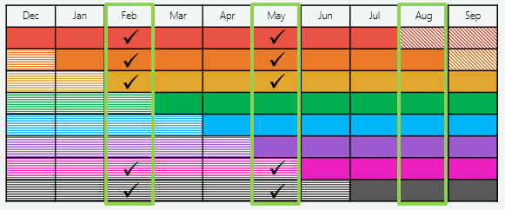
Key:
indicates a quarter month.
indicates the rotation groups in common between the LFS samples in February and May.
As outlined in Table A5, the calibration factors applied to the initial weights of the respondents in the common responding sample in q_{t} and q_{t+1} are such that the resulting longitudinal weights of these respondents sum up to the following three sets of population benchmarks in q_{t}:
- Set 1 – Region by sex by age group cross-classification (a total of 196 mutually exclusive population benchmarks)
- Set 2 – Sex by age group by labour force status cross-classification (a total of 42 mutually exclusive population benchmarks)
- Set 3 – Region by labour force status cross-classification (a total of 42 mutually exclusive population benchmarks)
The calibration method used was such that all three sets of benchmarks were met concurrently while minimising the overall weight changes applied to the initial weights of all in-scope respondents.
We also investigated whether any additional adjustment was required to counteract any non-response bias that may be present due to the approximately 14% of respondents in q_{t} who do not respond in q_{t+1}. Our conclusion from this investigation was that the calibration factors resulting from the population benchmarking process should be sufficient adjustments for minimising any non-response biases that may be present in the data.

A.4 Calculation of replicate longitudinal weights
In addition to the longitudinal weights, thirty sets of replicate longitudinal weights were calculated to estimate the uncertainty, or standard errors, of the estimates of the casual conversion rates and the casual transition rate via a replication method called the grouped jack-knife method of standard error estimation.
The idea behind this method is to obtain replicate estimates of the casual conversion rates and the casual transition rate, with each replicate based on a particular modification of the sample used to calculate these rates. The differences between the replicate estimates and the original estimates of the rates are then used in estimating the standard errors of the original estimates of the rates.
Initially, each respondent i in the common responding sample in q_{t} and q_{t+1} was assigned to a specific replicate group g, where g = 1, … , G (with G being the number of replicate groups, which in our case was 30). The replicate longitudinal weights for each respondent i and each replicate group g of the common responding sample in q_{t} and q_{t+1} were then calculated as follows (with term descriptions provided in Table A6):
Table A6: Descriptions of terms used in definition of replicate longitudinal weights.
Terms | Description
 | Replicate longitudinal weight for respondent i in the common responding sample in q_{t} and q_{t+1,} for replicate group g.
 | Replicate initial weight for respondent i in the common responding sample in q_{t} and q_{t+1}, for replicate group g (as detailed below).
 | Calibration factors that adjust the replicate initial weight of respondent i such that the replicate longitudinal weights of all respondents in the common responding sample in q_{t} and q_{t+1} and not in replicate group g sum up to the selected population benchmarks in q_{t} (as detailed above in Section A.3).

The replicate initial weights for each respondent i in the common responding sample in q_{t} and q_{t+1} and each replicate group g were defined as:
, for respondent i assigned to replicate group g,
, for respondent i not assigned to replicate group g.
As an example, the jack-knife variance estimator for an estimate of casual conversion rate A at quarter month q_{t+1} is
,
where is the replicate estimate of casual conversion rate A for replicate group g:
.
The square root of this variance is then taken to arrive at the requisite standard error estimate of the casual conversion rate A estimate at quarter month q_{t+1}. The jack-knife standard error estimates for estimates of casual conversion rate B and the casual transition rate were calculated in a similar manner.

APPENDIX B – MULTIVARIATE MODELLING DIAGNOSTICS AND ANALYTICAL RESULTS

B.1 Model fit statistics and diagnostics
As described in Section 6.1.3, the following four variants of the GLMM were fit to the in-scope LLFS data to determine whether the ‘After March 2021 indicator’ variable is statistically significant in the best fitting model and what the error structure is in the best fitting model:
- Explanatory variables listed in Table 7 and the ‘After March 2021 indicator’ variable included as fixed effects, and no random effect for the quarter month that a respondent was eligible for casual conversion.
- Explanatory variables listed in Table 7 and the ‘After March 2021 indicator’ variable included as fixed effects, and a random effect for the quarter month that a respondent was eligible for casual conversion.
- Explanatory variables listed in Table 7 included as fixed effects (excluding the ‘After March 2021 indicator’ variable), and no random effect for the quarter month that a respondent was eligible for casual conversion.
- Explanatory variables listed in Table 7 included as fixed effects (excluding the ‘After March 2021 indicator’ variable), and a random effect for the quarter month that a respondent was eligible for casual conversion.
Table B1 presents the model fit statistics for these four variants of the GLMM. A larger value for the -2 Log Likelihood model fit statistic indicates a better fitting model but for all of the other model fit statistics listed in Table B1, a smaller value indicates a better fitting model (because they all include a penalty for the number of parameters in the model).
Models B and D typically fit the data better than Models A and C, indicating that the inclusion of the random effect in the model for the quarter month that a respondent was eligible for casual conversion improves the model fit. On comparing the model fit statistics for Model B and D, where the only difference between these two models is the inclusion of the ‘After March 2021 indicator’ in Model B and the exclusion of it in Model D, Model D fits the data slightly better than Model B.
Table B1: Model fit statistics for the four GLMM variants.
Model fit statistics | Model A | Model B | Model C | Model D
-2 Log Likelihood | 12305.14 | 12295.57 | 12307.45 | 12296.22
AIC* | 12401.14 | 12393.57 | 12401.45 | 12392.22
AICc* | 12401.43 | 12393.88 | 12401.73 | 12392.51
BIC* | 12770.06 | 12417.33 | 12762.68 | 12415.49
HQIC* | 12523.12 | 12384.78 | 12520.89 | 12383.60
* AIC is the Akaike Information Criterion, AICc is the corrected AIC, BIC is the Bayesian Information Criterion and HQIC is the Hannah-Quinn Information Criterion.

Table B2 presents the p-values for the ‘After March 2021 indicator’ and the nine socio-economic and demographic factors found to be statistically significantly associated with conversion from casual to non-casual employment, for the four GLMM variants. Of particular interest are the p-values for the ‘After March 2021 indicator’ for Models A and B. While both of these p-values indicate that the ‘After March 2021 indicator’ is not statistically significantly associated with conversion from casual to non-casual employment in either model, the inclusion of the random effect in Model B for the quarter month that a respondent was eligible for casual conversion leads to an increased p-value for the ‘After March 2021 indicator’ compared to Model A. In conjunction with the model fit statistics in Table B1, this can be interpreted to mean that the random effect in Model B better accounts for some of the variability in the data that the ‘After March 2021 indicator’ attempts to explain in Model A.
Table B2: P-values for the ‘After March 2021 indicator’ and the nine socio-economic and demographic factors found to be statistically significantly associated with conversion from casual to non-casual employment, for the four GLMM variants.
Socio-economic and demographic factor | Model A | Model B | Model C | Model D
State or territory of usual residence | 0.0012 | 0.001 | 0.0012 | 0.001
Age | <.0001 | <.0001 | <.0001 | <.0001
Country of birth | 0.0004 | 0.0004 | 0.0004 | 0.0004
Whether children in the household (aged 0 to 14 years) | 0.0096 | 0.0107 | 0.0097 | 0.0107
Job tenure | <.0001 | <.0001 | <.0001 | <.0001
Full-time or part-time employment status | <.0001 | <.0001 | <.0001 | <.0001
Industry division | <.0001 | <.0001 | <.0001 | <.0001
Occupation main group | <.0001 | <.0001 | <.0001 | <.0001
Skill level of occupation | 0.0023 | 0.0025 | 0.0026 | 0.0027
After March 2021 indicator | 0.1287 | 0.4204 | - | -

A k-fold cross-validation technique was also employed to assist in determining the best model. Initially a 10-fold application was performed where the data for the models (approximately 16,100 eligible respondents) were split into ten randomly assigned parts (without replacement). Each of these ten parts were used to train the candidate models, to identify the set of variables which best explain eligible respondents’ conversion from casual to non-casual employment. However, the relatively small percentage of respondents that converted to non-casual employment (<20%) caused issues with the standard 10-fold approach. Instead, a 3-fold application was performed, where each of the three randomly assigned groups of data were used to train the candidate models, and the AIC and BIC model fit statistics were used to determine the model with the most explanatory set of variables for casual conversion.
The performance of the candidate models was tested using the AUC (area under the curve) and Somers’ Delta calculations. In simple terms, the AUC provides an indication of the predictive capability of a model, to predict whether a respondent did or did not convert from casual to non-casual employment. A value close to 1 indicates strong predictive power, meaning fewer false positives and false negatives. In general, most of the models achieved a similar AUC of approximately 0.6-0.7, which indicates a reasonable predictive power. However, closer inspection revealed that the AUC values were heavily influenced by the relatively large number of respondents who did not convert to non-casual employment.
An objective measure of this influence is provided by the Somers’ D statistic. A value close to -1 or 1 represents a strong correlation between the observed and model predicted conversions from casual to non-casual employment. The best model achieved a Somers’ D value of approximately 0.3, which indicates a relatively weak correlation.
The results for both the AUC and Somers’ D statistics indicate some gaps in the ability of the LLFS data to adequately explain eligible respondents’ conversion from casual to non-casual employment. The LLFS data possibly does not adequately identify eligibility and/or casual conversion, and does not include factors that affect an eligible respondent’s conversion from casual to non-casual employment.

B.2 Analytical results – Odds ratios
The odds ratios estimated from Model D represent the odds of an eligible respondent with a particular characteristic converting to non-casual employment compared to the odds of an eligible respondent with a different characteristic converting to non-casual employment. An odds ratio greater than 1 indicates a greater occurrence of conversion to non-casual employment while an odds ratio less than 1 indicates a lesser occurrence of conversion to non-casual employment.
For example, the estimated odds ratio from Model D for the comparison of the NT to the ACT is 1.59. This means that, according to Model D, eligible respondents living in the NT had a 59% greater chance of converting to non-casual employment than eligible respondents living in the ACT, all else being equal. Similarly, the estimated odds ratio of 0.72 from Model D for the comparison of TAS to the NT means that eligible respondents living in TAS had a 28% lesser chance of converting to non-casual employment than eligible respondents living in the NT, all else being equal.
Figures B1 to B7 and Tables B3 to B9 present the statistically significant odds ratios estimated from Model D, along with their 95% confidence intervals.

Figure B1: Statistically significant odds ratios for state or territory of usual residence, based on Model D.
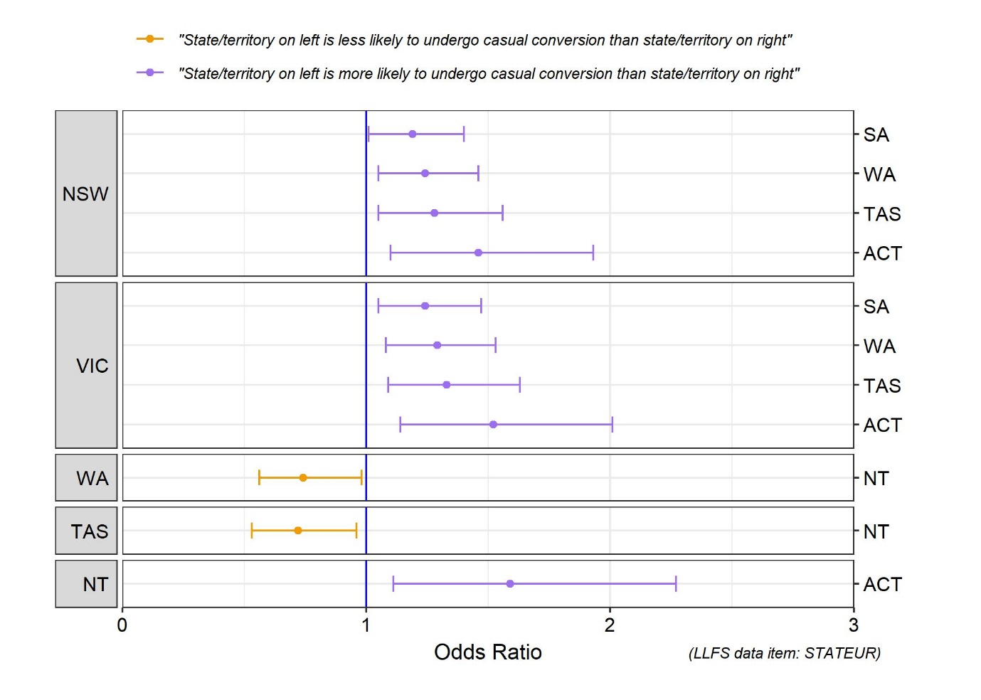
Table B3: Statistically significant odds ratios for state or territory of usual residence, based on Model D.
State/territory comparison |  | Odds ratio | Lower 95% CI | Higher 95% CI | P-value
NSW | SA | 1.19 | 1.01 | 1.40 | 0.033
NSW | WA | 1.24 | 1.05 | 1.46 | 0.012
NSW | TAS | 1.28 | 1.05 | 1.56 | 0.014
NSW | ACT | 1.46 | 1.10 | 1.93 | 0.008
VIC | SA | 1.24 | 1.05 | 1.47 | 0.012
VIC | WA | 1.29 | 1.08 | 1.53 | 0.004
VIC | TAS | 1.33 | 1.09 | 1.63 | 0.005
VIC | ACT | 1.52 | 1.14 | 2.01 | 0.004
WA | NT | 0.74 | 0.56 | 0.98 | 0.033
TAS | NT | 0.72 | 0.53 | 0.96 | 0.027
NT | ACT | 1.59 | 1.11 | 2.27 | 0.011

Figure B2: Statistically significant odds ratios for age, based on Model D.
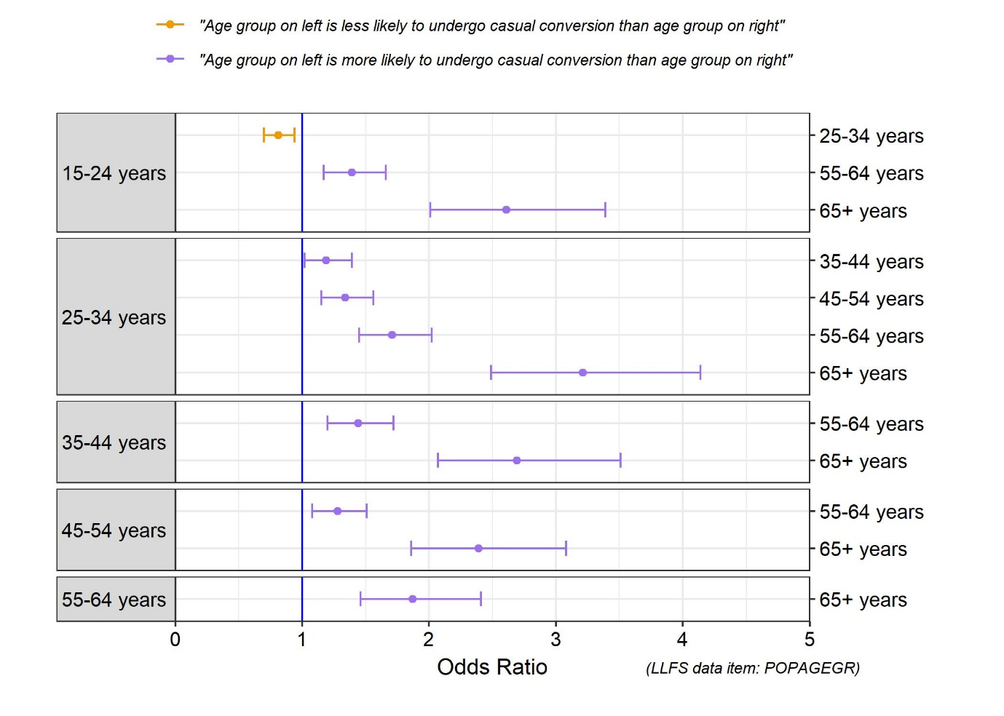
Table B4: Statistically significant odds ratios for age, based on Model D.
Age group comparison |  | Odds ratio | Lower 95% CI | Higher 95% CI | P-value
15-24 years | 25-34 years | 0.81 | 0.70 | 0.94 | 0.005
15-24 years | 55-64 years | 1.39 | 1.17 | 1.66 | 0.0002
15-24 years | 65+ years | 2.61 | 2.01 | 3.39 | <.0001
25-34 years | 35-44 years | 1.19 | 1.02 | 1.39 | 0.027
25-34 years | 45-54 years | 1.34 | 1.15 | 1.56 | 0.0002
25-34 years | 55-64 years | 1.71 | 1.45 | 2.02 | <.0001
25-34 years | 65+ years | 3.21 | 2.49 | 4.14 | <.0001
35-44 years | 55-64 years | 1.44 | 1.20 | 1.72 | <.0001
35-44 years | 65+ years | 2.69 | 2.07 | 3.51 | <.0001
45-54 years | 55-64 years | 1.28 | 1.08 | 1.51 | 0.005
45-54 years | 65+ years | 2.39 | 1.86 | 3.08 | <.0001
55-64 years | 65+ years | 1.87 | 1.46 | 2.41 | <.0001

Figure B3: Statistically significant odds ratios for country of birth, full/part-time employment status and number of children in household aged 0-14 years, based on Model D.
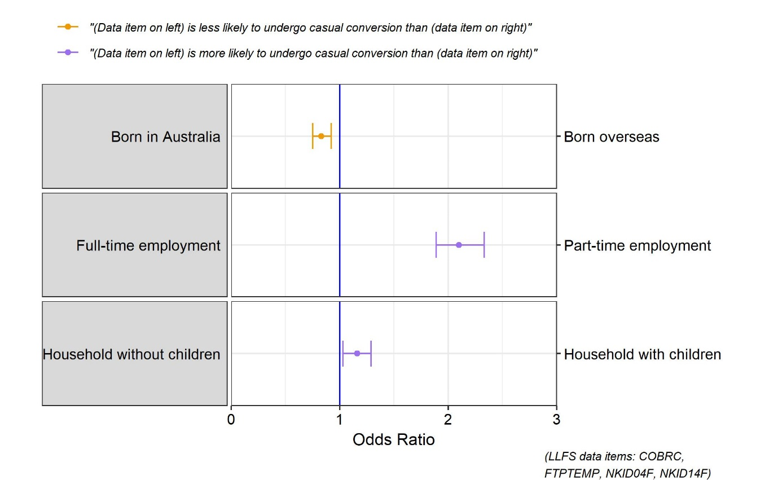

Table B5: Statistically significant odds ratios for country of birth, full/part-time employment status and number of children in household aged 0-14 years, based on Model D.
Comparison |  | Odds ratio | Lower 95% CI | Higher 95% CI | P-value
Born in Australia | Born overseas | 0.83 | 0.75 | 0.92 | 0.0004
Full-time employment | Part-time employment | 2.10 | 1.89 | 2.33 | <.0001
Household without children | Household with children | 1.16 | 1.03 | 1.29 | 0.011

Figure B4: Statistically significant odds ratios for industry divisions 1-6, based on Model D.
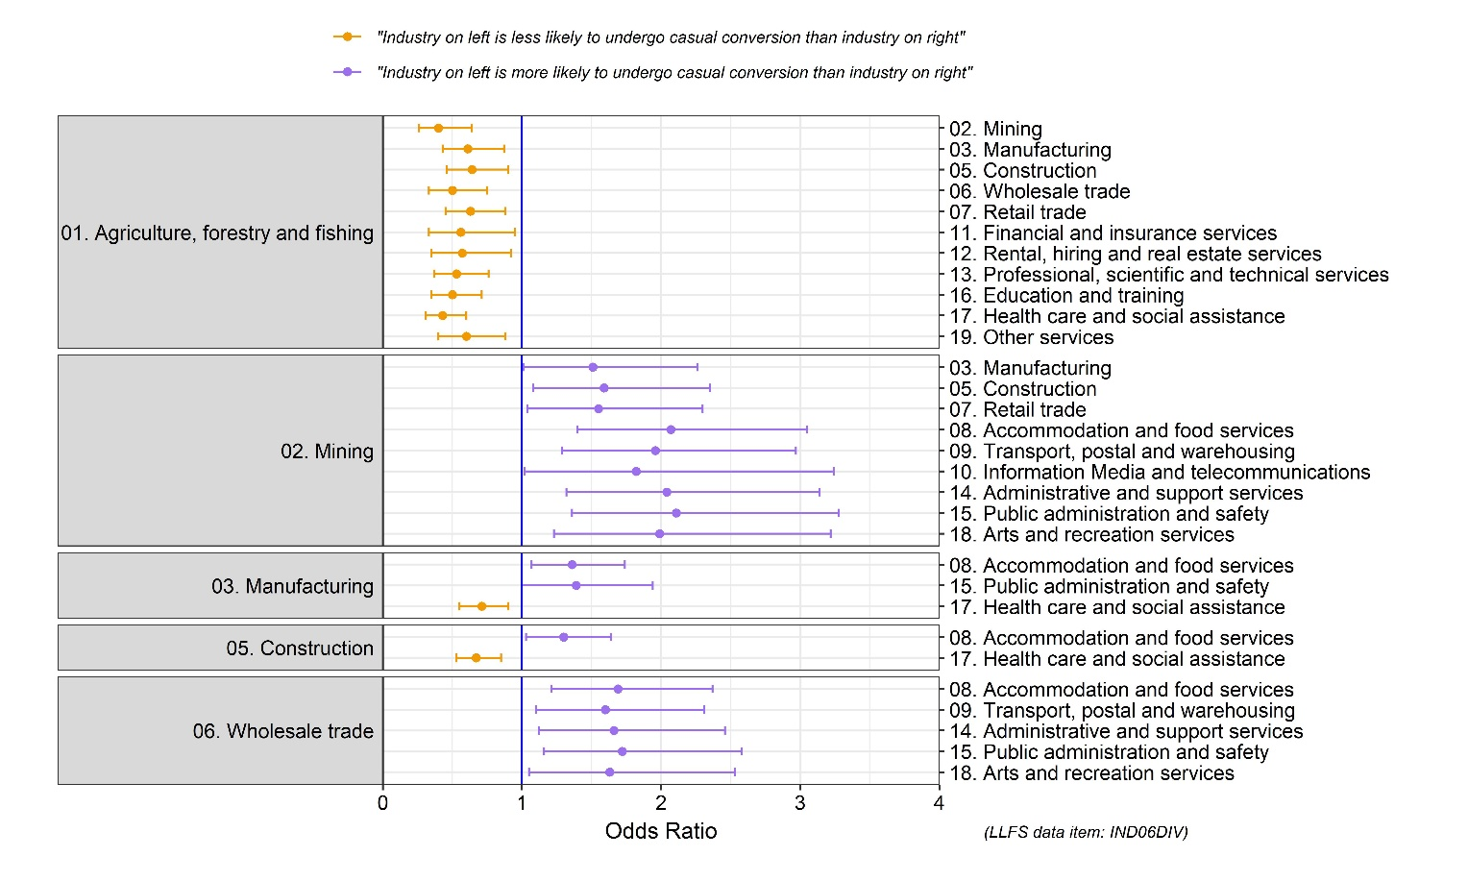
Figure B5: Statistically significant odds ratios for industry divisions 7-17, based on Model D.
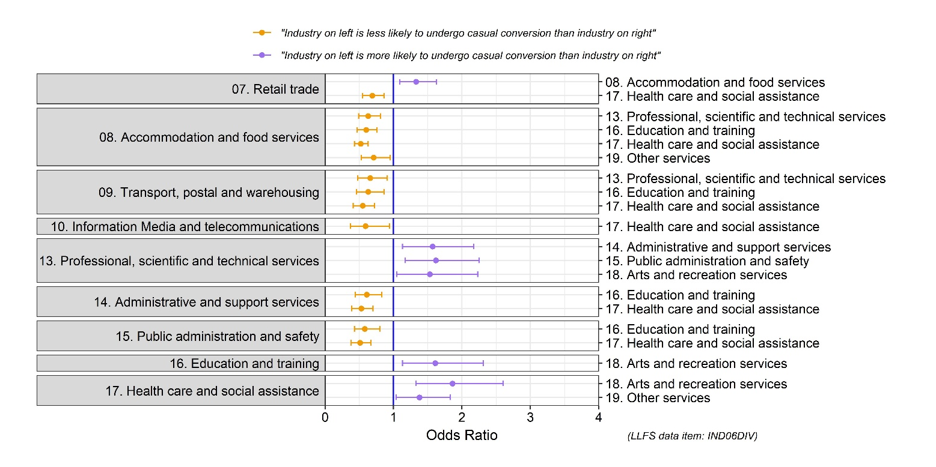

Table B6: Statistically significant odds ratios for industry divisions 1-6, based on Model D.
Industry comparison |  | Odds ratio | Lower 95% CI | Higher 95% CI | P-value
Agriculture | Mining | 0.40 | 0.26 | 0.64 | 0.0001
Agriculture | Manufacturing | 0.61 | 0.43 | 0.87 | 0.001
Agriculture | Construction | 0.64 | 0.46 | 0.90 | 0.011
Agriculture | Wholesale trade | 0.50 | 0.33 | 0.75 | 0.001
Agriculture | Retail trade | 0.63 | 0.45 | 0.88 | 0.007
Agriculture | Financial | 0.56 | 0.33 | 0.95 | 0.031
Agriculture | Rental & hiring | 0.57 | 0.35 | 0.92 | 0.022
Agriculture | Professional | 0.53 | 0.37 | 0.76 | 0.001
Agriculture | Education | 0.50 | 0.35 | 0.71 | 0.0001
Agriculture | Health care | 0.43 | 0.31 | 0.60 | <.0001
Agriculture | Other | 0.60 | 0.40 | 0.88 | 0.010
Mining | Manufacturing | 1.51 | 1.01 | 2.26 | 0.043
Mining | Construction | 1.59 | 1.08 | 2.35 | 0.020
Mining | Retail trade | 1.55 | 1.04 | 2.30 | 0.030
Mining | Accommodation | 2.07 | 1.40 | 3.05 | 0.0003
Mining | Transport | 1.96 | 1.29 | 2.97 | 0.002
Mining | Information | 1.82 | 1.02 | 3.24 | 0.043
Mining | Administrative | 2.04 | 1.32 | 3.14 | 0.001
Mining | Public | 2.11 | 1.36 | 3.28 | 0.001
Mining | Arts & recreation | 1.99 | 1.23 | 3.22 | 0.005
Manufacturing | Accommodation | 1.36 | 1.07 | 1.74 | 0.012
Manufacturing | Public | 1.39 | 1.00 | 1.94 | 0.048
Manufacturing | Health care | 0.71 | 0.55 | 0.90 | 0.005
Construction | Accommodation | 1.30 | 1.03 | 1.64 | 0.029
Construction | Health care | 0.67 | 0.53 | 0.85 | 0.001
Wholesale trade | Accommodation | 1.69 | 1.21 | 2.37 | 0.002
Wholesale trade | Transport | 1.60 | 1.10 | 2.31 | 0.013
Wholesale trade | Administrative | 1.66 | 1.12 | 2.46 | 0.011
Wholesale trade | Public | 1.72 | 1.16 | 2.58 | 0.008
Wholesale trade | Arts & recreation | 1.63 | 1.05 | 2.53 | 0.031

Table B7: Statistically significant odds ratios for industry divisions 7-17, based on Model D.
Industry comparison |  | Odds ratio | Lower 95% CI | Higher 95% CI | P-value
Retail trade | Accommodation | 1.33 | 1.09 | 1.63 | 0.005
Retail trade | Health care | 0.69 | 0.55 | 0.86 | 0.001
Accommodation | Professional | 0.63 | 0.49 | 0.81 | 0.0004
Accommodation | Education | 0.60 | 0.47 | 0.76 | <.0001
Accommodation | Health care | 0.52 | 0.43 | 0.63 | <.0001
Accommodation | Other | 0.71 | 0.53 | 0.95 | 0.022
Transport | Professional | 0.66 | 0.48 | 0.91 | 0.011
Transport | Education | 0.63 | 0.46 | 0.86 | 0.003
Transport | Health care | 0.55 | 0.41 | 0.72 | <.0001
Information | Health care | 0.59 | 0.37 | 0.94 | 0.027
Professional | Administrative | 1.57 | 1.13 | 2.17 | 0.007
Professional | Public | 1.62 | 1.17 | 2.25 | 0.003
Professional | Arts & recreation | 1.53 | 1.05 | 2.23 | 0.026
Administrative | Education | 0.61 | 0.44 | 0.83 | 0.002
Administrative | Health care | 0.53 | 0.39 | 0.70 | <.0001
Public | Education | 0.58 | 0.43 | 0.80 | 0.001
Public | Health care | 0.51 | 0.38 | 0.67 | <.0001
Education | Arts & recreation | 1.61 | 1.13 | 2.31 | 0.009
Health care | Arts & recreation | 1.86 | 1.33 | 2.60 | 0.0003
Health care | Other | 1.38 | 1.04 | 1.83 | 0.025
Figure B6: Statistically significant odds ratios for occupation major group, based on Model D.
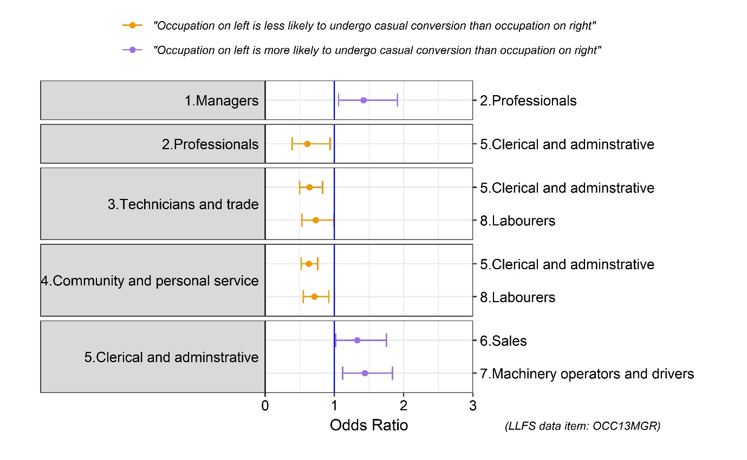
Table B8: Statistically significant odds ratios for occupation major group, based on Model D.
Occupation comparison |  | Odds ratio | Lower 95% CI | Higher 95% CI | P-value
Managers | Professionals | 1.42 | 1.06 | 1.91 | 0.020
Professionals | Clerical & admin. | 0.61 | 0.39 | 0.94 | 0.026
Technicians & trade | Clerical & admin. | 0.64 | 0.50 | 0.83 | 0.001
Technicians & trade | Labourers | 0.73 | 0.53 | 0.99 | 0.042
Community | Clerical & admin. | 0.63 | 0.52 | 0.76 | <.0001
Community | Labourers | 0.71 | 0.55 | 0.92 | 0.011
Clerical & admin. | Sales | 1.33 | 1.02 | 1.75 | 0.037
Clerical & admin. | Machinery | 1.44 | 1.12 | 1.84 | 0.004

Figure B7: Statistically significant odds ratios for skill level of occupation, based on Model D.
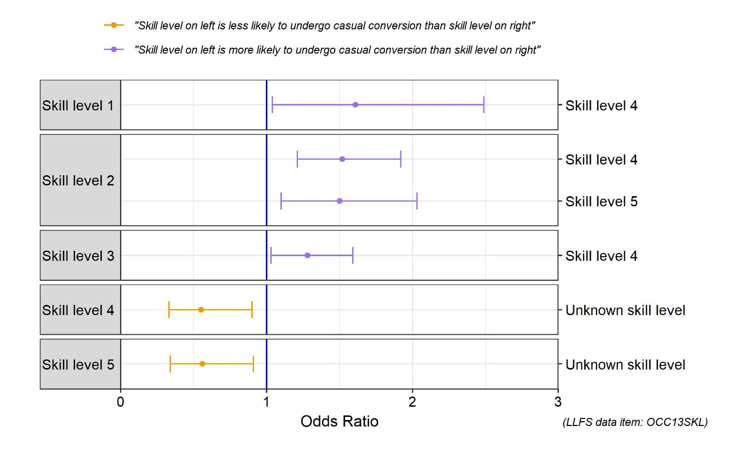
Table B9: Statistically significant odds ratios for skill level of occupation, based on Model D.
Skill level comparison |  | Odds ratio | Lower 95% CI | Higher 95% CI | P-value
Skill level 1 | Skill level 4 | 1.61 | 1.04 | 2.49 | 0.034
Skill level 2 | Skill level 4 | 1.52 | 1.21 | 1.92 | 0.0004
Skill level 2 | Skill level 5 | 1.50 | 1.10 | 2.03 | 0.010
Skill level 3 | Skill level 4 | 1.28 | 1.03 | 1.59 | 0.028
Skill level 4 | Unknown skill level | 0.55 | 0.33 | 0.90 | 0.017
Skill level 5 | Unknown skill level | 0.56 | 0.34 | 0.91 | 0.019

REFERENCES
[1] Fair Work Amendment (Supporting Australia’s Jobs and Economic Recovery) Act 2021 (legislation.gov.au)
[2] Becoming a permanent employee - Fair Work Ombudsman
[3] 1352.0.55.142 Research Paper: Modelling the Short-Term Dynamics of Unemployment Using the ABS Longitudinal Labour Force Survey File (Methodology Advisory Committee) (Sep 2014)
[4] Labour Force, Australia, May 2022 | Australian Bureau of Statistics (abs.gov.au)
[5] Microdata: Longitudinal Labour Force, Australia | Australian Bureau of Statistics (abs.gov.au)
[6] Chow, G.C. (1960), “Test of Equality between Sets of Coefficients in Two Linear Regressions”, Econometrica, 28, 591-605.
[7] Labour force survey sample design | Australian Bureau of Statistics (abs.gov.au)
[8] SAS/STAT GLIMMIX Procedure

A single job holder respondent is considered to not have coherent reported values of TENUREYR in consecutive quarter months if, for example, they have a reported TENUREYR value of 3 years in August 2019 and a reported TENUREYR value of 2 years in November 2019.
A single job holder respondent who has a reported TENUREYR value of at least 3 months is considered to not have a coherent reported value of RTRNCH3M if their answer is anything other than ‘No jobs left or lost in last 3 months’ (that is, they report having lost or left a job in the last 3 months).
For a multiple job holder, ‘main job’ is defined to be the job in which the respondent works the most hours in the LFS reference week of the month. For a single job holder, ‘main job’ is the respondent’s only job.
Rather than the expected 3 month difference in job tenure values, we allow for a difference of at most 1 year between a respondent’s q_{t} and q_{t+1} TENUREYR values due to the granularity of the data item TENUREYR. For job tenures of less than 12 months, TENUREYR has a monthly granularity (for example, an increase in job tenure from 6 months to 9 months is represented as a change from 0.5 to 0.75 years). For job tenures of more than 12 months, TENUREYR only has a yearly granularity, meaning tenures of 13 and 15 months are both represented by the value 1 year.
Three out of the eight rotation groups in q_{t} rotate out of the LFS by q_{t+1}, meaning five out of the eight rotation groups in in q_{t} remain in the LFS in q_{t+1}.
The longitudinal weights can be interpreted to be the number of people each contributing respondent represents in the Australian population aged 15 years and over in q_{t}.
The method for creating the confidence bands can be interpreted as producing a range within which the true casual conversion metric being estimated would fall 19 out of 20 times (that is, 95% of the time) if 20 different randomly selected LFS samples had been taken and the corresponding 20 confidence bands had been produced. It should be noted that the estimates and standard errors (and hence the confidence bands) would change each time a different LFS sample was taken, while the true values of the casual conversion metrics being estimated remain unchanged.
However, because these two rates have both conceptually different denominators and conceptually different numerators which reflect different segments of the population, it is possible for estimates of casual conversion rate A to reflect a large increase in casual conversion while the estimates of the casual transition rate over the same period can decrease sharply. This is what happens in the three months to November 2020 and results in the estimated casual transition rate falling below the casual conversion rate A estimate.
In this case, the statistical test is an F-test that determines whether the model parameter estimates for the model prior to the break point are statistically significantly different to the model parameter estimates for the model after the break point.
Casual conversion rate A was chosen over casual conversion rate B as it deems more respondents as eligible for casual conversion, including all the respondents deemed to be eligible for casual conversion as per the data scoping rules for casual conversion rate B.
The GLMM models were fit using the PROC GLIMMIX procedure in SAS [8].
Each state was split into two regions, the capital city and the balance of state, while the two territories (the NT and ACT) remained undivided.
Age groups were defined as 15-19 years, 20-24 years, 25-34 years, 35-44 years, 45-54 years, 55-64 years, 65+ years
In our analysis period of February 2018 to May 2022, the average non-response rate between consecutive quarters was approximately 14%.
LFS replicate weights are available in the LLFS data for each month of the LFS and were used to calculate the standard errors of the estimates of the proportion of the workforce casually employed in each quarter month. The LFS replicate weights are derived in a similar manner to how the replicate longitudinal weights were calculated via the grouped jack-knife method of standard error estimation.
If the confidence interval of an odds ratio includes 1, then this can be interpreted to mean that there is no statistically significant difference in the probability of the comparator characteristic converting from casual to non-casual employment compared to the baseline characteristic.

