Dept Employment_Inline (2)

Labour Market Conditions in the South Eastern Melbourne Priority Employment Area (PEA)

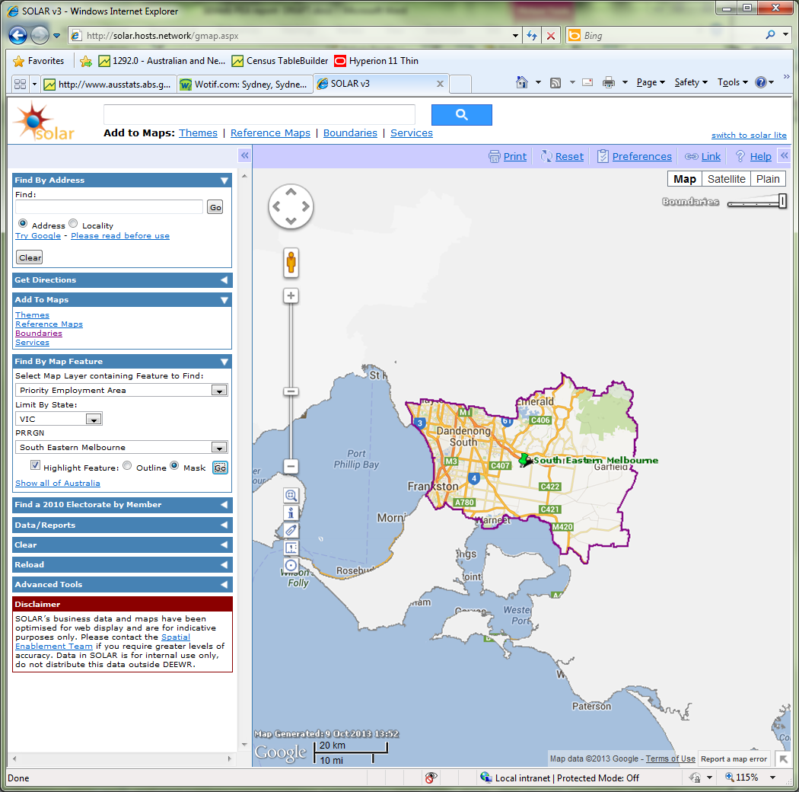Overall, labour market conditions in the South Eastern Melbourne PEA are subdued, with softening recruitment activity over the past two years.

**South Eastern Melbourne PEA**

* The unemployment rate is 7.0 per cent and has gradually increased since June 2011 (5.9 per cent).[[1]](#footnote-1)
* The working age participation rate (72.8 per cent)[[2]](#footnote-2) is below the national rate (76.5 per cent).[[3]](#footnote-3)
* While full time employment increased by 2,900 in the year to October 2013, it was largely offset by a loss of 2,400 part time jobs.[[4]](#footnote-4)
* At the time of the 2011 Census, the Other than Main English Speaking Country (OTMESC) unemployment rate (7.8 per cent) was considerably higher than the unemployment rate for people born in Main English Speaking Countries (MESC) (5.3 per cent).[[5]](#footnote-5)

|  |  |  |  |  |  |
| --- | --- | --- | --- | --- | --- |
| Region | Employment Growth  (past year)\* | Unemployment Rate | | Participation Rate\* | OTMESC\* |
| South Eastern Melbourne PEA | 0%[[6]](#footnote-6) | 7.0% | | 72.8% | 31%[[7]](#footnote-7) |
| Australia | 1% | 5.8%[[8]](#footnote-8) | | 76.5% | 19% |
| \*working age population (15-64 years old) | | |

# What employers are telling us[[9]](#footnote-9)

* Recruitment activity was relatively soft with 50 per cent of surveyed employers recruiting in the past year. This was considerably lower than the previous survey in 2012 (60 per cent).
* Recruitment activity varied considerably across industries with only 38 per cent of employers in the Construction industry recruiting, compared with 73 per cent in the Accommodation and Food Services industry[[10]](#footnote-10) and 68 per cent in the Health Care and Social Assistance industry.
* Competition for vacancies was high with an average of 13.5 applicants per vacancy, of whom 1.5 were considered suitable.
* Some 78 per cent of job applicants were not interviewed, due mainly to a lack of relevant experience (61 per cent) and insufficient qualifications or training (24 per cent).
* Despite the high average number of applicants, 4.5 per cent of vacancies remained unfilled.
* Some 31 per cent of employers expected to recruit in the year following the survey, compared with 42 per cent across all regions.

# Where are the opportunities?

Recruitment activity in the Accommodation and Food Services industry was high, with employers expecting to recruit for occupations such as Waiters and Cooks. Employers also expect to recruit for a range of other occupations in the next 12 months, including Sales Assistants, General Clerks, Sales Representatives, Child Carers and Registered Nurses.

1. Department of Employment, Small Area Labour Markets, September 2013. [↑](#footnote-ref-1)
2. Participation rate is for the South Eastern Melbourne Labour Force Region. [↑](#footnote-ref-2)
3. ABS, Labour Force, October 2013, 12 month averages of original data. [↑](#footnote-ref-3)
4. ABS, Labour Force, October 2013, 12 month averages of original data. [↑](#footnote-ref-4)
5. ABS, Census of Population and Housing, 2011. [↑](#footnote-ref-5)
6. Employment growth is for the South Eastern Melbourne Labour Force Region. [↑](#footnote-ref-6)
7. OTMESC countries are countries other than the United Kingdom, Ireland, Canada, South Africa, USA, New Zealand and Australia. [↑](#footnote-ref-7)
8. ABS, Labour Force, November 2013 (seasonally adjusted). [↑](#footnote-ref-8)
9. Based on a Survey of Employers’ Recruitment Experiences of employers undertaken by the Department of Employment in Aug 2013, Apr 2012 and Feb 2010. [↑](#footnote-ref-9)
10. Recruitment activity in the Accommodation and Food Services industry was almost entirely due to staff turnover. [↑](#footnote-ref-10)