Dept Employment_Inline (2)Labour Market Conditions in Capricornia

Labour market conditions in the Capricornia Employment Service Area (ESA) have softened since the region was previously surveyed in 2012.

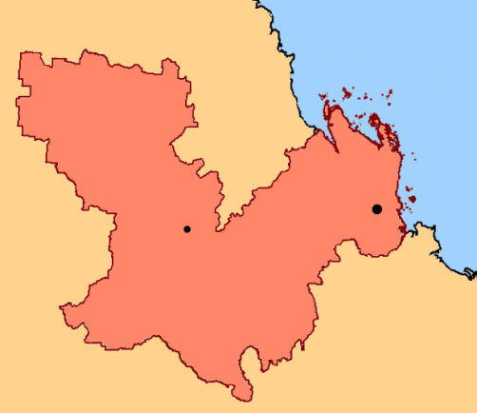

**Rockhampton**

Emerald

***Queensland***

* The unemployment rate has increased by 2.0 percentage points over the year to stand at 6.8 per cent in the September quarter 2013.[[1]](#footnote-1)
* The annual rate of employment growth in the broader region has slowed to 1.2 per cent in October 2013, compared with 6.1 per cent in September 2011.[[2]](#footnote-2)

At the time of the 2011 Census, almost one in four employed persons were in the Mining and Health Care and Social Assistance industries.

# Feedback from employers in Capricornia[[3]](#footnote-3)

* The proportion of businesses that decreased staff numbers due to decreasing demand/the economy has more than doubled from 9 per cent in 2012 to 24 per cent in 2013.
* Recruitment activity in the Capricornia ESA has softened notably since the region was last surveyed, with the average number of vacancies per 100 staff falling from 32 in 2012 to 22 in 2013, although this is still at a level higher than the average of all regions surveyed.
* Overall, businesses were able to fill most vacancies, with just 4.1 per cent of vacancies remaining unfilled.
  + However, 13.5 per cent of vacancies for Technicians and Trades Workers remained unfilled.
* Just over half (52 per cent) of employers reported that their single greatest future concern was demand for their products/services or the economy, suggesting that recruitment is likely to remain relatively subdued in the short term.

|  |  |  |  |
| --- | --- | --- | --- |
|  | Capricornia ESA 2013 | Capricornia ESA 2012 | All regions surveyed(d) |
| Average annual vacancies per 100 staff(a) | 22 | 32 | 16 |
| Unfilled vacancies(b) | 4.1% | 12.7% | 3.9% |
| Applicants per vacancy(b) | 11.1 | 5.4 | 11.4 |
| Expect to increase staff numbers(c) | 20% | 33% | 18% |
| 1. Based on the 12 months preceding the survey. 2. Based on employers’ most recent recruitment round. 3. In the 12 months following the survey. 4. Department of Employment, *Survey of Employers’ Recruitment Experiences, All regions surveyed in the six months to August 2013.* | | | |

# Where are the opportunities?

* The Health Care and Social Assistance industry has shown strong growth over the last few years. While recruitment in Mining has recently tapered off somewhat, job opportunities still exist.
* Employers continue to experience significant difficulties filling vacancies for some Technicians and Trades Worker occupations, such as Chefs and Motor Mechanics.
* Employers expected to recruit for a number of lower skilled or entry level occupations in the 12 months following the survey, including Sales Assistants, Bar Attendants and Baristas, Waiters, Kitchenhands and Checkout Operators and Office Cashiers.

1. Department of Employment, *Small Area Labour Markets,* September quarter 2013. [↑](#footnote-ref-1)
2. ABS, Labour Force, Australia, Detailed – Electronic Delivery, October 2013 (cat. no. 6291.0.55.001), 12-month average for the Mackay-Fitzroy-Central West Labour Force Region. [↑](#footnote-ref-2)
3. Based on a *Survey of Employers’ Recruitment Experiences* undertaken by the Department of Employment in July 2013. The region was previously surveyed in February 2012. [↑](#footnote-ref-3)