Shepparton Region

# Slide 1

|  |
| --- |
| Shepparton Region  9 April 2014  Presenter: Ivan Neville  Branch Manager  Labour Market Research and Analysis Branch |

# Slide 2

## Shepparton Region

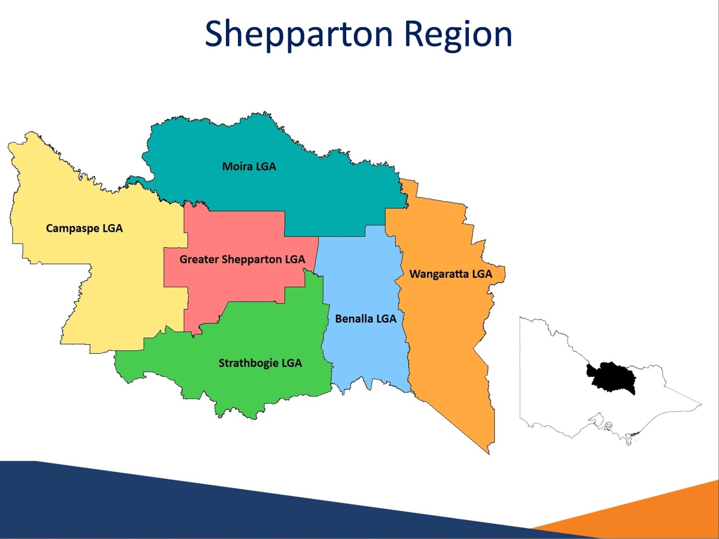

### The Shepparton Region

The Shepparton region and surrounding area is comprised of six LGAs:

Benalla

Campaspe

Greater Shepparton

Moira

Strathbogie

Wangaratta

The Shepparton Region accounts for 97 per cent of the Shepparton SA4 and 63 per cent of the Hume SA4

This region is part of the broader North Eastern Victoria Priority Employment Area (PEA). The Shepparton Region accounts for 57 per cent of the Goulburn-Ovens-Murray LFR working age population (ABS, *Estimated Residential Population, 2011)*.

# Slide 3

## Population Profile

| Region | Adult  Population(15 years+) | Adult  Population  Growth (2007 to 2012) | Median Age |
| --- | --- | --- | --- |
| Greater Shepparton LGA | 49,300 | 6% | 38 |
| Benalla LGA | 11,400 | 2% | 46 |
| Campaspe LGA | 29,700 | 2% | 42 |
| Moira LGA | 23,200 | 5% | 44 |
| Strathbogie LGA | 8,100 | 2% | 50 |
| Wangaratta LGA | 22,200 | 3% | 43 |
| Shepparton Region | 144,000 | 4% | 42 |
| Victoria | 4,599,100 | 10% | 37 |
| Australia | 18,419,600 | 10% | 37 |

### Population Profile

*Source: ABS, Estimated Resident Population ABS, Census of Population and Housing, 2011*

In June 2012, the adult population (aged 15 and over) in the Shepparton Region was 144,000.

The Shepparton Region experienced much slower population growth (4 per cent) in the 5 years to 2012 compared with the growth for Victoria and Australia (both 10 per cent).

The Greater Shepparton LGA experienced the highest growth across the region (6 per cent).

At the time of the 2011 Census, the median age in the Shepparton Region (42 years) was higher than the median age for Victoria and Australia (both 37 years).

# Slide 4

## Age Distribution

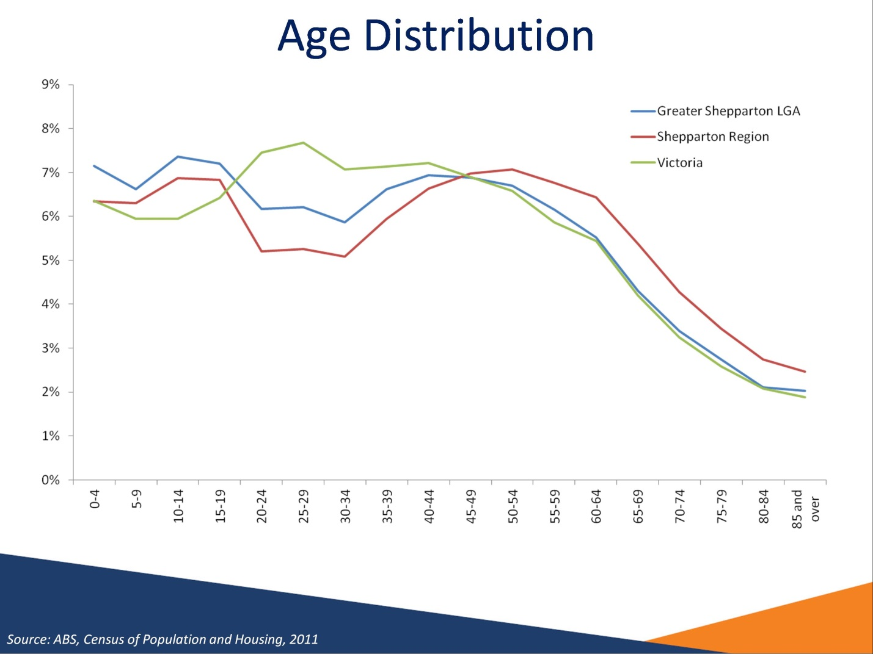

### Age Distribution

*Source: ABS, Census of Population and Housing, 2011*

This graph compares the age distributions of the Greater Shepparton LGA and the Shepparton Region with the age distribution of Victoria.

The age distribution of the Shepparton Region shows that a markedly smaller proportion of the population is made up of people aged between 20 and 44 years, when compared with the Victorian age distribution.

Similar demographic patterns exist for other regional areas and are due in part to young adults moving to major urban centres.

# Slide 5

## Recent decrease in unemployment…

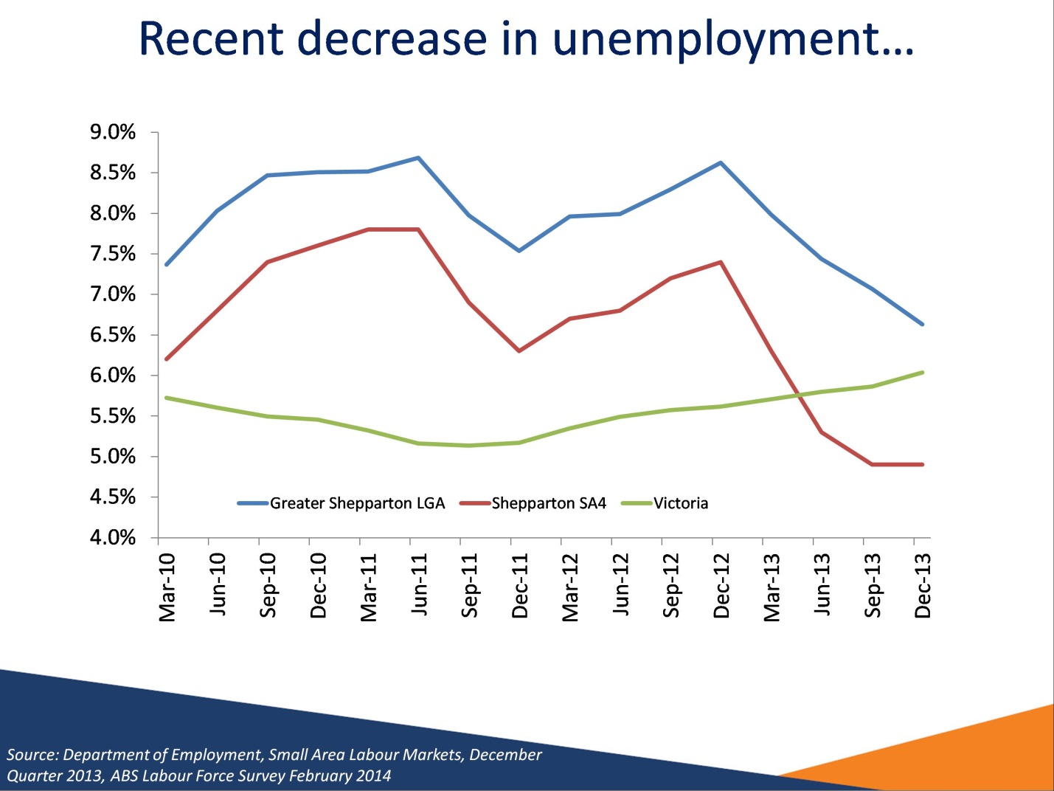

### Recent decrease in unemployment…

*Source:* *Department of Employment, Small Area Labour Markets, December Quarter 2013, ABS Labour Force Survey February 2014*

The unemployment rate for the Greater Shepparton LGA has remained consistently above the state and national unemployment rates since March 2010. However, the unemployment rate in the Shepparton SA4 has recently fallen below the state unemployment rate.

# Slide 6

## … But participation rate low and decreasing…

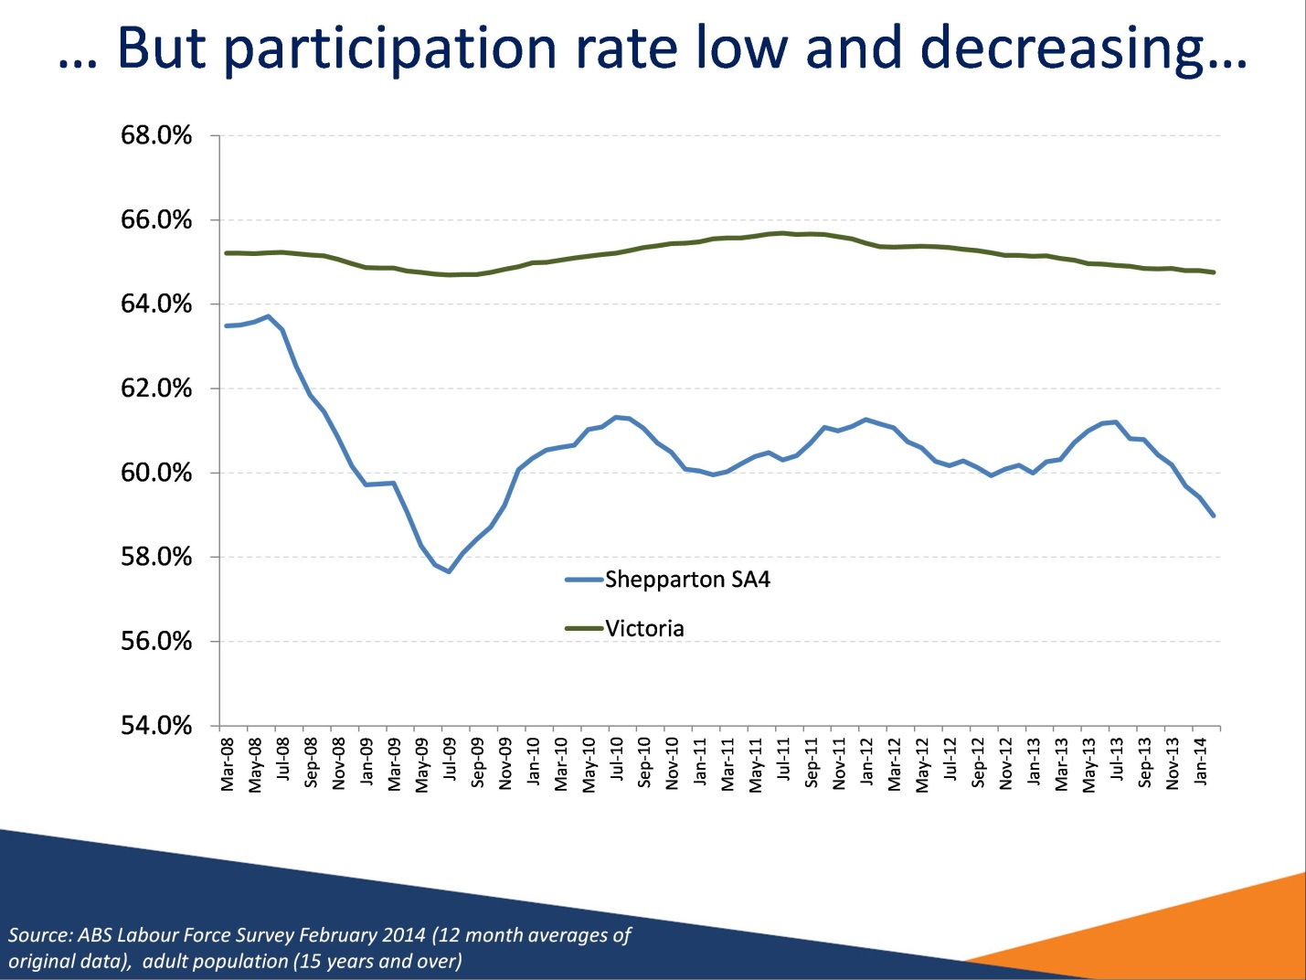

### … But participation rate low and decreasing…

*Source:* *ABS Labour Force Survey, February 2014 (12 month averages of original data), adult population (15 years and over)*

The adult population participation rate for the Shepparton SA4 (97 per cent of which is included in the Shepparton Region) has consistently remained below the Victorian participation rate, and recently decreased below 60 per cent.

# Slide 7

## … And full-time employment also decreasing

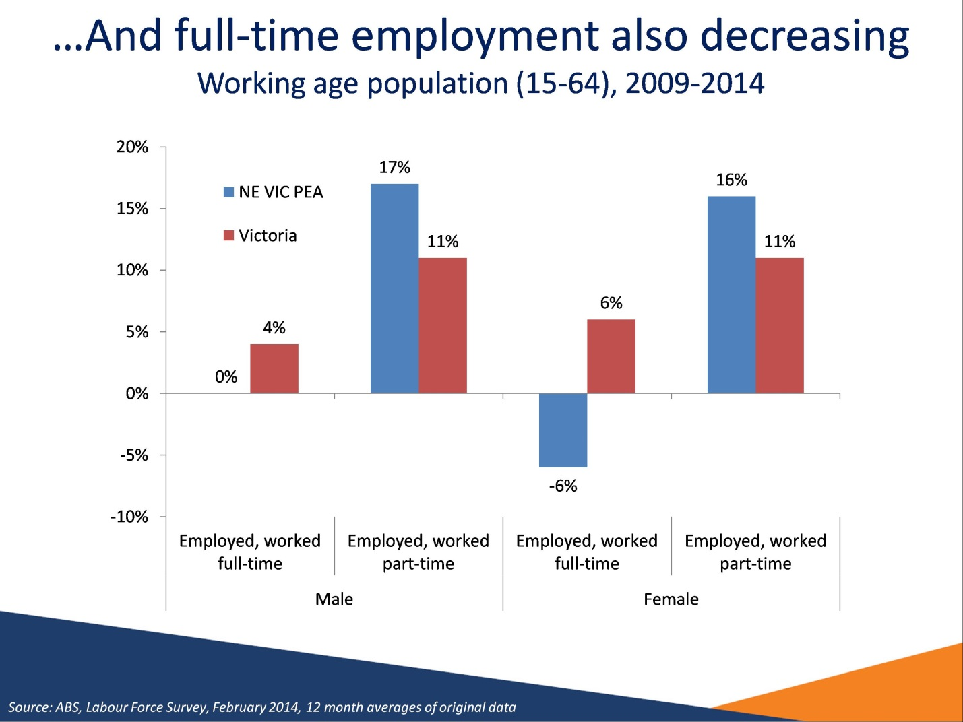

### … And full-time employment also decreasing

*Source:* *ABS Labour Force Survey, February 2014 (12 month averages of original data)*

*The NE Victoria PEA in this slide is represented by the combined Hume, Murray and Shepparton SA4s. The NE Victoria PEA accounts for 73 per cent of the population of these combined SA4s.*

While there has been employment growth in the PEA over the past 5 years, this has been entirely due to growth in part-time employment, with full-time employment decreasing.

# Slide 8

## Who is Unemployed?

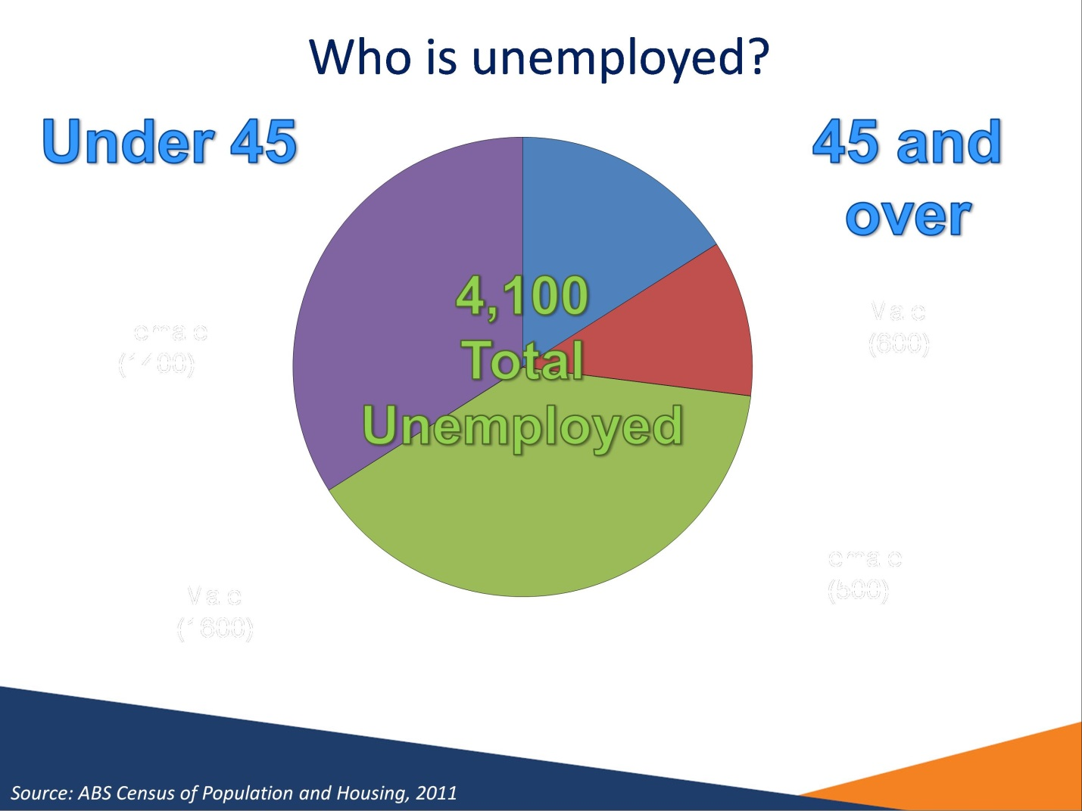

### Who is Unemployed?

*Source: ABS Census of Population and Housing, 2011*

73 per cent of unemployed people in the Shepparton Region were aged under 45 years

1,600 (39 per cent) were male and 1,400 (34 per cent) were female.

27 per cent of unemployed people in the Shepparton Region were aged 45 years and over.

600 (16 per cent) were male and 500 (11 per cent) were female.

# Slide 9

## Higher proportion of people are long-term unemployed

|  |  |  |  |
| --- | --- | --- | --- |
| Region | Long-term unemployed (52 weeks or more)- Persons | Long-term unemployed (52 weeks or more)- Percentage of all unemployed | Average duration of unemployment |
| Shepparton SA4 | 900 | 27% | 33 weeks |
| Hume SA4 | 1,000 | 24% | 35 weeks |
| Victoria | 32,200 | 18% | 34 weeks |
| Australia | 137,600 | 20% | 37 weeks |

### Higher proportion of people are long-term unemployed

*Source: ABS, Labour Force Survey, February 2014, 12 month averages of original data*

Long-term unemployed are those who have been unemployed for 52 weeks or more.

The proportion of unemployed persons who were long-term unemployed in the Shepparton SA4 (27 per cent) was higher compared with the Victorian (18 per cent) and national rates (20 per cent).

The average duration of unemployment in the Shepparton SA4 (33 weeks) and the Hume SA4 (35 weeks) was similar to Victoria (34 weeks).

# Slide 10

## Higher rates of income support

| Region | Proportion of the WAP receiving a benefit | Proportion of the WAP receiving an unemployment benefit |
| --- | --- | --- |
| Greater Shepparton LGA | 25% | 8% |
| Benalla LGA | 23% | 7% |
| Campaspe LGA | 21% | 6% |
| Moira LGA | 22% | 7% |
| Strathbogie LGA | 19% | 6% |
| Wangaratta LGA | 19% | 6% |
| Shepparton Region | 22% | 7% |
| Victoria | 16% | 5% |
| Australia | 16% | 5% |

### Higher rates of income support

*Source: Department of Employment, administrative data, December 2013; ABS, Estimated Resident Population, 2012*

In December 2013, 22 per cent of the working age population in the Shepparton Region were in receipt of income support. This was larger when compared with state and national levels (both 16 per cent).

Some 7 per cent of the Shepparton Region working age population were in receipt of an unemployment benefit, slightly above both state and national levels (both 5 per cent).

The Greater Shepparton LGA reported the highest proportion of the working age population on unemployment benefits (8 per cent).

Some 8.1 per cent of the working age population in the Shepparton Region were on Disability Support Pension (DSP). This was higher compared with Victoria (5.2 per cent) and Australia (5.3 per cent).

# Slide 11

## Many children growing up in families with no working parent

| Region | Number of children in jobless families* | Number of jobless families | Proportion of all families that are jobless |
| --- | --- | --- | --- |
| Greater Shepparton LGA | 3,010 | 1,230 | 20% |
| Benalla LGA | 560 | 240 | 21% |
| Moira LGA | 960 | 430 | 17% |
| Strathbogie LGA | 240 | 120 | 17% |
| Wangaratta LGA | 770 | 340 | 14% |
| Shepparton Region | 6,650 | 2,900 | 17% |
| Victoria | 145,050 | 66,720 | 13% |

### Many children growing up in families with no working parent

*Source: ABS, Census of Population and Housing, 2011*

*Note: as Census 2011 includes families with six children or more under the one classification, the numbers of children in the above slide are a minimum as an exact number is not available.*

Jobless families are families (with children under 15 years of age) where no parent is employed.

Some 17 per cent of families in the Shepparton Region did not have an employed parent, a figure larger than the figures for Victoria (13 per cent) and Australia (14 per cent).

Some 21 per cent of families with children in the Benalla LGA and 20 per cent in the Greater Shepparton LGA were jobless. On the other hand, 14 per cent of families with children in the Wangaratta LGA were jobless.

At least 6,650 children in the Shepparton Region were in a family where no parent was employed.

# Slide 12

## Is youth unemployment in Shepparton really 6.8%?

| Region | Youth unemployment rate(15-24 years) | | Participation rate(February 2014) |
| --- | --- | --- | --- |
| February 2014 | February 2013 |
| Shepparton SA4 | 6.8% | 12.4% | 72.7% |
| Hume SA4 | 15.6% | 15.5% | 68.5% |
| Victoria | 12.4% | 13.0% | 65.6% |
| Australia | 12.3% | 11.8% | 66.7% |

### Is youth unemployment in Shepparton really 6.8%?

*Source: ABS, Labour Force Survey, February 2014, 12 month averages of original data*

Youth unemployment in Shepparton is relatively low compared to Victoria at 6.8 per cent. This is also much lower compared to the same time last year when youth unemployment was 12.4 percent.

# Slide 13

## Youth unemployment rate volatile

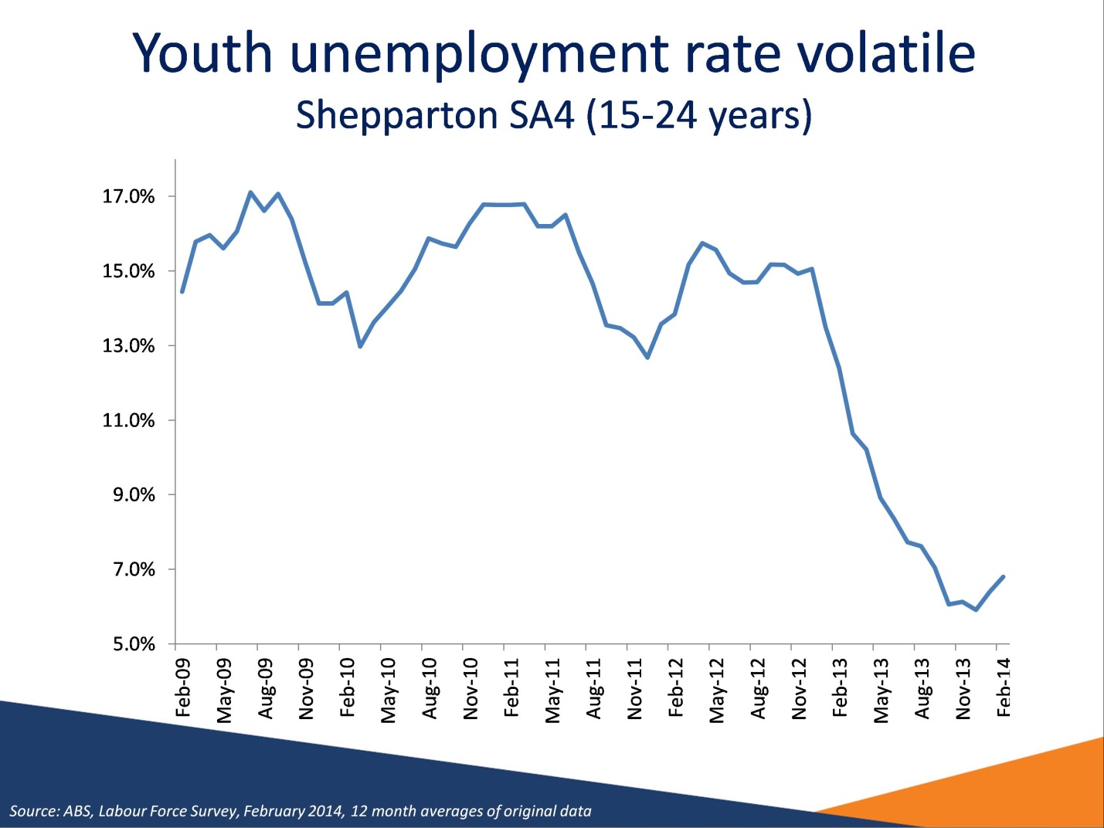

### Youth unemployment rate volatile

*Source: ABS, Labour Force Survey, February 2014, 12 month averages of original data*

This graph shows that the youth unemployment rate in the Shepparton region is quite volatile. In the last 12 months youth unemployment has dropped dramatically from 12.4 per cent to 6.8 percent.

# Slide 14

## What are the youth doing?

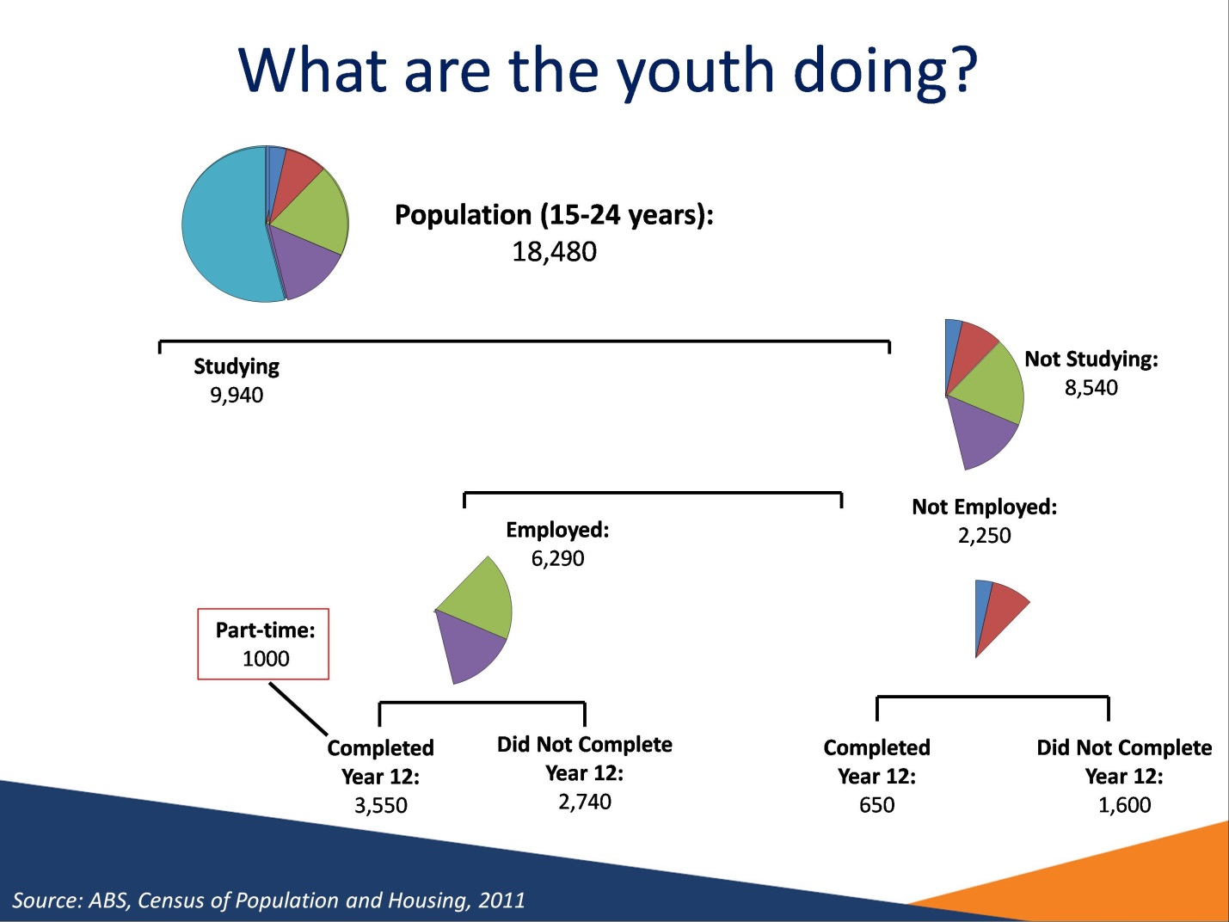

### What are the youth doing?

*Source: ABS, Census of Population and Housing, 2011*

At the time of the census, there were 18,480 15-24 years old in the Shepparton Region, of whom 8,540 (46 per cent) were not studying.

Of the 8,540 who were not studying, those who did not complete year 12, whether they are employed are not employed, are vulnerable and may have difficulty entering the labour market.

Some 2,250 (12 per cent) 15-24 year olds in the Shepparton Region were neither studying nor employed, higher compared with Victoria (9 per cent).

Note**:** Not stated records for FT/PT Student Status, Labour Force Status and Highest Year of School Completed have not been included.

# Slide 15

## High levels of disengagement among young adults

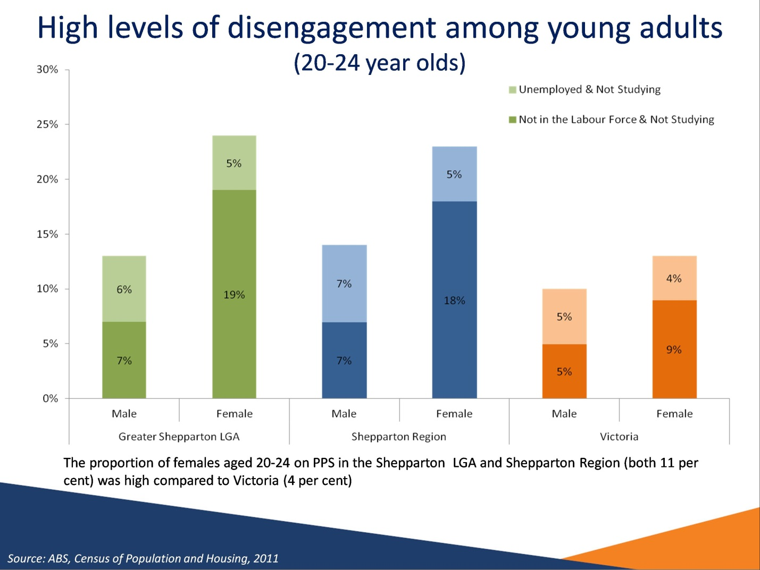

### High levels of disengagement among young adults

*Source: ABS, Census of Population and Housing, 2011*

At the time of the 2011 Census, 19 per cent of young adults (persons aged 20 to 24 years) in the Shepparton Region were neither working or studying. This figure was notably higher when compared with Victoria (11 per cent).

For young adult males in the Shepparton Region, 7 per cent were not in the labour force and not studying and a further 7 per cent were unemployed and not studying.

For young adult females in the Shepparton Region, 18 per cent were not in the labour force and not studying and a further 5 per cent were unemployed and not studying.

# Slide 16

## Lower Educational Attainment – persons aged 25-34 years

| Region | Completed Yr 12 | Attained Advanced Diploma, Diploma or Certificate III & IV Level | Attained Bachelor Degree or Higher |
| --- | --- | --- | --- |
| Greater Shepparton LGA | 62% | 33% | 22% |
| Benalla LGA | 57% | 40% | 17% |
| Campaspe LGA | 58% | 37% | 19% |
| Moira LGA | 56% | 39% | 15% |
| Strathbogie LGA | 62% | 39% | 20% |
| Wangaratta LGA | 63% | 40% | 22% |
| Shepparton Region | 60% | 37% | 20% |
| Victoria | 79% | 29% | 40% |

### Lower Educational Attainment – persons aged 25-34 years

*Source: ABS, Census of Population and Housing, 2011*

At the time of the 2011 Census, the proportion of 25 to 34 year olds in the Shepparton Region who had completed Year 12 or equivalent was 60 per cent. This was considerably lower than for Victoria (79 per cent). The lowest levels of Year 12 attainment were in the Moira LGA (56 per cent) and the Benalla LGA (57 per cent). The Wangaratta LGA had the highest level of Year 12 attainment in the Shepparton Region (63 per cent).

Job seekers who have not completed Year 12 and have limited experience in the workforce are likely to lack many basic employability skills that employers value and look for in applicants, particularly for lower skilled vacancies and entry level positions such as apprenticeships and traineeships.

At the time of the 2011 Census, the proportion of 25 to 34 year olds who had attained an Advanced Diploma, Diploma or Certificate level III or IV in the Shepparton Region (37 per cent) was larger than the state average (29 per cent) while the proportion who had attained a Bachelor Degree or higher (20 per cent) was far lower than the state average (40 per cent).

# Slide 17

## Educational Attainment and Labour Market Outcomes

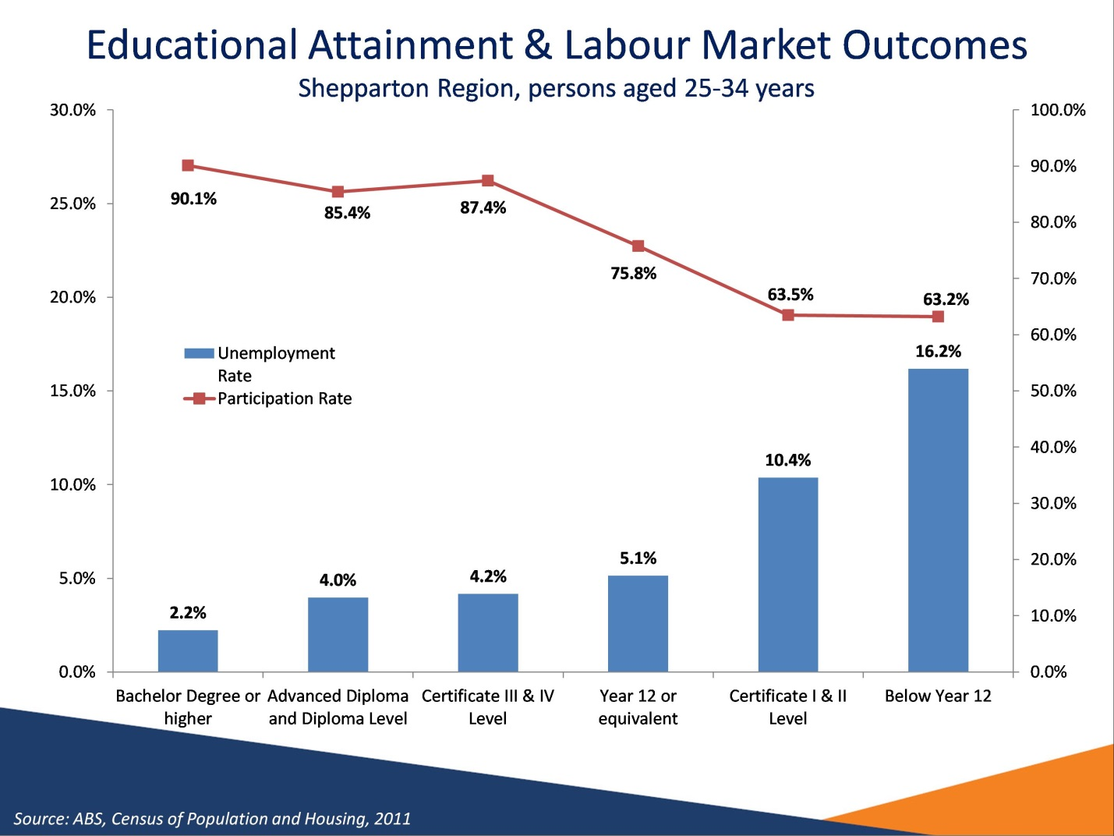

### Educational Attainment and Labour Market Outcomes

*Source: ABS, Census of Population and Housing, 2011*

There is a strong relationship between educational attainment and employment outcomes. For those aged 25 to 34 years in the Shepparton Region, there were high unemployment rates for those who had completed Certificate I & II but had not completed Year 12 (10.4 per cent) and those who had not completed Year 12 or a post school qualification (16.2 per cent).

Unemployment rates are considerably lower for those who have completed a tertiary education at the Bachelor Degree, Advanced Diploma and Diploma Level. It should also be noted that employment outcomes are better for those who have attained Certificate Levels III or IV. This emphasises the importance of post school education in gaining employment.

# Slide 18

## Weaker labour market outcomes for Indigenous working age population

| Region | % WAP Indigenous | Unemployment rate (%) -Indigenous | Unemployment rate (%) -Non-Indigenous | Participation rate (%) - Indigenous | Participation rate (%) -Non-Indigenous |
| --- | --- | --- | --- | --- | --- |
| Greater Shepparton LGA | 3.1% | 20.9% | 5.3% | 54.2% | 75.0% |
| Campaspe LGA | 2.2% | 14.8% | 4.5% | 51.9% | 75.6% |
| Shepparton Region | 2.1% | 17.6% | 4.9% | 53.7% | 75.3% |
| Victoria | 0.6% | 14.2% | 5.5% | 59.0% | 75.8% |
| Australia | 2.3% | 17.2% | 5.5% | 55.9% | 76.4% |

### Weaker labour market outcomes for Indigenous working age population

*Source: ABS, Census of Population and Housing, 2011*

At the time of the 2011 Census, the Greater Shepparton LGA had the largest Indigenous population in the Region (3.1 per cent of the working age population).

In the Shepparton Region, the unemployment rate for Indigenous residents was 17.6 per cent, over 3 times the unemployment rate for non-Indigenous residents (4.9 per cent). This disparity was greater compared with the state Indigenous and non-Indigenous unemployment rates. In the Greater Shepparton LGA the Indigenous unemployment rate was even higher at 20.9 per cent.

The proportion of the working age population participating in the labour market was significantly lower for Indigenous residents in the Shepparton Region (53.7 per cent compared with 75.3 per cent for non-Indigenous residents).

# Slide 19

## Large humanitarian migrant intake

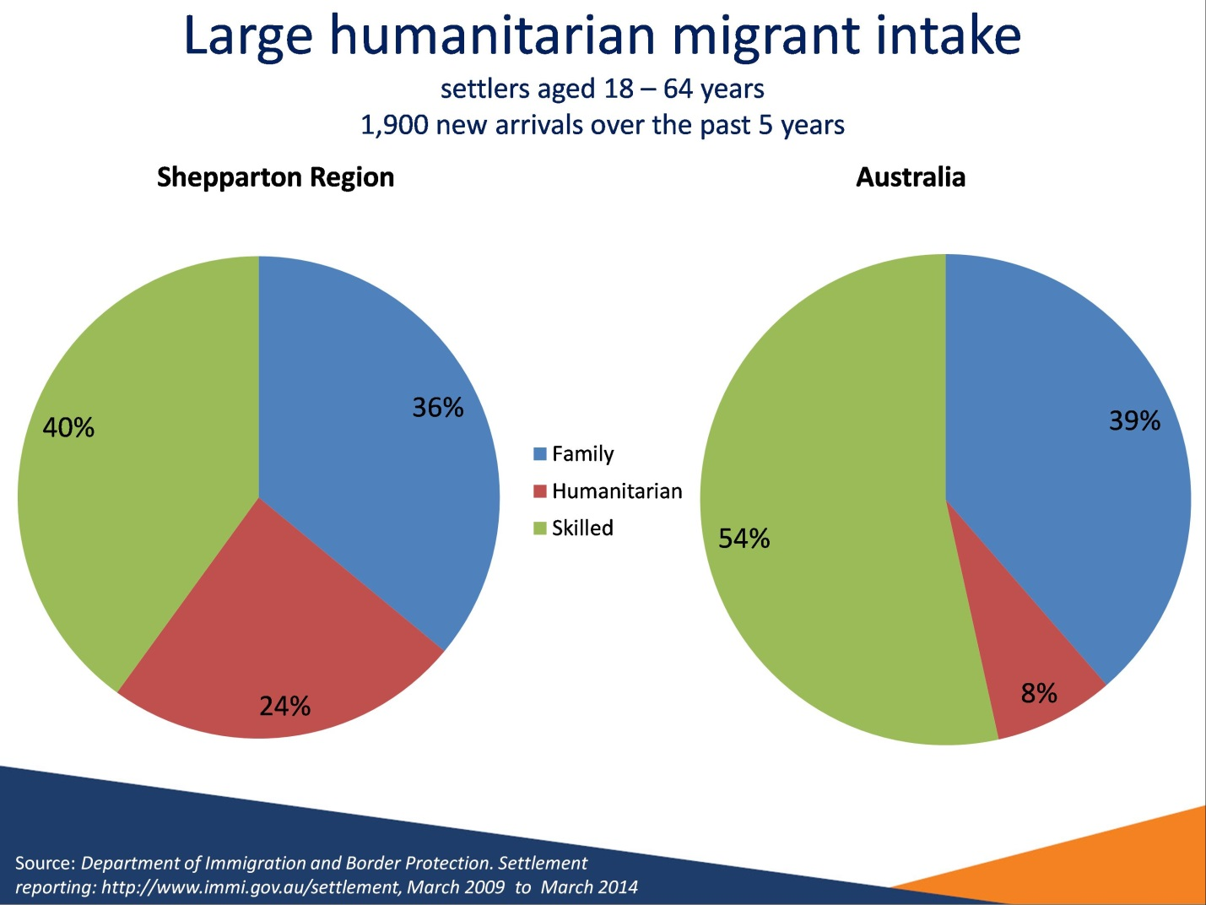

### Large humanitarian migrant intake

Source: *Department of Immigration and Border Protection. Settlement reporting: http://www.immi.gov.au/settlement, March 2009 to March 2014*

In the 5 years to March 2014, there have been 1,900 migrants(aged 18-64 years) settled in the Shepparton Region.

* 40 per cent (760 migrants) settled under the skilled migration stream, compared with 54 per cent for Australia.
* 36 per cent (680 migrants) settled under the family migration stream, compared with 39 per cent for Australia.
* 24 per cent (440 migrants) settled under the humanitarian migration stream compared with 8 per cent for Australia.

Shepparton Region:

* 36 per cent of skilled migrants had ‘nil’ or ‘poor’ English language proficiency.
* 74 per cent of family and humanitarian migrants had ‘nil’ or ‘poor’ English language proficiency.

# Slide 20

## OTMESC Labour Market Outcomes

| Region | Proportion of working age population  OTMESC  (2011) | Unemployment Rate (2011)OTMESC | Unemployment Rate (2011)Non-OTMESC | Participation Rate (2011)OTMESC | Participation Rate (2011)Non-OTMESC |
| --- | --- | --- | --- | --- | --- |
| Greater Shepparton LGA | 11% | 11.1% | 5.2% | 55.3% | 76.8% |
| Benalla LGA | 4% | 6.3% | 5.1% | 66.9% | 73.9% |
| Campaspe LGA | 3% | 3.2% | 4.7% | 68.9% | 75.3% |
| Moira LGA | 5% | 7.8% | 4.9% | 59.6% | 74.2% |
| Strathbogie LGA | 4% | 8.2% | 4.2% | 69.7% | 74.4% |
| Wangaratta LGA | 4% | 6.1% | 4.8% | 73.8% | 78.1% |
| Shepparton Region | 6% | 8.9% | 4.9% | 59.8% | 76.0% |
| Victoria | 23% | 7.9% | 4.9% | 68.4% | 77.9% |
| Australia | 19% | 7.7% | 5.3% | 69.2% | 77.5% |

### OTMESC Labour Market Outcomes

*Source: ABS, Census of Population and Housing, 2011*

This table compares the labour market outcomes for those people born in an other than main English speaking country (OTMESC) with those born in a main English speaking country (MESC) in the Shepparton Region. MESC countries are Australia, Canada, Ireland, New Zealand, South Africa, United Kingdom and the United States of America.

At the time of the 2011 Census, the Shepparton Region had a lower proportion (6 per cent) of working age people born in OTMESC countries than both Victoria (23 per cent) and Australia (19 per cent). The Greater Shepparton LGA had a slightly higher proportion (11 per cent) of its working age population born in an OTMESC country.

People born in OTMESC countries have a higher unemployment rate and lower participation rate when compared with those born in MESC countries.

In the Greater Shepparton LGA the unemployment rate for the OTMESC working age population was particularly high (11.1 per cent) when compared to the state and national figures (7.9 per cent and 7.7 per cent respectively).

The participation rate for the OTMESC working age population in the Greater Shepparton LGA (55.3 per cent) was also well below that for Victoria (68.4 per cent) and Australia (69.2 per cent).

# Slide 21

## Higher unemployment for OTMESC migrants (Shepparton Region)

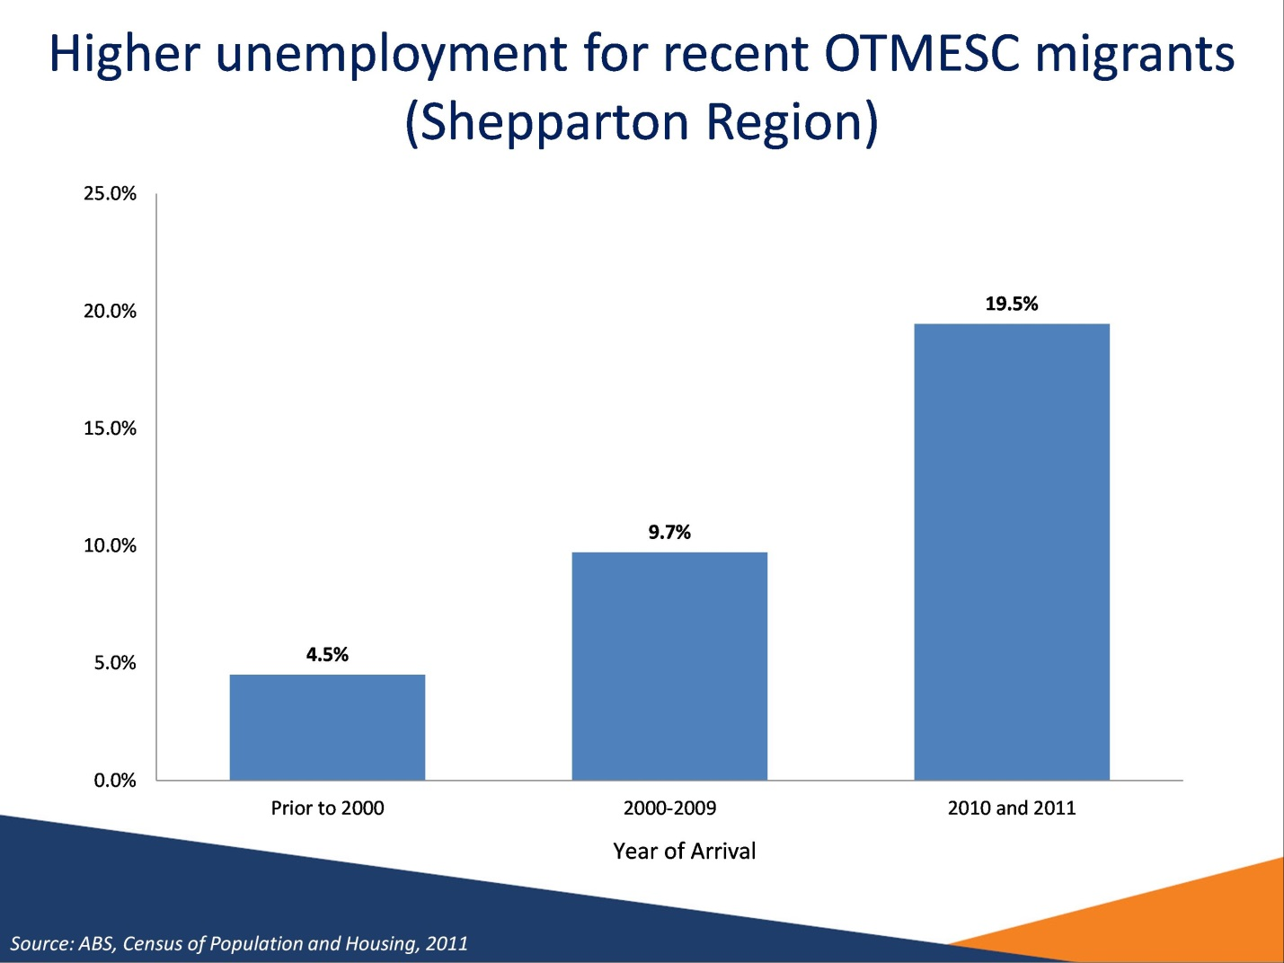

### Higher unemployment for OTMESC migrants (Shepparton Region)

*Source: ABS, Census of Population and Housing, 2011*

Recent OTMESC migrants to Australia living in the Shepparton Region have a higher unemployment rate than those who have been in Australia for longer. At the time of the 2011 Census, the unemployment rate for migrants who had arrived in 2010 and 2011 was 19.5 per cent. By contrast, the unemployment rate for migrants who arrived prior to 2000 was only 4.5 per cent.

# Slide 22

## Migrant underutilisation for people with a Bachelor Degree or higher in the Shepparton Region

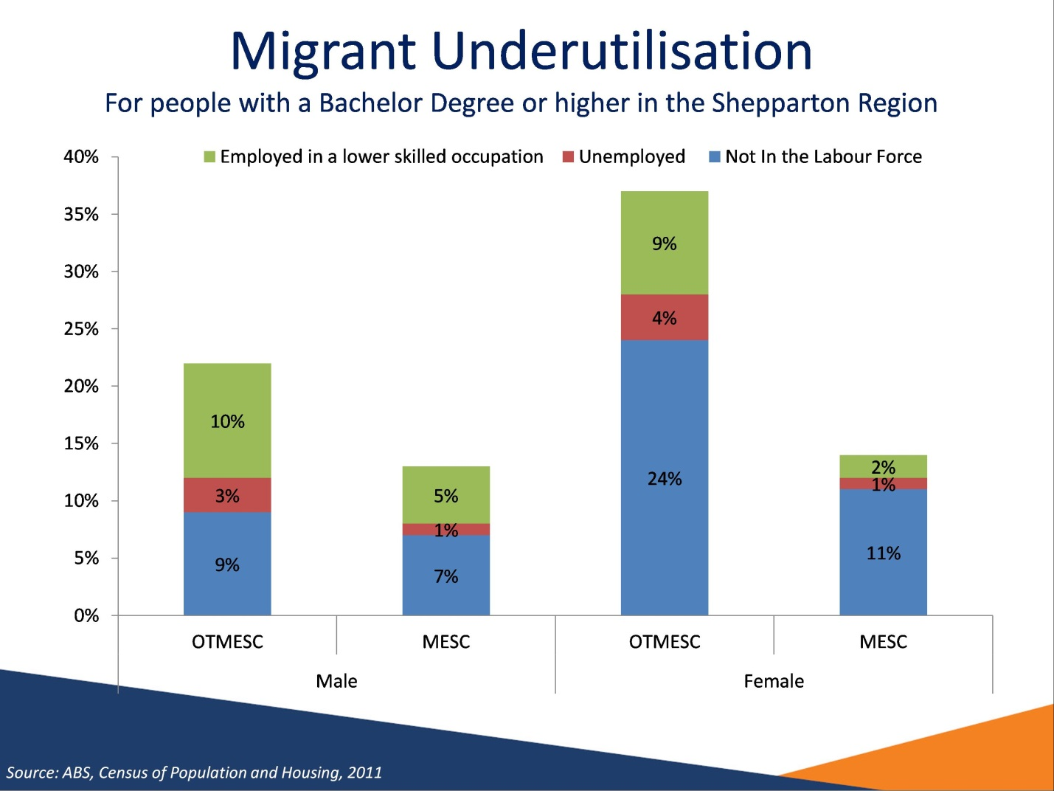

### Migrant underutilisation for people with a Bachelor Degree or higher in the Shepparton Region

*Source: ABS, Census of Population and Housing, 2011*

This chart illustrates migrant underutilisation by comparing labour market participation of those with a Bachelor Degree or higher by whether they were a migrant from an Other Than Main English Speaking Country (OTMESC) or not.

Overall, 27 per cent of the OTMESC working age population in the Shepparton Region have obtained a Bachelor Degree or higher qualification, this compares with 14 per cent for the non-OTMESC population.

There was a lower level of labour market participation for highly qualified OTMESC migrants compared with the non-OTMESC migrants. For both males and females, a higher proportion of the OTMESC population with a Bachelor Degree or higher were either not in the labour force, unemployed or employed in a low skilled occupation.

*\*Lower Skilled Occupation* refers to those in the Machinery Operators and Drivers, Sales Workers and Labourers occupation groups.

# Slide 23

## English Proficiency & Labour Force Outcomes

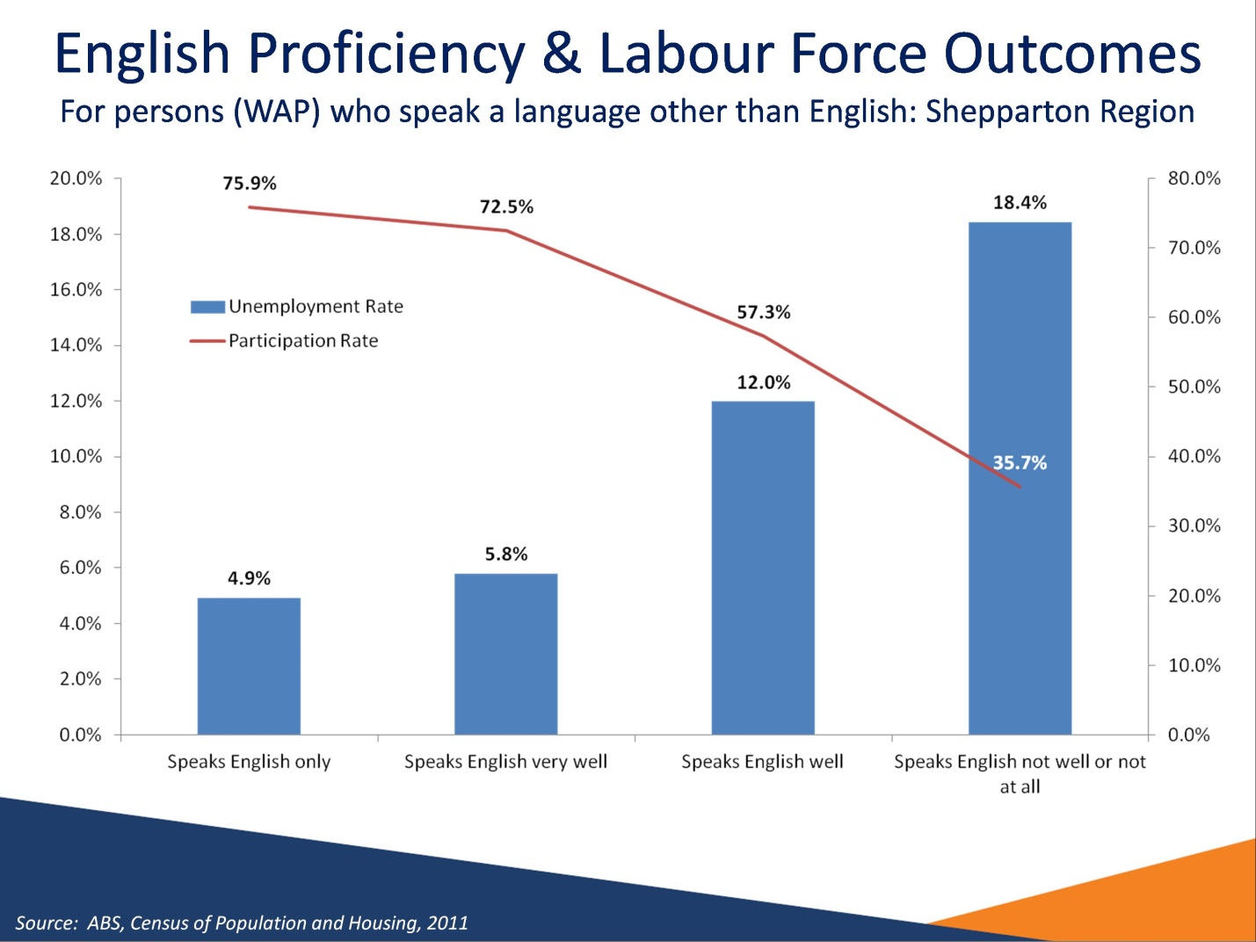

### English Proficiency & Labour Force Outcomes

*Source: ABS, Census of Population and Housing, 2011*

At the time of the 2011 Census, people in the Shepparton Region with lower levels of English proficiency were less likely to be successful in the labour market. People with low English proficiency are far more likely to be unemployed or not participating in the labour market.

In the Shepparton Region, the unemployment rate for working age people with poor English proficiency was 18.4 per cent and the participation rate was 35.7 per cent.

For working age people who only spoke English, the unemployment rate was lower (4.9 per cent) and participation rate higher (75.9 per cent).

# Slide 24

## Employment by Industry

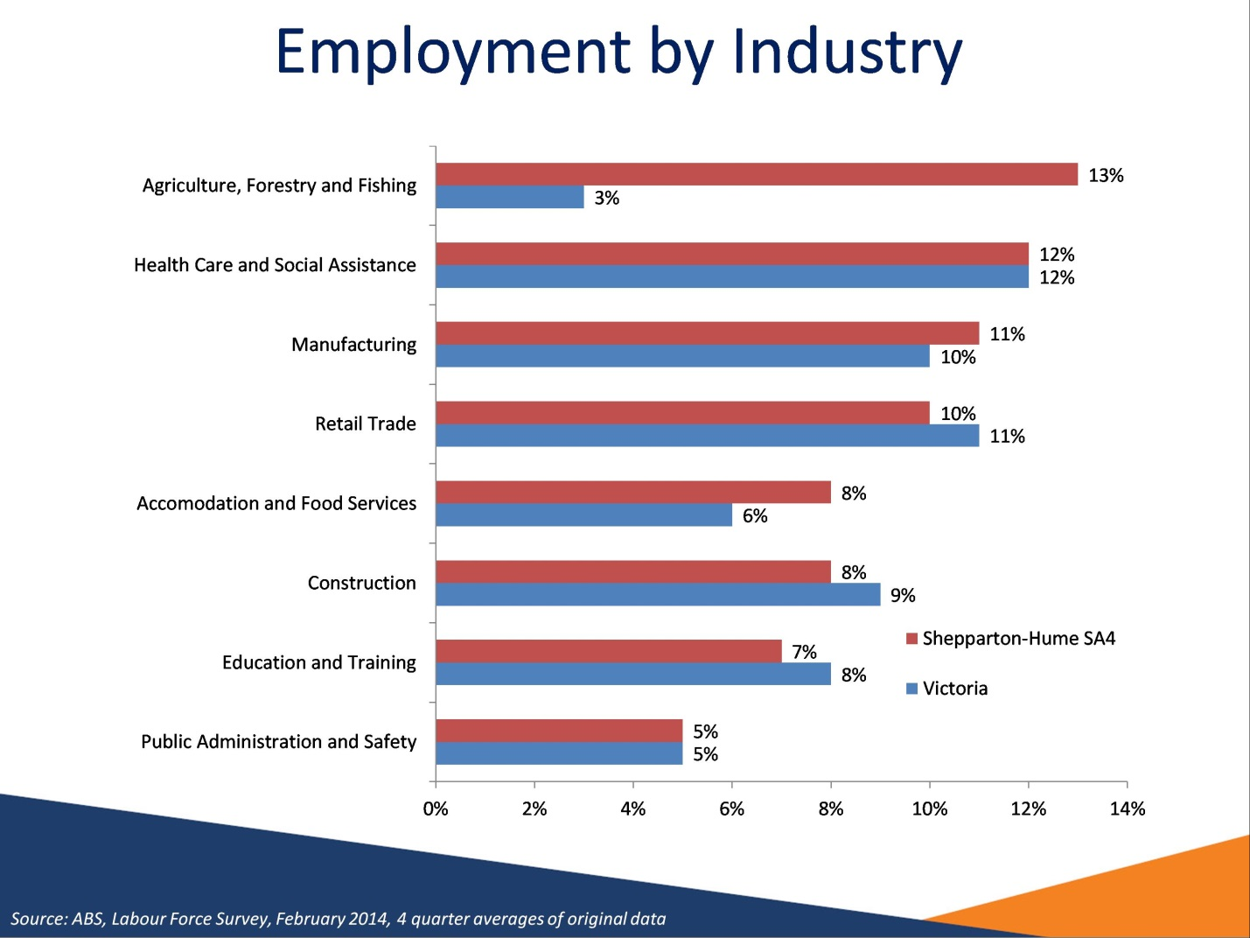

### Employment by Industry

*Source: ABS Labour Force Survey, February 2014, 4 quarter averages of original data*

*The figures in the above chart are based on the combined Shepparton and Hume SA4s.*

The largest employing industries in the Shepparton Region are the Agriculture, Forestry and Fishing, Health Care and Social Assistance, Manufacturing and Retail Trade industries.

# Slide 25

## Employment Growth for Largest industries

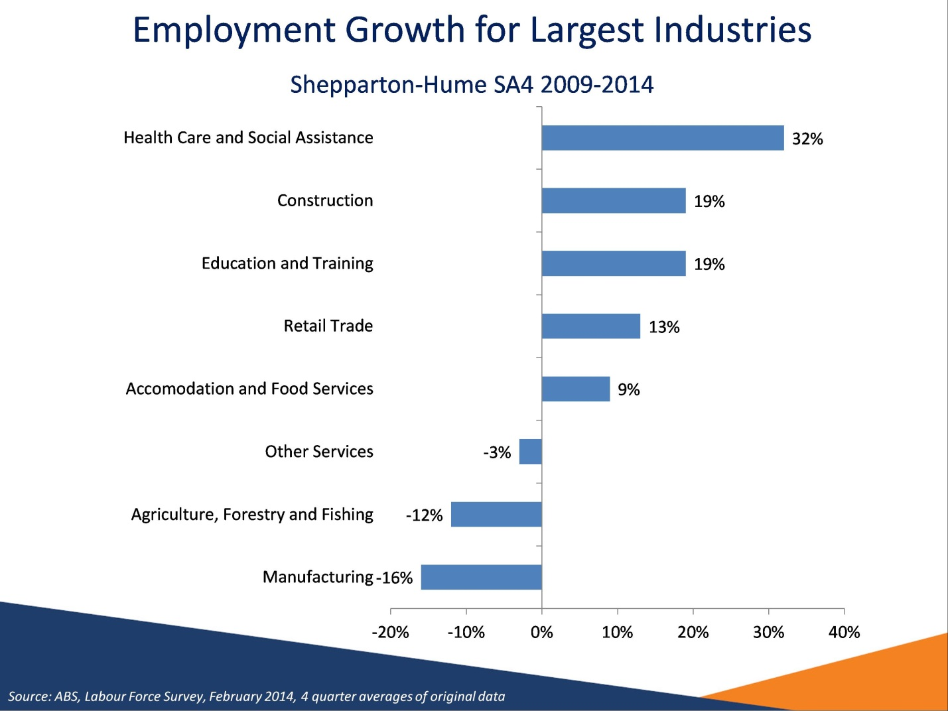

### Employment Growth for Largest industries

*Source: ABS Labour Force Survey, February 2014, 4 quarter averages of original data*

*The figures in the above chart are based on the combined Shepparton and Hume SA4s.*

Employment in Health Care and Social Assistance, Construction and Education and Training have increased significantly over the past 5 years, while employment has decreased substantially in both Agriculture, Forestry and Fishing and Manufacturing.

# Slide 26

## Recruitment activity mixed

|  |
| --- |
| Recruitment activity mixed   * Generally, recruitment activity was stronger compared with the previous year * The proportion of employers who had recruited (59 per cent) had increased since the region was last surveyed (53 per cent) * 15 per cent of employers increased staff numbers * Low proportion of unfilled vacancies and recruitment difficulty * Very small labour supply |

### Recruitment activity mixed

*Source: Department of Employment, Survey of Employers’ Recruitment Experiences, October 2013 and September 2012, North Eastern Victoria Priority Employment Area and all regions surveyed in the 9 months to November 2013.*

435 employers were surveyed in the North Eastern Victoria PEA in October 2013, of which 270 were located in the Shepparton Region.

The proportion of employers who had recruited in the past 12 months (59 per cent) had increased in the 13 months since the area was last surveyed (53 per cent), and was slightly lower than across all regions surveyed in the 9 months to November 2013 (62 per cent).

There were a smaller number of vacancies per 100 staff in the Shepparton Region (14 vacancies per 100 staff) compared with the North Eastern Victoria PEA (15 vacancies per 100 staff) and all regions surveyed (17 vacancies per 100 staff).

The rate of unfilled vacancies over the past 12 months for employers surveyed in the Shepparton Region (4.3 per cent) was slightly lower than in the previous survey (5.1 per cent).

# Slide 27

## Small increase in demand for labour: Shepparton Region

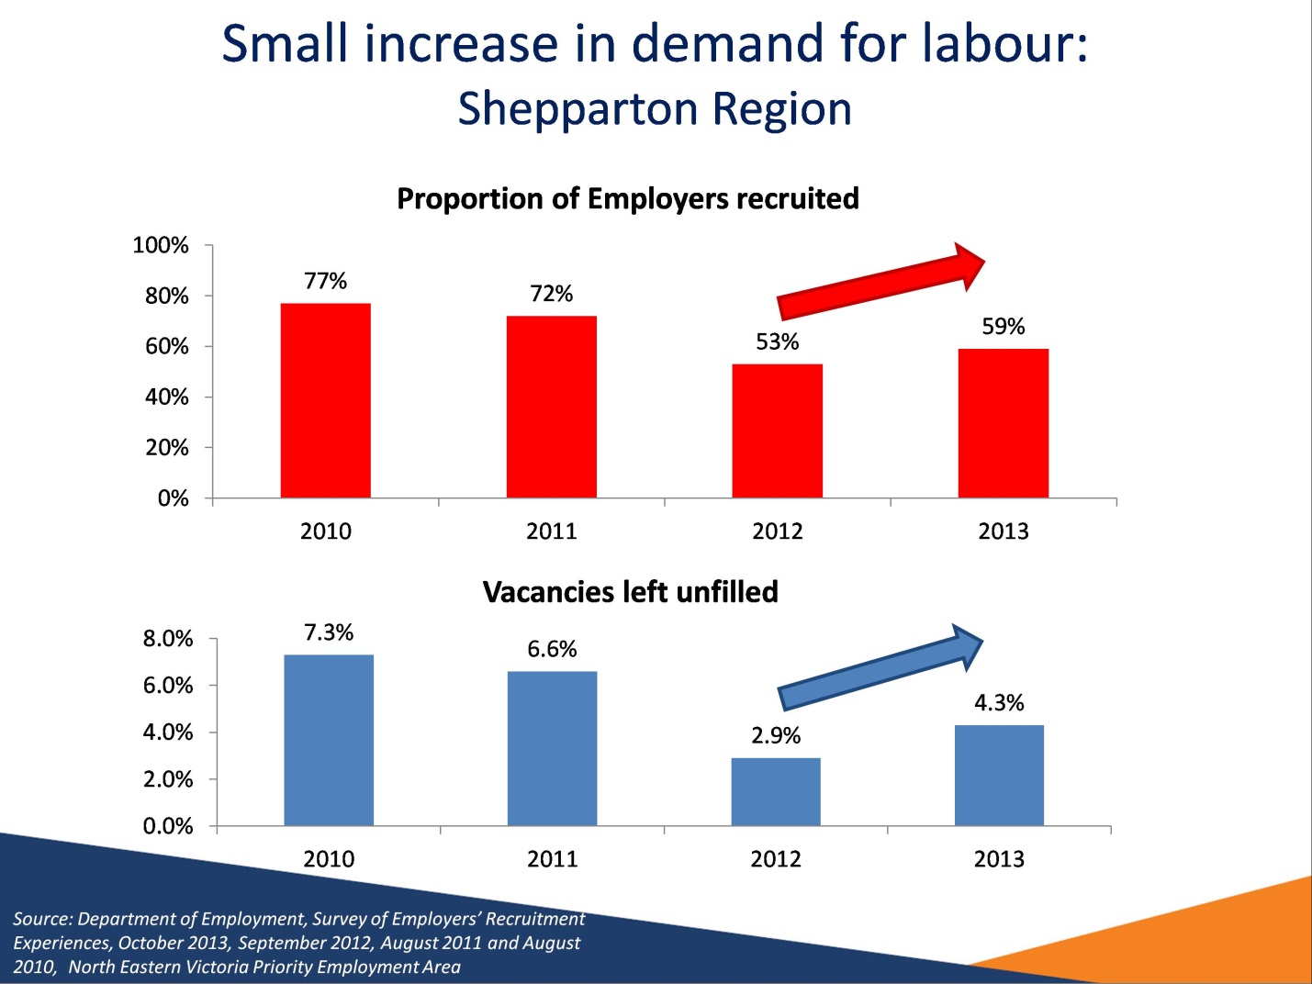

### Small increase in demand for labour: Shepparton Region

*Source: Department of Employment, Survey of Employers’ Recruitment Experiences, October 2013, September 2012, August 2011 and August 2010, North Eastern Victoria Priority Employment Area*

Graph 1: Proportion of employers who recruited in the past 12 months

Graph 2: Proportion of vacancies left unfilled in most recent recruitment round.

There was an increase in the proportion of employers who recruited in the past 12 months. In line with the increased recruitment activity in October 2013, the number of vacancies left unfilled had also increased.

# Slide 28

## Low competition for vacancies

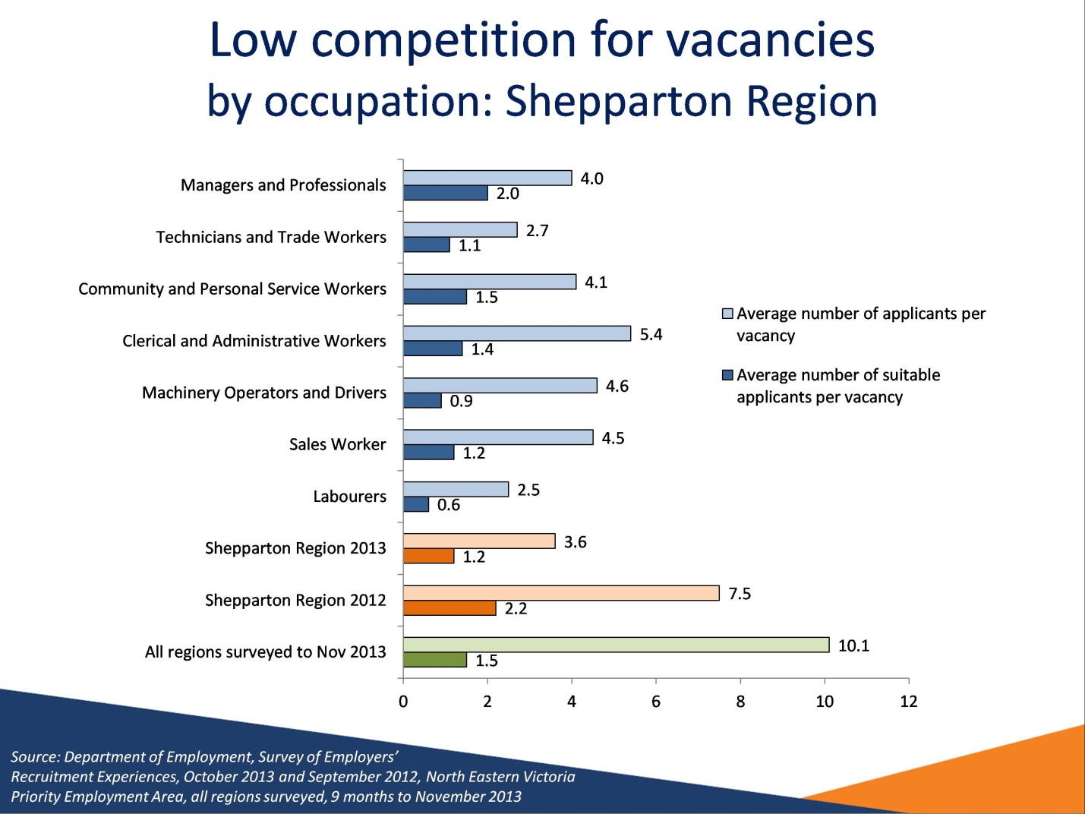

### Low competition for vacancies

*Source: Department of Employment, Survey of Employers’ Recruitment Experiences, October 2013 and September 2012, North Eastern Victoria Priority Employment Area and all regions surveyed in the 12 months to October 2013.*

There was, on average, less competition for vacancies in the Shepparton Region (3.6 applicants per vacancy) compared with the last time the area was surveyed (7.5 applicants per vacancy). However, the average number of suitable applicants per vacancy (1.2) had declined since the previous survey (2.2).

The highest level of competition was for Clerical and Administrative Workers vacancies, with an average of 5.4 applicants per vacancy.

Employers recruiting for Labourers had little choice of applicants with an average of 2.5 applicants of which only 0.6 were considered suitable.

# Slide 29

## The recruitment process – in the Shepparton Region

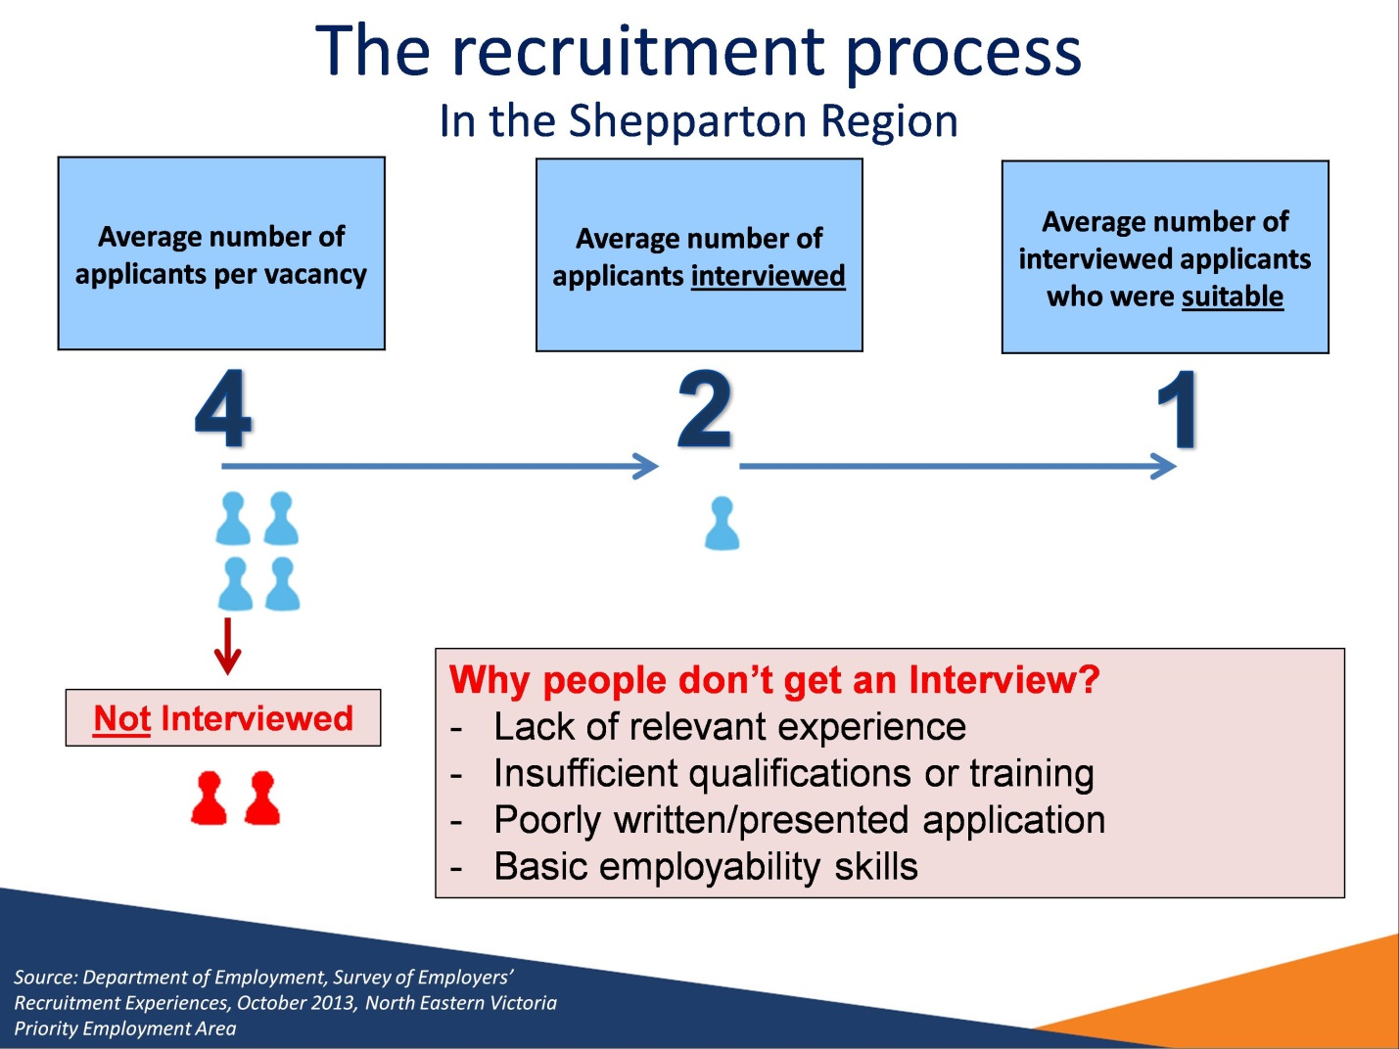

### The recruitment process – in the Shepparton Region

*Source: Department of Employment, Survey of Employers’ Recruitment Experiences, October 2013, North Eastern Victoria Priority Employment Area*

On average employers in the Shepparton Region received 4 (3.6) applicants per vacancy.

Of these applicants on average only 2 (1.9) were interviewed.

Of these interviewed applicants only 1 (1.2) was suitable for the vacancy.

The reasons applicants did not get an interview were:

* Lack of relevant experience
* Insufficient qualifications or training
* Poorly written/presented application
* Basic employability skills

# Slide 30

## Reasons applicants did not receive an interview

|  |
| --- |
| Reasons applicants did not receive an interview   * Just over half of all applicants received an interview * Reasons applicants did not get an interview include: * Insufficient experience to perform job duties (44%) * Insufficient qualifications or training (26%) * Application poorly written/presented or not good enough (23%) |

### Reasons applicants did not receive an interview

*Source: Department of Employment, Survey of Employers’ Recruitment Experiences, October 2013, North Eastern Victoria Priority Employment Area*

Just over half of all applicants received an interview

Reasons applicants did not get an interview include:

* Insufficient experience to perform job duties (44%)
* Insufficient qualifications or training (26%)
* Application poorly written/presented or not good enough (23%)

# Slide 31

## Many vacancies not advertised formally

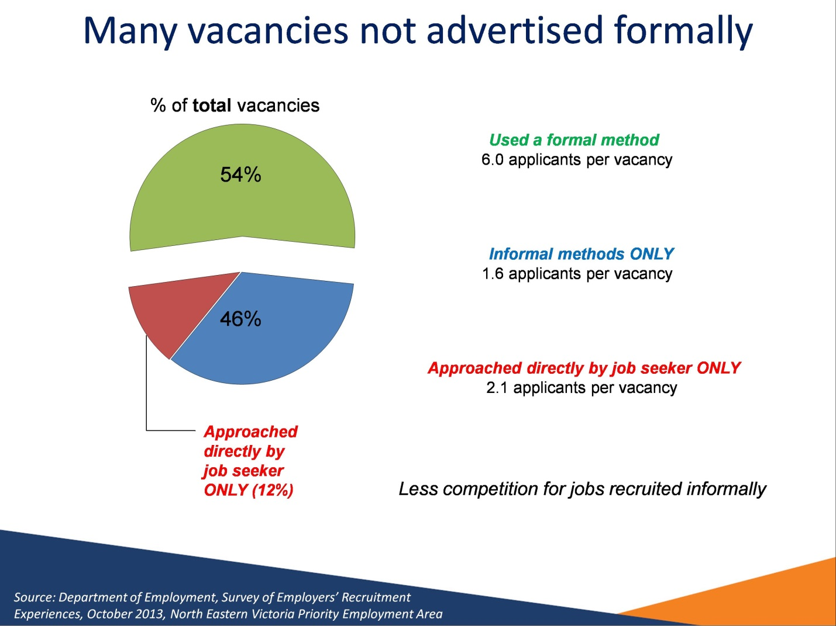

### Many vacancies not advertised formally

*Source: Department of Employment, Survey of Employers’ Recruitment Experiences, October 2013 North Eastern Victoria Priority Employment Area*

54 per cent of vacancies in the Shepparton Region were recruited for through formal methods of recruitment (such as the Internet or Newspapers) receiving an average of 6.0 applicants per vacancy.

By contrast, 46 per cent of vacancies were recruited for through informal methods only (such as word of mouth or approached by a job seeker), receiving an average of just 1.6 applicants per vacancy.

Employers for some 12 per cent of vacancies relied solely on being approached by job seekers. For those vacancies there was an average of 2.1 applicants per vacancy.

# Slide 32

## Applicants from non-English speaking backgrounds face significant barriers

|  |
| --- |
| Applicants from non-English speaking backgrounds face significant barriers   * Almost one third of recruiting employers had at least one applicant from a non-English speaking background * Almost half (47 per cent) of these reported lack of English language skills were a barrier to employment * All of these employers specified a lack of spoken English skills as an obstacle |

### Applicants from non-English speaking backgrounds face significant barriers

*Source: Department of Employment, Survey of Employers’ Recruitment Experiences, October 2013, North Eastern Victoria Priority Employment Area*

Almost one third (32 per cent) of employers had at least one applicant from a non-English speaking background.

Of these, almost half (47 per cent) reported lack of English language skills was a barrier to employment, with all of these employers specifying spoken English skills (or lack thereof) as an obstacle.

# Slide 33

## Recruitment Outlook

|  |
| --- |
| Recruitment Outlook   * Employers outlook generally cautious * Some 35 per cent of employers expected to recruit in the next 12 months with 17 per cent expecting to increase staff numbers * Strong recruitment expected in the Retail Trade and Health Care and Social Assistance industries. * Broad range of occupations expected to be available |

### Recruitment Outlook

*Source: Department of Employment, Survey of Employers’ Recruitment Experiences, October 2013, North Eastern Victoria Priority Employment Area*

35 per cent of employers expected to recruit in the next 12 months.

Only 17 per cent of employers expected to increase staff numbers in the next 12 months.

# Slide 34

## Occupations employers expect to recruit for in the 12 months following the survey

|  |  |
| --- | --- |
| Higher Skill Level – Bachelor Degree or higher  Medium Skill Level – Certificate IV to Associate Degree | |
| Early Childhood Teachers | Cabinetmakers |
| Chefs | - |
| Lower Skill Level – Compulsory Secondary Education to Certificate III | |
| Sales Assistants (General) | Packers |
| General Clerks | Truck Drivers |
| Crop Farm Workers | Waiters |
| Child Carers | Bar Attendants and Baristas |

### Occupations employers expect to recruit for in the 12 months following the survey

*Source: Department of Employment, Survey of Employers’ Recruitment Experiences, October 2013, North Eastern Victoria Priority Employment Area*

This slide shows the vacancies that employers most commonly expected to recruit for in the North Eastern Victoria PEA in the 12 months following the survey.

Higher Skill Level (1) - Bachelor Degree or Higher

Early Childhood Teachers

Medium Skill Level (2 & 3) – Certificate IV to Associate Degree

Cabinetmakers

Chefs

Lower Skill Level (4 & 5) – Compulsory Secondary Education to Certificate III

Sales Assistants

General Clerks

Crop Farm Workers

Child Carers

Packers

Truck Drivers

Waiters

Bar Attendants and Baristas

# Slide 35

## Conclusion

|  |
| --- |
| Conclusion   * Labour market conditions mixed * Unemployment rate has decreased, but still high in the Greater Shepparton LGA * Decline of full-time employing industries (Agriculture and Manufacturing) * Challenges * Disengaged groups: jobless families, less educated, recently arrived migrants, people with low levels of English proficiency * Underutilisation of migrants * Small labour supply * Transition from Agriculture and Manufacturing to the services sector * Opportunities * Recruitment activity picking up * Growth industries (Health Care and Social Assistance) * Improved opportunities for job seekers who tap into informal labour market * Job seekers need to have… * Employability skills * Education and Training * Literacy and English language skills (especially for migrants) * Collaboration with key stakeholders |

### Conclusion

* Labour market conditions mixed
* Unemployment rate has decreased, but still high in the Greater Shepparton LGA
* Decline of full-time employing industries (Agriculture and Manufacturing)
* Challenges
* Disengaged groups: jobless families, less educated, recently arrived migrants, people with low levels of English proficiency
* Underutilisation of migrants
* Small labour supply
* Transition from Agriculture and Manufacturing to the services sector
* Opportunities
* Recruitment activity picking up
* Growth industries (Health Care and Social Assistance)
* Improved opportunities for job seekers who tap into informal labour market
* Job seekers need to have…
* Employability skills
* Education and Training
* Literacy and English language skills (especially for migrants)
* Collaboration with key stakeholders

# Slide 36

## Further Information

|  |
| --- |
| * + [www.employment.gov.au/regionalreports](http://www.employment.gov.au/regionalreports)   + [www.lmip.gov.au](http://www.lmip.gov.au/)   + [www.emplyoment.gov.au/SkillShortages](http://www.emplyoment.gov.au/SkillShortages)   + [www.employment.gov.au/australianjobs](http://www.deewr.gov.au/australianjobs) * [www.joboutlook.gov.au](http://www.joboutlook.gov.au/) |

### Further Information

More information on labour market conditions and other research on small areas can be found on these websites:

* www.employment.gov.au/regionalreports
* www.lmip.gov.au
* www.emplyoment.gov.au/SkillShortages
* www.employment.gov.au/australianjobs
* www.joboutlook.gov.au

# Slide 37

|  |
| --- |
| If you have any questions about the presentation please contact the Recruitment Analysis and Employer Surveys sections on 1800 059 439 or email recruitmentsurveys@employment.gov.au |

If you have any questions about the presentation please contact the Recruitment Analysis and Employer Surveys sections on 1800 059 439 or email recruitmentsurveys@employment.gov.au

# Slide 38

