

New Job Seeker Assessment Framework

The Government announced that a new employment services model would be trialled in two Employment Regions: Adelaide South (South Australia) and Mid North Coast (New South Wales) from 1 July 2019 to 30 June 2022. The New Employment Services Trial (the Trial) is testing key elements of the new model, including a new job seeker assessment framework (the Framework). An assessment of each job seeker’s circumstances alongside the characteristics of the labour market is critical to ensuring job seekers receive the service they need. The Framework has two key objectives:

1. Link job seekers to the service most appropriate to their circumstances, and
2. Personalise the support a job seeker requires to move into work.

The Framework will be built in stages through a user-centred and iterative approach, including consultation with employers, job seekers, employment service providers and other stakeholders.

# **Developing the New Job Seeker Assessment Framework**

## Improved initial assessment process

The first assessment a job seeker undertakes after a claim for income support is called the Job Seeker Snapshot (also known as the Job Seeker Classification Instrument (JSCI). This assessment is being enhanced and streamlined as part of the New Employment Services Gateway to ensure job seekers are being referred to the service that is most appropriate to their needs. This includes:

* The addition of new questions, including to determine a job seeker’s level of access and ability to use an online employment service.
* A review of each question to ensure the assessment remains accurate and fair in the context of the Australian labour market.
* Providing job seekers with the opportunity to undertake the assessment online.
* Looking for opportunities to streamline the initial assessment by reducing duplication of questions asked of job seekers when applying for income support.

The enhanced initial assessment process will be used to refer job seekers to the level of service appropriate to their needs:

* **Digital First**: For job seekers who can self-manage their job search and other activities online.
* **Digital Plus**: For job seekers who require some support to manage their activities online.
* **Enhanced Services**: For job seekers who require additional assistance from a provider to effectively manage their job search or other activities.

## New targeted assessments to inform servicing

A suite of new tools that will assess a range of vocational and non-vocational factors beyond the level that is captured in the initial assessment will be available for job seekers in the online service. Tools that are being developed and tested iteratively during the Trial include:

* The Find a Role tool for Providers and the Job Switch tool for job seekers were introduced in September and October 2020. These tools aim to help job seekers discover occupations that have similar skills to their previous experience and encourage a broader job search effort.
* A new online job seeker self-assessment tool with a focus on motivation and resilience is being developed for testing in early 2021.

The new assessment tools will also help guide a job seeker’s job search effort and assist with better matching of job seekers with employer requirements.

## Safeguards being trialled in the Digital Service

A range of safeguards to ensure job seekers have the right skills and access to use the online system and self-manage their job search and training requirements is being trialled:

* A digital assessment undertaken during the initial assessment will help identify job seekers who may require additional assistance from a provider.
* Regular reviews will be undertaken to ensure the digital service remains appropriate for job seekers.
* Job seekers will be able to opt out of the digital service to a provider at any point.
* Job seekers will be able to update their Job Seeker Snapshot online if their circumstances change.
* Job seekers will be able to access advice and support through a Digital Services Contact Centre, and a have access to range of online resources to support their job search activities.

# **The New Job Seeker Assessment Framework at a glance**

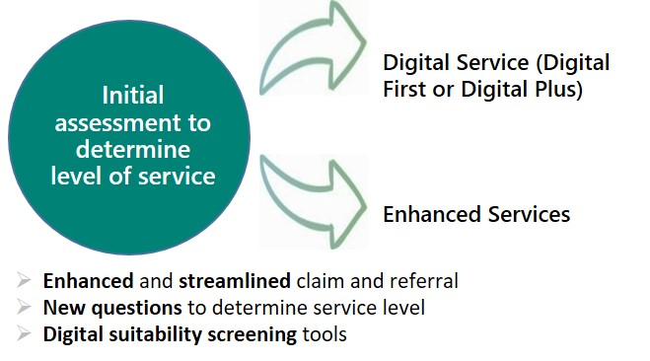

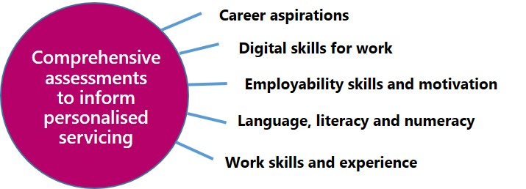

# **Next steps**

The new assessment tools are currently being developed and introduced for testing from January 2021.

Further information will be published on the Department’s website as work on the Framework is progressed.