# Chief Executive Certification for Government Advertising Campaigns

**Certification Statement – Child Care Assistance campaign**

I certify that the 2013 Child Care Assistance campaign complies with the *Guidelines on Information and Advertising Campaigns by Australian Government Departments and Agencies* (Guidelines).

This certification takes into consideration the Report of the Independent Communications Committee, which indicates the 2013 Child Care Assistance campaign, in their view, complies with principles 1 to 4 of the Guidelines,   
dated 3 May 2013.

My certification has also been informed by advice and evidence of compliance with the Guidelines provided by officers within the Department of Education, Employment and Workplace Relations with responsibility for the design, development and implementation of the 2013 Child Care Assistance campaign.

I certify compliance with relevant legal and procurement matters relating to the presentation and delivery of the campaign (principle 5 of the Guidelines).

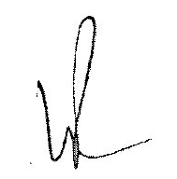

**Lisa Paul**

**Secretary**

**Department of Education, Employment and Workplace Relations**

**3 May 2013**