

Quick Reference Guide: How to upload documents to ADMS

You may find that when using ADMS that you need to upload supporting documents and evidence. This could be making a wage subsidy claim, creating a training contract, or any other process that requires evidence or documents attached. The document upload field appears wherever supporting documents can be added. This guide will show you how to use the document upload field in ADMS.

1. When you identify a need to upload a document in ADMS, first ensure that you have saved a copy of that document onto your device and know where it is located.
2. Open the location of the file you wish to upload.
3. Position the ADMS window and the file location window so that both are on screen at the same time.

*NOTE: You can do this be re-sizing and re-positioning the windows so that the file you are uploading, and the ADMS file upload field are both visible.*

1. Click and hold the left mouse button on the file you are uploading, and while still holding the mouse button, move the mouse so that the file is positioned on the ADMS file upload field.

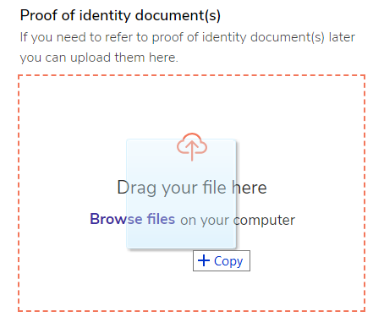

**RESULT:** You will receive confirmation of the document uploading successfully.

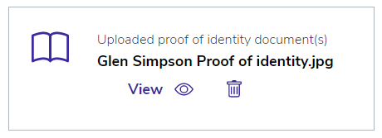

*NOTE: You can also upload a document by clicking ‘browse files’, navigating to the document, and attaching it through files explorer.*

# Support

For assistance with ADMS, contact the National Customer Service Line (NCSL) on **1800 020 108**.

For feedback on this quick reference guide, contact [ADMSEngagement@dese.gov.au](mailto:ADMSEngagement@dese.gov.au).