 

Jobs and Skills Councils Performance Framework

Document details

|  |  |  |  |
| --- | --- | --- | --- |
| **Document name** | Jobs and Skills Councils Performance Framework | | |
| **Document status** | Updated following first year of operations | Last updated | October 2024 |

**Note:** This is a controlled document in its electronic form only. Paper copies of this document are not controlled and should be checked against the electronic version prior to use.

Creative Commons

With the exception of the Commonwealth Coat of Arms, the Department’s logo, any material protected by a trade mark and where otherwise noted all material presented in this document is provided under a [Creative Commons Attribution 4.0 International](https://creativecommons.org/licenses/by/4.0/) (https://creativecommons.org/licenses/by/4.0/) licence.

The details of the relevant licence conditions are available on the Creative Commons website (accessible using the links provided) as is the full legal code for the [CC BY 4.0 International](https://creativecommons.org/licenses/by/4.0/legalcode) (https://creativecommons.org/licenses/by/4.0/legalcode)

The document must be attributed as the Jobs and Skills Councils– Strengthening Australia’s National Vocational Education and Training System Program (2022-2025) Performance Framework.

Contents

Context 4

Performance Assessment 4

Annual Performance Management Cycle 6

Meetings with the department 6

Annual Year in Review Meeting 6

# Context

1. The Jobs and Skills Councils (JSC) Performance Framework is a key element of the JSC Integrity Framework agreed by the Commonwealth and state and territory Skills Ministers, and supports the Jobs and Skills Council Program Guidelines.
2. The Performance Framework assists JSCs and the department in working together to identify and understand issues impacting performance and to discuss potential strategies to resolve those issues.
3. Under JSC Grant Agreements, each JSC provides a range of deliverables and activities and participates in meetings with the department that, together, forms the basis for considerations and insights into the performance of the JSC Program.
4. JSC deliverables include:

* Strategic Plans
* Progress Reports
* Workforce Plans
* Annual Activity Schedule
* Annual Training Product Development Plan
* Annual Corporate Governance Statement

1. The Performance Framework has and will continue to be updated to reflect the increasing maturity of JSCs and the JSC Program. The Board of each JSC also sets and oversees their organisation’s performance, including strategic objectives and key performance indicators that reflect the priorities of their industry sectors and program goals.
2. Through a process of co‑design, the department will continue to work closely with JSCs to refine longer-term performance arrangements for the JSC Program. These arrangements will:

* support ongoing measurement, evaluation and learning across the JSC Program
* balance Government requirements and expectations with the needs and insights of industry
* evolve over time.

1. As the JSC Performance Framework forms a key part of the JSC Integrity Framework that sets out all Skills Ministers’ expectations, advice from state and territory governments will inform JSC performance arrangements and insights into potential areas of focus.

# Performance Assessment

1. The JSC performance monitoring approach is an annual cycle. The department will work collaboratively with JSCs in a culture of ‘no surprises’, to identify and understand issues impacting performance and to discuss and inform potential strategies to resolve issues.
2. **Figure 1** below provides a high-level overview of performance expectations, including for the initial and subsequent years of JSC operations. Overall, focus areas for JSC performance include:

* compliance (ensuring that all grant agreement requirements are met)
* deliverables (in terms of appropriateness and timeliness).

**Figure 1: Performance overview**

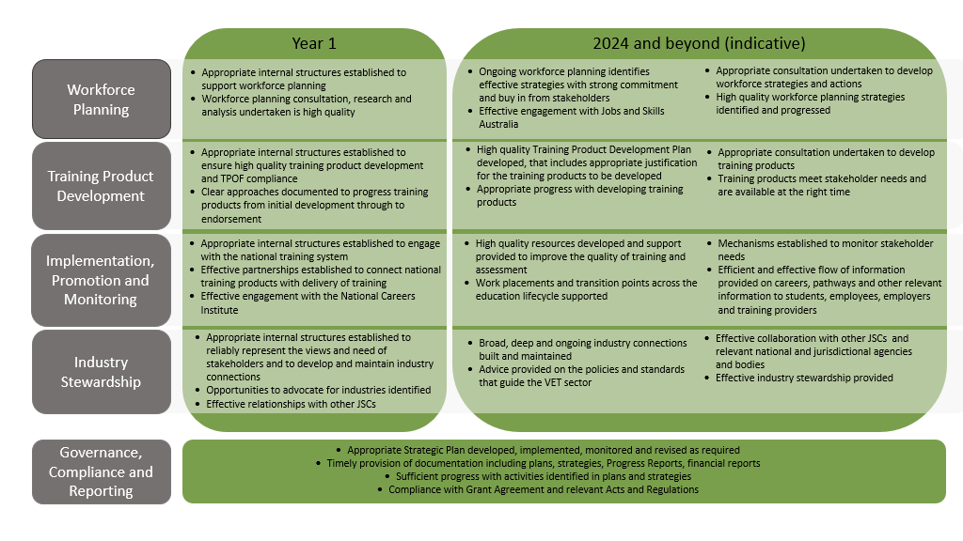

# Annual Performance Management Cycle

1. The JSC performance monitoring approach is an annual cycle. The department will work collaboratively with JSCs to identify and understand issues impacting performance and to discuss and inform potential strategies to resolve issues.

### Meetings with the department

1. Meetings will occur between JSCs and the department to support the management of the Program. This includes Progress Meetings which will be held following submission of JSC Progress Reports to share information that provides insights into performance.
2. The types of issues to be discussed include:

* plans to meet objectives and address issues, including any developments since the last meeting
* progress against plans, agreed activities and performance indicators, looking at both quantitative and qualitative evidence
* factors impacting progress
* agreed actions to be undertaken by the JSCs or department prior to next meeting
* issues and/or initiatives requiring joint problem-solving
* breadth and depth of stakeholder engagement.

1. The expected outcomes of these meetings include:

* a shared and agreed understanding of JSC activities
* agreed actions for the JSCs and, if required, for the department to assist JSCs to meet their objectives.

1. Each year, JSCs provide a Performance Self Reflection report as part of progress reporting, which reflects on the JSC performance over the full calendar year, identifies lessons learnt and informs priorities for the upcoming year. This is one of the various sources of information the department will consider when assessing JSC’s overall performance.

### Annual Year in Review Meeting

1. The Annual Year in Review Meeting is an opportunity for the department and JSCs to discuss the past year’s performance and any environmental or external factors that have impacted progress against the grant agreement.
2. These meetings will cover JSC effectiveness towards program outcomes, including:

* any environmental factors that have impacted progress against performance
* any proposed changes to the operational and delivery approaches
* any significant issues that remain unresolved
* evaluation of timing and quality of deliverables and progress
* findings of internal governance reviews and opportunities to evolve governance structures
* These meetings will also include a forward-looking focus for the year ahead, including shared priorities and expectations.

1. These meetings will also cover JSC views on opportunities to improve program administration and impact.
2. Given the nature of the Program for strengthened industry leadership and to drive system reform, the Performance Framework supports collaborative practice and joint problem solving between the department and JSCs.