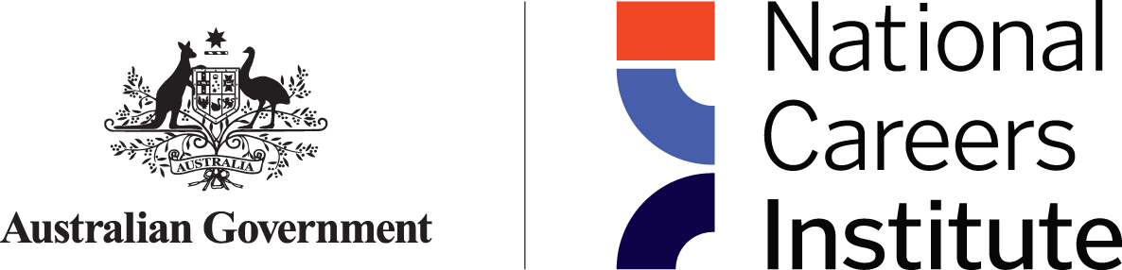

# National Careers Institute **Advisory Board** Communiqué

The National Careers Institute (NCI) Advisory Board meeting was held virtually on Thursday 8 June 2023. Discussion centred around two key priorities listed in the Advisory Board Forward Workplan: enhancing support for First Nations people; and enhancing support for People with Disability. These topics were discussed in-depth through presentations from the Department of Employment and Workplace Relations’ Skills and Training Group.

At the meeting:

* The Board received briefing from acting NCI Executive Director on the measures announced in the 2023-24 Federal Budget relevant to the work of the NCI, as well as on work underway in the NCI including enhancements to Your Career, key research milestones, the wrapping up of the Partnership Grants Program, the cessation of the School Leavers Information Service on 30 June 2023, the Australian Training Awards presentation in Hobart in November 2023, working with Jobs and Skills Australia and Jobs and Skills Councils to improve the promotion of career pathway information to priority cohorts of Australians, the House of Representatives Inquiry into the Perceptions and Status of VET, and the upcoming NCI evaluation which will help shape the future of careers information delivered by the Australian Government beyond the 2023-24 financial year.
* Through facilitated presentations on the Department of Employment and Workplace Relations’ work on enhancing support for First Nations people and People with Disability, board members discussed how the NCI could optimise efforts in enhancing career information support for these priority groups. The Board noted key insights in relation to support for First Nations people including that relationships are a key factor in successful culturally appropriate training design and building information about career pathways to create effective change. The discussion on enhancing support for People with Disability, included feedback around the importance of tailoring career pathway information in a non-discriminative way, and that support for identification as a person with disability was also important. In both discussions, the theme of pathways was emphasised, with a focus on the end goal and connecting the various parts of a journey.
* The Board considered updates to the forward workplan including holding an in-person meeting in Canberra on Thursday 24 August 2023, with consideration as to undertaking a board professional development training opportunity at the same time; bringing forward the discussion on the Net Zero/Clean Energy economy to August (from November); updating the November meeting to virtual and changing the date to 24 November 2023.

The NCI Advisory Board is next scheduled to meet in person on Thursday 24 August 2023.