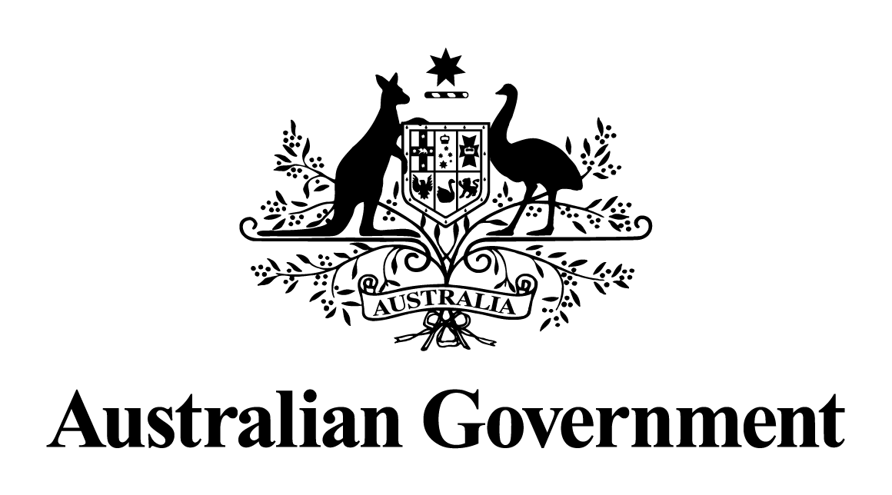

# Australian Government response to the Senate Education and Employment References Committee report:

# *“Wage theft? What wage theft?!”: The exploitation of general and specialist cleaners working in retail chains for contracting or subcontracting companies*

JULY 2024

## Acknowledgement

The Australian Government commends the Senate Education and Employment References Committee on its work in bringing to light the incidence of exploitation of general and specialist cleaners working in retail chains for contracting or subcontracting companies. The Government particularly acknowledges the valuable submissions to the inquiry made by 22 individuals and organisations and evidence provided in 5 public hearings.

## Response

The Australian National Audit Office responded to recommendation 7 on 22 March 2019.

The Government **notes** all other recommendations made in the Report. Since May 2022, the Government has been working to deliver secure jobs, better wages and a fairer workplace relations system.

As a result of the passage of time since the report was tabled and the action taken by the Government to respond to key issues raised in the Report, outlined below, a substantive Government response is no longer appropriate. Many of the Government’s reforms have been informed by the work and evidence of this Committee, and directly address the Report’s recommendations.

### Outline of reforms relevant to the Report’s recommendations

The *Fair Work Legislation Amendment (Secure Jobs, Better Pay) Act 2022* reinvigorates enterprise bargaining by making it easier to initiate bargaining for a single enterprise agreement and providing more options to access multi-enterprise bargaining through the Supported Bargaining Stream, Single Interest Bargaining Stream and Cooperative Workplaces Bargaining Stream. A key aim of these reforms was to extend the benefits of bargaining throughout the workforce, with a particular focus on low-paid sectors.

The *Fair Work Legislation Amendment (Closing Loopholes) Act 2023* introduces a criminal offence for intentional wage theft of employees’ wages and certain entitlements. This legislation also enhances the rights and protections for workplace delegates in carrying out their duties to represent union members.

The *Fair Work Legislation Amendment (Closing Loopholes No. 2) Act 2024* increases maximum penalties for standard and serious contraventions of certain civil remedy provisions in the *Fair Work Act 2009* for bodies corporate that are not small business employers. It also amends right of entry provisions to enhance the ability of entry permit holders to enter a workplace to investigate suspected wage underpayments.

The Government is also currently progressing, alongside states and territories, a harmonised approach to national labour hire regulation. This will protect labour hire workers from exploitation and establish an even playing field for business, irrespective of where a labour hire provider operates.

Alongside these reforms, the Government has taken targeted action to combat migrant worker exploitation. It has implemented many of the recommendations of the Migrant Workers’ Taskforce Report (MWT Report), a number of which relate to issues raised by the Committee, and is committed to implementing all recommendations in full. The Government will give serious consideration to relevant findings and conclusions of the Committee, in particular Recommendations 10 and 20, in addressing the remaining elements of the MWT Report.

The Government secured the passage of amendments to the employment and migration frameworks, through the *Fair Work Legislation Amendment (Protecting Worker Entitlements) Act 2023* and *Migration Amendment (Strengthening Employer Compliance) Act 2024*, to ensure that employers cannot argue that a migrant worker is not entitled to the same workplace protections as other workers in Australia because of their immigration status or right to work.

It is also implementing a dedicated package of measures announced in 2023. The Government is co-designing pilots, with unions, businesses and civil society, which are intended to address barriers to reporting of exploitation and pursuing workplace claims, such as a fear of visa cancellation or an expiring visa. It has also allocated $3.9 million over two years to the Fair Work Ombudsman (FWO) in the 2023-24 MYEFO to support the FWO’s role in pilots, thus bolstering its role in assisting vulnerable workers, including those from migrant and culturally diverse backgrounds.

The Government continues to make progress in its efforts to combat illegal phoenix activity designed to avoid liabilities including taxes and employee entitlements. A dedicated Taskforce comprising key federal, state and territory government agencies are working together to protect public revenue, businesses, and employee entitlements by taking action to reduce illegal phoenix activity.