PORTFOLIO additional

ESTIMATES STATEMENTS 2013–14

EDUCATION PORTFOLIO

Explanations of additional estimates 2013–14

© Commonwealth of Australia 2014

ISSN 2203-2975 (Print)  
ISSN 2203-2983 (Online)

This publication is available for your use under a [Creative Commons BY Attribution 3.0 Australia](http://creativecommons.org/licenses/by/3.0/au/deed.en) licence, with the exception of the Commonwealth Coat of Arms, the Department of Education logo, photographs, images, signatures and where otherwise stated. The full licence terms are available from  
<http://creativecommons.org/licenses/by/3.0/au/legalcode>.

CC by_grey

Use of Department of Education material under a [Creative Commons BY Attribution 3.0 Australia](http://creativecommons.org/licenses/by/3.0/au/deed.en) licence requires you to attribute the work (but not in any way that suggests that the Department of Education endorses you or your use of the work).

*Department of Education material used 'as supplied'*

Provided you have not modified or transformed Department of Education material in any way including, for example, by changing the Department of Education text; calculating percentage changes; graphing or charting data; or deriving new statistics from published Department of Education statistics—then the Department of Education prefers the following attribution:

*Source: The Australian Government Department of Education*

**Derivative material**

If you have modified or transformed Department of Education material, or derived new material from those of the Department of Education in any way, then Department of Education prefers the following attribution:

*Based on The Australian Government Department of Education data*

**Use of the Coat of Arms**

The terms under which the Coat of Arms can be used are set out on the It’s an Honour website (see [www.itsanhonour.gov.au](http://www.itsanhonour.gov.au)).

**Other Uses**

Inquiries regarding this licence and any other use of this document are welcome at the Department of Education on 13 33 97.

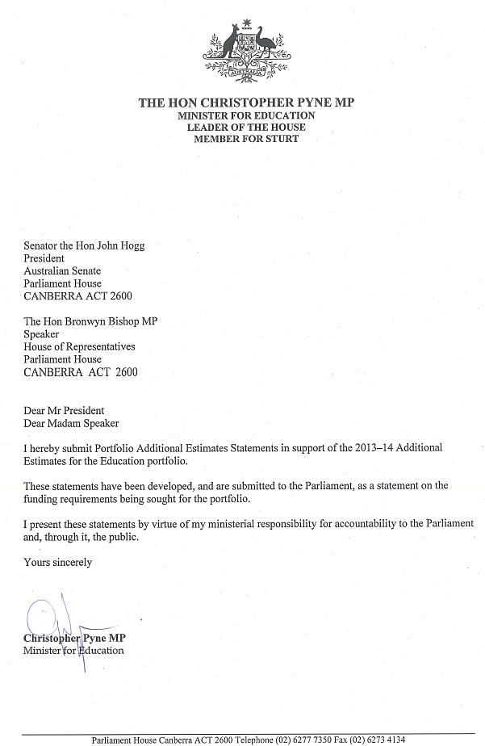

Abbreviations and conventions

The following notations may be used:

NEC/nec not elsewhere classified

‑ nil

.. not zero, but rounded to zero

na not applicable (unless otherwise specified)

nfp not for publication

$m $ million

Figures in tables and in the text may be rounded. Figures in text are generally rounded to one decimal place, whereas figures in tables are generally rounded to the nearest thousand. Discrepancies in tables between totals and sums of components are due to rounding.

Enquiries

Should you have any enquiries regarding this publication please contact Sheree Harrison, A/g Chief Finance Officer of the Department of Education on 13 33 97.

A copy of this document can be located on the Australian Government Budget website at [www.budget.gov.au](http://www.budget.gov.au).

User Guide  
to the  
Portfolio Additional  
Estimates Statements

# User Guide

The purpose of the Portfolio Additional Estimates Statements (PAES), like that of the Portfolio Budget Statements (PB Statements), is to inform Senators and Members of Parliament of the proposed allocation of resources to Government outcomes by agencies within the portfolio. The focus of the PAES differs from the PB Statements in one important aspect. While the PAES include an Agency Resource Statement to inform Parliament of the revised estimate of the total resources available to an agency, the focus of the PAES is on explaining the changes in resourcing by outcome(s) since the Budget. As such, the PAES provides information on new measures and their impact on the financial and/or non‑financial planned performance of programmes supporting those outcomes.

The PAES facilitate understanding of the proposed appropriations in Appropriation Bills (Nos. 3 and 4) 2013–14. In this sense the PAES is declared by the Additional Estimates Appropriation Bills to be a ‘relevant document’ to the interpretation of the Bills according to section 15AB of the *Acts Interpretation Act 1901*.

Whereas the *Mid‑Year Economic and Fiscal Outlook (MYEFO) 2013–14* is a mid-year budget report which provides updated information to allow the assessment of the Government’s fiscal performance against its fiscal strategy, the PAES update the most recent budget appropriations for agencies within the portfolio.

## Structure of the Portfolio Additional Estimates Statements

The PAES are presented in three parts with subsections.

|  |  |
| --- | --- |
| User Guide | |
| Provides a brief introduction explaining the purpose of the PAES. | |
| Portfolio Overview |  |
| Provides an overview of the portfolio, including a chart that outlines the outcomes for agencies in the portfolio. | |
| Agency Additional Estimates Statements | |
| A statement (under the name of the agency) for each agency affected by Additional Estimates. | |
| Section 1: Agency Overview and Resources | This section details the total resources available to an agency, the impact of any measures since Budget, and impact on Appropriation Bills Nos. 3 and 4. |
| Section 2: Revisions to Outcomes and Planned Performance | This section details changes to Government outcomes and/or changes to the planned performance of agency programmes. |
| Section 3: Explanatory Tables and Budgeted Financial Statements | This section contains updated explanatory tables on special account flows and staffing levels and revisions to the budgeted financial statements. |

Contents

Portfolio Overview 3

Department of Education 9

Portfolio Overview

# Portfolio Overview

The Portfolio Additional Estimates Statements provide information about the Education portfolio. Through its portfolio agencies, the Australian Government takes a national leadership role in education and works with state and territory governments, other Australian Government agencies and a range of service providers to provide high quality policy advice and services for the benefit of Australia.

Note that as a result of the September 2013 Administrative Arrangements Order, responsibility for programmes managed by the former Department of Education, Employment and Workplace Relations has been transferred to the Department of Education, the Department of Employment, the Department of the Prime Minister and Cabinet and the Department of Social Services.

The responsibility for higher education, research and international education has transferred to the Department of Education (Administrative Arrangements Orders of 18 September 2013 and 12 December 2013).

A full outline of the Education portfolio can be found at Figure 1.

Programme movement detail can be found at Figure 2 (see page 28).

Figure 1: Department of Education Portfolio Structure and Outcomes

|  |
| --- |
| **The Hon Christopher Pyne MP**—Minister for Education  **The Hon Sussan Ley MP**—Assistant Minister for Education  **Senator the Hon Scott Ryan**—Parliamentary Secretary to the Minister for Education |
| **Department of Education**  Lisa Paul AO PSM—Secretary  **Outcome 1**  Improved access to quality services that support early childhood learning and care for children through a national quality framework, agreed national standards, investment in infrastructure, and support for parents, carers, services and the workforce.  **Outcome 2**  Improved learning and literacy, numeracy and educational attainment for school students, through funding for quality teaching and learning environments, workplace learning and career advice.  **Outcome 3**  Promote growth in economic productivity and social wellbeing through access to quality higher education, international education and international quality research. |
| **Australian Curriculum, Assessment and Reporting Authority** Mr Robert Randall—Chief Executive Officer  **Outcome** Improved quality and consistency of school education in Australia through a national curriculum, national assessment, data collection and performance reporting system. |
| **Australian Institute of Aboriginal and Torres Strait Islander Studies**  Russell Taylor—Principal (Chief Executive Officer)  **Outcome**  National and international understanding of Aboriginal and Torres Strait Islander cultures through undertaking and disseminating high-quality research, and developing, maintaining and providing access to world-class print and audiovisual cultural collections. |
| **Australian Institute for Teaching and School Leadership**  Margery Evans—Chief Executive Officer  **Outcome**  Enhance the quality of teaching and leadership through developing standards, recognising teacher excellence, providing professional development opportunities and supporting the teacher profession. |
| **Australian Research Council**  Professor Aidan Byrne—Chief Executive Officer  **Outcome**  Growth of knowledge and innovation through managing research funding schemes, measuring research excellence and providing advice. |
| **Tertiary Education Quality and Standards Agency**  Dr Carol Nicoll PSM—Chief Executive Officer  **Outcome**  Contribute to a high quality higher education sector through streamlined and nationally consistent higher education regulatory arrangements; registration of higher education providers; accreditation of higher education courses; and investigation, quality assurance and dissemination of higher education standards and performance. |

Agency Additional Estimates Statements

Department of Education 9

# 

# DEPARTMENT OF EDUCATION

Section 1: Agency Overview and Resources 11

1.1 Strategic Direction 11

1.2 Agency Resource Statement 12

1.3 Agency Measures Table 16

1.4 Additional Estimates and Variations 21

1.5 Breakdown of Additional Estimates by Appropriation Bill 25

Section 2: Revisions to Agency Outcomes and Planned Performance 27

2.1 Resources and Performance Information 27

Section 3: Explanatory Tables and Budgeted Financial Statements 47

3.1 Explanatory Tables 47

3.2 Budgeted Financial Statements 48

# DEPARTMENT OF EDUCATION

## Section 1: Agency Overview and Resources

### 1.1 Strategic Direction

The Department of Education is the Australian Government’s lead agency in the development and delivery of early childhood and school education, higher education, international education and research policy and funding.

We work to provide opportunity through learning for all Australians.

The department collaborates closely with other Australian Government agencies, state and territory governments and education stakeholders to develop and provide access to:

* early childhood education and care that enriches early learning, by supporting nurturing, flexible and stimulating early childhood learning environments that meet the needs of Australian society, including ensuring child care and early learning is accessible and affordable
* school education that puts students first, by offering high quality teaching, learning and policy implementation that optimises student outcomes and supports students at key transition points leading to bright and successful futures
* higher education and research so Australia excels through knowledge, byenabling the delivery of quality higher education, international education and research that contributes to individual prosperity and Australia’s place in the world.

We work across the department to improve services in regional Australia and support people with disability. Within the department, Indigenous business is everyone’s business and we work to improve the educational opportunities for Indigenous Australians, thereby improving their overall prosperity and wellbeing.

Some of the major measures impacting the Education portfolio as a result of Additional Estimates include:

* **Students First—A fairer funding agreement for schools—Queensland, Western Australia and the Northern Territory**—($1.2 billion over four years) to implement a national funding agreement for schools in Queensland, Western Australia and the Northern Territory. As part of this funding $55.0 million will be provided over four years to Catholic Education Commissions and $110.0  million to the Association of Independent Schools.
* **Students First—Independent Public Schools Fund**—($70.0 million over four years) to encourage 1500 Government schools to become Independent Public Schools by 2017.
* **Juvenile Diabetes—clinical research**—($35.0 million over five years) to provide funding to the Juvenile Diabetes Research Foundation’s Clinical Research Network for research to help find a cure for Type 1 Juvenile Diabetes. This includes $7.0 million of funding in 2017–18.

### 1.2 Agency Resource Statement

The Agency Resource Statement details the resourcing for the Department of Education at Additional Estimates. Table 1.1 outlines the total resourcing available from all sources for the 2013–14 Budget year, including variations through Appropriation Bill No. 3 and No. 4, Special Appropriations and Special Accounts.

Table 1.1: Department of Education Resource Statement—Additional Estimates for 2013–14 as at Additional Estimates February 2014



Table 1.1: Department of Education Resource Statement—Additional Estimates for 2013–14 as at Additional Estimates February 2014 (continued)



1 Appropriation Act (No. 1) 2013–14 and Appropriation Bill (No. 3) 2013–14.

2 Estimated adjusted balance carried from previous year for annual appropriations.

3 Includes an amount of $20.423m in 2013–14 for the Departmental Capital Budget (refer to table 3.2.5 for further details). For accounting purposes this amount has been designated as 'contributions by owners'.

4 s31 Relevant Agency receipts – estimate.

5 Appropriation Act (No. 2) 2013–14 and Appropriation Bill (No. 4) 2013–14.

6 Estimated opening balance for Special Accounts (less ‘Special Public Money’ held in a Services for Other Entities and Trust Moneys Special Accounts (SOETM)). For further information on Special Accounts see Table 3.1.1.

7 Appropriation receipts reflect the amount drawn from the Special Appropriation to establish the Early Years Quality Fund Special Account balance.

Reader note: All figures are GST exclusive.

Table 1.1: Department of Education Resource Statement—Additional Estimates for 2013–14 as at Additional Estimates February 2014 (continued)

Third Party Payments from and on behalf of other agencies



Note: figures are subject to change pending the finalisation of s32 agreements.

### 1.3 Agency Measures table

Table 1.2 summarises new Government measures taken since the 2013–14 Budget. The table is split into revenue, expense and capital measures, with the affected programme identified.

Table 1.2: Agency 2013–14 Measures since Budget



Table 1.2: Agency 2013–14 Measures since Budget (continued)



Table 1.2: Agency 2013–14 Measures since Budget (continued)



Table 1.2: Agency 2013–14 Measures since Budget (continued)



Table 1.2: Agency 2013–14 Measures since Budget (continued)



1 This is a measure announced in the 2013–14 Budget but not previously reported in a portfolio statement.

2 The savings shown for the measure are shared across the Department of Employment, Department of the Prime Minister and Cabinet and the Department of Social Services, following the Administrative Arrangements Order of 18 September 2013.

3 This measure was originally announced in the 2013 Pre-Election Economic and Fiscal Outlook and has been fully reversed by a cessation measure announced in the 2013–14 Mid-Year Economic and Fiscal Outlook. The above dashes reflect that the measure has no fiscal impact as it has ceased.

4 Lead agency is the Department of Immigration and Border Protection.

5 This measure was originally announced in the 2013 Economic Statement and has been fully reversed by a cessation measure announced in the 2013–14 Mid-Year Economic and Fiscal Outlook. The above dashes reflect that the measure has no fiscal impact as it has ceased.

6 This measure involves the transfer from the former Department of Education, Employment and Workplace Relations to the Department of Social Services.

7 $15m has been provided for the establishment of the Australian Indonesia Centre. $7.5m was offset from redirected Reward Programme Funding.

Prepared on a Government Financial Statistics (fiscal) basis.

### 1.4 Additional Estimates and variations

The following tables detail the changes to the resourcing for the Department of Education at Additional Estimates, by outcome. Table 1.3 details the Additional Estimates and variations resulting from new measures since the 2013–14 Budget in Appropriation Bills Nos. 3 and 4. Table 1.4 details Additional Estimates or variations through other factors, such as parameter adjustments.

Table 1.3: Additional Estimates and Variations to Outcomes from Measures since 2013–14 Budget



Table 1.3: Additional Estimates and Variations to Outcomes from Measures since 2013–14 Budget (continued)



Table 1.3: Additional Estimates and Variations to Outcomes from Measures since 2013–14 Budget (continued)



Table 1.4: Additional Estimates and Variations to Outcomes from Other Variations



### 1.5 Breakdown of additional estimates by appropriation bill

The following tables detail the Additional Estimates sought for the Department of Education through Appropriation Bills Nos. 3 and 4.

Table 1.5: Appropriation Bill (No. 3) 2013–14



Table 1.6: Appropriation Bill (No. 4) 2013–14



## 

## Section 2: Revisions to Agency Resources and Planned Performance

### 2.1 Resources and performance information

As a result of the Administrative Arrangements Order (AAO) that took effect on 18 September 2013, responsibilities of the former Department of Education, Employment and Workplace Relations have been distributed between the Department of Education, the Department of Employment, the Department of the Prime Minister and Cabinet and the Department of Social Services. Distribution of programmes is illustrated in Figure 2.

Responsibility for tertiary education, research and international education has transferred from the Department of Industry, Innovation, Climate Change, Science, Research and Tertiary Education to the Department of Education, including the Australian Research Council and the Tertiary Education Quality and Standards Agency.

The estimates following for the 2013–14 Financial year are for the period   
18 September 2013 to 30 June 2014, reflecting the commencement of the new department. The estimates are subject to finalisation of Machinery of Government negotiations.

Figure 2: Movement of programmes from the former Department of Education, Employment and Workplace Relations

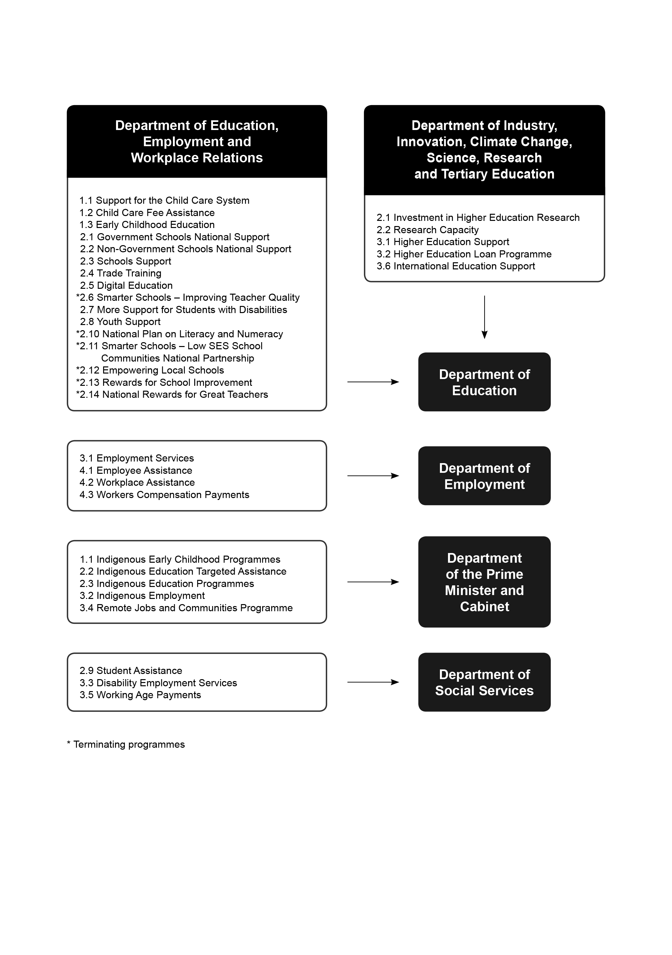

Outcome 1

#### Outcome 1 Strategy

There is no change to the Outcome strategy as a result of the 2013–14 Additional Estimates. Additional Estimates variations for 2013–14 are outlined at Table 1.3 and other variations including parameter adjustments are outlined in Table 1.4. There are no new programmes.

Adjustments to programme performance indicators are below. Any programmes, deliverables or indicators not listed below remain unchanged from the 2013–14 Portfolio Budget Statements.

Table 2.1.1 Budgeted Expenses for Outcome 1



1 Departmental Appropriation combines ‘Ordinary annual services (Appropriation Act No. 1 and Bill No. 3)’ and ‘Revenue from independent sources (s31)’.

2 Expenses not requiring appropriation in the Budget year is made up of Depreciation Expense, Amortisation Expense and Audit Fees.

Note: Estimated expense covers the period 18 September 2013 to 30 June 2014.

Programme 1.1 Support for the Child Care System

##### Programme 1.1 Expenses



##### Programme 1.1 Deliverables

|  | Budget 2012–13 | Actual  2012–13 | Budget  2013–14 | Revised Budget 2013–14 |
| --- | --- | --- | --- | --- |
| Child care services support |  |  |  |  |
| Number of child care services receiving sustainability assistance | 2,300 | 2,604 | 2,300 | 2,500 |
| Number of Budget Based Funded Services | 342 | 342 | 344 | 343 |
| Jobs, Education and Training Child Care Fee Assistance |  |  |  |  |
| Number of parents assisted | 30,400 | 36,200 | 36,900 | 34,700 |

##### Programme 1.1 Key Performance Indicators

|  | **Budget 2012–13** | **Actual  2012–13** | **Budget  2013–14** | **Revised Budget 2013–14** |
| --- | --- | --- | --- | --- |
| Trend in the number of children with additional needs using government approved child care services—by target group: |  |  |  |  |
| Aboriginal, Torres Strait and Australian South Sea Islander children | 2% | 2% | 2% | 3% |
| Children from non-English-speaking backgrounds | 13% | 13% | 13% | 17% |

Programme 1.2 Child Care Benefit

##### Programme 1.2 Expenses

##### 

##### Programme 1.2 Deliverables

|  | **Budget 2012–13** | **Actual  2012–13** | **Budget  2013–14** | **Revised Budget 2013–14** |
| --- | --- | --- | --- | --- |
| Child care benefit |  |  |  |  |
| Number of children using approved child care places | 1,321,000 | 1,347,000 | 1,345,000 | 1,436,000 |
| Number of families using approved child care services | 941,000 | 938,000 | 942,000 | 998,000 |
| Number of families using approved child care services and receiving a child care payment (percentage of families who use care and receive a payment) | 918,000 (98%) | 919,000 (98%) | 923,000 (98%) | 978,000  (98%) |
| Number of families receiving both CCB and CCR | 659,000 | 649,000 | 652,000 | 686,000 |
| Number of families receiving only CCB | 121,000 | 92,000 | 92,000 | 89,000 |

Programme 1.3 Child Care Rebate

##### Programme 1.3 Expenses

##### 

##### Programme 1.3 Deliverables

|  | Budget 2012–13 | Actual  2012–13 | Budget  2013–14 | Revised Budget 2013–14 |
| --- | --- | --- | --- | --- |
| Number of families receiving only CCR | 138,000 | 178,000 | 179,000 | 203,000 |

Programme 1.4 Early Childhood Education

##### Programme 1.4 Expenses



Outcome 2

#### Outcome 2 Strategy

The Government’s strategy for Outcome 2 is to put students first and improve their education outcomes and the performance of our schools. The Government has committed to ensuring our students have a world class education with access to the best teachers and an up-to-date and relevant curriculum, and that parents, teachers, principals and community are able to make informed decisions that will affect their education.

Under the students-first approach, the Australian Government will work with the states and territories, teachers and parents to focus on four key areas that will make a difference:

* Teacher quality
* Principal autonomy
* Engaging parents in education
* Strengthening the curriculum.

Adjustments to programme performance indicators are below. Any programmes, deliverables or indicators not listed below remain unchanged from the Department of Education, Employment and Workplace Relations Portfolio Budget Statements 2013–14.

Table 2.1.2 Budgeted Expenses and Resources for Outcome 2



Table 2.2 Budgeted Expenses and Resources for Outcome 2 (continued)



1 Departmental Appropriation combines ‘Ordinary annual services (Appropriation Act No. 1 and Bill No. 3)’ and ‘Revenue from independent sources (s31)’.

2 Expenses not requiring appropriation in the Budget year is made up of Depreciation Expense, Amortisation Expense and Audit Fees.

Note: Estimated expense covers the period 18 September 2013 to 30 June 2014.

Programme 2.1 Government schools national support

##### Programme 2.1 Expenses



##### Programme 2.1 Deliverables

|  | Budget 2012–13 | Actual  2012–13 | Budget  2013–14 | Revised Budget 2013–14 |
| --- | --- | --- | --- | --- |
| Government schools specific purpose payment |  |  |  |  |
| Number of full-time equivalent students funded (enrolment projections) | 2,316,717 | 2,316,717 | 2,349,000 | 2,351,000 |

Programme 2.2 Non-government schools national support

##### Programme 2.2 Expenses

##### 

##### Programme 2.2 Deliverables

|  | Budget 2012–13 | Actual  2012–13 | Budget  2013–14 | Revised Budget 2013–14 |
| --- | --- | --- | --- | --- |
| Recurrent grants—non-government |  |  |  |  |
| Number of full-time equivalent students funded (enrolment projections) | 1,232,497 | 1,232,497 | 1,255,000 | 1,260,000 |

##### Programme 2.2 Performance Indicators

|  | **Budget 2012–13** | **Actual  2012–13** | **Budget  2013–14** | **Revised Budget 2013–14** |
| --- | --- | --- | --- | --- |
| Enrolment trends–non-government |  |  |  |  |
| Full-time student enrolments in Australian schools |  |  |  |  |
| * Primary | 646,000 | 646,709 | 662,000 | 659,839 |
| * Secondary | 599,000 | 599,139 | 608,000 | 609,054 |
| Trend in the number of Indigenous students at school | 26,000 | 26,630 | 28,000 | 28,573 |

Programme 2.3 Schools support

##### Programme 2.3 Expenses

##### 

1 These programmes were transferred to the Department of the Prime Minister and Cabinet on 1 December 2013.

##### Programme 2.3 Deliverables

|  | **Budget 2012–13** | **Actual  2012–13** | **Budget  2013–14** | **Revised Budget 2013–14** |
| --- | --- | --- | --- | --- |
| Parliament and Civics Education Rebate |  |  |  |  |
| Number of schools visiting Canberra under PACER | 1,992 | 1,988 | 2,072 | 1,980 |
| Helping Children with Autism Package |  |  |  |  |
| Number of teachers and other school staff attending professional development courses | 597 | 1,146 | 450 | 590 |
| National School Chaplaincy and Student Welfare Programme |  |  |  |  |
| Number of schools receiving support for chaplaincy or student welfare services | 3,500 | 3,543 | 3,551 | 3,527 |
| Teach Next |  |  |  |  |
| Number of Teach Next participants commencing | 8 | 8 | 50 | 0 |

Programme 2.4 Trade training

##### Programme 2.4 Expenses

##### 

##### Programme 2.4 Deliverables

|  | **Budget 2012–13** | **Actual  2012–13** | **Budget  2013–14** | **Revised Budget 2013–14** |
| --- | --- | --- | --- | --- |
| Trade Training Centres in Schools Programme |  |  |  |  |
| Total announced projects (cumulative) | 376 | 375 | 517 | 511 |
| New projects announced | 0 | 0 | 141 | 136 |
| New projects announced—number of schools benefiting | 0 | 0 | 230 | 225 |

Programme 2.5 Digital Education Revolution

##### Programme 2.5 Expenses

##### 

Programme 2.6 More Support for Students with Disabilities

##### Programme 2.6 Expenses

##### 

Programme 2.7 Youth Support

##### Programme 2.7 Expenses



Programme 2.11 Smarter Schools—Low SES School Communities National Partnership

##### Programme 2.11 Deliverables

|  | **Budget 2012–13** | **Actual  2012–13** | **Budget  2013–14** | **Revised Budget 2013–14** |
| --- | --- | --- | --- | --- |
| Smarter Schools—Low SES School Communities National Partnership |  |  |  |  |
| Number of schools assisted | 1734 | 1790 | 1734 (over 2009 to 2015) | 1734 (over 2009 to 2013) |

Note: Programme terminated on 31 December 2013.

Outcome 3

#### Outcome 3 Strategy

The Outcome 3 strategy has been updated to reflect the most recent Administrative Arrangement Orders of 12 December 2013.

Under this outcome, the department will support the government’s objectives for higher education, international education and research through supporting autonomous, high quality and outward looking universities and research bodies that provide real opportunity for students from all backgrounds, and contribute the highest level of quality research to the Australian society and economy.

The department’s approach revolves around the following areas of activity:

* supporting students to acquire the skills and qualifications needed to contribute to Australian society and a productive national and international economy
* reducing the burden of red tape, regulation and reporting for the higher education and research sectors
* supporting the further development of the international education sector as part of creating a world class education system
* fostering world class research through supporting researchers and the facilities in which they operate
* working to increase international research collaboration and awareness of the value of research.

Adjustments to programme performance indicators are below. Any programmes, deliverables or indicators not listed below remain unchanged from the Department of Industry, Innovation, Climate Change, Science, Research and Tertiary Education Portfolio Budget Statements 2013–14.

##### Table 2.1.3 Budgeted Expenses and Resources for Outcome 3



##### Table 2.3 Budgeted Expenses and Resources for Outcome 3 (continued)



1 Departmental Appropriation combines ‘Ordinary annual services (Appropriation Act No. 1 and Bill No. 3)’ and ‘Revenue from independent sources (s31)’.

2 Expenses not requiring appropriation in the Budget year is made up of Depreciation Expense, Amortisation Expense and Audit Fees.

Note: Estimated expenses covers the period 18 September 2013 to 30 June 2014 for Special Appropriations and Special Accounts, and 1 December 2013 to 30 June 2014 for ordinary annual services.

Programme 3.1 Commonwealth Grants Scheme

##### Programme 3.1 Expenses

##### 

##### Programme 3.1 Deliverables

|  | Budget 2012–13 | Actual  2012–13 | Budget  2013–14 | Revised Budget 2013–14 |
| --- | --- | --- | --- | --- |
| Provision of support for tertiary education infrastructure |  |  |  |  |
| Value of funding for tertiary education infrastructure through Education Investment Fund (incl SAF-EIF) ($’000) | 206,198 | 206,198 | 170,241 | 156,665 |
| Provision of support to universities for structural adjustment |  |  |  |  |
| Value of funding provided through the SAF-(HESA) ($’000) | 74,468 | 74,468 | 1,270 | 1,257 |
| Provision of supplementary support—Indigenous and low SES (1) |  |  |  |  |
| Number of Indigenous students enrolled at funded institutions | 12,000 | 12,181 | 12,500 | 12,700 |
| Number of Indigenous completions at funded institutions | 1,670 | 1,547 | 1,740 | 1,770 |

1 The data on this indicator is by calendar year—e.g. the 2013–14 data relates to the 2013 calendar year.

##### Programme 3.1 Performance indicators

|  | Budget 2012–13 | Actual  2012–13 | Budget  2013–14 | Revised Budget 2013–14 |
| --- | --- | --- | --- | --- |
| Increased student participation in higher education |  |  |  |  |
| Number of domestic enrolments (full-time equivalents) | 664,000 | 659,710 | 700,000 | 696,000 |
| Number of domestic postgraduate enrolments (full-time equivalents) | 112,000 | 110,100 | 118,000 | 116,000 |
| Number of undergraduate completions | 196,000 | 186,710 | 203,000 | 197,000 |
| Number of postgraduate coursework completions | 114,000 | 104,517 | 120,000 | 110,000 |
| Improved infrastructure for tertiary education |  |  |  |  |
| Number of infrastructure projects supported—EIF and SAF | 34 | 29 | 18 | 19 |

Programme 3.2 University Superannuation Programme

##### Programme 3.2 Expenses



Programme 3.3 Higher Education Support

##### Programme 3.3 Expenses



Programme 3.4 Higher Education Loan Programme

##### Programme 3.4 Expenses



##### Programme 3.4 Deliverables

|  | Budget 2012–13 | Actual  2012–13 | Budget  2013–14 | Revised Budget 2013–14 |
| --- | --- | --- | --- | --- |
| Provision of HELP loans to higher education students |  |  |  |  |
| Number of places for which VET FEE-HELP loans paid1 | 68,600 | 37,700 | 87,700 | 87,700 |

1 Indicator changed from ‘Number of Commonwealth supported places for which VET FEE-HELP loans paid’.

**Programme 3.4 Performance indicators**

|  | **Budget 2012–13** | **Actual  2012–13** | **Budget  2013–14** | **Revised Budget 2013–14** |
| --- | --- | --- | --- | --- |
| **Students who are able to repay their HELP debts do so** |  |  |  |  |
| Proportion of new debt not expected to be repaid (%) | 18% | 17% | 19% | 17% |

Programme 3.5 Investment in Higher Education Research

##### Programme 3.5 Expenses



Programme 3.6 Research Capacity

##### Programme 3.6 Expenses



Programme 3.7 International Education Support

##### Programme 3.7 Expenses

##### 

##### Programme 3.7 Deliverables

|  | Budget 2012–13 | Actual  2012–13 | Budget  2013–14 | Revised Budget 2013–14 |
| --- | --- | --- | --- | --- |
| Provision of international education support |  |  |  |  |
| Number of projects and/or activities funded by Regional Links | 12 | 26 | 12 | 26 |
| Number of projects and/or activities funded by the Increased profile of Australian International Education Sector programme | 15 | 23 | 15 | 12 |
| Number of international scholarships, fellowships and exchange opportunities supported (Endeavour and AsiaBound programmes) | 2,038 | 2,038 | 5,300 | 6,128 |
| Number of eligible applications funded through the Assessment Subsidy for Overseas Trained Professionals Programme | 500 | 418 | 500 | 465 |

##### Programme 3.7 Performance indicators

|  | Budget 2012–13 | Actual  2012–13 | Budget  2013–14 | Revised Budget 2013–14 |
| --- | --- | --- | --- | --- |
| Enhanced international collaborations |  |  |  |  |
| Number of international collaborations supported per annum 1 | ≥ 20 |  | ≥ 20 | – |

1. Measure is no longer necessary and now deleted.

## Section 3: Explanatory Tables and Budgeted Financial Statements

## 3.1 Explanatory Tables

#### Estimates of Special Account Flows

Special Accounts provide a means to set aside and record amounts used for specified purposes. Table 3.1.1 shows the expected additions (receipts) and reductions (payments) for each account used by the Department of Education.

Table 3.1.1: Estimates of Special Account Flows and Balances



(A) = Administered

(D) = Departmental

### 3.2 Budgeted financial statements

#### 3.2.1 Analysis of Budgeted Financial Statements

The financial statements have been updated to reflect the changes resulting from the new measures and variations as outlined in Table 1.3 and Table 1.4.

The department commenced operations on 18 September 2013. The financial results for the year reflect this part year of operations.

#### 3.2.2 Budgeted Financial Statements

Table 3.2.1: Comprehensive Income Statement (Showing Net Cost of Services) for the period ended 30 June 2014



1. From 2010–11, the Government introduced net cash appropriation arrangements where Appropriation Act No. 1 or Bill No. 3 revenue appropriations for the depreciation/amortisation expenses of FMA Act agencies were replaced with a separate capital budget (the Departmental Capital Budget, or DCB) provided through Appropriation Act No. 1 or Bill No. 3 equity appropriations. For information regarding DCBs, please refer to Table 3.2.5 Departmental Capital Budget Statement.

Table 3.2.2: Budgeted Departmental Balance Sheet (as at 30 June 2014)



Prepared on Australian Accounting Standards basis.

Table 3.2.3: Departmental Statement of Changes in Equity—Summary of Movement (Budget Year 2013–14)



Prepared on Australian Accounting Standards basis

Table 3.2.4: Budgeted Departmental Statement of Cash Flows (as at 30 June 2014)



Table 3.2.5: Capital Budget Statement—Departmental

Consistent with information contained in the Statement of Asset Movements and the Budgeted Statement of Cash Flows.

1 Includes both current and prior Act 2 and Bills 4/6 appropriations and special capital appropriations.

2 Does not include annual finance lease costs. Includes purchases from current and previous years' Departmental Capital Budgets (DCBs).

3 Includes the following sources of funding:

* current and prior year Act 1 and Bills 3/5 appropriations (excluding amounts from the DCB)
* donations and contributions
* gifts
* internally developed assets
* s31 relevant agency receipts (for FMA agencies only)
* proceeds from the sale of assets.

Table 3.2.6: Statement of Asset Movements (2013–14)



1 ‘Appropriation equity’ refers to equity injections or Administered Assets and Liabilities appropriations provided through Appropriation Acts No. 2 and Bill No. 4 2013–14, including CDABs.

2 ‘Appropriation ordinary annual services’ refers to funding provided through Appropriation Act No. 1 and Bill No. 3 2013–14 for depreciation/amortisation expenses, DCBs or other operational expenses.

Prepared on Australian Accounting Standards basis.

#### Schedule of Administered Activity

Table 3.2.7: Schedule of Budgeted Income and Expenses Administered on Behalf of Government (for the period ended 30 June 2014)



Prepared on Australian Accounting Standards basis.

Table 3.2.8: Schedule of Budgeted Assets and Liabilities Administered on Behalf of Government (as at 30 June 2014)



Prepared on Australian Accounting Standards basis.

Table 3.2.9: Schedule of Budgeted Administered Cash Flows (for the period ended 30 June 2014)

Prepared on Australian Accounting Standards basis.

Table 3.2.10: Schedule of Administered Capital Budget



1 Includes appropriation to fund prior year liabilities from the former Department of Education, Employment and Workplace Relations.