Understanding your Payment Documentation for Funding under the *Australian Education Act 2013* (FUAEA)

From 1 January 2014 all Recurrent Funding payments will be made under the *Australian Education Act 2013.*

As per previous arrangements Approved Authorities will continue to receive and be able to download their payment documentation from School Entry Point (SEP).

Your payment documentation will consist of:

* Recipient Created Tax Invoice (RCTI) – an invoice used for taxation purposes
* Payment Advice – the Departmental notification of payment; and
* Excel Worksheet – details of entitlements by school including SRS amounts and loadings

A sample copy of these document templates along with a description of each field/value are provided in the following pages.

Recipient Created Tax Invoice (RCTI)

An RCTI is a tax invoice that is issued by the Department for the purposes of meeting the requirements of the *A New Tax System (Goods and Services Tax) Act 1999* for theAustralian Tax Office. The RCTI is issued by the Recipient (the Department of Education) of the goods and/or services to the Supplier (the Approved Authority). It is a summary of the total payment to the Approved Authority.

A sample template of a beginning of year payment is included below along with a brief description of each field.

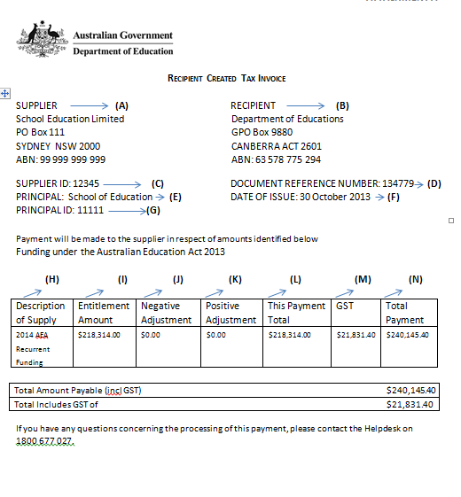

1. **Supplier:** - This field represents the details of the schools Approved Authority (Name, Address and ABN).
2. **Recipient:** - This field represents the details of the Commonwealth Department of Education (Name, Address and ABN).
3. **Supplier ID:** - The Commonwealth Department of Education’s unique numeric identifier for the Approved Authority (often referred to as AA ID).
4. **Document Reference Number**: This is the unique reference number relevant to this particular document.
5. **Principal**: The approved name of the School.
6. **Date of Issue**: Date the RCTI was generated.
7. **Principal ID**: The Commonwealth Department of Education’s unique number identifier for the School (often referred to as AGE ID).
8. **Description of Supply**: Description of the type of Funding being paid – in this sample template 2014 AEA Recurrent Funding is recurrent funding under the *Australian Education Act 2013* for the 2014 program year.
9. **Entitlement Amount**: Actual amount of funding the AA is entitled to receive in this payment but does not take into account any negative or positive adjustments that may be applied.
10. **Negative Adjustment**: If the Commonwealth Department of Education is recovering any outstanding amounts of recurrent funding for the current or previous program years, these are known as ‘offsets’ and an amount will be shown in the Negative Adjustment column.
11. **Positive Adjustment**: If the Commonwealth Department of Education owes the Approved Authority any outstanding entitlements that are not part of this payment Entitlement Amount but are included in the current payment, then additional amount is shown in the Positive Adjustment column.
12. **This Payment Total**: Total amount of payment, which includes any negative or positive payments being applied (but does not include GST). Therefore, the payment is calculated as: Entitlement Amount (I)– Negative Adjustment (J) + Positive Adjustment (K) = This Payment Total (L).
13. **GST**: Amount of GST applied.
14. **Total Payment**: Total amount of Payment inclusive of any negative, positive adjustment and GST.

FUAEA Payment Advice

The FUAEA (Funding under the Australian Education Act) Payment Advice provides the Approved Authority with a summary of the total amount being paid in a specific payment run.

A sample template of a beginning of year payment is included below along with a brief description of each field.

***Note:*** *The amounts shown in a payment advice are not the SRS amounts as spelled out in the Act. Schools will transition to the SRS over a period of time, and the 2014 amounts will have had the transition formula applied to them.*

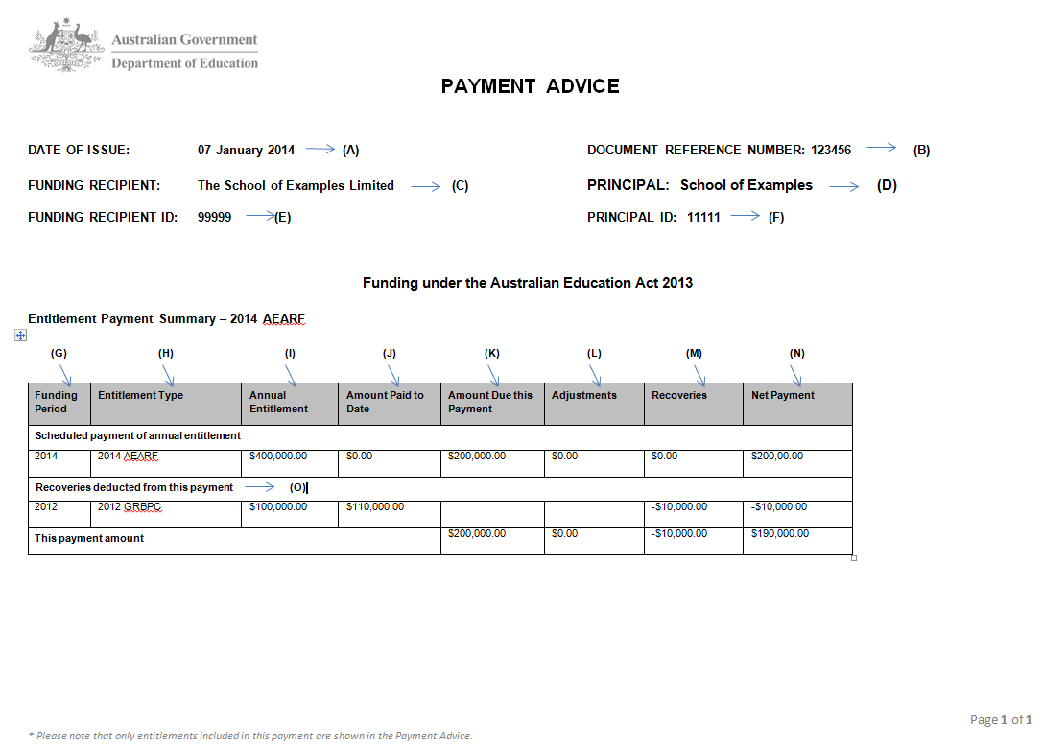

1. **Date of Issue**: Date the Document was generated.
2. **Document Reference Number**: the reference number relevant to this particular document.
3. **Funding Recipient**: - the name of the schools Approved Authority.
4. **Principal**: The approved name of the School.
5. **Funding Recipient ID**: - The Commonwealth Department of Education’s unique numerical identifier for the Approved Authority.
6. **Principal Id**: The Commonwealth Department of Education’s unique numerical identifier for the School.
7. **Funding Period**: Program Year for which the entitlement is paid for.
8. **Entitlement Type**: This represents the Program Name of the entitlement
9. **Annual Entitlement**: Total entitlement amount for the Program Year.
10. **Amount paid to date**: Total amount of payments already paid to date.
11. **Amount due this payment**: Amount of entitlement for this payment exclusive of any Adjustments and Recoveries.
12. **Adjustments**: If the Commonwealth Department of Education owes the Approved Authority any outstanding amounts due to the over recovery of entitlements, then an Adjustment amount is created and shown in this column.
13. **Recoveries**: If the Commonwealth Department of Education is recovering any outstanding amounts under this Program, these are known as offsets and applied in this column.
14. **Net Payment**: Total payment amount after any Adjustments/Recoveries are applied BUT excluding GST e.g. Amount due this payment (K) + Adjustments (L) – Recoveries (M) = Net Payment (N).
15. **Recoveries deducted from this payment**: Recoveries details will only appear in this section if there are outstanding Recoveries that are being recovered from previous program payments made under an Act other than the *Australian Education Act 2013*. The amount shown in the Recoveries Column (M) may consist of the full outstanding amount being recovered in this payment or an amount to be recovered as per a previously set repayment plan.

Excel Worksheet

The excel worksheet is a detailed companion to the Payment Advice. The worksheet will give the Approved Authority a comprehensive breakdown of the payment details for their school/s including Adjustments and Recoveries under the FUAEA program. Details of any outstanding Recoveries being applied from previous program payments under an Act other than the *Australian Education Act 2013* will be shown in the worksheet as per the blue highlighted area in the report sample below.





1. **Client Id**: The Department’s unique numerical identifier for the School (also known as an AGEID).
2. **Client Name**: The approved name of the school.
3. **Funding Period**: The program year to which the entitlement belongs to.
4. **Entitlement Type**: Description of the funding type being paid – in this sample template recurrent funding under the *Australian Education Act 2013* for the 2014 program year (AEARF = Australian Education Act Recurrent Funding).
5. **Annual Entitlement**: Total entitlement amount for the program year.
6. **Amount Paid to Date**: Total amount of payments already paid to date including positive adjustments.
7. **Amount Due this Payment**: Total amount to be paid in this payment.
8. **% of Entitlement**: The percentage of the annual entitlement paid in this payment.
9. **Adjustments**: If the Department owes the Approved Authority any money for a particular school under the FUAEA program, then an Adjustment will be shown at the school level.
10. **Recoveries**: If the Department is recovering any outstanding amounts under the FUAEA program for a school, then a Recovery amount is shown.
11. **Net Payment**: Total payment amount after any FUAEA Adjustments/Recoveries are applied e.g. Amount Due this Payment (G) +Adjustments (I) – Recoveries (J) = Net Payment (K).
12. **Primary FTE**: Total number of Primary Full Time Equivalent (FTE) students at the whole school level (eg main school location + any additional approved locations such as campuses) at the time of calculation.
13. **Secondary FTE**: Total number of Secondary Full Time Equivalent (FTE) students at whole school level (eg main school location + any additional approved locations such as campuses) at the time of calculation.
14. **Annual Base Amount**: often referred to as the Student Resource Standard (SRS) annual base amount exclusive of any loading.
15. **Annual Location Loading**: amount is based on the schools ARIA score
16. **Annual Size Loading**: annual amount paid to schools based on size characteristics eg: (Small, Medium or Large).
17. **Indigenous FTE**: total number of primary and secondary Full Time Equivalent (FTE) indigenous students at the whole school (eg main school + approved additional campuses) at the time of calculation.
18. **Annual Indigenous Loading**: the loading is calculated on the percentage of indigenous Full Time Equivalent (FTE) students at the whole school.

Excel Worksheet – cont’d

1. **ELP Proportion**: English Language Proficiency Proportion based on the number of students at the school for the year in which they are identified by ACARA as having a disadvantaged language background other than English students.
2. **Annual ELP Loading**: annual payment amount for students with a disadvantaged language background other than English students.
3. **Low SES – Q1 (%)**: schools proportion of ICSEA Q1 students used in the calculation of Low SES loading amount for the program year.
4. **Low SES – Q2 (%)**: schools proportion of ICSEA Q2 students used in the calculation of Low SES loading amount for the program year.
5. **Annual Low SES Loading**: Annual payment amount for the Low SES Q1 and Q2 values.
6. **SWD FTE**: total number of primary and secondary Full Time Equivalent (FTE) students with disabilities at whole school level e.g. main School + additional approved campuses at the time of calculation.
7. **Annual SWD Loading**: annual amount of SWD Loading in respect of students with disabilities.
8. **Primary Distance FTE**: the number of Primary Full Time Equivalent (FTE) students receiving distance education at the whole school level (main school + additional approved campuses) on the school census day.

AB. **Secondary Distance FTE**: the number of Secondary Full Time Equivalent (FTE) students receiving distance education at the whole school level (main

school + additional approved campuses) on the school census day.

AC. **Transition Group**: schools transitioning category of either ABOVE, BELOW or ON.

AD. **SES Score**: SES score used to calculate entitlements.

Recoveries under previous Program and Act - ie Recurrent Expenditure funding under the ***Schools Assistance Act 2008***

*or the* ***Schools Assistance (Learning Together – Achievement Through Choice and Opportunity) Act 2004***

AE. **Client Id**: The Department’s unique numerical identifier for the School (also known as an AGEID).

AF. **Client Name**: The approved name of the school.

AG. **Funding Period**: The program year to which the entitlement belongs to (ie program year prior to 2014)

AH. **Entitlement Type**: Description of the funding type under which Recoveries where calculated – in this sample template recurrent funding under the *Schools Assistance Act 2008* for the 2012 program year.

AI. **Annual Entitlement**: Total entitlement amount for the program year.

AJ. **Amount Paid to Date**: Total amount of payments already paid to date.

AK. **Recoveries**: If the Department is recovering any outstanding amounts under a previous Program and Act, then a Recovery amount is shown. Please note that this amount:

🞄 may consist of the full outstanding recovery amount for that program year; or

🞄 may be an amount as per a previously approved repayment plan, where the recovery is applied over multiple future payments.

AL. **Net Payment**: Total Recovery payment amount being applied.

**NOTE**: From 2015, if your school is receiving an adjustments for a previous program year under the FUAEA program, the details of that payment will be contained in a separate worksheet within the same payment documentation as your current FUAEA payment but under its own worksheet tab highlighted with the program year. See example above.