P3M3® Assessment Report
Department of Education, Employment and Workplace Relations (DEEWR)
Version
6 (Final)
Date Created
Friday, 24 November 2011
Date Updated
Wednesday, 29 July 2026
© Tanner James Management Consultants.
All rights reserved. No part of this publication may be reproduced, stored in a retrieval system, or transmitted in any form or by any means, electronic, mechanical, photocopying, recording or otherwise, without the written permission of Tanner James Management Consultants.
Classification: Unclassified

Document Control
Distribution List
Name | Position | Organisation
Michael Manthorpe | Deputy Secretary, Corporate & Network | DEEWR
Stephen Moore | Group Manager, Employment Systems | DEEWR
Susan Monkley | Group Manager, Technology Solutions | DEEWR
Helen Willoughby | Group Manager, Communication & Parliamentary | DEEWR
Craig Storen | Group Manager, Finance & Business Services (CFO) | DEEWR
John Howarth | Director | Tanner James
Anthony Court | Partner | KPMG
Revision History
Date | Version | Modified By | Changes Made, Review History
25/11/2011 | 2 | John Howarth | Clarifications and changes to the first draft
28/11/2011 | 3 | Elena Chirich | First draft for DEEWR review
29/11/2011 | 4 | Elena Chirich | Minor changes to the draft for DEEWR review
30/11/2011 | 5 | Elena Chirich | Updates to the draft as per DEEWR’s initial feedback
01/12/2011 | 6 | Elena Chirich | Updates as per DEEWR’s feedback

Contents
1 Executive Summary 4
1.1 Portfolio Management (assessed as level 2, repeatable) 4
1.2 Programme Management (assessed as level 1, aware) 5
1.3 Project Management (assessed as level 2, repeatable) 6
2 Introduction 7
2.1 Assessment summary 7
2.2 Report Purpose 7
2.3 Scope Inclusions 7
2.4 Scope Exclusions 8
2.5 Assessment Background 8
2.6 Assessment Approach 8
2.7 Key Definitions 8
3 Current P3M3® Ratings 10
3.1 Portfolio Management Maturity 10
3.1.1 Organisational Governance (level 3) 11
3.1.2 Management Control (level 3) 12
3.1.3 Stakeholder Engagement (level 2) 12
3.1.4 Benefits Management (level 2) 13
3.1.5 Financial Management (level 3) 13
3.1.6 Resource Management (level 2) 14
3.1.7 Risk Management (level 2) 14
3.1.8 Generic Attributes for Portfolio Management (level 2): 15
3.2 Programme Management Maturity 17
3.2.1 Organisational Governance (level 2) 19
3.2.2 Management Control (level 1) 19
3.2.3 Stakeholder Engagement (level 2) 19
3.2.4 Benefits Management (level 1) 20
3.2.5 Financial Management (level 2) 20
3.2.6 Resource Management (level 1) 21
3.2.7 Risk Management (level 2) 21
3.2.8 Generic Attributes for Programme Management (level 1): 22
3.3 Project Management Maturity 24
3.3.1 Organisational Governance (level 3) 25
3.3.2 Management Control (level 3) 26
3.3.3 Stakeholder Engagement (level 2) 27
3.3.4 Benefits Management (level 2) 27
3.3.5 Financial Management (level 3) 28
3.3.6 Resource Management (level 2) 28
3.3.7 Risk Management (level 3) 29
3.3.8 Generic Attributes for Project Management (level 2) 29
4 Appendix A – P3M3® Overview 32

Executive Summary

Portfolio Management (assessed as level 2, repeatable)
Level 2 maturity definition:
DEEWR ensures that each programme and/or project in its portfolio is run with its own processes and procedures to a minimum specified standard (there is limited consistency or coordination).
Headline issues:
Governance of the ICT investment is well defined and observed. However there is a sense of it being driven bottom-up as a compliance exercise to secure resources. Current governance structure separates ICT and business streams of activities, but combines delivery of changes with ‘business as usual’ operations.
Chart 1: Portfolio Management Maturity
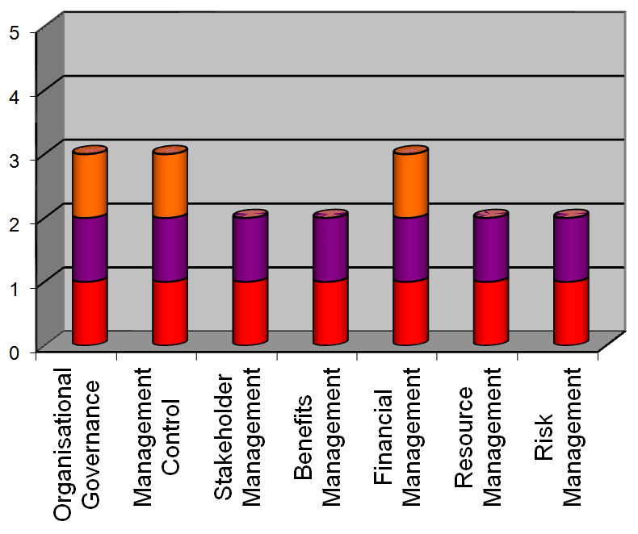
Table 1: Text version of Chart 1
Portfolio Management Maturity  Process Perspective | Score out of 5
Organisational Governance | 3
Management Control | 3
Stakeholder Management | 2
Benefits Management | 2
Financial Management | 3
Resource Management | 2
Risk Management | 2

Programme Management (assessed as level 1, aware)

Level 1 maturity definition:
DEEWR recognises programmes and runs them differently from projects (programmes are run informally with no standard processes or tracking system).

Headline issues:
DEEWR has no shared understanding of what programme management means. Programme management specific roles are not evident. While individuals have contemplated the practices required to manage such things as benefits and resources at programme level DEEWR has no formal approach - programmes are in essence managed using project management practices
Chart 2: Programme Management Maturity
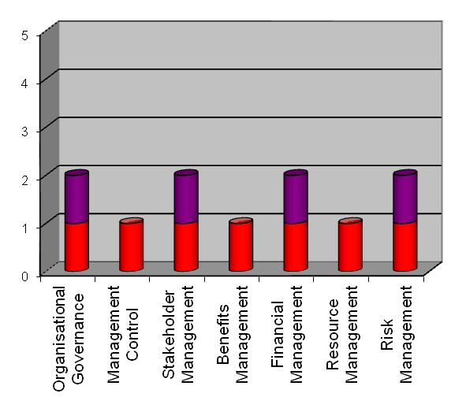
Table 2: Text version of Chart 2
Programme Management Maturity  Process Perspective | Score out of 5
Organisational Governance | 2
Management Control | 1
Stakeholder Management | 2
Benefits Management | 1
Financial Management | 2
Resource Management | 1
Risk Management | 2

Project Management (assessed as level 2, repeatable)

Level 2 maturity definition:
DEEWR ensures that each project is run with its own processes and procedures to a minimum specified standard (there is limited consistency or coordination between projects).

Headline issues:
DEEWR has embedded strong elements of project management. However it has weaknesses in three key areas – management of benefits, stakeholders and resources. The role of project sponsor is understated and undervalued.
Chart 3: Project Management Maturity
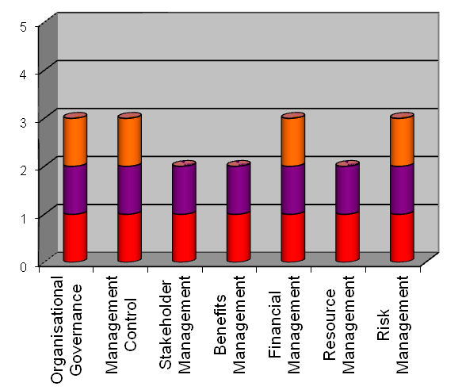
Table 3: Text version of Chart 3
Project Management Maturity  Process Perspective | Score out of 5
Organisational Governance | 3
Management Control | 3
Stakeholder Management | 2
Benefits Management | 2
Financial Management | 3
Resource Management | 2
Risk Management | 3

Introduction

Assessment summary
A P3M3® (Portfolio, Programme and Project Management Maturity Model) assessment of the Department of Education, Employment and Workplace Relations (DEEWR) ICT-enabled portfolio, programmes and projects has been conducted during November 2011. The following P3M3® ratings have been derived from that assessment by way of interviewing selected staff as well as reviewing defined guidance for management practices and examining specific information (e.g. plans and status reports) from the current portfolio, programmes and projects.
The future target ratings for DEEWR in Portfolio, Programme and Project Management Maturity, including strategies for capability improvement, will be developed separately from this report.
The following commentary shows the current maturity levels in each sub-model (portfolio, programme and project management) and exposes details for the seven process perspectives.
Assessments of other Commonwealth Government FMA agencies during 2010 and 2011 have yielded maturity scores in a range from 0 to 3, with the median level for Portfolio and Project Management sub-models being 2, and for Programme Management 1.

Report Purpose
The purpose of this assessment report is to:
- Report upon an assessment for DEEWR’s ICT-enabled initiatives covering Portfolio, Programme and Project Management maturity assessment; and
- Document DEEWR’s current P3M3® ratings.

Scope Inclusions
This P3M3® assessment covers the ICT-enabled project, programme and portfolio management activities across DEEWR. This included sampling sufficient projects and programmes for a representative sample set. In total twenty five successful interviews were conducted with staff across most DEEWR clusters. One interview was terminated as the nominated person for the P3M3 role of Programme Sponsor was not involved in any Programme Management activities and did not have sufficient visibility on Programme Management across the Department.

Scope Exclusions
Departmental programs (i.e. policy programs as opposed to ICT-enabled change programmes) are excluded from the assessment. Also projects that do not have an ICT component or are managed by DEEWR’s ICT service providers are excluded.

Assessment Background
This P3M3® assessment was undertaken in response to the directive from the Department of Finance and Deregulation that all FMA agencies conduct the assessment.

Assessment Approach
Prior to conducting interviews, Tanner James made an assessment of current documentation of management processes to gain an initial understanding of current formal methodologies. Prior to, during and after interviews with individual staff members, documentation from specific initiatives was reviewed.
For the purpose of this assessment, DEEWR conducts a single ICT-enabled change portfolio governed by the IT Committee. P3M3® defines a portfolio as “the totality of an organisation’s investment (or a segment thereof) in the changes required to achieve its strategic objectives”. Interviews were conducted with individuals in the P3M3® portfolio management roles of Portfolio Director, Investment Committee Member, Head of Portfolio Office, Head of Programmes and Head of Programme Office.
ICT-enabled change programmes have been assessed. These were determined to be larger initiatives under which there are one or more projects that are delivering ICT products, even where these programmes are being managed using project, rather than programme management disciplines. Departmental programs (i.e. policy programs) were not assessed as they do not satisfy the definition of P3M3® Programmes. Programme Management interviews were conducted with individuals in the P3M3® roles of Head of Programmes, head of Programme Office, head of Projects, Programme Sponsor, Business Change Manager and Programme Manager.
Project management interviews were conducted with individuals in the P3M3® roles of Head of Projects, Head of Project Office, Project Sponsor and Project Manager.
The assessment team has spent over 140 hours assessing DEEWR documented processes, interviewing staff and examining documentation from initiatives to develop this assessment report.

Key Definitions
P3M3® (Portfolio, Programme and Project Management Maturity Model) is an overarching capability maturity model containing three sub-models, Portfolio Management Maturity Model (PfM3), Programme Management Maturity Model (PgM3) and Project Management Maturity Model (PjM3)
Portfolio Management
The totality of an organisation’s investment (or a segment thereof) in the changes required to achieve its strategic objectives. Portfolio Management describes the management of an organisation’s portfolio of business change initiatives.
Programme Management
Programmes exist to manage the complexities involved in delivering beneficial change. Programme Management is focussed on the areas of tension between strategic direction, project delivery and operational effectiveness.
Project Management
A project is a unique set of coordinated activities, with definite starting and finishing points, undertaken by an individual or team to meet specific objectives within defined time, cost and performance parameters as specified in the business case. Project Management guides a project through a visible set of activities, from controlled start-up, through delivery, to controlled closure, and review.
Further definition of the model, process perspectives and maturity levels are provided at Appendix A of this report.

Current P3M3® Ratings
This part of the assessment report contains:
- Definitions from P3M3® (in italics) of DEEWR’s maturity level for each process perspective; and
- Key observations made by the assessment team (in plain text).

Portfolio Management Maturity
DEEWR’s Portfolio Management maturity level is 2: DEEWR ensures that each programme and/or project in its portfolio is run with its own processes and procedures to a minimum specified standard (there is limited consistency or coordination).
Chart 4: Portfolio Management Maturity
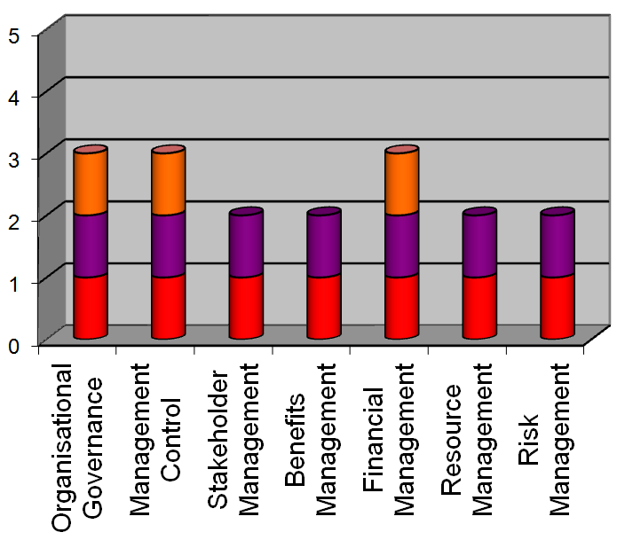
Table 4 Text version of Chart 4
Portfolio Management  Process Perspective | Score out of 5
Organisational Governance | 3
Management Control | 3
Stakeholder Management | 2
Benefits Management | 2
Financial Management | 3
Resource Management | 2
Risk Management | 2

Chart 5: Portfolio Management Generic Attributes
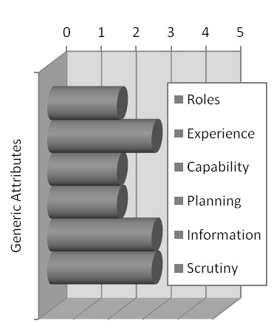
Table 5: Text Version of Chart 5
Portfolio Management  Generic Attributes | Score out of 5
Roles | 2
Experience | 3
Capability | 2
Planning | 2
Information | 3
Scrutiny | 3
Below are the key observations made by the assessment team during the portfolio management assessment, noting that, as per 2.5, for the purpose of this assessment, DEEWR conducts a single ICT-enabled change portfolio.

Organisational Governance (level 3)
Centrally defined organisational controls are applied consistently to the portfolio, with decision-making structures in place and linked to organisational governance.

Observations
- DEEWR follows an annual IT investment process, which is based on a bottom-up approach for presenting new initiatives. Recently more focus has been given to a holistic view and prioritisation of initiatives against consistent criteria. However, when investment decisions are made by the IT Committee, projects are grouped and reviewed for each cluster, and so individual cluster budgets impact investment decisions.
- Business areas are clearly involved in making decisions on the use of IT to ensure alignment with business priorities. However, the current governance model is not structured toward delivery of business change that is IT-enabled; separate bodies are involved in managing the business aspects of change and IT aspects of change.
- It was observed that management of Business As Usual (BAU) operations and delivery of new initiatives is not separated. This results in limited distinction between the effort and actions required to:
- run existing business programs that require supporting IT, and
- delivery of new IT-enabled business capabilities and program outcomes.
- It was noted that a holistic view on new change initiatives (projects and programmes) is reliant on network and relationships of key individuals rather than defined roles and responsibilities.
- Disregarding some differences in governance models implemented across different lines of business, overall guiding governance principles are consistent.

Management Control (level 3)
Portfolio management processes are centrally defined, documented and understood, as are roles and responsibilities for delivery.

Observations
- The annual IT investment process is consistent across all clusters: each initiative is documented first as a Concept Definition paper, then it is developed into a proposal, and finally, if approved by ITC, documented in a more detailed Project Management Plan.
- Terms of References across System Boards and Steering Committees appear to be consistent. However they do not provide necessary details; in particular they do not articulate individual Board or Committee members responsibilities on a portfolio level.

Stakeholder Engagement (level 2)
Portfolios will be communicated to stakeholders, but this is linked more to the personal initiative of portfolio managers than to a structured approach deployed by the organisation.

Observations
- Stakeholder engagement at DEEWR occurs at a cluster level due to diverse nature of cluster business and their stakeholders. This approach seems to be the most suitable given the array of stakeholders and a rare cross-over amongst clusters in this space.
- Although stakeholder engagement and communication seems to be implemented effectively, there is very little documentation on processes or structured stakeholder identification principles within each cluster. Documentation is mostly initiative specific and effectiveness of processes is reliant on key individuals driving the changes.

Benefits Management (level 2)
The development of the investment cycle will increase the awareness of the importance of identifying benefits and subsequently tracking whether they have been realised. However, realisation of benefits is still likely to be patchy, inconsistent and unmonitored.

Observations
- Benefits are identified for individual initiatives only, and there has been no evidence observed on managing benefits at a portfolio level.
- Benefits are documented mostly for compliance purposes in order to get an initiative approved and do not seem to be managed after that.
- Benefits ownership is not clear and / or inconsistent. In some cases business stakeholders believe IT is responsible for delivering benefits.
- Focus on benefits realisation seems to be increasing and new benefits management processes are being embedded for larger initiatives.

Financial Management (level 3)
There are established standards for the investment management process and the preparation of business cases. Portfolio investment costs are monitored and controlled.

Observations
- DEEWR’s financial management is one of the strongest perspectives at a portfolio level; with clearly structured and documented processes and rules.
- The same system (SAP) is used by the Department to track costs, and some Groups started using project server in parallel. Financial management processes, however, are mostly defined by reporting requirements and estimation templates. There are no specific guides on where in SAP to obtain necessary information and how to reconcile actuals from SAP with actuals from project server. This is reliant on individuals’ prior knowledge of the systems.
- There is still some grey area on costs of BAU vs change initiatives due to current governance structures, however senior DEEWR stakeholders have a good visibility of this on a portfolio level.
- Due to the time constraints of an annual investment cycle, there is limited flexibility to approve new investments identified during course of financial year, which limits DEEWR’s ability to respond to changing environment.

Resource Management (level 2)
The organisation has started to develop portfolio resource management processes and improve the identification and allocation of resources to specific initiatives. However, this is likely to be reliant on key individuals and does not assess the impact of resources allocation against the strategic objectives and priorities.

Observations
- Resource planning is developed bottom-up, based on skills and levels.
- Resource estimation for IT-enabled initiatives is inconsistent across clusters and groups. It is often perceived as a way to maintain current capability and is significantly dependent on experience and skills of Branch and/or Group Managers.
- Often there is no clear visibility on BAU resource requirements vs resourcing for new initiatives. This is due to project resourcing being usually considered via a BAU workforce planning process.
- The New Capability Development Framework is being implemented by DEEWR and Project Server is becoming more commonly used for resource utilisation tracking.

Risk Management (level 2)
There is generally a top-down approach to risk identification, focusing on major organisational initiatives, but some initiatives are increasingly carrying out bottom-up risk identification.

Observations
- The Risk Management Framework is documented and accepted across the department and processes are followed consistently across all clusters, particularly during investment decision-making.
- However, risks are usually identified and managed bottom-up for individual change initiatives and more strategic risks that do not take into consideration a difference between BAU and new initiatives. Risk aggregation seems to be mostly done at Group level (i.e. BAU structure) rather than IT portfolio level.
- Risk ownership is quite strong across the department, however it is clearly separated for business risks and IT risks.
- Risk review on a portfolio level is taking place regularly but it is focused on escalated risks of individual initiatives.
- It was noted that risk evaluation is inconsistent across clusters as some business areas are known for being more risk averse, while others are less so. Moreover, some areas follow risk processes mostly for compliance purposes, while a smaller grouping recognise value in developing and regular updating practical mitigation strategies.

Generic Attributes for Portfolio Management (level 2):
The six generic attributes and their assessment for the Portfolio Management sub-model are provided below.

Observations

Roles & Responsibilities (level 2)
Roles, responsibilities and competencies defined in some areas but not consistently across the organisation.
Terms of references for the ICT Committee and other executive governance bodies define the role and responsibilities of the committee in general, however specific roles and responsibilities of the Chair and members are not defined. In addition, there are some variances in the number, authority levels and frequency of meetings for governing bodies across clusters.

Experience in Portfolio Management (level 3)
Key individuals have practical delivery experience and track record.
Most executives and ITC members have some experience in portfolio management, which is a key reason for recent improvements in this area.

Capability Development (level 2)
Generic training may be provided in key concepts, and there may be individuals undertaking qualification training. Local sharing of knowledge may exist but mostly ad hoc.
Capability development is coordinated within DEEWR through a relatively new Capability Development Framework and leadership development (which is not tailored for P3M). No formal training courses have been provided on portfolio management, and knowledge is mostly obtained on the job and through some coaching initiatives.

Planning & Estimating Process (level 2)
Plans exist but are not underpinned by consistent development methodology, yet may still be effective locally. Planning seen as activity tracking rather than proactive forecasting. Estimation is more “guesstimation” and does not use standard techniques.
ITC develops an annual plan of investments for each financial year. It has a reference to general DEEWR strategic values, however a direct correlation between ICT Strategy and IT Investment decisions has not been observed. Detailed planning and estimating is done at individual project and programme level, and there is no clear aggregate IT Investment plan demonstrating interdependencies across projects and programmes. Estimation success is mostly dependant on experience and skills of individuals in addition to function point analysis method, which is used in some groups.

Information & Documentation (level 3)
Information has a refresh cycle or is regularly accessed. Organisation-wide information standards on confidentiality, availability and integrity. Formal information release management procedures.
ITC is provided with an elaborative and consistent pack of documents and reports on each considered or approved project / programme. Appropriate management of documents presented to the committee, including agendas, briefing papers and minutes.

Scrutiny & Review (level 3)
Independent reviews take place. Scrutiny largely for compliance reasons, identifying failures rather than opportunities for improvement.
Regular internal audits are focusing on individual initiatives within a portfolio. In addition, an external ICT advisor, who is a member of the IT Committee, provides recommendations for improvement of portfolio management.

Programme Management Maturity
DEEWR’s Programme Management maturity level is 1: DEEWR recognises programmes and runs them differently from projects (programmes are run informally with no standard processes or tracking system).
Chart 6: Programme Management Maturity
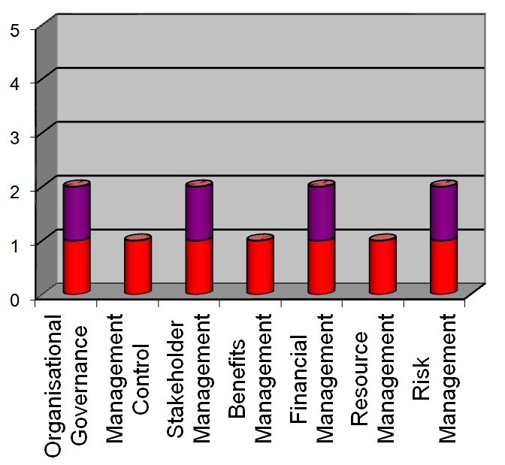
Table 6: Text Version of Chart 6
Programme Management  Process Perspective | Score out of 5
Organisational Governance | 2
Management Control | 1
Stakeholder Management | 2
Benefits Management | 1
Financial Management | 2
Resource Management | 1
Risk Management | 2

Chart 7: Programme Management Generic Attributes
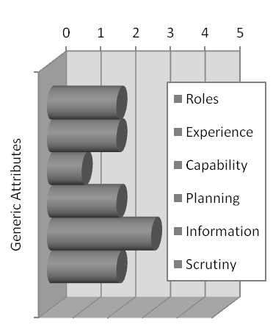
Table 7: Text Version of Chart 7
Programme Management  Generic Attributes | Score out of 5
Roles | 2
Experience | 2
Capability | 1
Planning | 2
Information | 3
Scrutiny | 2
Below are the key observations made during the programme management assessment, noting that, as described in the following paragraph, departmental programs were not assessed.
Only ICT-enabled change programmes have been assessed. These were determined to be larger initiatives under which there are one or more projects that are delivering ICT products.

Overall observations
Programme management in DEEWR is less mature than portfolio and project management. Project management disciplines are being applied to programmes with subordinate projects, rather than the programme management disciplines underpinning P3M3®. Successful management of programmes is highly dependent upon key, experienced individuals; in their absence other staff would struggle due to lack of documented management guidance.

Organisational Governance (level 2)
Programme management from an organisational perspective is beginning to take shape, but with ad hoc control and no clear strategic control. Roles and responsibilities will be inconsistent, as will reporting lines.

Observations
- Current governance model approach is blending BAU and change, which indicates programme level governance is not well understood and it seems that programmes report to both business and IT bodies.
- Governance lines are not always documented for programmes; however, interviewed stakeholders believe they are well understood such that programmes maintain alignment with DEEWR and broader Government strategy.

Management Control (level 1)
Programme management terminology is used by some members of the organisation but not consistently, and possibly not understood by all stakeholders. Programmes are conducted and managed according to individual preferences.

Observations
- Understanding of programme management discipline (including lifecycle and specific programme roles) is inconsistent across clusters. Decisions on whether to run an initiative as a programme are made by leadership within each cluster and there don’t seem to be common criteria for a programme definition.
- Programmes are usually represented by large or multiple projects, but there is no common programme management terminology or templates (e.g., “programme”, “government program” and “project” are used as interchangeable terms).
- Planning on a programme level usually takes place only during concept definition, after which focus shifts to individual projects within a programme.
- Programme control usually takes the form of a traffic light report from each project within the programme.

Stakeholder Engagement (level 2)
Some programmes will be communicated to stakeholders, but this is linked more to the personal initiative of programme managers than to a structured approach being deployed by the organisation.

Observations
- On a programme level stakeholders are usually engaged regarding change programmes (e.g., iterative consultations with external customers, other government authorities and industry bodies). These interactions seem to be developed and undertaken as part of ongoing BAU engagement by DEEWR clusters.
- There is no consistent approach to stakeholder engagement for programmes at DEEWR, and the majority of communication is based on personal relationships and, therefore, driven by individuals rather than established processes.
- Comprehensive communication plans are sometimes developed for more complex programmes affecting multiple stakeholders, however these plans are inconsistent across programmes and mostly based on prior experience of programme sponsors and re-use of earlier programme documents.
- Success of internal programmes is usually due to good working relationships between development teams and business stakeholders.
- The DEEWR Corporate Communication team is not utilised by most programmes.

Benefits Management (level 1)
There is some recognition that the concept of benefits can be differentiated from programme outcomes.

Observations
- Benefits management maturity at DEEWR is consistently lower than other management disciplines. Benefits are usually well defined and better monitored for government programs. As for IT-enabled changes, benefits do not need to be identified on a programme level for investment or other considerations, and in the best case are presented as an aggregate of project benefits.
- Benefits ownership normally seem to be shared by business and IT, however the ownership is rarely documented, and business areas do not always take responsibility for benefits realisation.
- None of interviewees have participated in a programme closure process. Some interviewees commented that benefits are usually discussed at the beginning, but their realisation progress has been rarely followed up or measured.

Financial Management (level 2)
Programme business cases are produced in various forms and the better and more formal cases will present the rationale on which to obtain organisational commitment to the programme. Overall cost of the program is not monitored or fully accounted for.

Observations
- Majority of programmes that are managed as large projects, have the same financial management approach as on the project level, and thus track budget utilisation on an individual project base. However, total budget and total costs on programmes are visible on a departmental level.
- Some areas within DEEWR can track programme costs separately to BAU, however the process for this is not documented, is inconsistent across clusters and is reliant on key individuals. In one interview it was disclosed that if a particular person decides to leave, the Group will not have other skilled resources to pick up the budget tracking processes without major issues.
- There is no specific documented guidance regarding the financial control and reporting. This has lead to variations across programmes in terms of aggregated financial visibility at programme level.
- Financial information for programmes is available from the financial system, but use of this information varied from programme to programme, mostly due to inconsistent definitions of a programme.

Resource Management (level 1)
There is some recognition within the organisation of the need to manage resources effectively to enable successful delivery of programmes, but little evidence of resources acquisition, planning or management.

Observations
- There has been no evidence observed for resource management being conducted on a programme level. Resources are usually specified (including their skill and levels) on an individual project base, and then summarised on a Branch / Group / Cluster level. This means that quality of the programme level estimates is as good as the quality of the individual project estimates, and some estimates include only IT component (no structured planning for SME resources).
- Often resource planning is based on BAU processes, does not clearly separate BAU and new initiatives requirements, and is about capacity planning based on existing capabilities.
- Some believe resource planning is focused on fulfilling the current capacity.
- Project Server is being implemented as one system for resource utilisation monitoring, however some business areas have not started using it and advised that forecast data received from SAP does not yet always provide valid estimates.
- Once a programme is approved, responsibility for delivery falls on respective groups and branches, and when business resources are not allocated to programmes, some people become overloaded.

Risk Management (level 2)
Risk management is recognised and used on programmes, but there are inconsistent approaches which result in different levels of commitment and effectiveness.

Observations
- It was noted that significant progress has been achieved on risk management maturity within DEEWR and a consistent risk management approach is applied across the organisation: one system is used to manage risks across all clusters, the registers and mitigation plans are created in the same manner and are regularly updated.
- Programme risk registers are usually an aggregate of risks from subordinate projects, however frequency of risk reviews and a level of aggregation varies across clusters.
- Similarly to the portfolio level, risks are managed separately for IT and business areas, and some interviewees commented that they are not confident that risks for individual projects they are responsible for cover all risk aspects on a programme level.

Generic Attributes for Programme Management (level 1):
The six generic attributes and their assessment for the Programme Management sub-model are provided below.

Observations

Roles & Responsibilities (level 2)
Roles, responsibilities and competencies defined in some areas but not consistently across the organisation.
Given that programmes are being managed using project management method, staff generally commented that they understood their role, however there is very limited understanding of programme management specific roles apart from the generic functions documented in terms of References for relevant Committees and Boards.

Experience in Programme Management (level 2)
Key individuals may have practical delivery experience and track record.
Interviewees felt that those involved in programme management are appropriately experienced and that DEEWR top management have substantial experience in programme management. However, it was observed that key stakeholders do not clearly differentiate between programme management and project management, so there is limited comprehension of what constitutes experience in programme management. Also programme management is confused by some stakeholders with a delivery of policy programs.

Capability Development (level 1)
Training provision is uncoordinated, with little or no knowledge sharing.
There is no evidence of capability development in programme management. Skills are normally obtained through on the job training and personal relationships. There is no formal induction on programme management for new starters.

Planning & Estimating Process (level 2)
Planning is seen as activity tracking rather than proactive forecasting. Estimation is more “guesstimation” and does not use standard techniques.
Some interviewees believe estimation practice for programmes is embedded, however there was no evidence observed on it being documented or followed consistently across clusters, and the majority of feedback indicates that it is based on personal experience. Programmes do not have a consolidated schedule that draws together the subordinate projects, interdependencies and resources; it is rather a set of separate project schedules. Programme management plans exist, but they use the same approach and terminology as project management plans.

Information & Documentation (level 3)
Information has a refresh cycle or is regularly accessed. Organisation-wide information standards on confidentiality, availability and integrity. Formal information release management procedures.
Similarly to the Portfolio level, reporting and documentation on programmes is robust. Some stakeholders recognise the importance of good documentation practice and recognise the need for all programmes to align. Focus on documentation is normally higher during initiation and definition stage of programmes. Documentation is consistent when standard processes and templates are in use (e.g., risk management, PMPs).

Scrutiny & Review (level 2)
Local reviews, with some corrective actions undertaken within the group.
Periodic internal audits are conducted for some aspects, however there is no tailored review approach on a programme level.

Project Management Maturity
DEEWR’s Project Management maturity level is 2: DEEWR ensures that each project is run with its own processes and procedures to a minimum specified standard (there is limited consistency or coordination between projects).
Chart 8: Project Management Maturity
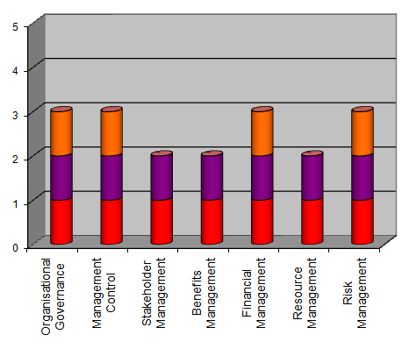
Table 8: Text Version of Chart 8
Process Perspective | Score out of 5
Organisational Governance | 3
Management Control | 3
Stakeholder Management | 2
Benefits Management | 2
Financial Management | 3
Resource Management | 2
Risk Management | 3

Chart 9: Project Management Maturity Generic Attributes
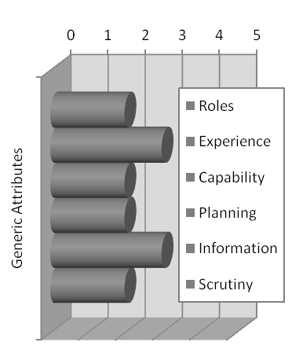
Table 9: Text Version of Chart 9
Project Management  Generic Attributes | Score out of 5
Roles | 2
Experience | 3
Capability | 2
Planning | 2
Information | 3
Scrutiny | 2
Below are the key observations made during the project management assessment.

Organisational Governance (level 3)
Centrally defined organisational controls are applied consistently to all projects, with decision-making structures in place and linked to organisational governance.

Observations
- Overall project governance in DEEWR is quite strong and, with the exception of a few differences across various lines of business, consistent across projects: there is a central body that monitors and influences progress of all projects; there is a consolidated reporting process; key roles and responsibilities are documented in PMPs and individual Boards and Committees’ Terms of References.
- It was noted that each assessed project has a clear direct reporting line to a Board or Committee; however, most project managers and some project sponsors do not have a clear understanding of how the boards and committees interact (e.g., many project managers and project sponsors could not explain differences in authorities between various project(s) boards and project(s) steering committees). This is mostly due to intertwined management approach to BAU and change initiatives governance, and potentially an excessive number of Boards and Committees. In addition, some progress monitoring bodies (e.g., Project Review) are perceived as a governance body, when they don’t seem to have a decision-making authority.
- Although overall governance principles are consistent across the department, some differences across clusters were observed.

Management Control (level 3)
There is a centrally defined and documented approach to a project management life cycle and controls, and it is applied in all projects by capable staff who support project teams.

Observations
- All projects across DEEWR follow an annual investment process, including longer-term projects that are implemented over multiple years. This ensures efficient control over projects.
- Project initiation process, particularly during concept definition and proposal development stage, is consistent across all clusters, although it was observed that the level of control diminishes towards the project completion stage and not all projects are closed according to established methodology (i.e. not all projects seem to have closure reports).
- DEEWR established a thorough project review process. All assessed projects are regularly reviewed from the same perspective (e.g., providing standard “project on a page” reports), and have stage gate reviews that require a formal sign off by sponsors (e.g., sign off on PMP and then on requirements). The sign off, however, is followed mostly for compliance purposes in some areas.
- PPMO established a strong project management framework supported by a comprehensive governance model, which provides consistent controls to all projects. The framework is getting more widely accepted within the department; however, it was observed that business areas outside the Employment Cluster have a certain resistance level in fully embracing the framework due to its cluster affiliation.
- Some ICT-enabled projects have multiple Project Sponsors due to more than one business areas benefiting from the projects. This leads to less clear ownership for success of the projects, and in some cases to a transfer of responsibilities for the success to IT project teams. Best practice frameworks suggest that ultimate accountability for the project should rest with one individual (potentially a representative from the area that is expected to achieve most benefits).

Stakeholder Engagement (level 2)
Projects will be communicated to stakeholders, but this is linked more to the personal initiative of project managers than to a structured approach being deployed by the organisation.

Observations
- The majority of project stakeholder engagement is conducted via project reporting and seem to be the ultimate responsibility of business sponsors. Engagement of stakeholders beyond the project teams / Boards / Committees resides with individual committee members. The concept of stakeholder engagement is understood but most project managers were not aware of documented guidance.
- Project status reporting is satisfying the communication needs of some project stakeholders but not others. There appears to be a common separation of business and IT teams and limited engagement across them.
- Identification of stakeholders and communication plans are usually developed at a high level as a part of PMPs, and seem to be created mostly for compliance purposes. Although communication with external stakeholders seems to occur, there are no common processes, it is not well documented, and is mostly reliant on individual initiative and experience.
- While there are basic communications plans in project templates, there is little guidance known to interviewees on how to plan for effective project communication.

Benefits Management (level 2)
Benefits are recognised as an element within project business cases. There may be some documentation on who is responsible for particular benefits and their realisation, but this is unlikely to be followed through or consistent.

Observations
- Benefits definition for projects is consistent across projects, however often it is driven by compliance purposes in order to obtain an approval for an initiative.
- Most projects list benefits in key project documentation, but benefits are not always measurable and often described at a high level.
- Focus on benefits is significantly decreasing once projects are approved, and there was no evidence observed of benefits realisation plans put in place. However, it is recognised that DEEWR is trying to reinforce a policy on effective benefits management for critical projects.
- Ownership of benefits is not well understood by all project stakeholders. Some interviewees believe accountability lies with IT delivery teams. There was no evidence observed of benefits ownership being documented.

Financial Management (level 3)
There are centrally established standards for the preparation of business cases and processes for their management throughout the project life cycle. Project managers monitor costs and expenditure in accordance with organisational guidelines and procedures, with defined interfaces with other financial functions within the organisation.

Observations
- Every project has a fairly consistently structured budget, which is based on a commonly used estimating template.
- Most projects would also have forecasted expenditure until the end of financial year, and would identify expected over- or under-budget.
- Although well managed, there is no practical documentation on budget tracking, and the process relies on project managers’ experience, and there are no unified guides or project processes for financial reconciliations.
- Conflicting opinions on project budgeting were observed whereby some business interviewees commented that the ICT project budget does not address all of the project costs and would include only CAPEX without visibility on the total cost of ownership, yet some interviewees commented that the ICT project budgets are comprehensive.
- It was observed that estimates are usually delivered by a combined effort from business and IT areas, however it seems to vary across clusters and some interviewees commented that their budgets were set without consulting ICT specialists.

Resource Management (level 2)
Resources are being deployed across the organisation and individual projects have an approach to resource acquisition, planning or management. However, there is little evidence of consistency of approach.

Observations
- Resources planning and allocation is becoming more consistent with the recent implementation of “Connect” (SAP module).
- Resource estimation is mostly bottom-up driven, when resource requirements for individual initiatives and BAU functions are aggregated on Branches / Groups and Cluster levels. At the same time there is a strong focus on resources allocation within current capabilities as it is not always possible to obtain resources with particular skills within required timeframes.
- Most IT projects would develop realistic resources plans, however often requirements for business Subject Matter Experts are not included. Current resource management approach does not provide realistic overview on spikes and downtimes.

Risk Management (level 3)
Project risk management is based on a centrally defined process that is cognisant of the organisation’s policy for the management of risks and is used consistently.

Observations
- Risk management process is well documented and is evidenced by consistent implementation across clusters. Risks are identified from a concept proposal stage (at this stage is mostly compliance driven), and iteratively managed until project completion under clear escalation guidelines.
- The organisation has a strong risk management focus, resulting in every project being assessed for risk, having a risk register, all registers being consistent across the assessed projects, and senior management reviewing key risks on a regular basis.
- It was noted that although there are common guidelines for risk assessments, it is believed that risk levels are not always consistent across projects, and particularly clusters (e.g., what might be identified as a high project risk within one cluster, might be raised as a lesser priority project risk within another cluster).
- Risk ownership typically identifies an accountable group or branch.
- Project status reporting to ITC and System Boards consistently addresses project risks, however the risks reflect IT and business component separately and do not consolidate both aspects under the same project.

Generic Attributes for Project Management (level 2)
The six generic attributes and their assessment for the Project Management sub-model are provided below.

Observations

Roles & Responsibilities (level 2)
Roles, responsibilities and competencies defined in some areas but not consistently across the organisation.
It was observed that in general roles and responsibilities are well understood and often supported by governance documentation (usually PMP). However, project documentation describes roles at a high level, which sometimes makes it challenging for staff that are new to project discipline to grasp their responsibilities. This leads to some inconsistencies in project responsibilities across clusters.

Experience in Project Management (level 3)
Key individuals have practical delivery experience and track record.
Most interviewees have some qualifications and /or strong experience in project management. However, experience varies across clusters, and in some instances individuals are appointed to project manager positions due to their line management experience rather than professional project management skills.

Capability Development (level 2)
Generic training may be provided in key concepts, and there may be individuals undertaking qualification training. Local sharing of knowledge may exist but mostly ad hoc.
Project capability development is not formalised yet, however some generic project management courses are offered to staff. DEEWR mostly relies on engaging already experienced and qualified people. It is planned for the new Capability Development Framework to include a career development path for Project Managers.

Planning & Estimating (level 2)
Plans exist but are not underpinned by consistent development methodology, yet may still be effective locally. Planning is seen as activity tracking rather than proactive forecasting. Estimation is more “guesstimation” and does not use standard techniques.
Estimates and plans are developed on various approaches across clusters (e.g., people based or project lifecycle / activity based), and usually are milestone-driven. There are no guidelines or requirements for demonstrating projects critical path or dependencies. The planning and estimating techniques are dependent on individual experience and seem to vary in cost components (e.g., some projects include only CAPEX, others include OPEX as well).

Information & Documentation (level 3)
Information has a refresh cycle or is regularly accessed. Organisation-wide information standards on confidentiality, availability and integrity. Formal information release management procedures.
It was evident that all assessed projects are supported by key documentation in a standard format. Senior project stakeholders believe that project documentation is up-to-date and approved. Furthermore, there are corporate tools for centralised document management (e.g., SharePoint2010), however not all assessed projects utilise the tools and key documentation on those projects is not accessible unless requested.

Scrutiny & Review (level 2)
Local reviews, with some corrective actions undertaken within the organisation.
Some projects are regularly undergoing internal reviews by an internal audit function, however the reviews are not focused on project management rigor. At the same time PMPs for all projects are reviewed by PPMO for compliance purposes.

Appendix A – P3M3® Overview
P3M3® is an overarching model containing three sub-models, Portfolio Management Maturity Model (PfM3), Programme Management Maturity Model (PgM3) and Project Management Maturity Model (PjM3);
For each of the three sub-models P3M3® examines up to 7 different process perspectives (Management Control, Benefits Management, Financial Management, Stakeholder Management, Risk Management, Organisational Governance and Resource Management). Within each perspective 5 levels are used to describe maturity, 1 – Aware, 2 – Repeatable, 3 - Defined, 4 – Managed, 5 – Optimised. These levels can be applied independently within each model, or across all three to assess overall P3M3® maturity.
3 Sub-models
Portfolio Management
The totality of an organisation’s investment (or a segment thereof) in the changes required to achieve its strategic objectives. Portfolio Management describes the management of an organisation’s portfolio of business change initiatives.
Programme Management
Programmes exist to manage the complexities involved in delivering beneficial change. Programme Management is focussed on the areas of tension between strategic direction, project delivery and operational effectiveness.
Project Management
A project is a unique set of coordinated activities, with definite starting and finishing points, undertaken by an individual or team to meet specific objectives within defined time, cost and performance parameters as specified in the business case. Project Management guides a project through a visible set of activities, from controlled start-up, through delivery, to controlled closure, and review.
7 Process Perspectives
1. Management Control
This covers the internal controls of the initiative and how direction is maintained throughout its life cycle, with appropriate break points to enable it to be stopped or redirected by a controlling body if necessary. Best practice is characterized by clear evidence of leadership and direction, scope, stages, tranches and review processes during the course of the initiative.
2. Benefits Management
This ensures the desired business outcomes are clearly defined, measurable and ultimately delivered through a structured approach. Best practice recommends that benefits are assessed and approved by the organizational areas that will deliver them. Benefit dependencies and other requirements should be clearly defined, and understanding gained on how the initiative’s outputs will deliver the benefits.
3. Financial Management
This ensures that likely costs are captured and evaluated in a formal business case and are categorized and managed over the investment life cycle. There should be appropriate involvement from the organization’s financial functions, with approvals being embedded in the broader organizational hierarchy. Best practice suggests that a business case should define the value of the initiative to the business and contain a financial appraisal of the possible options.
4. Stakeholder Management
Best practice suggests that both internal and external stakeholders are analysed and engaged in order to achieve the initiative’s objectives. Stakeholder Management includes communications planning, the effective identification and use of different communications channels, and techniques to enable objectives to be achieved.
5. Risk Management
This views the way in which the organization manages threats to, and opportunities presented by, the initiative. Risk Management maintains a balance of focus on threats and opportunities, with appropriate management actions to reduce or eliminate the likelihood/impact of any identified threat.
6. Organizational Governance
This looks at how the delivery of initiatives are aligned to the organisation’s strategic direction, including start-up, closure and during the initiative’s lifecycle. This perspective looks at how the impact of external factors might be controlled/mitigated, as opposed to Management Control, which considers how internal control is maintained.
7. Resource Management
This covers management of all resources required for delivery, including human resources, buildings, equipment, supplies, information, tools and supporting teams. A key element is the process for acquiring resources and how supply chains are utilized to maximize their effective use. In best practice there will be evidence of capacity planning and prioritization to enable effective resource management.
5 Maturity Levels
Maturity Level 1 - Awareness of Process
- Processes are not usually documented, actual practice is determined by events or individual preferences, and performance is variable.
- Successful initiatives are often based on key individuals’ competencies rather than organization-wide capability and past successes can not be repeated consistently.
- Processes are undeveloped or incomplete. There is little or no guidance or supporting documentation and even terminology may not be standardized.
Maturity Level 2 - Repeatable Processes
- Basic management practices, e.g. tracking expenditure and scheduling resources, are in place and being improved. Key individuals are trained and demonstrate a successful track record and through them, the organization is capable of repeating success.
- Initiatives are performed and managed according to their documented plans; project status and delivery is visible to management at defined points.
- There may still be inadequate measures of success; unclear responsibilities; ambiguity/inconsistency in business objectives; unintegrated Risk Management; limited Change Management; and inadequacies in communications strategy.
Maturity Level 3 – Defined Processes
- Management and technical processes are documented, standardised and integrated to some extent with business processes. There is some process ownership and a group responsible for maintaining consistency and delivering process improvements.
- Senior management are engaged consistently, providing active and informed support.
- There is an established training programme to develop individual’s skills and knowledge.
Maturity Level 4 – Managed Processes
- The organization has defined processes that are quantitatively managed, i.e. controlled using metrics. There are quantitative objectives for quality and process performance, and these are being used in managing processes.
- Top management are proactively seeking out innovative ways to achieve goals.
- Using metrics, management can effectively control processes and identify ways to adjust and adapt them to particular initiatives without loss of quality.
Maturity Level 5 – Optimized Processes
- There is focus on optimization of quantitatively managed processes to account for changing business needs. The organisation exhibits continuous process improvement, and can show strong alignment of organizational objectives with business plans.
- Top managers are seen as exemplars, reinforcing the need and potential for capability and performance improvement.
- Information from process and product metrics enables the organisation to understand causes of variation and to optimize its performance.

