**Certification of Compliance with the Guidelines on Information and Advertising Campaigns by Australian Government Departments and Agencies**

I, Lisa Paul, certify that phase two of the Child Care Assistance Campaign complies with the *Guidelines on Information and Advertising Campaigns by Australian Government Departments and Agencies* and all relevant government policies and laws.

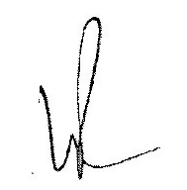

Lisa Paul, PSM

Secretary

Department of Education, Employment and Workplace Relations

24 May 2011