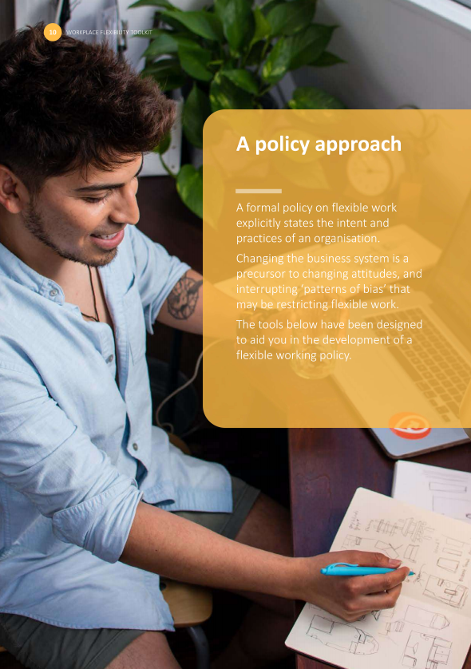

Below are key features of a flexible working policy, adapted from the Workplace Gender Equality Agency resource Developing a flexible working arrangements policy.
Area | Key features that may be included
Purpose | Provide a level of autonomy and flexibility within work role to accommodate various priorities at work, home and in community:  - Vocational education while in paid work  - Caring, parenting and/or cultural responsibilities while in paid work  - Managing health/medical issues while in paid work  - Reduced working hours whilst phasing in or out of paid work  - Any other personal commitments  Describe the process and procedures for establishing flexible working arrangements
Guidelines and procedures | DEFINITIONS  - Clear definitions of key terms (e.g. flexible working, official worksite, alternative location) and options available (e.g. compressed hours, job-sharing, purchased leave)  ELIGIBILITY AND EXCLUSIONS  - An outline of the conditions/exclusions applicable to employment status, tenure, to access flexible working arrangements  - An outline of the conditions/exclusions applicable to variable working hours, to leave and other Absences when working flexibly  PROCESS  - An outline of the process involved in identifying positions eligible for flexible working arrangements or aspect of working arrangements that could possibly be modified  - An outline on developing and implementing effective consultation mechanisms which encourage cooperation and engagement between employees and the employer  - An outline of the operational process and steps involved in applying, reviewing, accepting or rejecting application requests (e.g. application, approval levels, timeline for approval/denial, training requirements, written agreements)  - An outline of the operational process and steps involved in changing/modifying or terminating/withdrawing a flexible working arrangement  - An outline of support, materials, and equipment provided  - An outline of the specific requirements for record keeping, reporting and monitoring of use  - An outline of the expectations imposed upon employees who have entered into a flexible working arrangement and their managers:  - Define the responsibilities of supervisors and managers of employees working flexibly  - Define the responsibilities of employees working flexibly (e.g. performance expectations and monitoring, communication protocols, occupational health and safety issues)  PERFORMANCE AND REVIEW  - A statement confirming employees working flexibly access the same opportunities as other employees (e.g. work assignments, awards and recognition, development opportunities, promotions) and that the performance of employees working flexibly is evaluated consistent with the employer’s regular performance management system  - A commitment to regularly review written agreement of the flexible working arrangements in place  - An outline of the consequences of breaches of flexible working arrangements rules and conditions
References and resources | - A reference to relevant governing legislations such as Fair Work Act 2009 and National Employment Standards  - A reference to relevant internal policies (e.g. gender equality policy, family-friendly policies, IT and cybersecurity policies, occupational health and safety policy)
For more information please refer to the Flexible by Design webpage on the Queensland Government webpage: https://www.forgov.qld.gov.au/flexible-by-design

