8

Clarification

# Industry Cluster Governance Arrangements

28 September 2022

1. overview of the industry Cluster Program governance ARRANGEMENTS

Central to the design of the *Stage One Industry Clusters Grant Opportunity Guidelines* (the Guidelines) was the requirement that applicants provide evidence of strong industry leadership and ownership and propose governance structures that both support and provide a high level of industry engagement for the sectors within their remit.

The Government is committed to delivering a collaborative, tripartite VET system that brings all parties to the table to find solutions to skills and workforce challenges. In line with this, Industry Clusters are expected to be tripartite. This will be demonstrated by employer organisations and unions aligning on Industry Cluster governance (board composition, membership structures), and operational arrangements (strategic taskforces and technical sub-committees). Participation by employer organisations and Unions is intended to be fair and equitable.

The Guidelines specify that Industry Clusters are to be established with high performing boards that are well-regarded and balance the interests of all industry stakeholders. These boards will be required to provide strategic direction, actively drive organisational performance and effectively manage conflicts of interest.

The Guidelines set out the below principles as guidance for Industry Clusters to develop their governance structures. Each Cluster has flexibility to determine the governance, organisational and sub-committee structures that best meet the needs of their industries and enable them to deliver on their critical functions. However, it is recommended that all stakeholders, including employers and employees, have a voice in the Cluster governance through board composition, membership structures and/or at the strategic taskforce and technical sub-committee levels.

Boards must have a combination of industry-specific expertise with deep connections to industry, and professional board expertise. This will support independent decision making, while still ensuring all industry players have confidence in the Industry Cluster itself. The preferred legal structure for Industry Clusters, is that they be established as not-for-profit companies limited by guarantee under the *Corporations Act 2001* (Cth). The Guidelines are clear that the preferred governance of the Industry Clusters is that they be structured to provide for;

* + 1. a skills-based board with a mix of representative and independent board directors, a majority of which must be independent directors. The board should preferably comprise no more than nine board directors including the Chair;
    2. a membership base that provides for industry ownership, which facilitates fair and equitable representation of different stakeholder interests e.g. employer and employee;
    3. a high calibre Chief Executive Officer (CEO) appointed by and reporting directly to the board;
    4. staff/secretariat with research, technical and administrative capabilities to support the functions of the board, the CEO and the work of the taskforces/sub-committees; and
    5. strategic taskforces and technical advisory sub-committees to underpin and inform the strategic direction of the board, and the work of the Cluster.

1. role and BOARD COMPOSITION

Industry Cluster Boards will perform their role and functions in line with best practice corporate governance principles. This role will involve setting the strategic direction for the organisation and monitoring the implementation of that strategy. The board will be expected to focus on the financial and organisational performance of the organisation, as well as overseeing risk, assurance and compliance activities. This compliance role will involve ensuring the Industry Cluster is acting in accordance with the terms of its grant agreement for the program.

Expectations regarding board composition are set out above. It is expected that boards will be skills-based, with a mix of representative and independent board directors, a majority of which are independent directors, and with the board to preferably comprise no more than nine board directors including the Chair.

These expectations allow for flexibility in how Industry Clusters constitute their boards. Two examples of board compositions that would meet these expectations are set out below.

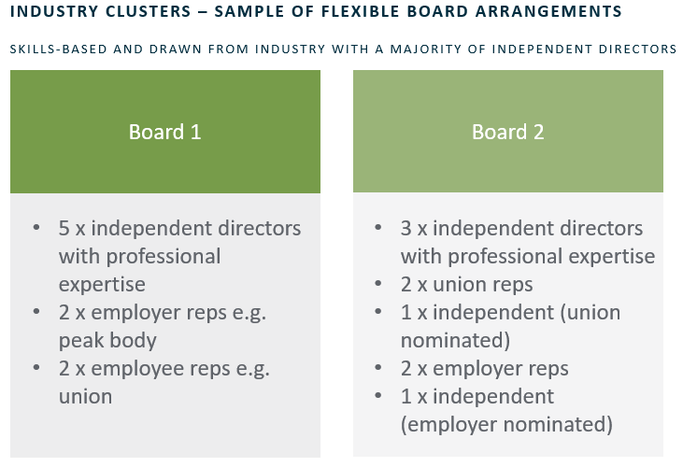

**2.1 SIZE OF THE BOARD**

These expectations can be met with a board that comprises more than nine directors, provided:

1. a majority of directors are independent;
2. a reasonable justification can be made for the increased number of directors i.e. that a larger board would allow access to a broader range of skills/experience or more board members are necessary to allow for greater board diversity and knowledge of different industry sectors; and
3. the board would still be effective and functional.

The department will take a pragmatic approach to assessing requests for a larger board size. In considering a request, the department will require assurance that this will support the good governance of the organisation i.e. there is industry support and it will not compromise the effective functioning of the board.

2.2 independent directors FOR INDUSTRY CLUSTERS

The Guidelines indicate that Industry Clusters are to be established with a majority of 'independent directors'.[1] Appointing 'independent directors' is recognised as a better practice governance principle by a wide range of significant organisations, including the Australian Institute of Company Directors (**AICD**)[2] .In the context of the Industry Clusters Program, the intent is that independent directors act in a manner that is in the best interests of industry and all relevant industry stakeholders as a whole. In accepting the role of independent director, an individual is expected to commit to:

* + 1. exercise independent judgement on issues before the board; and
    2. act in the best interest of the company as a whole, rather than the interests of individuals or a limited group of stakeholders.

In most cases, a board director would not be considered ‘independent’ if they:

* + 1. hold an executive position or are employed within or contracted by the Industry Cluster; or
    2. are a director (remunerated or unremunerated), remunerated office-holder, employee, consultant or contractor of a member of the Industry Cluster.

For the avoidance of doubt, a board director's independence will not necessarily be compromised by the mere fact that:

* + 1. they have previously been employed by or worked as a contractor for a peak industry body, employer organisation or union that is also a member of the Industry Cluster; or
    2. are currently a member of a peak industry body, employer organisation or union that is also a member of the Industry Cluster.

It would be expected that the above interests or relationships would be disclosed and managed as a matter of standard practice in line with the Industry Cluster’s conflict of interest policies and the department’s Industry Clusters Code of Conduct.

If an applicant has proposed a board director who has an interest, position or relationship that might be seen to compromise their independence, applicants should provide reasons as to why they consider the director should be considered independent.

The department can then consider these reasons, taking into account the unique circumstances of each Industry Cluster, in particular the nature of their governance arrangements and industry stakeholders.

1. THE ROLE OF THE MEMBERS

The members of the company exercise ultimate control over a company (via the appointment or removal of the board) and play an important role in holding the board accountable. The members typically have control over key decisions such as appointment of directors, amending the company constitution and winding up of the company. They are not responsible for the management of the company as this is the role of the board.

Central to the design of the Stage One assessment criteria is the requirement that applicants provide evidence of strong industry leadership and ownership and propose governance structures that both support and provide a high level of industry engagement for the industry sectors within their remit. The department requires that Industry Clusters’ membership arrangements be open to all industry stakeholders within a Cluster’s remit and facilitates fair and equitable representation of different stakeholder interests e.g. employee and employer, large and small business.

The department recognises that industry will require flexibility in how it establishes

the membership base of its organisation and that this may vary depending on the industry

stakeholders involved.

In light of this, the department expects that the membership models proposed by applicants

could comprise of:

* + 1. individual members;
    2. organisational members (including employer and employee organisations); or
    3. a combination of both organisational and individual members.

It is also recognised that different Industry Clusters may utilise and adopt different

membership classes to allow for the inclusion of different stakeholders.

The department is open to considering different membership classes that might be proposed by applicants. However, proposed membership classes should not be used to limit fair and equitable participation of any one industry group or member in the governance of the Cluster e.g. limiting certain stakeholders to non-voting status.

1. THE ROLE OF SUB-COMMITTEES

4.1 Strategic and operational sub-COMMITTEES

Industry Clusters will be expected to establish strategic taskforces, sub-committees and technical committees, which will be pivotal to bringing a strong, strategic industry voice to the work of the Cluster. They will lead work drawing on intelligence and insight across industry to inform and advise on the strategic approach of the Industry Cluster’s board and ensure delivery of critical functions, including workforce planning and training product development.

Diverse stakeholder views and representation, including employer and employees, are to be captured at the taskforce and sub-committee levels across respective industry sectors and stakeholders. Sub-committees related to training product development and delivery should include individuals with technical expertise alongside a broad range of industry stakeholders.

4.2 Board sub-committees

At a minimum, the board is required to establish an Audit and Risk Committee to review the appropriateness of the Cluster’s financial reporting; performance reporting; system of risk oversight and management; and system internal controls.

The boards of Industry Clusters will be expected to play an ongoing role in monitoring the work of any committee's established, including by ensuring that:

* + 1. conflicts of interest at the committee level are being identified and appropriately managed; and;
    2. ensuring the work of any committees is consistent and in line with the Industry Cluster's obligations under its grant agreement.

1. Grant Opportunity Guidelines, Part 4.2, p. 13.
2. See various AICD articles on director independence here: [Independent director (aicd.com.au)](https://www.aicd.com.au/board-of-directors/roles/independent.html)