Decision about stopping Centrelink money

For not doing your activities in the time you need to

  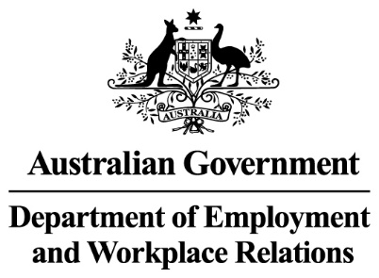 | The Australian Government  - Department of Social Services wrote this.  We say DSS for short.  - Department of Employment and Workplace Relations  We say DEWR for short.  When you see the word we it means DSS and DEWR.
 | We wrote this in an easy to read way.  We use pictures to explain some ideas.
 | We have some words in bold.  This means the letters are thicker and darker.  These are important words.
 | This is an Easy Read summary of another document.  This means it has the most important ideas.
 | You can ask for help to read this document.  You can ask  - A friend  - Family members  - A support person.

Contents

What is the reconnection requirement | 5
Decisions we have made | 11
Why we made this decision | 12
Who will be affected | 14
What you need to do | 17
Past decisions | 18
Support | 19
Other decisions that are stopped for now | 20
What is next | 21

What is the reconnection requirement

 | We have laws for  - People who get Centrelink money for not having a job  We call this job seeker.
 | - The things they need to do to get their Centrelink money.  We call these activities.  Laws are rules for how we live.
 | You can read about the different activities on our website.  www.dewr.gov.au/resources/assuring-integrity-targeted-compliance-framework  It is in Easy Read.
 | It is called mutual obligation failure if you do not do them.
 | We can stop your Centrelink money if you do not  - Do your activities
 | - Agree to or start a job.  This is called work refusal failure.
 | You will be told what you need to do to start your Centrelink money again.
 | You might need to talk to  - Your employment provider
 | - The Digital Services Contact Centre  1800 314 677.
 | You can say  - What you will do to make up what you missed
- Tell them if you have a good reason.

You can read about some of the reasons for not doing your activities on our website.

www.dewr.gov.au/resources/assuring-integrity-targeted-compliance-framework

It is in Easy Read.
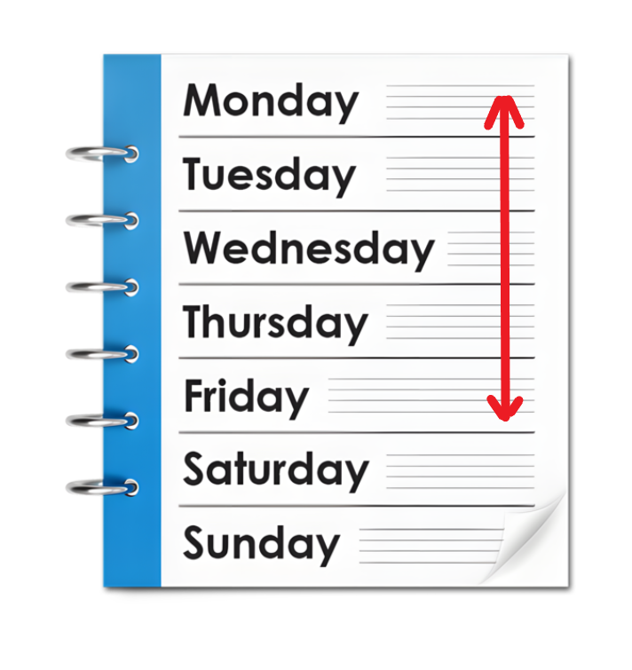 | You will have 5 workdays to do this.  Workdays are the days between  - Monday  - Friday.
 | We will stop your Centrelink money for a short time if you do not do this.
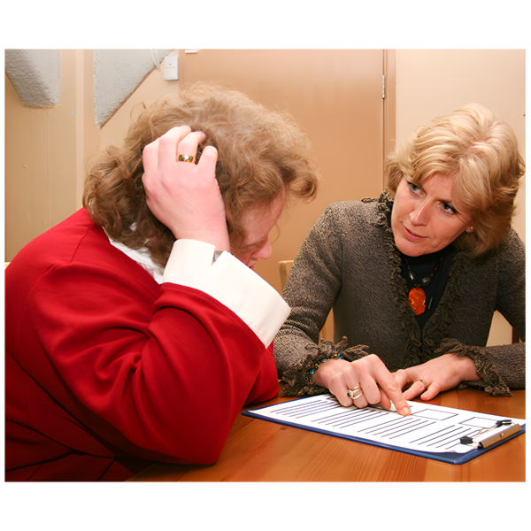 | If we stop your Centrelink money we will tell you what you need to do to start it again.  This is called reconnection requirement.
 | You have less than 4 weeks to tell us  - A good reason for not doing your activities
 | - Start doing your activities again  From when we stopped your Centrelink money.  We will start your money again if you do.
 | If you take longer than 4 weeks and  - Do not have a good reason for not doing your activities
 | - Do not start doing your activities again  We can stop your Centrelink money.  The law says we can do this.
 | You need to apply for your Centrelink payments again if they are stopped.  Apply means you send in information to Services Australia about  - Who you are  - What payments you need.
 | You will have to wait for 4 weeks before you get money from Centrelink.

Decisions we have made

 | On 24 September 2024 DEWR stopped for now cancelling Centrelink money for people who are not doing their activities on purpose.  They have 4 weeks to start doing them again.

Why we made this decision

 | The government has laws to follow to make sure things are done in a fair way.  We are worried that our computer systems are not following the rules at all times.  We need to make sure this is fixed quickly.
 | We found out that our computer system was not following the rules at all times in September 2024.
 | We found out that the computer problem started in December 2020.
 | We made the decision to stop Centrelink money being  - Changed  - Stopped.  Because the computer system is not following the rules at all times.
 | These decisions will be stopped for now while we make things better.

Who will be affected

 | You might be affected if you had your Centrelink money stopped for not doing your reconnection requirement in 4 weeks.
 | Some of the people who are affected got Centrelink money for  - Job seeker
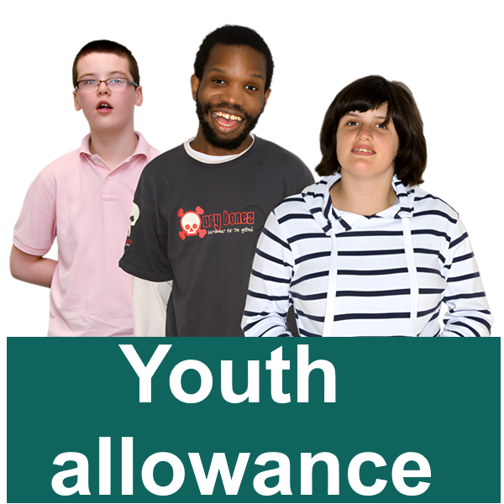 | - Youth allowance other
 | - Parenting payment single  After your youngest child is 6 years old.
 | - Special benefit for nominated visa holders.  This is for people from overseas working here.
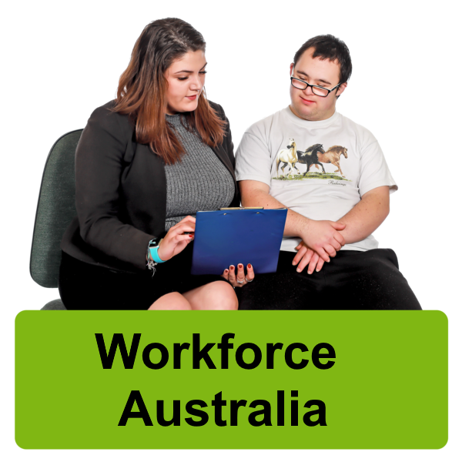 | It could also be anyone who took part in  - Workforce Australia
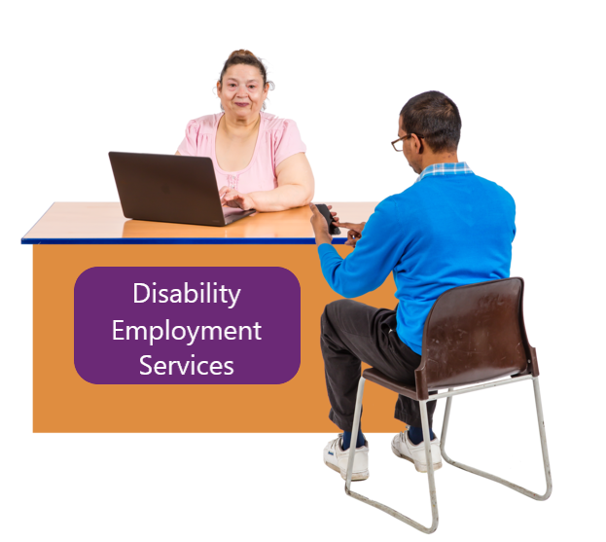 | - Disability Employment Services  We call it DES for short.
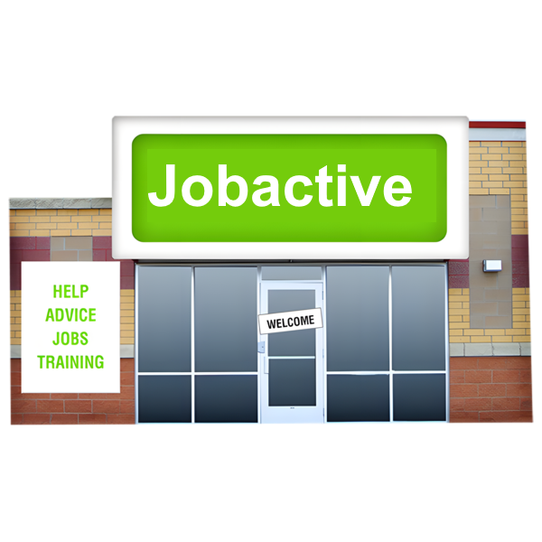 | - The Jobactive program
 | It does not affect anyone who was in the Community Development Program.
 | This program supports people who live in remote areas to get  - Fair money for work they do  - Jobs that help the community.

What you need to do

 | You do not need to do anything at the moment.
 | You need to keep doing your activities.
Talk to

- Your employment provider
- The Digital Services Contact Centre

1800 314 677

To make sure your activities are right for you.

Past decisions

 | We are looking at decisions we have already made.  They are called past decisions.
 | We are still working out what we need to do next.

Support

 | You might  - Have questions
 | - Be worried
 | - Want to make a complaint.  Complaints are when you tell someone they have not done a good job.  Everyone has the right to make a complaint.
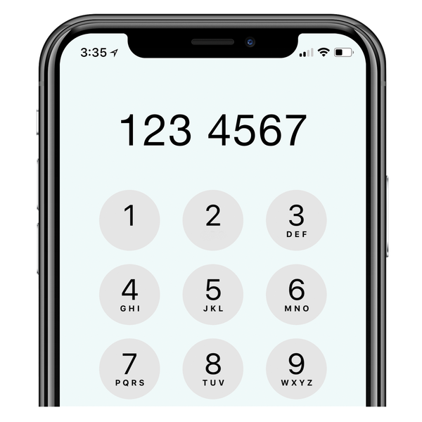 | You can call the DEWR National Customer Service Line  1800 805 260

Other decisions that are stopped for now

There are other decisions that have been stopped for now.
You can go to our website to read about the other decisions we have stopped for now.

www.dewr.gov.au/resources/assuring-integrity-targeted-compliance-framework

It is in Easy Read.

What is next

 | We have updated our computer systems.  They will not stop Centrelink payments for not doing your reconnection requirements in 4 weeks.
 | We will keep working to make sure the decisions  - Follow the law  - Are fair.
 | We are doing a review of this law.  A review is when you check what  - Works  - Needs to change.
 | We have made sure the review is  - Done in a fair way  - Following the law.
 | We have an independent person checking our computer systems.  Independent means separate to the government.
 | This means we are checking if our computer systems are following the rules.
If we do not believe the decisions

- Follow the law
- Are fair

We will stop them right away.
 | We need to make sure that any changes to  - The way we do things
 | - Our computer systems
- The law

Are done in the right way.
 | We are working on this.
 | We will let you know when we make more decisions.

Images in this Easy Read must not be used or copied without permission

