

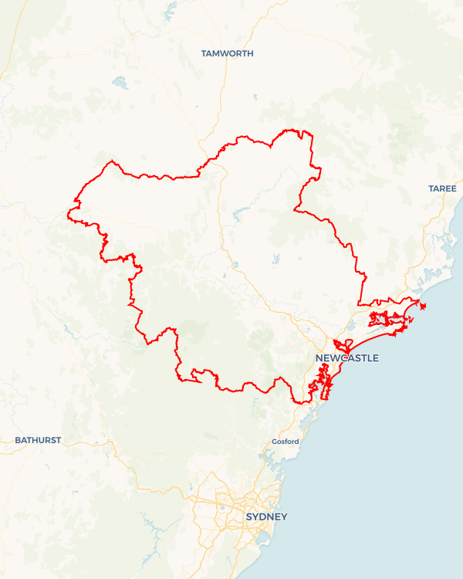Local Jobs Plan

Hunter Employment Region | NSW | ****February 2024****

Workforce Australia Local Jobs (Local Jobs) supports tailored approaches to accelerate   
reskilling, upskilling and employment pathways in response to current and emerging local workforce needs.

## Local Jobs elements

### Local Jobs Plan

The Local Jobs Plan sets out the skills and employment challenges and priorities of the region, and associated strategies that will drive the design and implementation of activities to be implemented to address these challenges.

### Employment Facilitators

Employment Facilitators and Support Officers support the delivery of the program by bringing together key stakeholders including businesses, employment services providers, higher education and training organisations.

### Local Jobs and Skills Taskforce

Each Employment Region has its own Taskforce. Representatives include local stakeholders who have demonstrated experience in upskilling, reskilling, and an ability to represent, connect and collaborate with others in the region to meet labour market needs.

### Local Recovery and National Priority Funds

The Local Recovery Fund supports projects that meet the priorities identified in the Local Jobs Plan. The National Priority Fund provides funding for innovative local solutions to address structural barriers to employment.

Explore labour market insights for the   
[Hunter](https://www.jobsandskills.gov.au/work/employment-region-dashboards-and-profiles/monthly-labour-market-dashboards) Employment Region

## Local labour market challenges in the region

* Difficulty in securing adequately skilled workers in growth and demand sectors with accessible entry level work, including aged and disability care, tourism, advanced manufacturing and construction.
* More acute impacts for vulnerable groups, including Aboriginal and Torres Strait Islanders, youth, mature aged and people with a disability.
* Limited take up and understanding of apprenticeship and traineeship opportunities across the region coupled with limited knowledge of mentoring and support services available for apprentices and trainees including the state led Better Supervision program.
* An accelerated target in the energy sector linked to the Hunter’s transformation to Net Zero, and how this impacts existing workers and communities.
* Enduring business concerns regarding soft and employability skills.
* Uncertainty around the skills and qualifications required for future and emerging industries.
* Limited access to transport including public transport and access to driver training, particularly in rural and larger regional towns.

## Local jobs and skills priorities and strategies in the region

## Priority 1 – Health, care, and community services

#### What are our challenges and opportunities?

#### There is critical workforce demand across the care sector, specifically aged, disability and child care. There is an opportunity to meet growing workforce demand by creating sector-specific solutions and pathways to employment within the care and community services sector while supporting associated supply chain.

#### How are we responding?

* Building profiles of care careers as a desirable career choice for participants including raising awareness of long-term career progression of other roles within the industry (e.g. support services, human resources and maintenance).
* Undertaking industry consultation to refine and tailor pathways into entry level roles, such as increasing the availability of traineeship options and industry endorsed training programs.
* Supporting small and micro businesses in the sector to employ through collaborative programs, connection to funding and incentives and tailored supports.
* Streamlining access to opportunities for vulnerable cohorts such as Aboriginal and Torres Strait Islanders, youth, mature aged, women, Culturally and Linguistically Diverse (CaLD) and refugees.
* Leveraging existing funding opportunities, projects and programs including NSW Government Smart and Skilled funding to enhance the training opportunities within the care sector.

### Priority 2 – Hospitality, tourism and customer service

#### What are our challenges and opportunities?

There is growing workforce demand within the hospitality, tourism, and customer service sector. There is an opportunity to challenge perceptions for people to consider roles in this industry as valid career options. We aim to meet growing workforce demand by creating sector-specific solutions and pathways to employment within the hospitality, tourism and customer service sector.

#### How are we responding?

* Building collaborative employment and training solutions which align to Destination Management and Economic Development strategies of Local and State governments.
* Developing projects which address attraction and retention issues with input from industry, community, and employment services providers.
* Building awareness and attraction campaigns around long-term career pathways within the industry.
* Leveraging existing funding and initiatives across the region.
* Utilising existing working groups and industry groups to minimise duplication and provide specific focus on workforce development and industry activity.
* Streamlining access to opportunities for vulnerable cohorts such as Aboriginal and Torres Strait Islanders, youth, mature aged, women, CaLD, and refugees.

### Priority 3 – Manufacturing, construction and traditional trades

#### What are our challenges and opportunities?

#### The ongoing increase in workforce demand, with reduced levels of diversification in these industries. There is an opportunity to address growing workforce demand and current skills gaps across manufacturing and construction with consideration to emerging skill sets that assist with net zero targets, traditional trades, and roles within advanced manufacturing across the Hunter.

#### How are we responding?

* Collaborating with industry to build clear pathways into manufacturing, construction and traditional trades and increasing gender diversification.
* Building an awareness campaign around long-term career opportunities within manufacturing and construction including entrepreneurship opportunities.
* Working with businesses to create streamlined access to programs and projects that provide a direct pathway to employment.
* Working with industry to ensure training meets future workforce demand, specifically for large-scale projects to ensure local workforce is available.
* Using a proactive approach to training and skilling Workforce Australia participants and the community in collaboration with Training Services NSW to ensure suitably skilled pools of candidates are available to meet workforce demand in infrastructure projects.
* Improving traditional skills to meet the needs of renewable energy and net zero opportunities via the promotion of apprentice and trainee opportunities in the sector.
* Ensure collaboration with industry bodies to maximise opportunity and minimise duplication.
* Streamlining access to opportunities for vulnerable cohorts such as Aboriginal and Torres Strait Islanders, youth, mature aged, women, CaLD, and refugees.

### Priority 4 – Net zero, emerging industries, skills, and innovation

#### What are our challenges and opportunities?

#### Limited community knowledge of net zero projects, emerging industries and what potential jobs and opportunities the net zero transformation will bring to the region. There is an opportunity to support net zero projects in the Hunter that align to our net zero targets, by preparing participants for immediate and long-term employment opportunities through collaborative projects with government, business and community.

#### How are we responding?

* Building collaborative employment and training solutions which align to Economic Development strategies of federal, state and local governments.
* Leveraging existing opportunities to support businesses emerging within the Hunter - Central Coast Renewable Energy Zone and surrounding areas.
* Leveraging existing funding models and programs including other federal departments and State led programs and initiatives including the NSW Future Jobs and Investment Authority and the Australian Government Net Zero Economy Agency.
* Proactively approaching training and awareness activities in collaboration with all levels of government to address opportunities in net zero. This includes Science, Technology, Engineering, Mathematics and Medicine (STEMM) Precinct/Regional Transformation Hub, circular economy opportunities and Muswellbrook innovation precinct.
* Increasing knowledge and awareness of regional activity through existing networks and groups including Hunter Defence Taskforce, Hunter Hydrogen Taskforce, Hunter Young Business Minds, the University of Newcastle, TAFE NSW and other relevant Registered Training Organisations and key community groups and stakeholders.
* Identifying opportunities for vulnerable cohorts such as Aboriginal and Torres Strait Islanders, youth, mature aged, women, CaLD, and refugees.

### Priority 5 – The Upper Hunter

#### What are our challenges and opportunities?

#### The Upper Hunter is undergoing significant structural change with a skilled workforce experiencing transition. There is an opportunity to support the Upper Hunter and work closely with key stakeholders, community groups and local industries to facilitate a collaborative approach to future skills and workforce development.

#### How are we responding?

* Assisting industries with immediate workforce demand including equine, mining, meat product manufacturing and agriculture through pre-employment and skill set based training programs.
* Supporting the diversification of the energy sector as part of our net zero transformation.
* Building regional skills capability by mapping future workforce and skill requirements within the region, particularly with the introduction of net zero projects.
* Conducting education pieces across the Upper Hunter to assist in showcasing the emerging industries and opportunities for the future workforce and the positive impacts this will have across the region.
* Building engagement with local governments across the Upper Hunter to determine their industry priorities and economic development outlook as well as to respond to employment opportunities as they emerge.
* Supporting self-employment and entrepreneurship opportunities across the Upper Hunter.
* Leveraging existing funding across federal, state and local government departments and agencies to assist the region.
* Leveraging existing programs and groups including Upper Hunter Education and Training Working Group, Self-Employment Assistance program and Singleton Council Skills and Employment Exchange Program.
* Streamlining access to local opportunities for vulnerable cohorts such as Aboriginal and Torres Strait Islanders, youth, mature aged, women, CaLD, and refugees.

## Want to know more?

* Contact: Kempsey Litten, Hunter Employment Facilitator: [kempsey.litten@hunterfacilitator.com.au](mailto:lionelcottingham@hunterfacilitator.com.au)
* Visit: [Local Jobs](https://www.dewr.gov.au/local-jobs) or [Workforce Australia](https://www.workforceaustralia.gov.au/)
* The Australian Government Employment Facilitator is working collaboratively with the Employment Facilitator in the Hunter Employment Region to support the positive and orderly transition to a net zero economy. For further information, please refer to the Australian Government Employment Facilitator’s  
  [Supporting Workforce Transition to a Net Zero Economy plan](https://www.dewr.gov.au/local-jobs/resources/supporting-workforce-transition-net-zero-economy-hunter).